Introduction

- On 9 May 2012, the SFC published the Consultation Paper on regulation of sponsors
- On 12 December 2012, the SFC published the Consultation Conclusions on the regulation of IPO Sponsors
- New sponsor regulatory regime became effective from 1 October 2013
- Listing Rules changes (to complement the new regime) came into effect on 1 October 2013 (with transitional arrangements)

Agenda

- Background
- SFC’s Consultation Paper and Consultation Conclusions
- Summary of changes under the new sponsors regime
- Paragraph 17 of Code of Conduct
- Major Listing Rules changes (including new and revised Guidance Letters on financial information in listing documents)
- Impact on IPO sponsors
- Appointment of sponsors, notification obligations, sponsor fees
- Eligibility criteria of sponsor principals and new regulatory examination
- Hong Kong Sponsors Due Diligence Guidelines
- Sponsor due diligence work plan

Background

IPOs in Hong Kong
- Hong Kong was among the world’s top 5 exchanges in IPO fundraising for the past decade
- ranked no. 1 for 3 consecutive years from 2009 to 2011 in terms of funds raised
- US$11.6 billion raised through 64 IPOs in 2012
- Hong Kong 2012 market capitalisation = US$2.831.9bn
- IPOs play an important role in the development of Hong Kong as a leading international financial centre
- Unique sponsor regime
- Primary vehicle for Mainland China companies to raise funds outside domestic markets

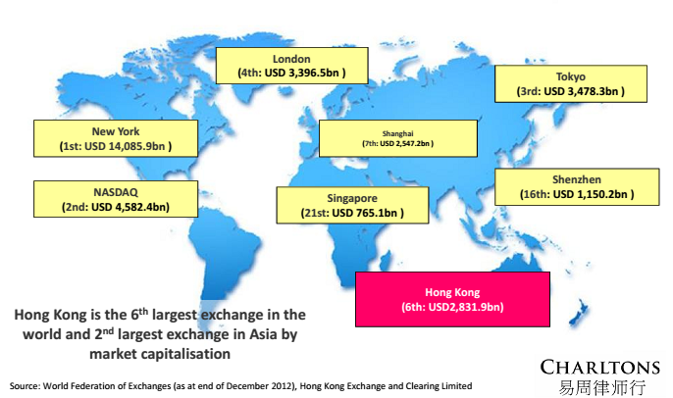

IPOs in Hong Kong - Gateway to Mainland China

 | Unit | Total | Mainland Enterprise | % of Total
As at 31 December 2012
No. of listed companies |  | 1,547 | 721 | 47%
Market capitalisation | HK$bn | 21,950 | 12,598 | 57%
As of 31 December 2012
Total equity funds raised | HK$bn | 301.2 | 215.0 | 71%
- IPO funds raised | HK$bn | 89.8 | 81.2 | 90%
- Post IPO funds raised | HK$bn | 214.4 | 133.8 | 62%
Average daily turnover | HK$m | 38,579.5 | 26,835.7 | 70%

Source: Hong Kong Exchanges and Clearing Limited

Unique features of the Hong Kong IPO Market
- Multi-cultural
- High proportion of overseas companies listed
- Involvement of advisers in various jurisdictions
- Sponsor regime:
- Sponsor, an investment bank, takes lead role in IPO:
- Coordinating with other advisers
- Advising and guiding the listing applicant and its directors throughout the listing process
- Conducting due diligence
- A sponsor regime does not exist in some other large markets, for example the US and Australia

- Challenges facing Hong Kong IPO Market
- Accuracy of accounts of Mainland China companies
- Inability to subject directors of overseas companies to Hong Kong jurisdiction
- High-profile scandals highlight challenges:
- Hontex International Holdings Company Limited:
- Trading halted only 3 months after its December 2009 IPO
- Prospectus found to contain materially false and misleading information
- Financial position was materially overstated in the prospectus
- In 2012, Hontex was ordered by the court to make HK$1.03 billion repurchase offer to investors who subscribed for shares in its IPO or purchased its shares in secondary market
- SFC revoked the licence of Mega Capital, the sole sponsor of Hontex’s IPO
- SFC fined Mega Capital HK$42 million
- Due diligence work of Mega Capital found to be inadequate and sub-standard

Challenges facing Hong Kong IPO Market not unique for IPOs of China companies

Example: China IPOs in the United States
- From 2009-2011, 67 IPOs of companies from China (valued at a combined US$8.26 billion). In 2012, only 2 IPOs of companies from China in the US
- Concerns with reverse merger structure
- Subsequent delistings (ex: delisting of SinoTech Energy from Nasdaq), buy-outs (ex: Harbin Electric’s US$750 million buy-out) or drops in stock price (ex. Sino Forest, after accusations of fraud)
- Accusations of accounting fraud, overstatements of the value and quality of assets and misrepresentations regarding the use of IPO proceeds
- In 2012, administrative proceedings brought by the US Securities and Exchange Commission against Chinese affiliates of 5 U.S. accounting firms for not handing over work papers for audits in China in relation to accounting frauds at nine companies
- May 2013, US Public Company Accounting Oversight Board (“PCAOB”) signed Memorandum of Understanding with Chinese regulators to allow PCAOB to obtain audit work papers of China-based audit firms

SFC’s Consultation Paper on the Regulation of Sponsors

Consultation Paper on regulation of sponsors published on 9 May 2012

Background to proposals:
- “the SFC remains concerned that standards of sponsor work…fall short of reasonable expectations.” Contributory factors may include:
- Resources (insufficient resources or expertise devoted to sponsor work)
- Insufficient involvement of senior management (issues not being escalated and insufficient oversight by senior management)
- Over-delegation to other parties (especially legal counsel)
- Multiple sponsors (fragmentation of work, gaps and overlaps)
- Uncritical reliance on experts (especially accountants and valuers)

Major rules and regulations governing sponsors:
- Securities and Futures Ordinance (SFO)
- Code of Conduct for Persons Licensed by or Registered with the SFC (Code of Conduct)
- Corporate Finance Adviser Code of Conduct (CFA Code)
- Additional Fit and Proper Guidelines for Corporations and Authorised Financial Institutions applying or continuing to act as Sponsors and Compliance Advisers (Sponsor Guidelines)
- Management, Supervision and Internal Control Guidelines for Persons Licensed by or Registered with the SFC (Internal Control Guidelines)
- Chapter 3A and Practice Note 21 (PN 21) of the Main Board Listing Rules and Chapter 6A and Practice Notice 2 (PN 2) of the GEM Rules)

- Proposed to consolidate requirements for sponsors into a new paragraph 17 of Code of Conduct

Summary of 10 Key Proposal Areas:

- Due Diligence
- Completion of due diligence before submission of listing application
- Remediation of material deficiencies before submission of listing application

- Reliance on experts
- Sponsor should not place undue reliance on experts’ work, including accountants’ and valuers’ reports

- Reliance on non-expert third parties to conduct due diligence
- No over-reliance on legal counsel
- Sponsors ultimately responsible for due diligence, responsibility cannot be delegated

- Information to regulators
- Sponsor to reasonably satisfy itself information provided to regulators is accurate, complete and not misleading
- Disclosure to regulators of all material information in relation to non-compliance of the listing applicant known to sponsor

- Publication of first draft (Application Proof or AP)
- First draft of a listing document submitted with a listing application to be made available on HKEx website when application is made

- Records
- Sponsor to maintain a record of work done for 7 years, in Hong Kong

- Resources, systems and procedures
- Sponsor to maintain sufficient resources and effective systems and procedures
- Senior management of a sponsor should monitor and guide the process

- Principals
- Comments invited concerning licensing criteria to increase number of individuals who may qualify as Principals while not affecting quality of sponsor work

- Multiple sponsors
- Either (i) sole independent sponsor or (ii) a limit on the number of sponsors

- Prospectus liability
- Sponsor has civil and criminal liability under sections 40 and 40A of the
Companies Ordinance for untrue statements, including
material omissions, in a prospectus

Market response and SFC’s Consultation Conclusions

- Consultation period was extended from 6 July 2012 to 31 July 2012
- 71 written responses received from sponsor firms, lawyers, accountants, the investor community and various corporate governance bodies
- 6 respondents represented groups of sponsor firms, investment banks or pension funds

Consultation Conclusions
- Published on 12 December 2012
- Adopted most of the proposals including prospectus liability and publication of Application Proof
- Refined the details of certain proposals
- E.g. not necessary to remedy all material deficiencies prior to submission of listing application; if cannot be remedied prior to application → sponsor to make adequate disclosure
- New issues:
- Minimum appointment period of sponsors of 2 months
- Notification obligations in relation to sponsor appointment and cessation to act
- Sponsor’s terms of engagement
- Financial adviser’s obligation to co-operate with sponsors

- ADVISING A LISTING APPLICANT (Paragraph 17.30)

- Question 1 - Do you agree a sponsor should have a sound understanding of a listing applicant for which it acts? If not, why not?

- Question 2 - Do you agree that a sponsor should advise and guide a listing applicant and its directors as to their responsibilities under the Listing Rules and other applicable regulatory requirements and take all reasonable steps to ensure that at all stages of the listing application process they understand and meet these responsibilities? If not, why not?

- Question 3 - Do you agree that a sponsor should provide appropriate advice and recommendations to a listing applicant on any material deficiencies identified in relation to its operations and structure, procedures and systems, or its directors and key senior managers and ensure that any material deficiencies are remedied prior to the submission of a listing application? If not, why not?

- WORK REQUIRED BEFORE SUBMITTING A LISTING APPLICATION (Paragraph 17.4)

(i) Completion of reasonable due diligence

- Question 4 - Do you agree that before submitting a listing application a sponsor should complete all reasonable due diligence on the listing applicant save only any matters that by their nature can only be dealt with at a later date? If not, why not?

- Question 5 - Do you agree that before submitting a listing application a sponsor should come to a reasonable opinion that the information in the Application Proof is substantially complete?

(ii) Resolving fundamental compliance issues

- Question 6 - Do you agree that before submitting a listing application a sponsor should come to a reasonable opinion that the applicant has complied with all applicable listing conditions (except to the extent that waivers from compliance have been applied for), has established adequate systems and procedures and the directors have the necessary experience, qualifications and competence?

(iii) Identifying material issues

- Question 7 - Do you agree that a sponsor should ensure that all material issues known to it which, in its reasonable opinion, are necessary for the consideration of the application as described in paragraph 57* above are disclosed to the regulators when submitting a listing application? If not, why not?
- * This relates to whether a listing applicant is suitable for listing and whether the listing of the applicant’s securities is contrary to the interest of the investing public or to the public interest

- SPONSOR’S RESPONSIBILITY FOR DISCLOSURE IN A LISTING DOCUMENT (Paragraph 17.5)

(i) Overall disclosure

- Question 8 - Do you agree that a sponsor, after reasonable due diligence, should ensure that at the time of issue a listing document contains sufficient particulars and information to enable a reasonable person to form a valid and justifiable opinion of the financial condition and profitability of the listing applicant? If not, why not?

(ii) Disclosure: non-expert sections

- Question 9 - Do you agree that a sponsor, after reasonable due diligence, should have reasonable grounds to believe and does believe that at the time of issue of a listing document the information in the non-expert sections is true, accurate and complete in all material respects and that there are no material omissions?

Question 10 – disclosure: expert reports

- Do you agree that at the time of issue of a listing document a sponsor should be in a position to demonstrate that it is reasonable for it to rely on the expert sections of the listing document?
- Examples of market responses:
- primary responsibility for the expert sections of a prospectus should be taken by the experts themselves who are qualified professionals in areas where sponsors do not have expertise
- contrary to SFC’s view, in fact no other major markets, including Australia, is imposing such an obligation on sponsors or underwriters
- SFC’s conclusions:
- Amended to require that a sponsor, from the perspective of a non-expert, should have no reasonable grounds to believe and should not believe that the information in the expert reports is untrue or misleading or contains any material omission

Question 11 – due diligence on expert reports

- Do you agree that the sponsor should take these steps in connection with an expert report? Are the steps set out in paragraph 17.6(g) of the draft Provisions sufficient and appropriate? If not, why not?
- Examples of market responses:
- Experts’ responsibility must not be transferred to sponsors
- it is not possible for a sponsor to “audit” or replicate the work done by experts
- other advanced markets do not impose such onerous obligations
- SFC to publish a draft of the “final rule” so the market can have a complete picture of the regulations before expressing its opinion on the proposed amendment
- SFC’s conclusions:
- imperative to indicate the typical areas of due diligence to be carried out in respect of expert reports
- did not further consult with market participants

- DUE DILIGENCE (Paragraph 17.6)

(i) Reliance on non-expert third parties to conduct due diligence

- Question 12 – Do you agree that a sponsor cannot delegate responsibility for due diligence? If not, why not?

- Question 13 - Are the steps we propose a sponsor should take when seeking assistance from a third party in its due diligence work sufficient and appropriate? If not, why not?

- COMMUNICATIONS WITH THE REGULATORS (Paragraph 17.7)

- Question 14 - Do you agree that a sponsor should reasonably satisfy itself that all information provided to the Stock Exchange and the SFC during the listing application process is accurate, complete and not misleading and, if it becomes aware that the information provided does not meet this requirement, the sponsor should inform them promptly? If not, why not?

- Question 15 - Do you agree that a sponsor should deal with all enquires raised by the regulators in a cooperative, truthful and prompt manner? If not, why not?

- Question 16 - Do you agree that a sponsor should disclose to the Stock Exchange in a timely manner any material information relating to a listing applicant or listing application of which it becomes aware which concerns non-compliance with the Listing Rules or other applicable legal or regulatory requirements? If not, why not?

- Question 17 - Do you agree that if a sponsor ceases to act for a listing applicant during the listing application process, it is required to inform the Stock Exchange in a timely manner of the reasons for ceasing to act? If not, why not?

Question 18 – publication of Application Proof
- Do you agree that the Application Proof submitted with a listing application should be made publicly available when the application is made? If not, why not?
- Examples of market responses:
- premature disclosure of commercially sensitive information of a listing applicant before there is any certainty of the success of listing → reduce attractiveness of HK as a listing venue
- utility of the publication of Application Proofs for investors is questionable as the Application Proof is subject to changes
- proposal goes against the requirements of other advanced markets and recent developments in the U.S.
- Exchange is already entitled under Listing Rule 9.03(3) to reject a draft prospectus if it does not consider it to be in an advanced form
- SFC to reconsider the proposal, or engage an external consultant to do a cost and benefit analysis or consult the industry group further
- Do you agree that the Application Proof submitted with a listing application should be made publicly available when the application is made? If not, why not?
- SFC’s conclusions:
- publication of Application Proof would enhance the transparency of the listing application process which should improve market efficiency
- intended that ultimately all successive amended drafts, regulatory comments and the applicant’s responses would be make public and SFC will assess the position after the implementation of the new practice before deciding whether to introduce this as a requirement
- argument that information about the applicant should not be public because the applicant may not achieve an IPO was unsustainable
- concluded to proceed to implement the proposal to publish Application Proof without conducting further public consultation or engaging external consultant for further study

- PROPER RECORDS (Paragraph 17.8)

- Question 19 - Do you agree that a sponsor’s records should be sufficient to demonstrate that the sponsor has complied with all applicable legal and regulatory requirements and in particular compliance with the Provisions? If not, why not?

- Question 20 - Do you agree that a complete set of a sponsor’s records in connection with a listing transaction should be retained in Hong Kong for at least seven years after completion or termination of the transaction? If not, why not?

- RESOURCES, SYSTEMS AND PROCEDURES (Paragraph 17.9)

(i) Sufficient resources

- Question 21 - Do you agree that before accepting any appointment as a sponsor, a firm should ensure that, taking account of other commitments, it has sufficient staff with appropriate levels of knowledge, skills and experience to devote to the assignment throughout the period of the assignment? If not, why not?

- Question 22 - Do you agree that the provisions of the Sponsor Guidelines concerning the Transaction Team should be transferred to the Code of Conduct? If not, why not?

(ii) Due diligence plan

- Question 23 - Do you agree that a sponsor should maintain effective systems and procedures to ensure that an appropriate due diligence plan is formulated, updated as necessary and implemented in respect of each assignment and there are clear and effective reporting lines to ensure that key issues are escalated to Management for deliberation? If not, why not?

(iii) Management oversight

- Question 24 - Do you agree that a sponsor’s Management is obliged to adequately supervise the performance of due diligence including but not limited to the key issues discussed in paragraph 97? If not, why not?

(iv) Sponsor principals

- Question 25 - Which, if any, of the proposals in paragraph 103 would achieve the objectives enlarging the category of individuals qualified to act as Principals whilst not affecting the overall quality of sponsor work? Do you have alternative suggestions to address the issues?

(v) Multiple sponsors

- Question 26 - Do you agree that there should only be one sponsor on each engagement?

- Question 27 - If more than one sponsor is allowed, do you agree that they should all be required to meet the Listing Rules independence requirements? If not, why not?

- Question 28 - Do you agree that if more than one sponsor is appointed each sponsor’s responsibilities should remain unaffected and that each sponsor should comply with all the expectations of a sponsor? If not, why not?

- OVERALL MANAGEMENT OF A PUBLIC OFFER (Paragraph 17.10)

- Question 29 - Do you agree that the provisions of the CFA Code relating to the management of a public offer should be transferred to the Code of Conduct? If not, why not?

- INFORMATION PROVIDED TO ANALYSTS IN NEW LISTINGS (Paragraph 17.11)

- Question 30 - Do you agree that the obligation in the CFA Code relating to the provision of information to analysts should be transferred to the Code of Conduct? If not, why not?

(i) Scope of Provisions

- Question 31 - Do you agree that the Provisions should equally apply to a listing agent appointed for the listing of a REIT? If not, why not?

Market response and SFC’s Consultation Conclusions - prospectus liability

Question 32 – prospectus liability

- Do you agree that it should be made clear that sponsors are liable for untrue statements (including material omissions) in a prospectus? If not, why not?

Existing prospectus liability provisions of Companies Ordinance

- Section 40 – civil liability
- every director, promoter and person who has authorised the issue of a prospectus containing any untrue statement shall be liable to all persons who subscribe for any shares or debentures on the faith of the prospectus for their loss or damage as a result of the untrue statement, unless he had reasonable grounds to believe and did up to the time of the allotment of the shares or debenture, believe that the statement was true
- Sections 40A & 342F – criminal liability
- every person who authorised the issue of a prospectus containing any untrue statement shall be liable to imprisonment for up to 3 years and a fine of up to HK$700,000 unless he proves either that that statement was immaterial or that he had reasonable grounds to believe and did up to the time of the issue of the prospectus, believe the statement was true
- Applicable to sponsors?
- Diverging views in the market
- No case law on whether sponsors are subject to the prospectus
- liability provisions of the Companies Ordinance

Examples of market responses:

- Adequacy of existing provisions

- Sponsors’ civil and criminal liability under sections 107, 108, 277, 298, 281, 305 and 384 of the SFO for misrepresentation or disclosure of false or misleading information inducing transactions
- Sponsors are already subject to SFC’s extensive disciplinary powers, e.g. revocation of licence, imposition of fines
- Investors additionally protected under the laws of contract and tort
- Existing provisions are already adequate

Examples of market responses:

Unfair to shift responsibility to sponsors
- IPO is without doubt a collaborative process involving not only sponsors
- unfair to make a sponsor liable for others’ wrong-doing or malpractice
- due diligence cannot guarantee the absence of fraud, forgery or deliberate non-disclosure
- sponsors, as non-experts without the required expertise and resources, cannot be expected to assume responsibility for experts

More lengthy and complicated prospectuses
- exacerbate the tendency to include as much information as possible as a means to avoid liability
- even longer and more complicated

Facilitating action against parties “primarily responsible”
- should instead focus on developing cooperative arrangements with the relevant regulatory bodies and other professional regulators to introduce effective enforcement and sanctions against the directors of applicants and promoters of businesses and experts for inaccurate prospectus information

Mens rea shall be present
- no mens rea requirement under existing section 40A of the Companies Ordinance
- SFC acknowledged this shortcoming
- even if the SFC were to amend Section 40A to require intent or recklessness, terms such as “recklessness” and “knowledge” lack certainty
- only circumstances in which a sponsor should be criminally liable would be where it has acted dishonestly or with intent to defraud IPO investors

Proper defences should be incorporated
- appropriate defences must be incorporated into the legislation to ensure that sponsors are not liable for a listing applicant’s fraud or deliberate withholding of information

Burden of proof should be placed on prosecution
- prosecution must have the normal responsibility of proving beyond reasonable doubt that the accused acted dishonestly or with the intent to defraud investors

Restrict imprisonment penalties
- liability should be restricted to fines only; or
- penalty of imprisonment, should only apply to sponsors if they act dishonestly or with intent to defraud investors

Separate consultation needed
- liability under the Companies Ordinance is an issue of great importance, a separate consultation should be conducted to ensure the issues are addressed fully

SFC’s conclusions:
- concluded to proceed with the proposal
- no further public consultation conducted
- agreed to recommend to the government to amend the sections imposing criminal liability to shift the burden of proof to the prosecution
- not intended that a due diligence failure will of itself involve criminal liability
- unlikely to be held liable if a sponsor fully complies with the paragraph 17 of Code of Conduct

SFC’s proposed Companies Ordinance amendments
According to the Consultation Conclusions
- The civil and criminal liability provisions under sections 40, 40A and 342F of the Companies Ordinance will be amended so that a person who has authorized the issue of a prospectus includes a sponsor
- The criminal liability provisions will be amended so that the prosecution bears the burden of proving that:
  - the defendant knew that, or was reckless as to whether, a statement in the prospectus was untrue; and
  - the untrue statement was materially adverse from an investor’s perspective.
- section 40A relates to a prospectus of any shares in or debentures of a company incorporated in Hong Kong
- section 342F relates to a prospectus of any shares in or debentures of a company incorporated outside Hong Kong

Question 33 – definition of sponsor

- Do you have any views on the proposed definition of “sponsor”? Please explain your views.

Examples of market responses
- Some agreed that the definition of sponsor should be restricted to the relevant corporate entity

SFC’s conclusions
- “sponsor” will be defined to relate only to sponsor firms and not individuals
- where there is evidence that an individual (not limited to directors or senior management) in a sponsor’s firm has colluded in the making of an untrue prospectus statement, or where a director or other officer has participated in or consented to the commission of the offence, it is possible that such individual will be prosecuted for aiding and abetting, consenting or conniving to commit an offence under the general law

SFC’s proposed Companies Ordinance amendments

Definition “sponsor”
- According to the Consultation Conclusions (at para 294), the term “sponsor” for the purposes of the civil and criminal liability provisions of the Companies Ordinance, will be defined as the sponsor firm i.e. “any licensed corporation or registered institution that is licensed or registered under the Securities and Futures Ordinance for Type 6 regulated activity and permitted under its licence or certificate of registration to undertake work as a sponsor and that is appointed as a sponsor under the Listing Rules.”

Summary of changes brought by the new sponsors regime

3 main parts:
- prospectus liability (already discussed)
- a new paragraph 17 of the Code of Conduct
- Listing Rules changes to implement the new sponsor regime

2nd part – new paragraph 17 of the Code of Conduct

- Major requirements include:

  - assist to remedy material deficiencies before listing application or disclose
  - complete all reasonable due diligence before listing application and submit substantially complete AP
  - due diligence on work of experts and non-experts
  - prepare Management Discussion and Analysis of Financial Information and Condition (MD&A)
  - more substantive record keeping requirements
  - new requirements in relation to appointment of sponsors

3rd part – Listing Rules changes

- Main changes:
  - submission of a substantially complete Application Proof failing which the Exchange will return the listing application and issue a return decision
  - 8-week moratorium period
  - publication of the Application Proof on the website of the Exchange
  - 2-level review for returned decision
  - Replacement of WPIP with PHIP
  - Streamlined commenting process & documentary requirements
  - New & revised guidance letters
  - Revised sponsor appointment rules, undertakings & declarations

- Transitional arrangements
- Transfer applications from GEM to Main Board not subject to the Listing Rule changes

Others
- New examination for licensed representatives or relevant individuals intending to engage in sponsor work
- Expanded eligibility criteria for sponsor principals

New para. 17 of Code of Conduct & other regulatory rules and guidelines

Conflicts or overlaps of relevant rules, codes or guidelines

- Para. 17.1 (d) of the Code of Conduct:
“in case of any conflicts amongst the Listing Rules, the Sponsors Guidelines, the CFA Code and this paragraph, the provisions of this paragraph shall prevail”

- New para. 1A of PN21:
“To the extent that any matters under this Practice Note and the SFC Sponsor Provisions overlaps, the more onerous provisions imposing a higher standard of conduct on sponsors will prevail.”

Understanding a listing applicant (Para. 17.3(a) of Code of Conduct)

- “Based on reasonable due diligence, a sponsor should have a sound understanding of:
  - a listing applicant, including its history and background, business and performance, financial condition and prospects, operations and structure, procedures and systems; and
  - the personal and business backgrounds of the directors, key senior managers and (where applicable) controlling shareholders of the listing applicant.”
- Based on the existing “know your client” requirement under para. 6.1 of the CFA Code
- SFC does not expect performing reasonable due diligence can guarantee an absence of fraud or deliberate non-disclosure
- Standard of reasonable due diligence
- based on what a sponsor’s peers would consider to be objectively appropriate

New para. 17 of Code of Conduct - advice and guidance

Advice and guidance (Para. 17.3(b)(i) of Code of Conduct)

- “A sponsor should advise and guide a listing applicant and its directors as to their responsibilities under the Listing Rules and other relevant regulatory requirements which apply to a Hong Kong listed company and its directors and take reasonable steps to ensure that during the listing application process they understand and meet these responsibilities.”

- Based on para. 6.3 of the CFA Code: “A CFA should use all reasonable efforts to ensure that its client understands the relevant regulatory requirements and their implications at all stages of a transaction.”

- SFC clarified that sponsor not obliged to guarantee compliance
- Sufficient if able to demonstrate reasonable efforts had been made
- Reconsider whether to continue to act if directors ignore advice

- Suggested steps for a sponsor to take include ensuring that prior to A1 submission, each director of a listing applicant:

  - attends interviews conducted by sponsors to assess whether they appear to understand relevant obligations (Para. 15(b)(ii) PN21)

  - attends, in the presence of the sponsor and its Hong Kong counsel, directors’ training

- Suggested steps for a sponsor to take include ensuring that prior to A1 submission, each director of a listing applicant (cont’d):

  - following (ii) above, confirms his/her understanding of his/her responsibilities and obligations under the Listing Rules and other Hong Kong laws and regulations (and other applicable laws) and of good corporate governance requirements, in particular the requirements under the code of corporate governance practices that the Exchange publishes from time to time

  - if a director fails to understand his or her relevant obligations, steps such as training tailored to the needs of individual directors might be needed (Para. 16 of PN21)

Assisting to remedy material deficiencies and disclosing non-remediable material deficiencies (Para. 17.3(b)(ii) & (iii) of Code of Conduct)

- Para. 17.3(b)(ii): sponsor to provide adequate advice and recommendations to assist the listing applicant to remedy material deficiencies identified in relation to the operations and structure, procedures and systems, or directors and key senior managers of a listing applicant

- Para. 17.3(b)(iii): where such material deficiencies cannot be remedied prior to the submission of a listing application, a sponsor should make adequate disclosure as part of its submission of the application

New para. 17 of Code of Conduct - material deficiencies of a listing applicant

Assisting to remedy material deficiencies and disclosing non-remediable material deficiencies (Para. 17.3(b)(ii) & (iii) of Code of Conduct)

- “material deficiencies” →→ deficiencies in relation to a listing applicant which would reasonably be expected to affect the consideration of the applicant’s suitability by the regulators or which, if disclosed, would reasonably be expected to materially and adversely affect an investor’s decision (para 97 of Consultation Conclusions)

- The sponsor should explain why it believes that the listing applicant is still suitable for listing despite any material deficiencies that cannot be remedied prior to listing and, where appropriate, seek guidance from the regulators (para 99 of Consultation Conclusions)

Recommended Steps
- Sponsor to review due diligence findings with the findings of any experts or 3rd parties engaged for due diligence, e.g. internal control consultants
- Discuss and consider with the experts and 3rd parties and the listing applicant
- Advise as to the recommended steps and the timeline for rectification
- Conduct follow up review
- If material deficiencies identified cannot be remedied prior to A1 submission, disclose in accordance with new Guidance Letter HKEx-GL63-13

- Sponsors’ obligations under para. 17.9(c) of the Code of Conduct to report to the Exchange in a timely manner any material information which it becomes aware of relating to a listing applicant which concerns non-compliance with the Listing Rules or other legal or regulatory requirements relevant to the listing

- Exchange normally expects all rectification actions in respect of material non-compliance incidents to be completed before listing (HKEx-GL63-13)

New para. 17 of Code of Conduct – completion of reasonable due diligence

Completion of reasonable due diligence before submitting a listing application (Para. 17.4(a) Code of Conduct)

- Before 1 October 2013

- No rules or regulations specifically and expressly requiring completion of reasonable due diligence before submission of listing application

- Only to submit advanced proof prospectus and the information of the listing application to be substantially complete (old MB Rule 9.03(3))

- Only at the time of issue of prospectus, sponsor to confirm accuracy and truthfulness of information in prospectus after making reasonable due diligence enquiries (old MB Rule 3A.15, Appendix 19 of MB Rules)

- Para. 17.4(a)(i)
- new requirement
- sponsors to perform all reasonable due diligence before submitting listing application except in relation to matters that by their nature can only be dealt with at a later date

- Para. 17.4(a)(ii)
- sponsor to ensure that all material information as a result of due diligence on the listing applicant has been included in the AP

- No definition of “all reasonable due diligence” and “matters that by their nature can only be dealt with at a later date”

- SFC clarified that “matters that by their nature can only be dealt with at a later date” refer to those matters which cannot be ascertained, finalised or fulfilled at the time a listing application is submitted

- Examples:
- treatment of waivers
- determination of the size and structure of an offering
- preparation of an indebtedness statement or a working capital forecast
- a change in financial position since the most recent reporting period
- changes in circumstances and developments or events arising subsequent to the submission of the application.

New para. 17 of Code of Conduct – substantially complete AP

AP must be substantially complete (Para. 17.4(b) Code of Conduct)

- Para. 17.4(b)
- “Before submitting an application on behalf of a listing applicant to the Stock Exchange a sponsor should come to a reasonable opinion that the information in the Application Proof is substantially complete except in relation to matters that by their nature can only be dealt with at a later date”

- Before 1 October 2013
- advanced proof and information in the advanced proof must be substantially complete, failing which the Exchange will not commence review (old MB Rule 9.03(3))

- MB 9.03(3) has been amended accordingly to be in line with the wording of para 17.4(b)

- Listing Rules have been changed to provide that non-substantially complete AP will be returned by the Exchange and the applicant will be subject to 8-week moratorium period

- Refer to new Exchange Guidance Letter HKEx-GL56-13 for content requirements of a substantially complete AP

New para. 17 of Code of Conduct – resolving fundamental compliance issues

Resolving fundamental compliance issues (Para. 17.4(c) Code of Conduct)

Para 17.4(c) in summary:

before submitting an application, a sponsor should come to a reasonable opinion that the listing applicant:

- is in compliance with all relevant listing qualifications under Chapter 8 of the Listing Rules (except to the extent that waivers from compliance with those requirements have been applied for to the Exchange in writing);
- has established procedures, systems and controls for complying with the Listing Rules and other legal and regulatory requirements on an ongoing basis;
- has established procedures, systems and controls which provide a reasonable basis for the directors to make a proper assessment of the financial position and prospects of the listing applicant on an ongoing basis; and
- the directors of the listing applicant collectively and individually have the required experience, qualifications and competence.

- Very similar wording under old MB Rule 3A.15 sponsor’s declaration in Appendix 19 of MB Rules

- However, the sponsor’s declaration under old MB Rule 3A.15 is only required to be made at the time of the issue of the prospectus, not at the time of submitting listing application

- MB Rule 3A.15 has been repealed under the new regime and the wording of the sponsor’s declaration in Appendix 19 of the MB Rules has been changed to be in line with the wording of Para. 17.4(c)

Practical difficulties for compliance
- Some listing conditions relate to circumstance that can only be ascertained on the date of listing (e.g. the requirement to have an adequate spread of public shareholders)
- some structures and procedures are typically finalized closer to, or upon listing (e.g. the appointment of independent non-executive directors)
- SFC Clarified:
- should have regard to all facts and circumstances available at the time of making the listing application
- sponsor's responsibility will not be affected by a change in or evolution of circumstances after the application is made
- listing applicant will be deemed to have complied with all relevant listing qualifications for the purposes of para. 17.4(c)(i) on the basis that adequate measures have been taken to ensure compliance by the time of listing

Sponsors should refer to paras. 11, 12 and 15 of PN21 which respectively set out typical due diligence inquiries in relation to:

- the collective and individual experience, qualifications, competence and integrity of the directors
- the new applicant’s compliance with the qualification for listing
- the new applicant’s accounting and management systems and directors’ appreciation of their and the new applicant’s obligations

New para. 17 of Code of Conduct – identifying material issues

Identifying material issues (Para. 17.4(d) Code of Conduct)

“When submitting an application on behalf of a listing applicant to the Stock Exchange, a sponsor should ensure that all material issues known to it which, in its reasonable opinion, are necessary for the consideration of:
  - whether the listing applicant is suitable for listing; and
  - whether the listing of the applicant’s securities is contrary to the interest of the investing public or to the public interest;
are disclosed in writing to the Stock Exchange”

It is suggested that a sponsor should:
- consider the business and overall circumstances of the listing applicant based on its due diligence review to identify issues which would affect the suitability for listing of the listing applicant
- Examples of aspects that the Exchange would consider (among others):
- public interest concerns
- over-reliance on third parties
- non-compliance with laws and regulations
- concerns over financial performance and sustainability
- internal controls failings and unsubstantiated assertions

New para. 17 of Code of Conduct – over all disclosure

Overall disclosure (Para. 17.5(a) Code of Conduct)

- “At the time of issue of a listing document, a sponsor, after reasonable due diligence, should have reasonable grounds to believe and should believe that the listing document contains sufficient particulars and information to enable a reasonable person to form as a result thereof a valid and justifiable opinion of the shares and the financial condition and profitability of the listing applicant.”
- Same as the requirement under the old MB Rule 3A.15(3) → sponsor’s declaration
- The wording originally proposed was “a sponsor, after reasonable due diligence, should ensure…”
- higher standard of confirmation
- Wording now changed to “should have reasonable grounds to believe and should believe “

New para. 17 of Code of Conduct – due diligence on non-expert sections

Due diligence on non-expert sections (Para. 17.5(b) and 17.6(g) of Code of Conduct)

Expert section VS non-expert section:

- Expert: include engineer, valuer, accountant and any other person whose profession gives authority to a statement made by him

- Expert report (Code of Conduct) / expert section (Listing Rules):
- any part of the listing document purporting to be made on the authority of an expert or purporting to be a copy of or extract from a report, opinion, statement or valuation of an expert where the expert gives consent for the inclusion in the listing document of the copy or extract and the listing document includes a statement that he has given and has not withdrawn such consent

- Non-expert section: any part of the listing document that is not part of any expert report (for Code of Conduct) / expert section (for Listing Rules)

- SFC’s Consultation Conclusion:
- Expert section any part of a listing document that reproduces a self-standing report or opinion made on the authority of, and with a consent issued by, an expert
- Non-expert section → all other parts of the listing document

- Permissible for sponsor to delegate due diligence tasks to 3rd parties

- Sponsors remain responsible for the due diligence responsibilities

- Para 17.5(b) requires a sponsor to confirm accuracy and completeness of information in non-expert section

- Para 17.6(g) sets out procedures that a sponsor has to take to ascertain whether it can rely on or to what extent it can rely on a 3rd party’s work in a non-expert section

Para. 17.5(b) of Code of Conduct:
“At the time of issue of a listing document, a sponsor, after reasonable due diligence, should have reasonable grounds to believe and should believe that:
  - the information in the non-expert sections of the listing document is true, accurate and complete in all material respects and not misleading or deceptive in any material respect; and
  - there are no matters or facts the omission of which would make any information in the non-expert sections of a listing document or any other part of the listing document misleading in a material respect”

- The source rule is para. b(iv) of Appendix 19 of the MB Rules
- However the wording is not exactly the same

Revised paragraph b(iv) of sponsor’s declaration under Appendix 19 of the MB Rules

“Having made reasonable due diligence inquiries, we have reasonable grounds to believe and do believe that the information in the non-expert sections of the listing document:

- (A) contains all information required by relevant legislation and rules;

- (B) is true, accurate and complete in all material respects, and not misleading or deceptive in any material respect, or, to the extent it consists of opinions or forward looking statements by the Company’s directors or any other person, such opinions or forward looking statements have been made after due and careful consideration and on bases and assumptions that are fair and reasonable

- (C) does not omit any matters or facts the omission of which would make any information in the non-expert sections of a listing document or any other part of the listing document misleading in a material respect. “

→ underlined part is not in para.17.5(b) of Code of Conduct

Para 17.6(g) in relation to seeking assistance from 3rd parties:

- “… the degree to which a third party’s work can be relied on may depend on the professional qualifications of the third party to conduct the work. As a minimum the sponsor should:
  - assess whether the third party is appropriately qualified and competent for the tasks assigned to it;
  - consider the scope and extent of the tasks to be performed by the third party
  - assess the results of the work performed by the third party and arrive at its own opinion whether the work provides a sufficient basis to determine that reasonable due diligence has been conducted and whether further due diligence is required;
  - assess whether the results of the work are consistent with other information known to the sponsor including that derived from its other due diligence work; and
  - assess whether the results of the work should be incorporated in the listing document and whether they should be brought to the attention of the regulators.”
- Similar to but more specific than paragraph 5 of PN21

Other suggested due diligence steps on non-expert sections

- It would be good practice for a sponsor to perform the following additional due diligence on non-expert sections:

- the sufficiency of the non-expert’s resources
- the independence from the listing applicant, its directors and controlling shareholders
- the material bases and assumptions on which the work performed by non-expert third parties are based

Due diligence on expert reports (Para. 17.5(c) of Code of Conduct)

- The original proposed para. 17.5(c) : at the time of issue of a listing document, a sponsor should be in a position to demonstrate that it is reasonable for it to rely on the expert sections
- Revised new para. 17.5(c) provides that:
“At the time of issue of a listing document, a sponsor as a non-expert, after performing the due diligence set out in paragraph 17.7, should have no reasonable grounds to believe and should not believe that the information in the expert reports is untrue, misleading or contains any material omissions.”

Due diligence on expert reports (Para. 17.7 of Code of Conduct)

- To rely on an expert report, a sponsor has to perform due diligence in four main areas:
  - para. 17.7 (a) - the expert’s qualifications, experience and independence;
  - para. 17.7 (b) - the expert’s scope of work;
  - para. 17.7 (c) - the bases and assumptions underlying the report; and
  - para. 17.7 (d) – review the expert report against all other information known to the sponsor to identify any inconsistency or irregularity

- Para. 17.7(e) – standard expected of a sponsor not itself an expert

Para. 17.7(b) - the expert’s scope of work
- The sponsor should assess whether the scope of the expert’s work:
  - is appropriate to the opinion given by the expert; and
  - adequately covers the reliability of information provided to the expert, if not, the sponsor should:
    - request that the scope of the expert’s work be expanded;
    - seek the assistance of a third party; or
    - extend its due diligence having regard to the procedures set out in paragraph 7.6,
to cover the information provided to the expert

New para. 17 of Code of Conduct – due diligence in general

Due diligence practices (Para. 17.6 Code of Conduct)

- Incorporates the general principles from PN 21 of the MB Rules
- Additional guidance in areas where the need to pursue specific lines of enquiry are commonly encountered
- Emphasizes that sponsors should exercise reasonable judgement on the nature and extent of due diligence work
- Should examine with professional scepticism with critical assessment
- Para 17.6(c)
- Over reliance on management’s representation for verifying information cannot be regarded as reasonable due diligence
- Para 17.6(d)(ix)
- Sponsor to undertake independent verification of all material information, including documents provided by the listing applicant and its directors

New para. 17 of Code of Conduct – independent due diligence steps

Due diligence - independent due diligence steps (Para. 17.6(e) Code of Conduct)

- Para 17.6(e)(i) to (iii)
- Largely covered by existing PN21
- Interview directors, key management staff, controlling shareholders etc.
- Inspection of key physical assets and production facilities (if applicable)
- Interview major business stakeholders
- Para 17.6(e)(iv)
- Review underlying records and supporting documents when dealing with material matters
- Para 17.6(e)(v)
- Independently obtain information from sources outside the listing applicant when dealing with material matters

New para. 17 of Code of Conduct – interview practices

Due diligence - interview practices (Para. 17.6(f) Code of Conduct)

- Not covered in PN21
- Para 17.6(f)(i)
- sponsor should select independently those to be interviewed based on objective and proportionate criteria, e.g. customers and suppliers parties to high value transactions or customers or suppliers with special or unusual characteristics
- Para 17.6(f)(ii)
- carry out the interview directly with the person or entity selected for interview with minimal involvement of the listing applicant
- Para 17.6(f)(iii)
- confirm the bona fides of the interviewee (including establishing the identity of the interviewee)
- Para 17.6(f)(iv)
- Follow up on any incomplete or unsatisfactory responses or outstanding matters
- Recommend to cross check with information provided by the listing applicant or obtained from other sources for consistency
- Para 17.6(f)(v)
- Ensure any irregularities are adequately explained and resolved (e.g. interview not taking place at the registered or business address of the interviewee)

New para. 17 of Code of Conduct – preparation of MD&A

Preparation of MD&A (Para. 17.8 of Code of Conduct)

- Sponsors are required to work closely with the management of a listing applicant, to prepare a relevant, adequate and comprehensible MD&A section in the prospectus
- The MD&A should:
  - avoid excessive or irrelevant disclosure
  - focus on matters that have materially affected the listing applicant’s historical financial performance;
  - analyse and explain material fluctuations in the financial items and amounts with specific and substantive reasons
  - discuss any material factors or events that are likely to affect the applicant’s future financial performance; and
  - identify any exceptional items or unusual accounting treatments that require further enquiry or disclosure in the MD&A.
- Refer to the Exchange’s new Guidance Letter HKEx-GL59-13 on MD&A so as to fulfill the requirements of a substantially complete AP

New para. 17 of Code of Conduct – communication with the regulators

Communication with the regulators (Para. 17.9 of Code of Conduct)

- 1st part of para. 17.9(a): a sponsor should reasonably satisfy itself that all information provided to the Stock Exchange and the SFC during the listing application process is accurate and complete in all material respects and not misleading in any material respect
- 2nd part of para. 17.9(a): if a sponsor becomes aware that the information provided does not meet this requirement, the sponsor should inform the Stock Exchange and the SFC (as the case may be) promptly
- Para. 17.9(b): a sponsor should deal with all enquiries and provide all relevant information requested by the Exchange and the SFC (as the case may be) in cooperative and truthful manner
- Providing false and misleading information to the Exchange and SFC may attract criminal liability

Para. 17.9(c):

- imposes positive obligation on a sponsor to disclose non-compliance in relation to the listing applicant or its application with the Listing Rules or other legal or regulatory requirements relevant to the listing

- “Where a sponsor becomes aware of any material information relating to a listing applicant or listing application which concerns non-compliance with the Listing Rules or other legal or regulatory requirements relevant to the listing (except as otherwise disclosed pursuant to paragraph 17.4(d)), it should report the matter to the Stock Exchange in a timely manner. Such duty continues after the sponsor ceases to be the sponsor of the listing applicant, if the material information came to the knowledge of the sponsor whilst it was acting as the sponsor”

New para. 17 of Code of Conduct – proper record

Proper records (Para. 17.10 of Code of Conduct)

- Previously under para 2.3 CFA Code and para 4 of PN 21 of MB Rules
- Para. 17.10 of Code of Conduct is more extensive

Para 17.10 (a)
- maintain adequate records to demonstrate its compliance with the Code
- Document its systems and controls and the annual assessment of the effectiveness of its systems and controls

Para 17.10 (b)
- Keep record of all sponsor work
- Must be in detail to cover the names, titles and roles of staff assigned to each listing

Para 17.10 (c)
- In respect of each listing assignment, a sponsor should keep records, including relevant supporting documents and correspondence, within its control relating to, in summary:
- Transaction team appointed for the listing and any subsequent variations
- Due diligence record
- Due diligence plan, changes to due diligence plan and reasons
- Nature, timing and extent of due diligence procedures and assessments of due diligence results
- Record of due diligence on 3rd parties work (refer to para 17.6(g) of Code of Conduct)

- In respect of each listing assignment, a sponsor should keep records, including relevant supporting documents and correspondence, within its control relating to, in summary:
- The bases for the opinions, assurances and conclusions required under para. 17.3, 17.4, 17.5 and 17.7 of Code of Conduct
- Should include internal discussions and any actions taken prior to these opinions and assurances being given or conclusions being reached
Para 17.10 (d)
- Complete set of records in relation to listing assignment to be retained in HK for 7 years after completion or termination of the relevant transaction

- SFC does not expect the sponsor to keep underlying records of the applicant, working papers of experts or original documents not prepared by the sponsor
- Electronic form or in off-site storage facilities in HK is acceptable

New para. 17 of Code of Conduct –team structure chart

Team Structure Chart (Para. 17.11(f) of Code of Conduct)
- submit the team structure chart in respect of a listing within 2 weeks after the first day of dealings of an IPO to the Licensing Department of the SFC
- SFC Consultation Conclusions state that the new Paragraph 17 of the Code of Conduct applies to listing applications submitted on or after 1 October 2013
- However, SFC’s FAQs published on 8 October 2013 provide that the obligation to submit a team structure chart applies to IPOs completed on after 1 October 2013
- sponsors to listing applications submitted prior to 1 October 2013, but completed on or after 1 October 2013 must comply with this requirement
- encouraged to submit team structure charts for IPOs completed in the five years before 1 October 2013

Major Listing Rules changes to implement the new sponsors regime – transitional arrangements

- Unless a waiver is granted, applicants of spin-offs/dual listings/ deemed new listings are also subject to the Listing Rules changes
- Rule changes apply to all listing applications submitted on or after 1 October 2013
- Both Main Board and GEM applicants are subject to rules changes

For the 6 months from 1 October 2013 to 31 March 2014, the following requirements will be suspended:
- Publication of APs on the Exchange’s website
- Publication of the name of the sponsor and the listing applicant, and the date of return of a returned listing application
- Submission of Chinese version of APs
- Note: such suspension does not apply to the publication of PHIP in both English and Chinese
- All other changes effective from 1 October 2013

For the year from 1 October 2013 to 30 September 2014, there will be an initial 3-day check arrangement:
- The Exchange will carry out detailed vetting for listing applications only after completion of an initial 3-day check of the AP
- The initial 3-day check will be based on a prescribed checklist in Table B of Guidance Letter HKEx-GL56-13 (3-day Checklist)
- APs failing to include matters listed in the 3-day Checklist will be returned by the Exchange
- The Exchange is entitled to return an AP for not being substantially complete after it accepts the AP for detailed vetting following the 3-day check period

- The SFC and the Exchange will review the initial 3-day check process during the first 6 months of its implementation to determine whether to continue the process during the second 6 months
- The SFC’s consent is needed for the decision to continue or dispense with the initial 3-day check process after the first 6 months of its implementation

Substantially complete AP for vetting

- Definition of AP:

“in the case of a new applicant, a draft listing document that is required to be substantially complete and is submitted to the Exchange together with a listing application form…’

(MB Rule 1.01; GEM Rule 1.01)

- MB Rule 9.03(3) has been revised to:

“an applicant must submit a listing application form, an Application Proof and all other relevant documents under rule 9.10A(1), and all information in these documents must be substantially complete except in relation to information that by its nature can only be finalised and incorporated at a later date. If the Exchange decides this information is not substantially complete, the Exchange will not continue to review any documents relating to the application…”.

Application Proof for Vetting VS Application Proof for Publication
- Except during transitional arrangements period from 1 October 2013 to 31 March 2014, a listing applicant is required to publish an AP on the Exchange’s website when it files its listing application (para. 9 of PN22 of MB Rules; para 8 of PN5 of GEM Rules)
- Need to submit 2 versions of AP when filing listing application: (1) AP for vetting and (2) AP for Publication
- AP for publication = “AP for vetting” less “Offer-related Information”
- Offer-related Information:
- any information about the offering, price or means to subscribe for an applicant’s securities; and
- any information regarding the proposed offering or other information to the extent that will constitute the AP for Publication a prospectus under section 2(1) of the Companies Ordinance; or an advertisement under section 38B(1) of the Companies Ordinance; or an invitation to the public in breach of section 103(1) of the SFO.

Substantially complete AP for vetting – disclosure requirements

- Table A of Exchange Guidance Letter HKEx-GL56-13 :
- Sets out the disclosure requirements expected for a substantially complete AP for vetting
- All information in each section of Table A must be included in an AP for vetting unless not applicable
- Certain information that will be updated later during the vetting process can be in brackets
- such information in the AP for vetting must be to the date or shortly before the date of submission of the AP for vetting
- Certain information can be omitted in the AP for vetting → information not available at the time of the AP
- Sponsor to inform the Exchange with detailed reasons if any part of the guidance is not followed

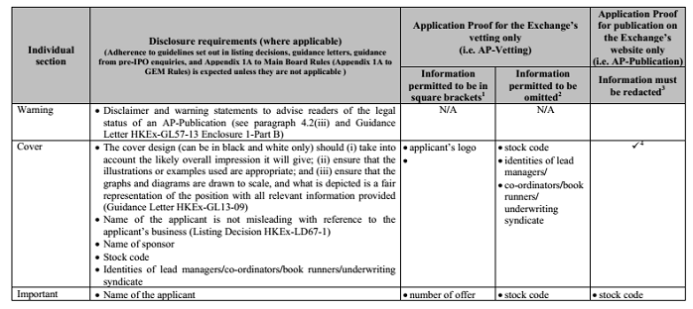

(Extracted from Table A of the Exchange Guidance Letter HKEx-GL56-13)

Substantially complete AP for vetting – 3-day checklist

3-day checklist - Table B of the Exchange Guidance Letter HKEx-GL56-13 :

- For the one year from 1 October 2013 to 30 September 2014 (subject to review by the SFC and the Exchange)
- All listing applications are subject to an initial 3-day check based on checklist in the Table B
- Failure to include matters listed in the 3-day Checklist or an AP being considered not substantially complete for other reasons (e.g. failure to include material information) may lead to a return of the listing application
- The Exchange will either confirm acceptance for detailed vetting or will return the listing application with a letter detailing the reasons

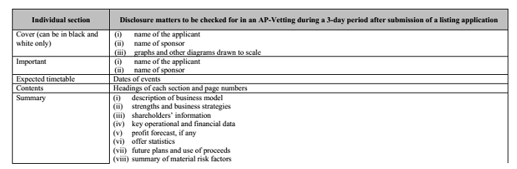

(Extracted from the 3-day Checklist - Table B of the Exchange Guidance Letter HKEx-GL56-13)

- Exchange reserves right to return an application even if AP for Vetting meets 3-day Checklist requirements but other grounds render it not substantially complete; and even after accepting for detailed vetting but later considers the AP not substantially complete

Failure to submit a substantially complete AP for vetting

If a listing applicant fails to submit a substantially complete AP for vetting:

- the Exchange will return the listing application (Return Decision) (MB Rule 9.03(3); GEM Rule 12.09(2))
- Listing fee will be refunded unless the return is made after the Exchange issues its first comment letter to the sponsor (Note 2 to MB Rule 9.03(1)(b); Note to GEM Rule 12.14(4))
- Subject to accelerated review procedure, after an application is returned, a new application cannot be submitted until 8 weeks after the Return Decision
- Such 8-week moratorium starts from the date of the return letter from the Exchange
- The names of the applicant and sponsor and the Return Decision date will be published on the Exchange’s website

Publication of AP – content requirements

- AP for Publication = “AP for vetting” – “offer-related information”
- Information set out in Table A of the Guidance Letter HKEx-GL56-13 and Enclosure 2 of Guidance Letter HKEx-GL57-13 must be redacted
- Further redaction requires the Exchange’s consent by application with detailed reasons
- Examples of redacted information: information on cornerstone investors, offer price and the terms of the underwriting agreement
- Must include minimum disclaimer and warning statement set out in Enclosure 1 of Guidance Letter HKEx-GL57-13 (to be further discussed in the section of publication of PHIP )

Publication of AP – returned application

- Where an applicant’s application is returned, the applicant’s AP will be removed from the Exchange’s website upon completion of all the review procedures or when the time for invoking such review has passed.

- The Exchange will only publish the name of the applicant and its sponsor, and the date of the return and such information will remain on the Exchange’s website even if the application is subsequently re-submitted.

Publication of AP – confidential filing of AP

Overseas listed applicant with large market capitalisation:

- New applicants listed on a recognised overseas exchange for not less than 5 years; and

- a significantly large market capitalisation (as determined by the Exchange from time to time – currently as US$400 million) at the time of filing their listing application,
- not required to publish AP unless requested to do so by the Exchange or the SFC.

- A list of 15 recognised overseas exchanges set out in HKGL-57-13 (Shanghai Stock Exchange and Shenzhen Stock Exchange are not included)
(PN 22 of MB Rules ; PN5 of GEM Rules)

Publication of AP – other waivers

the Exchange or the SFC may waive or modify the publication of AP requirement for an applicant in a spin-off from an overseas listed parent on a case by case basis and taking into account whether the applicant can generally satisfy one of the following requirements:
- The proposed listing in HK is price sensitive to its overseas listed parent; the parent is not required by the rules of the relevant overseas exchange to disclose the applicant’s proposed listing; and the parent keeps and undertakes to keep the applicant’s proposed listing confidential before the applicant’s PHIP;
- The AP contains price sensitive information to the overseas listed parent; the parent is entitled to keep the price sensitive information confidential under the rules of the relevant overseas exchange by redacting such information in the AP; but the extent of the redactions will make the content of the AP and its publication meaningless; or
- the overseas listed parent’s jurisdiction or the relevant exchange has requirements or regulations that prevent the parent or the applicant from publishing a draft listing document relating to the spin-off.
(PN 22 of MB Rules ; PN5 of GEM Rules; HKEx-GL57-13)

- For an applicant of a spin-off from a Hong Kong listed parent:
- will only consider a waiver from the publication requirements on a case by case basis in the light of the relevant application of the inside information requirement as applicable to that case

- If applicant envisages difficulties in complying with the publication of an AP:
- consult the Exchange of SFC (as the case may be) for a waiver or modification of requirement at an early stage

(PN 22 of MB Rules ; PN5 of GEM Rules; HKEx-GL57-13)

Publication of AP – timing and others

- publish an AP at the same time the new applicant files a listing application with the Exchange
- The Exchange clarified that an applicant is not required to publish the subsequent proofs of listing documents on the Exchange’s website unless the listing application lapses.
- Where an applicant re-submits its listing application, no AP is required to be submitted for publication if at the time of the submission, (i) a PHIP has been published on the Exchange’s website and (ii) the sponsor provides a written confirmation that the PHIP published on the Exchange’s website does not need to be updated and remains valid.
- Where a new AP is submitted for publication on the Exchange’s website, no mark-up against the previous proof is required.
- A confirmation from the applicant’s legal adviser must be provided to the Exchange confirming that the Exchange’s guidance on redactions and inclusion of appropriate warnings and disclaimers for publication of APs has been complied with → wording to follow para.7 of PN22 or para.6 of PN5
- AP submitted during 1 October 2013 to 31 March 2013 is not required to be published after 1 April 2014 unless the listing application is refiled on or after 1 April 2014
(PN22; PN5; FAQ series 24)

Accelerated review procedures

Right to review the return decision

- Commencing on 1 October 2013, the Listing Division’s decision to return a listing application on the ground that the listing application is not “substantially complete” can be reviewed by the Listing Committee.
- If the Listing Committee endorses the decision of the Listing Division to return the listing application on the ground that the listing application is not “substantially complete”, the decision of the Listing Committee can be reviewed by the Listing (Review) Committee (Main Board Rules Chapter 2B; GEM Rules Chapter 4).
- The decision of the Listing (Review) Committee on the review is conclusive and binding on the new applicant and the sponsor (Main Board Rule 2B.05 (2)(b)).

General procedures of the review procedures

- The review procedures are referred to as the “Accelerated Review Procedures” by the Exchange.
- A guidance letter (GL61-13) has been issued by the Exchange to provide guidance on the general procedures and the time frame in relation to the Accelerated Review Procedures in relation to the decision to return a listing application.
- The Accelerated Review Procedures are generally commenced upon the filing of a written “Review Request” by the new applicant and/or the sponsor.

The Review Request

- A “Review Request” is defined to mean a written request by the relevant party for a review of the decision of the Listing Division or the Listing Committee which must be served on the Secretary of the Listing Committee or the Secretary of the Listing (Review) Committee, as the case may be.
- A Review Request (including a review request for reviewing the decision of the Listing Division or the Listing Committee) is required to be served within five (5) business days after receipt of the return decision (Main Board Rule 2B.08(2)).
- It must include grounds for the review together with reasons and the review fee, and it must be based on the original materials submitted to the Listing Division when the new applicant first filed its listing application (Main Board Rule 2B.11(5)(d)).

Upon receipt of the Review Request by the Exchange

- On the next business day after the receipt of the Review Request, the Secretary to the Listing Division or the Listing (Review) Committee (as the case may be) will send a letter to the applicant and/or the sponsor setting down the date and time for the review hearing.
- At least two (2) days before the hearing date, the Listing Division will submit a report to the secretary of the Listing Committee or the Listing (Review) Committee (as the case may be), and the report will comprise (a) the return decision; and (b) the Application Proof and/or other documents submitted together with the application form to support the return decision.
- At least one (1) day before the hearing date, the secretary to the Listing Committee or the Listing (Review) Committee (as the case may be) will circulate the review request, the report of the Listing Division and the agenda to the Listing Committee or the Listing (Review) Committee (as the case may be).

Conduct of the hearing

- Quorum
- The number of members required to form a quorum for a review hearing by the Listing Committee or the Listing (Review) Committee is five (5), which includes the chairman of the Listing Committee or the Listing (Review) Committee (as the case may be) and excluding conflicted members) (Main Board Rule 2B.11(2); GEM Rule 4.11(2)).
- Attendees
- Attendees who can attend include (Main Board Rule 2B.11(9); GEM Rule 4.11(9)):
- Listing Division IPO Team
- The applicant’s directors
- One representative of each of the applicant’s legal adviser, financial adviser and auditors
- One representative from each sponsor
- One representative from the sponsor’s legal adviser

Absence from the hearing

- If all parties seeking a review decide not to attend the hearing, the hearing will proceed based on the documents submitted for the hearing.
- If a party seeking a review decides not to attend the hearing, the hearing will proceed in his absence.

The decision of the review hearing

- The decision of the review hearing will be delivered to the applicant and/or the sponsor the next business day after the review hearing.
- The Listing Committee decision which endorses the return decision will contain reasons for the return (Main Board Rule 2B.13(2); GEM Rule 4.13(2)).

Timing for the review hearing

- According to the guidance letter on the Accelerated Review Procedures, the shortest possible time for a review to be heard is seven (7) days from the date (say, a Friday) on which a review request is received by the Exchange and the review will be heard on the immediate Thursday which is not less than three (3) business days after the receipt of the review request.
- In circumstances where the immediate Thursday after receipt of the review request falls on a public holiday, the review will be heard on the following Tuesday if there are sufficient numbers of the Listing Committee (or the Listing (Review) Committee (as the case may be)) to form a quorum, but if there are not sufficient members to constitute a quorum on the Tuesday, the hearing will be heard on the Thursday of the same week.
- In such circumstances, the longest possible time for a hearing to be heard will be 17 days (including the day on which the review request is received and the hearing date).

Examples of the possible timing for a review hearing

- This example of a review hearing time-table illustrates the shortest possible timing for a review hearing.

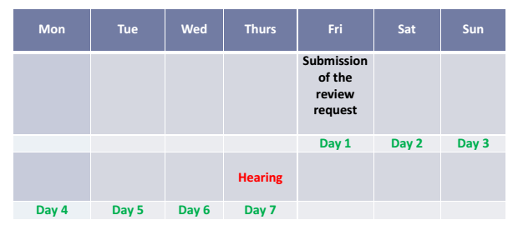

- This example of a review hearing time-table illustrates the longest possible timing for a review hearing.

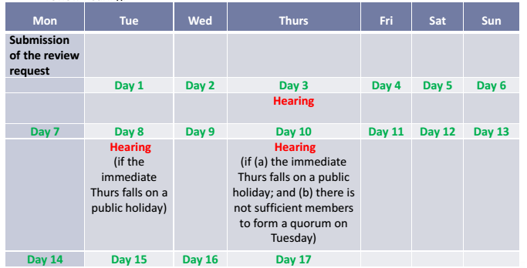

Publication of PHIPs - introduction

- A PHIP is defined to mean “a near-final draft listing document for the listing of equity securities published on the Exchange’s website” (MB Rule 1.01; GEM Rule 1.01)
- Web Proof Information Pack (WPIP) will be replaced with PHIP
- To codify the requirement of WPIP which was introduced by a joint policy statement of the Exchange and the SFC in November 2007
- Designed to increase the equality of information available to retail investors and institutional IPO investors
- Effective from 1 October 2013

Publication of PHIPs – content requirements

- Required to be in English and Chinese (no transitional arrangements)
- any offer-related information, e.g. price, means to subscribe for the securities must be redacted
- Required redactions set out in Enclosure 2 of Guidance Letter HKEx-GL57-13
- Further redactions will need Exchange’s consent before a listing application is made
- Obligation to update information in PHIP
- bracketed or omitted information in an Application Proof should be updated or included upon the publication of PHIP

(PN 22 of MB Rules; PN 5 of GEM Rules, HKEx-GL57-13 )

Disclaimer & warning statements for AP for publication and PHIP

- Both AP for publication and PHIP are required to include minimum disclaimer and warning statements

- Two levels of minimum disclaimer and warning statements:
- Minimum warning statement in a dedicated section of the Exchange’s website
- →Part A of Enclosure 1 of Guidance Letter GL57-13
- Minimum disclaimer statement on every AP for publication and PHIP
- →Part B of Enclosure 1 of Guidance Letter GL57-13

- Allowed to adopt warning and disclaimer statements that contain additional elements but not to detract from those set out in Enclosure 1 of GL57-13.

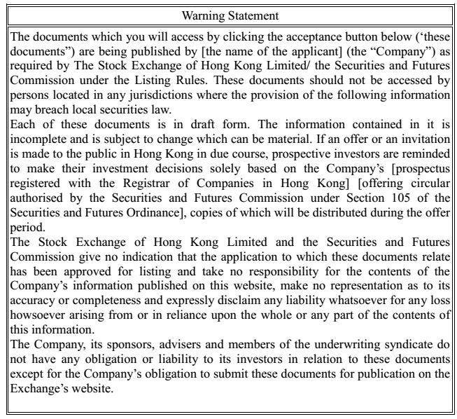
(Part A of Enclosure 1 of Guidance Letter HKEx-GL57-13)

- Part B of Enclosure 1 of Guidance Letter HKEx-GL57-13:

- “…This [*Application Proof] [*PHIP] is in draft form. The information contained in it is incomplete and is subject to change which can be material…”
- “…this document is only for the purpose of providing information about the Company to the public in Hong Kong and not for any other purposes. No investment decision should be based on the information contained in this document…”
- “…this document does not constitute a prospectus, offering circular, notice, circular, brochure or advertisement offering to sell any securities to the public in any jurisdiction, nor is it an invitation to the public to make offers to subscribe for or purchase any securities, nor is it calculated to invite offer s by the public to subscribe for or purchase any securities…”
- “…this document must not be regarded as an inducement to subscribe for or purchase any securities, and no such inducement is intended…”

Publication of Rule 9.08/12.10 statements

- MB Rule 9.08/ GEM Rule 12.10 statements to allow listing applicants to notify the public that they should not rely on media reports regarding the applicants following the publication of AP or PHIP
- Standard form set out in Enclosure 3 of Guidance Letter 57-13
- Publication of the statements is voluntary
- No pre-vetting by the Exchange required if the standard form is adopted, although applicants must submit a copy to the Exchange prior to publication

Timing requirements of the publication of PHIPs

- A PHIP is to be published on the Exchange’s website when:
- A post hearing letter from the Exchange together with a request to post a PHIP is received; and
- The directors of the new applicant concluding that the material comments of the Exchange and the SFC have been addressed
- Further, in the case of a offer of equity securities to the public in Hong Kong, a PHIP must be submitted for publication no later than the earlier of:
- Any red herring is first distributed to institutional or other professional investors
- “bookbuilding” commences
- For applicants who have scheduled a listing overseas at or around the time of its HK listing, upon any publication of similar information overseas

- Even not public offer, or no bookbuilding or red herring, still required to publish PHIP according to point 1 above

Revisions to a PHIP & exemptions from PHIP

- Publication of revised PHIP is required if additional or revised red-herring prospectus is distributed to institutional or other professional investors following the publication of PHIP
- Marked up against the old PHIP
- Where an application lapsed after a PHIP, the subsequent PHIP is not required to be marked up
- No PHIP is needed if:
- a listing applicant delays its listing plan by informing the Exchange or the SFC;
- But need to publish PHIP when resuming the listing plan
or
- The listing is by way of introduction and the final listing document is to be issued immediately after the obligation to publish a PHIP arises

Vetting process flowchart during transitional period (1 October 2013 – 30 September 2014)

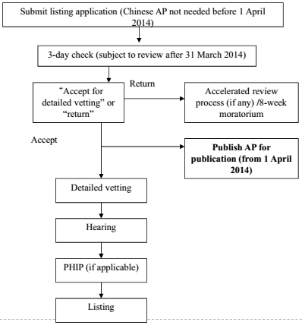

Vetting process flowchart after transitional period (from 1 October 2014)

Submit listing application
“Accept for detailed vetting” or “return”
Accelerated review process (if any) /8-week moratorium
Return
Detailed vetting
Hearing
Listing
PHIP (if applicable)
Publish AP for publication
(in both English and Chinese)
Accept

Logistics arrangements

Status indication on the Exchange’s website

The Exchange will publish the following status marks on its website to indicate the status of each listing application:
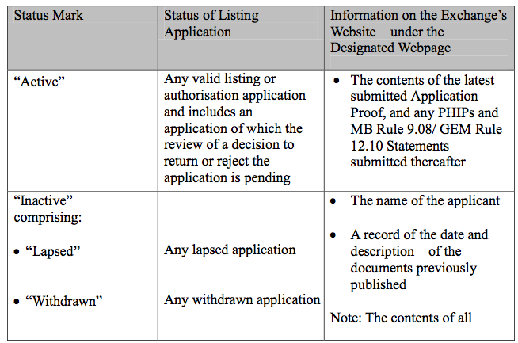
(Extracted from Guidance Letter HKEx-GL57-13)

The Exchange will publish the following status marks on its website to indicate the status of each listing application:

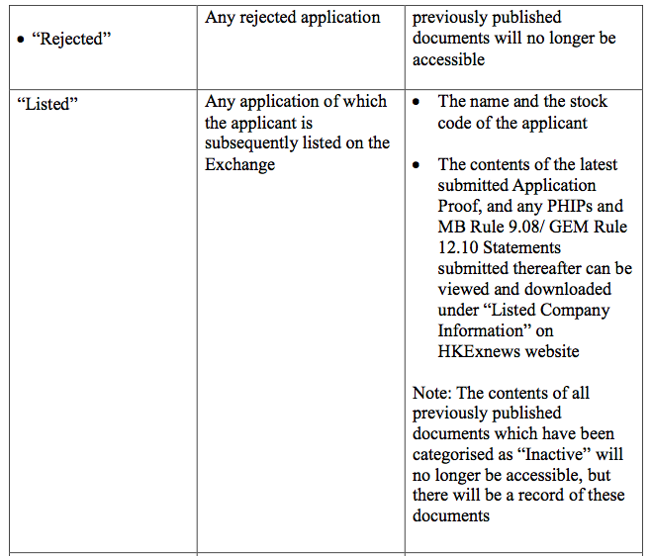
(Extracted from Guidance Letter HKEx-GL57-13)

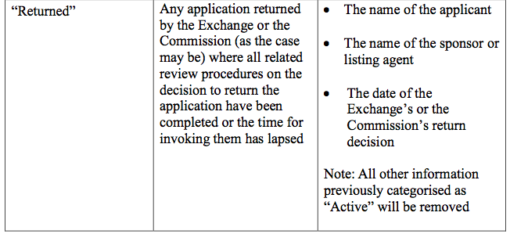
(Extracted from Guidance Letter HKEx-GL57-13)

Note the difference between “Rejected” and “Returned
- “Return Decision” → return a listing application on the ground of “not substantially complete”
- “ rejection” → refers to the Exchange’s general discretion to accept or reject applications

Logistics for submission

- Logistical arrangements for publication of AP, PHIPs and related materials are set out in Section B of Guidance Letter HKEx-GL57-13
- Sponsors to arrange for publication of AP, PHIP and Rule 9.08/12.10 statements on behalf of listing applicants through the HKEx-ESS (e-submission system)
- Obtain a company case number at least 1 business day before the filing of the listing or authorisation application
- Every AP, PHIP and Rule 9.08/12.10 statements must be in a ready-to-publish electronic version in both English and Chinese when submitted through the HKEx-ESS for publication
- Every publication submission must be accompanied by a written confirmation from each sponsor to the Listing Division confirming that submission is under the applicant’s authority

Streamlined commenting process & documentary requirements

Streamlined commenting process – Pre-IPO enquiries

- Early consultation with the Exchange is encouraged
- Exchange expressed that only novel and specific enquiries will be considered
- Not meant to be a means to shift the sponsor’s obligations such as pre-vetting draft listing documents to the Exchange
- Before making any pre-IPO enquiries, sponsors or applicants should go through all guidance letters and listing decisions
- No-name basis pre-IPO enquiries will not be considered

(FAQ Series 24 of the Exchange)

The Exchange has stated in a seminar in relation to the new sponsor regime that:
- subject to the complexity of a listing application and the quality of the replies from the listing applicant, two rounds of comments are generally expected
- regulatory commenting process will focus on major issues such as:
- eligibility
- suitability
- sustainability
- Listing Rules, Companies Ordinance and SFO compliance
- any material disclosure deficiencies

- The Exchange has also expressed in its seminar that:

- verbal comments and comments in relation to drafting matters will be avoided
- Comments on due diligence will generally be avoided unless there are concerns over the overall standard or scope of due diligence
- Professional opinions will be relied on by the Exchange
- Listing application may be returned by the Exchange if substantial new information submitted after the listing application (i.e. A1 /5A submission) without valid reasons

New timing of comments:

- 2 rounds of comments is expected
- Assuming 1st round of comments to be issued within 10 business days from receipt of listing application
- Assuming 2nd round of comments to be issued within 10 business days from receipt of replies
- Assuming sponsor responds within 5 business day for each round of comment
- normally take about 40 business days to present an application to the Listing Committee/ GEM Listing Approval Group for consideration
- Applicant may submit a timetable on the basis it would take around 25 business days from the date of the listing application to the hearing date
- No minded to reject letters will be issued

(FAQ series 24 of the Exchange and Guidance Letter HKEx-GL13)

Streamlined documentary requirements

New documents required for submission at A1/5A stage from 1 October 2013:

- Reporting accountants’ confirmation that no significant adjustment is expected to be made to the draft accountants’ report in the AP
- template confirmation set out in the Appendix of Guidance Letter HKEx-GL58-13
- Expert’s confirmation that no material change is expected to be made to the expert opinion in the AP
- template confirmation set out in the Appendix of Guidance Letter HKEx-GL60-13
- regardless whether the opinion is in the form of a report, statement or opinion
- Confirmation from director’s (and supervisor’s in the case of PRC applicants) that the information in the AP is accurate and complete in all material respect and is not misleading or deceptive
- new Form M110

Documents previously submitted at a later stage but need to be submitted at A1/5A submission from 1 October 2013:

- Profit and cash flow forecast memorandum
- previously 15-day document for Main Board applications
- Advanced draft sufficiency of working capital statement by sponsor
- previously 4-day document for Main Board applications
- Compliance adviser’s undertaking (MB and GEM applications) and Compliance Adviser’s declaration of interest (GEM applications)
- previously required to submit before dealing commences
- Certificate of new applicant’s incorporation or equivalent document
- previously required to submit before bulk printing of prospectus for Main Board applications
- A final or an advanced draft of all waivers application
- previously a 4-day document for Main Board applications
- Refer to new Guidance Letter HKEx-GL55-13

New and revised guidance letters on financial information

New Guidance Letters:

- Guidance on the financial information for the trading record period expected in the first draft listing document for listing applications – HKEx-GL6-09A
- Guidance on confirmations required on the accountants’ report, pro forma financial information and profit forecast in APs and subsequent listing documents – HKEx-GL58-13
- Guidance on management discussion and analysis on the MD&A in listing documents – HKExGL59-13

Revised Guidance Letters
- Guidance on indebtedness, liquidity, financial resources and capital structure disclosure in the listing document – HKEx-GL37-12
- Guidance on the Latest Practicable Date and the Latest Date for Liquidity Disclosure in listing documents – HKEx-GL38-12

Guidance on the financial information for the trading record period expected in the first draft listing document for listing applications – HKEx-GL6-09A

Background
- Trading record period to be covered in the accountants’ report:
- 3 years for Main Board applicants (MB Rule 4.04); or
- 2 years for GEM Board applicants (GEM Rule 7.03)

- The latest financial period reported on by the reporting accountants for a new applicant must not have ended more than 6 months from the date of the listing document. (MB Rule 8.06 (GEM Rule 11.11))

- Therefore, required financial information reporting period = trading record period + stub period (if applicable)

- Since 2005, administrative practices on accepting early filings of listing applications implemented to reduce possible seasonal congestion of filling of IPO applications as applicants’ financial year-ends are often clustered towards the end or the first quarter of a calendar year
- Subject to certain conditions, HKEx-GL6-09A allows applicants to submit their AP without disclosing financial information covering the whole required reporting period

Application within 2 months from the end of the trading record period
- If unable to include financial information for the most recent financial year in an audited or advanced form in the Application Proof, can still submit Application Proof if
- The sponsor confirm that the applicant will satisfy
- (i) the profit test; (ii) the market capitalisation/revenue cash flow test; or (iii) the market capitalisation/revenue test or other financial standard requirements following its due diligence review under Ch. 3A and PN 21 of the MB Rules (Ch. 6A and PN 2 of the GEM Rules);
- Include in the AP the audited financial information for the first 2 financial years of the trading record period (or first financial year for GEM applicant) in the Accountants’ Report and the related MD&A; and
- Include in the AP the financial information for a stub period of at least 9 months (I.e. the first 9 months of the last financial year) and comparative information of the corresponding period of the preceding financial year of the last financial year and the related MD&A.

Application after 2 months from the end of the trading record period

To have early filing, (i) the sponsor has to provide the same confirmation as an application within 2 months from the end of the trading record period; and (ii) include the following information in the AP:

Time between filing and the end of the Trading Record Period

Required audited financial information and related MD&A
Stub period financial and comparative information and related MD&A
More than 2 months, less than 6 months

The entire Trading Record Period
None
More than 6 months, less than 8 months

The entire Trading Record Period
Stub period of at least three months
More than 8 months, less than 12 months

The entire Trading Record Period
Stub period of at least six months

Stub period financial and comparative information

- must be reviewed by the reporting accounts in accordance with the Hong Kong Standards on Review Engagements 2410 (“HKSRE 2410”)

- stub period financial information may be part of the Accountants’ Report or in a separate appendix to the AP

- must include at least the information required for interim reports under para. 37 of Appendix 16 to the MB Rules (GEM Rule 18.55)

- audited financial information and the reviewed stub period financial information must be presented in the same table together with the related MD&A in the Financial Information section of the AP

Accountants’ confirmation

To submit an early application under HKEx-GL6-09A

- must provide a confirmation from the reporting accountants to the applicant (and copied to the sponsor, the Exchange and the SFC) at the same time as the submission of the listing application confirming that :
  - no significant adjustment is expected to be made to the financial years which must be subject to an audit under the HKEx-GL6-09A based on the work done as of confirmation
  - the stub period financial information (if applicable) has been substantially reviewed by the reporting accountants according to HKSRE 2410.
- must provide the updated financial information that the applicant did not include previously in its Application Proof as soon as possible along with the above reporting accountants’ confirmation for that updated financial information.
- Template confirmation at Appendix of HKEx-GL58-13

Pro forma information of the enlarged group (under certain circumstances)

- If the listing applicant acquires or intends to acquire a company or business since the latest audited or advanced draft accounts were made up, and if the acquisition(s) (the Acquisition) constitutes a major subsidiary under Main Board Rule 4.28 (GEM Rule 7.30), an Application Proof must include pro forma information of the listing applicant’s enlarged group, as required by Main Board Rule 4.29 (GEM Rule 7.31).
- However, the pro forma information may not be required in the Application Proof if the draft listing document is subsequently updated to cover a later period such that the financial information in relation to the Acquisition is included. Such updates must be in the hearing proof of the listing document.

Other guidance

- Guidance letter HKEx-GL6-09A also apply to applicants with shorter trading record periods allowed under the Listing Rules
- Listing applications filed before the end of the applicants trading record period are not acceptable to the Exchange
- Applicants that comply with this guidance letter HKEx-GL6-09A do not need to apply for an early filing
- The old guidance letter HKEx-GL6-09 was superseded from 1 October 2013.

Guidance on confirmations required on the accountants’ report, pro forma financial information and profit forecast in APs and subsequent draft listing document– HKEx-GL58-13

- Substantially complete AP and all other relevant documents (MB Rule 9.03(3); GEM Rule 12.09)
- Therefore, financial information including accountant’s report, pro forma financial information and any profit forecast (Report) in an AP must be in a final form or advanced form
- Signed accountants’ report to be submitted with AP
- If financial information not in final form, reporting accountants are required to confirm to the sponsor, the Exchange and the SFC that no significant adjustment is expected to be made to these draft Reports based on the work done up to that point
- If there is a delay in listing timetable, confirmation must be provided again for any update of the financial information
- A template confirmation is provided in the Appendix of the Guidance Letter HKEx-58-13

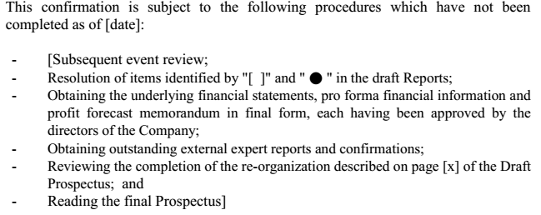

- The Exchange expects any outstanding procedures to be minimal
- If there are other outstanding procedures, an applicant should consult the Exchange before submission of its listing application.

Guidance on management discussion and analysis on the historical financial information in listing documents – HKEx-GL59-13

MD&A section is required in the prospectus under the Listing Rules, the Companies Ordinance and the Code of Conduct

- Purpose of MD&A is to help investors to understand an applicant’s past performance, present position and future prospects
- An AP where its MD&A section fails to follow this Guidance Letter may be considered not substantially complete (para. 1.2 of HKEx-GL59-13 )
- The Exchange expects the MD&A section to be clear, insightful and consistent with the financial information
- The use of tables, charts and diagrams are recommended

The Guidance Letter GL59-13 specific disclosures that listing applicants may wish to include in the MD&A :

- Key factors that affect the results of operations
- critical accounting policies and estimates
- review of historical results, financial position and cash flows
- liquidity and capital resources

Key factors that affect the results of operations may include:

- economic and regulatory factors that affect the industry and market
- the applicant’s business lines, locations and products and services;
- the applicant’s business processes and value creation process; and
- significant relationships, opportunities, challenges and risks that are likely to affect the applicant.

Should avoid:
- overly detailed descriptions
- repeated information from the “Business” section

The disclosure of critical accounting policies and estimates include:

- the procedures and methods of making accounting estimates
- the accuracy of past estimates compared to the actual results ;
- any changes in past estimates or assumptions ; and
- the reasons for any future changes in estimates or assumptions (if any)

Review of historical results, financial position and cash flows :

- Purpose is to communicate to potential investors indicators of the applicant’s future performance and management’s assessment of its prospects
- The following specific disclosures should be included :
- details of related party loans, advances, guarantees and/or pledges of securities to/from the applicant
- details of material related party transactions
- the applicable tax rate and any preferential tax treatments, tax benefits or special tax arrangements and when they expire
- whether the applicant has paid all relevant taxes
- details of any disputes or unresolved tax issues with the relevant tax authorities
- post-balance sheet events including share subdivision, share consolidation and the declaration and payment of dividends

Disclosure in relation to liquidity and capital resources should include:

- historical information on sources of cash flow and significant expenses
- the amounts and certainty of cash flows
- the existence and timing of capital expenditures and commitments
- expected changes in the mix and relative cost of capital resources
- indications of which balance sheet or income or cash flow items should be considered in assessing liquidity
- prospective information regarding sources of and needs for capital
- material covenants relating to outstanding debts, guarantees or other contingent obligations

Guidance on indebtedness, liquidity, financial resources and capital structure disclosure in listing document – HKEx-GL37-12

- Working capital statement by the directors of an applicant that it and its subsidiaries (if any) have available sufficient working capital for at least the next 12 months from the date of the listing documents
- MB Rule 9.11(28) and GEM Rule 12.23A(1) require that before a listing document is bulk printed, the sponsor of an applicant should submit a final letter confirming that it is satisfied that the working capital statement by the directors has been made by the directors after due and careful enquiry and that the persons or institutions providing such finance have issued written confirmation on the existence of such facilities.
- From 1 October 2013, the above sponsor’s final confirmation letter should be based on
    - the sponsor’s own due diligence work
    - the confirmation from the listing applicant
    - the confirmation from the reporting accountants to the applicant (copied to the sponsor, the Exchange and the SFC) dated the same date of the sponsor’s confirmation

Guidance on the latest practicable date and the latest date for liquidity disclosure in listing document – HKEx-GL38-12

- Guidance letter revised to take into account the requirement of submitting and substantially complete Application Proof
- Latest practicable date:
- no more than 10 calendar days before the date of the AP
- no more than 10 calendar days before the date of the listing document
- Latest date for liquidity disclosure:
- no more than 2 calendar months before the AP
- no more than 2 calendar months before the date of the listing document

Other new guidance letters – disclosure of material non-compliance incidents in listing documents

- HKEx-GL63-13 - Guidance on disclosure of material non-compliance incidents in listing documents
- Listing documents to provide investors with sufficient information to make an informed assessment of an applicant for listing and that such information must be accurate and complete in all material respects and not be misleading or deceptive
- (MB Rules 2.03(2) and 2.13(2) ((GEM Rules 2.06(2) and 17.56(2))
- Exchange expects a director of a listed issuer to fulfill fiduciary duties and to have duties of skill, care and diligence to a standard at least commensurate with the standard under Hong Kong law; and to have the character, experience and integrity and is able to demonstrate a standard of competence commensurate with his position as a director of a listed issuer
- MB Rules 3.08 and 3.09 (GEM Rule 5.01 and 5.02):
- non-compliance incidents may affect suitability of directors, senior management and/or applicant for listing

Disclosure requirements for non-compliance incidents if material non-compliance incidents can be resolved by way of disclosure:
- reasons for the non-compliance incidents, nature and extent of breaches, corresponding risk factors
- identity and position of director(s)/senior management involved in the non-compliance incidents
- whether the applicant has or will be charged or penalised for the non-compliance incidents during the track record period and up to the latest practicable date with confirmation from the relevant authorities and if so, disclosure of the actual or maximum penalty, whether the applicant has made any provision and the potential impact on the applicant
- how and when rectification actions were taken/ will be taken, enhanced internal controls to prevent their recurrence and, if applicable, the identity and salient terms of engagement of an internal control expert and its findings and recommendations and the applicant’s timing of implementation of such recommendations
- where the Exchange accepts that a certain non-compliance incident can only be rectified within a short period after listing, disclose (i) a legal adviser’s view, with basis, whether there is any impediment to rectify the non-compliance and (ii) a statement that the applicant will disclosure the progress of the rectification in interim/annual reports
- the views of directors and sponsor(s), with basis, on whether the applicant’s enhanced internal control measures are adequate and effective, the suitability of the directors and the applicant’s suitability for listing

- Highlights in “Summary and Highlights” section
- Exchange may request a demonstration period (usually an audited period) of compliance from the cessation of the non-compliance incident(s)

Other new guidance letters – disclosure of directors, supervisors and senior management section

- To include the following for each director, supervisor (if applicable) and senior management on the front page of the “Directors, Supervisors and Senior Management” section in a table:
- full name and age
- date of joining, present position in the applicant and date of appointment
- brief description of the roles and responsibilities of each of them and relationship among them (if applicable)
- To include the following in the biography of each director, supervisor and senior manager
- his/her academic background and professional qualifications, including when (month and year) obtained and the granting authorities
- his/her previous working experience relevant to his/ her present position in the applicant (preferably in tabular format if information is excessive)
- his/ her current and past directorships in any listed companies in the last three years (or an appropriate negative statement)
- The sponsor should carry out the following verification:

- check whether the relevant academic accreditation bodies are authorised by competent authorities to grant accreditations
- ascertain whether the courses attended were long-distance or online courses and, if so, specify it in the listing document
- Other required disclosure:
- role, composition and chairperson of each committee
- remuneration of directors, supervisors and senior management
- incentive plan for senior management and key employees
- any deviation from the code provisions of the Corporate Governance Code in Appendix 14 to Main Board Rules (Appendix 15 to GEM Rules)

Revised sponsor’s undertaking and declarations – Appendix 17

Old Appendix 17 of MB Rules – Sponsor’s undertaking

- Pursuant to MB Rule 3A.03
- Undertaking given by sponsors when submitting listing application undertaking, inter alia, to:
- comply with Listing Rules
- use reasonable endeavours to ensure all information provided to the Exchange during the applicant’s listing application process is true in all material respects and does not omit any material information
- cooperate in any investigation conducted by the Exchange

New Appendix 17 – Sponsor’s undertaking and statement of independence

- Merged with Appendix 18 – sponsor’s statement relating to independence
- Revised wording - to align with paragraph 17.9 of Code of Conduct
- New undertakings added:
- Para. 1(e): undertake to report to the Exchange in writing as soon as practicable when it becomes aware of any material information relating to the applicant or its listing application which concerns non-compliance with the Listing Rules or other legal or regulatory requirements relevant to the listing. This obligation continues after the sponsor ceases to be the applicant’s sponsor, if the material information came to the sponsor’s knowledge whilst acting as the sponsor
- Para. 1(f): report to the Exchange the reasons for ceasing to act as soon as practicable
- (Equivalent changes made to Appendix 7K of the GEM Rules)

Revised sponsor’s undertaking and declarations – Appendix 19

Appendix 19 of MB Rules – Sponsor’s declaration
- A declaration by sponsor on sufficiency, accuracy and truthfulness of information in prospectus after making reasonable due diligence inquiries

- New declaration merged with sponsor’s declaration previously in para. 13 of Form A1 in Appendix 5 :
- “there are no other facts being on the Company’s application for listing of and permission to deal in its securities which, in our opinion, should be disclosed to the Exchange”

Impact on sponsors - sponsor’s engagement

Sponsor’s appointment

- all terms of appointment of the sponsor should be agreed as early as possible and in sufficient time for the sponsor to meet its obligations and responsibilities under the Code and the Listing Rules, including detailed planning, engagement of other professionals and completion of all reasonable due diligence
- Rule 3A.02 requires the sponsor to be appointed by written engagement and such engagement must be entered at least two months prior to the submission of the listing application
- where there is more than one sponsor, two months must have lapsed from the date when the last sponsor was formally appointed
- sponsors should consider whether additional time would be needed depending on the specific circumstances of the listing applicant at the time of appointment including, nature, scale and complexity of the listing applicant

Notification and reporting obligations of sponsors

- A listing client should acknowledge in the engagement letter the following notification and reporting obligations of the sponsor:
- sponsors are required under the revised Code and Rule 3A.02 to notify the Stock Exchange of its appointment as soon as practicable and provide it with a copy of the engagement letter
- similarly, if a sponsor ceases to act as a company’s sponsor at any time after its appointment or if it resigns or is terminated from acting as the company’s sponsor, it is required to inform the Stock Exchange in writing of its reasons for ceasing to act and notify it of its resignation or termination
- if the departing sponsor is the sole independent sponsor for a listing applicant, then the two-months notification rule under Rule 3A.02 applies to the newly appointed sponsor
- a sponsor must report to the Stock Exchange in a timely manner if it becomes aware of any material information relating to a listing applicant or listing application in respect of non-compliance with the Listing Rules or other legal or regulatory requirements relevant to the listing

Concerns with notification/reporting and breach of client confidentiality

- a group respondent to the Consultation expressed concern that:
- compliance with notification obligations by sponsors would amount to a breach of confidentiality to the listing applicant (i.e. expose them to legal action brought against it by it listing client)
- that the listing applicant may be unfairly prejudiced if the regulators pursue lines of enquiry on the basis of unsubstantiated allegations
- the SFC responded that the sponsor performs a unique role as the key gatekeeper of market quality in the IPO and therefore has an explicit public interest function over the process. In discharge of such public interest function, disclosure of material information relating to the listing applicant to regulators is inevitable.
- a listing client should acknowledge in the engagement letter that the sponsor is required, and should be given every assistance, to provide information to the Stock Exchange and the SFC
- any confidentiality undertakings in the engagement letter should include carve-outs for disclosures required by applicable laws, rules and regulations

Sponsor fees – to be based solely on sponsor’s role

- the practice of large financial institutions in providing underwriting, bookbuilding and other services in addition to their role as a sponsor have adversely impacted the role of sponsors because:
- fees generated from such services typically comprise a far greater proportion of the total compensation charged, and creates downward pressure on sponsor fees
- give sponsor disincentives to carry on proper due diligence
- risks inaccurate perception that a sponsor’s role is less important compared with other services and thus undermine their authority to carry out their work properly
- to address this issue, sponsor fees are required under the revised Code to be specified in the sponsor’s engagement letter and must be based solely on a sponsor’s role as such and not on unrelated services such as bookbuilding, pricing and similar functions governed by underwriting and other related agreements

Sponsor fees – staged payments and “no deal; no fee” arrangements

SFC expressed in the Consultation Conclusion that:

- any “no deal; no fee” arrangements should be avoided (requirement in the revised Code of Conduct)
- such prohibition should be explicitly stated in sponsor engagement letters
- Total amount of sponsor fees paid and payable should be disclosed in the listing document (not a requirement in the revised Code of Conduct but stated in the Consultation Conclusions and FAQ series 24)
- any staged payments should be proportional to the amount of work done up to that stage (not incorporated into the revised Code)
- potentially problematic for sponsors who charge non-refundable upfront signing fees or down payments given no substantial work performed up to date of engagement
- do not however appear to be the focus of SFC’s concern regarding sponsor fee arrangements

Obligations of listing applicant

- the revised Code of Conduct requires a sponsor’s engagement letter to clearly specify the listing applicant’s responsibilities to facilitate the sponsor’s performance of its duties and the sponsor’s compliance with its obligations under the Code and the Listing Rules
- it should contain provisions which require the listing applicant to, without limitation:
- fully assist the sponsor in connection with all due diligence work and investigations
- procure all professional parties, financial advisers and experts to cooperate fully with the sponsor
- give assistance to the sponsor to provide information to regulators
- give sponsor access to all relevant records in connection with the listing application, including access to experts, and expert reports
- keep the sponsor informed of material changes to information previously given to the sponsor

Material deficiencies

- the revised Code of Conduct requires a sponsor to:
- provide adequate advice and recommendations to listing applicants in respect of any material deficiencies identified in relation to the operations and structure, procedures and systems, or directors and key senior managers of a listing applicant
- where such material deficiencies cannot be remedied, make adequate disclosure in the submission of the listing application including the nature of the deficiencies, reasons for non-rectification and remedial actions taken or to be taken
- to comply with these requirements, sponsors should explain such obligations to the listing applicant and include in their terms of engagement an acknowledgement from the listing applicant of these obligations
- the “material deficiencies” refers to deficiencies in relation to a listing applicant which would reasonably be expected to affect the consideration of the applicant’s suitability by the regulators or which, if disclosed, would reasonably be expected to materially adversely affect an investor’s decision

Impact on sponsors - eligibility criteria of sponsor principals

Sponsor principals

- many respondents attributed the problem of shortage of sponsor principals to the requirement for a principal to demonstrate a “substantial role” in the capacity of a sponsor in at least two completed IPO transactions on the Main Board or Growth Enterprise Market in the five years immediately preceding the listing application
- respondents also considered that the proposal to recognise overseas experience offers the best opportunity to increase the pool of qualified individuals to become sponsor principals
- relevant experience would be experience in overseas jurisdictions with comparable regulatory standards to Hong Kong
- such overseas experience should not take precedence over local experience given the uniqueness of Hong Kong market and specific local rules and regulations

Sponsor principals – expansion of eligibility criteria

- the SFC expanded the eligibility criteria for principals to accept any applicants who can satisfy one of the following criteria:
- Option 1 - satisfy the requirements of the previous Sponsor Guidelines – i.e. minimum 5 years of relevant corporate finance experience and demonstration of a “substantial role” in at least 2 completed IPO for companies listed on the Stock Exchange
- Option 2 - the individual:
- is highly experienced in areas of due diligence (as a result of leading IPOs in Australia, UK or US) and in area of corporate finance (in respect of companies listed in Australia, the UK, or US);
- has completed a refresher course or special examination on ethics, sponsor work and the legal and regulatory requirements governing IPO transactions in Hong Kong within the 6 months preceding appointment by a sponsor as a principal; and
- is accredited to a sponsor that has at least one other individual who is approved as a principal pursuant to requirements of (i) above
- Option 3 - the individual:
- has participated actively and substantially in due diligence work in at least four completed IPO transactions in Hong Kong within the five years preceding the appointment as a principal;
- has acquired a minimum of five years of corporate finance experience in respect of companies listed on the Main Board and/or GEM Board of the Stock Exchange preceding the appointment as a principal;
- has passed a special examination on ethics, sponsor work and the legal and regulatory requirements governing the conduct of IPO transactions in Hong Kong within the six months preceding the appointment by a sponsor as a principal; and
- is accredited to a sponsor that has at least one other individual who is approved as a principal pursuant to requirements of (i) above

Clarification of “substantial role” in an IPO

- the term “substantial role” should be given its ordinary meaning.
- the SFC also outlined the following additional factors which it will take into account in establishing whether an individual applying to be a principal has been engaged in a “substantial role” in the IPO:
- whether the individual was responsible for leading and supervising due diligence and participated in due diligence meetings and discussions with the listing applicant and other professional parties appointed
- whether the individual was responsible for making key decisions relating to due diligence work carried out by the transaction team and was fully aware of key risks involved
- whether the individual was responsible for signing off for the sponsor firm that due diligence had been completed
- whether the individual was responsible for certifying the referral of any issues arising from due diligence or issues raising reputational risks or material changes in circumstances to the appropriate committee or senior management of the sponsor firm
- whether the individual was responsible for determining the scope, review, and sign off of major documentation submitted to the regulators, e.g. the prospectus and formal notice of the IPO, Listing Application Form (Form A1), Sponsors’ Declaration and Sponsor’s Undertaking to the Stock Exchange and any waiver applications
- whether the individual had a supervisory leading role in advising the client on IPO requirements under the Listing Rules including:
- advising the listing applicant on corporate and financial structure and compliance with the Listing Rules
- formulating the listing timetable and related plans
- supervision of the transaction, including due diligence and IPO execution

New regulatory examination

Type 6 licensed representatives

- from 1 October 2013, according to para. 1.4A.1 of the revised Additional Fit and Proper Guidelines for Corporations and Authorized Financial Institutions Applying or Continuing to Act as Sponsors and Compliance Advisers (“Sponsor Guidelines”)
- Type 6 licensed representatives or relevant individuals intending to engage in IPO sponsor work are required to have passed the Licensing Examination Paper 16 (Sponsor Examination for Representatives)
- not more than 3 years prior to and not later than 6 months after the date of their first engagement in such work.

Exemptions
- one off grandfathering arrangement
- individuals who have engaged in sponsor work as a type 6 licensed representative or relevant individual within the 3 years preceding 1 October 2013 in at least one completed IPO transaction are exempt
- individuals approved as sponsor principals are also exempt
- (Para. 1.4A.2 & 1.4A.3 of Sponsor Guidelines)

Sponsor principals exam

- individuals seeking to become a principal under Option 2 (i.e. relying on due diligence as a result of leading IPO transactions in Australia, the UK, or the USA)
- or Option 3 (i.e. individual who has played less than a substantial role but has participated actively and substantially in DD work in at least 4 completed IPOs in HK within the 5 years preceding the proposed appointment)
- required to have passed Paper 15 (Sponsor Examination for Principals) within 6 months preceding their appointment as a principal
- Individuals seeking to be qualified under Option 2 may choose to take a refresher course developed by the HKSI instead

Hong Kong Sponsor Due Diligence Guidelines

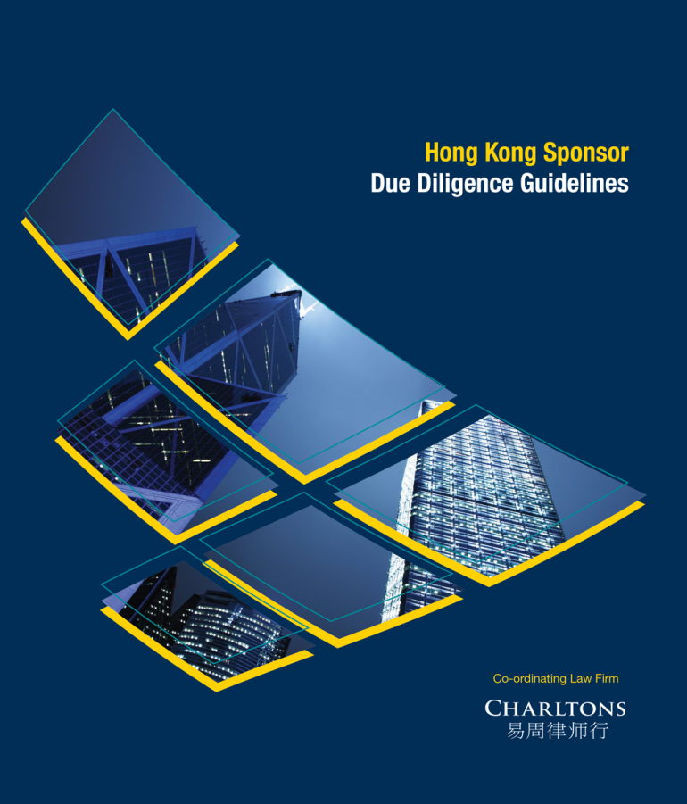

Ad hoc group of 53 sponsors, accountants, law firms and other industry professionals

- Objectives:
- Promote the professional standards of market practitioners engaging in corporate finance advisory activities in Hong Kong by developing practical due diligence guidelines for Hong Kong IPOs representing a broad consensus of opinion of those who act as sponsors as to what is ‘good market practice’ in relation to carrying out due diligence work with particular regard to the requirements of new Paragraph 17 of the Code of Conduct
- Approach:
- Guidelines provide guidance and recommended steps for sponsors to implement which should, typically, meet the requirements in the relevant paragraphs of the Code of Conduct.
- The circumstances of a particular case may mean that:
- reasonable due diligence might dictate that additional enquiries should be undertaken with respect to any aspect of due diligence, or
- it is unnecessary to undertake particular enquiries envisaged in the Due Diligence Guidelines

Development of guidelines
- Drafted by various law firms
- Plain language guidance
- Collaborative commenting process
- Input from law firms, various sponsor groups, accountants and other industry professionals (eg: mineral companies industry professionals) regarding issues posed by certain types of due diligence and common practice
- Focus on offering guidance on compliance with the requirements of new Paragraph 17 of the Code of Conduct
- Designed to incorporate all relevant regulatory standards/ guidance from the SFC and the HKEx as well as other industry guidance (ex: from the Hong Kong Institute of Certified Public Accountants) into relevant topic areas
- Comprehensive handbook for practitioners – each topic references all relevant requirements and guidance from different sources as well as industry input
- Available free to the public online at www.duediligenceguidelines.com

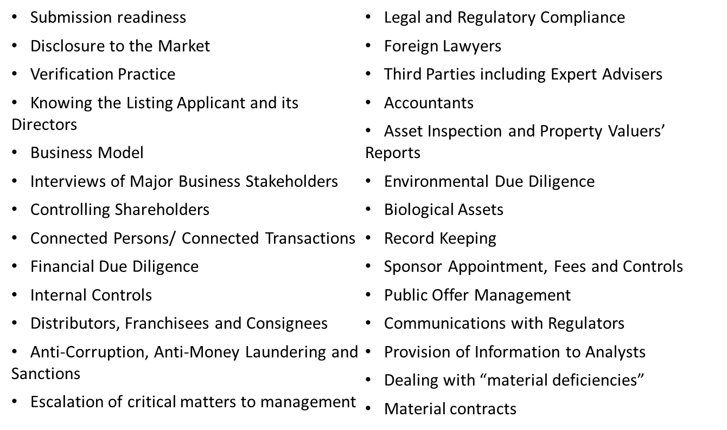

- The Due Diligence Guidelines comprise two interrelated sections:
- General Principles - these are essentially statements of good standards of conduct to be observed in the conduct of due diligence. The General Principles are expressed in broad general terms and do not define the extent or the limits of their application.

- Due Diligence Guidelines - these are in turn structured in three inter-related sections:
- Standards - these are statements of sponsors’ due diligence obligations under Hong Kong’s regulatory regime;
- Guidance – this section sets out guidance as to the market’s interpretation of the Standards which elaborates on, but does not in any way extend, the obligations of sponsors under the Standards; and
- Recommended Steps – these set out practical steps which would generally be expected to meet the Standards in a typical case.

Due Diligence Guideline – Interviews with Major Business Stakeholders

- Topics covered in Due Diligence Guideline – Interviews with Major Business Stakeholders:
- Interviews with Business Stakeholders
- Selection of Interviewees
- Interview Timing and Preparation
- Arranging and Conducting Interviews
- Establishing the Identity and Authority of Interviewees
- The Interview and Follow-up
- Irregularities During Interviews
- Records of Interviews
- Guidance given on various aspects of interviews, for example:
- Aims of interviews with major business stakeholders
- Certain areas of focus for an interview and selection of interviewees
- Notation of relevant related Stock Exchange Guidance Letters, Listing Rules, etc.
- Cross-references to other guidelines for further detail on particular issues (eg., distributors)
- Identification of situations in which further steps may be required (eg., a further interview with a more appropriate person if it becomes apparent that the interviewee lacks sufficient authority or knowledge)
- Recommended steps given, based on ‘good market practice’ among sponsors, for practical details on actions a sponsor should take or should consider taking
- eg., sample steps to ensure the independence of the process of selecting interviewees
- Acknowledgment of limitations (eg. third party interviewees are under no compulsion to cooperate and may refuse to make personal documents available)

Sponsor due diligence work plan

What is a sponsor due diligence work plan?

- A sponsor due diligence work plan identifies the relevant work and steps required to be undertaken under the requirements of the new sponsor regime for the purpose of assessing and co-ordinating the overall due diligence exercise.
- A sponsor due diligence work plan generally includes :
- the nature, timing and extent of due diligence procedures
- the required time and skills sets of persons involved needed to implement the plan
- changes to the plan, if any
- results of due diligence performed together with the sponsor’s assessment of the results
- It also serves as a proper trail of record of due diligence work carried out by the sponsor during the listing process.

Requirements of keeping proper record

- A sponsor is required to document due diligence planning and significant deviations, if any, from plans.
- Paragraph 17.2(e) of the Code of Conduct requires a sponsor to maintain proper books and records that are sufficient to demonstrate its compliance with the Code of Conduct.
- Paragraph 17.10 of the Code of Conduct sets out detailed requirements as to what is required in order to maintain proper records, including keeping records within its control of a due diligence plan identifying (i) the required time and skills sets of persons needed to implement the plan (ii) changes to the plan, (iii) the nature, timing and extent of due diligence procedures and (iv) the results of due diligence performed together with the sponsor’s assessment of the results.
- Rule 2.3 of the SFC’s Corporate Finance Advisers’ Code of Conduct requires the maintenance of proper books and record and that a proper trail of work can be provided upon request.

Requirements of keeping proper record

- In order to fulfil these requirements, the sponsor should nominate one or more team members to assume responsibility for (i) reviewing and updating this due diligence plan and (ii) maintaining records and copy documents as appropriate.
- Where joint sponsors are appointed, they are jointly and severally liable for their work conducted in the offering of the Shares.
- Accordingly, each sponsor should
- ensure that its team is appraised of, and familiar with, all due diligence work conducted by the sponsors collectively; and
- nominate one or more team members to assume responsibility so far as that sponsor is concerned for (i) reviewing and updating this due diligence plan; and (ii) maintaining records and copy documents as appropriate.

The transaction team

- Under Paragraph 17.11(c) of the Code of Conduct, taking account of the nature, scale and complexity of the assignment and any other factors that may affect the standard of work, a sponsor should appoint a Transaction Team to carry out a listing assignment which :
- comprises staff with appropriate levels of knowledge, skills and experience; and
- includes at least one Principal who acts as the supervisor of the Transaction Team.
- A sponsor should implement and maintain systems for tracking deal staffing and consult these systems when assessing a potential sponsor assignment. The systems should be periodically updated to reflect changes to deal staffing.
- The sponsor should include details of the Transaction Team in respect of each listing assignment.

Escalation / referral of critical matters

- Paragraph 17.11(e)(vi) of the Code of Conduct provides that management of the sponsor must put in place appropriate systems, controls and procedures to govern sponsor work, including escalation of critical matters (such as resolution of suspicious circumstances, difficult or sensitive issues, conflicting information and material non-compliance by a listing applicant.) to management or its designated committee for decision.
- For each critical matter escalated / referred to Management or its designated committee during the course of due diligence and the listing assignment, the Transaction Team should ensure that details of the escalation / referral is recorded in the plan.

Content of a sponsor due diligence work plan

- A sponsor due diligence work plan should generally include the following :
- major categories of issues relating to a listing
- approach / process / steps required to be taken in relation to the relevant issues
- regulatory reference
- status / comments

Content of a sponsor due diligence work plan

Examples of major categories of issues include:
- qualifications for listing
- directors and persons identified in the prospectus
- financial information
- business model
- on-site Inspection
- Taxation
- foreign exchange
- operations, products and services
- real estate : ownership / usage / planning / regulatory
- property valuation
- group structure
- connected parties and transactions
- insurance
- environmental
- litigation, material disputes and contingencies
- impartiality and independence of sponsors
- US offering issues (if applicable)

- Relevant steps and procedures that are required to be carried out should set out under “approach / process / steps” and examples of these steps and procedures will generally include actions such as :
- Conduct public searches and background searches
- Review records and documents and plans
- Interview and making relevant inquiry with the relevant persons (including directors, shareholders, connected persons, suppliers, customers)
- Verify information by documents provided or available in the public domain
- Obtain further documents and information and confirmation
- Compare with relevant industry peers
- Identify key risks
- Assess strength and weakness
- It is always helpful to include in the due diligence work plan relevant regulatory references as the sources and bases on which the due diligence work should be carried out. These regulatory references should generally include :
- Listing Rules
- Guidance letters
- Code of Conduct
- Due diligence guidelines
- Listing Decisions
- SFC Dual Filing Updates
- SFC thematic investigation report

Example of a sponsor due diligence work plan

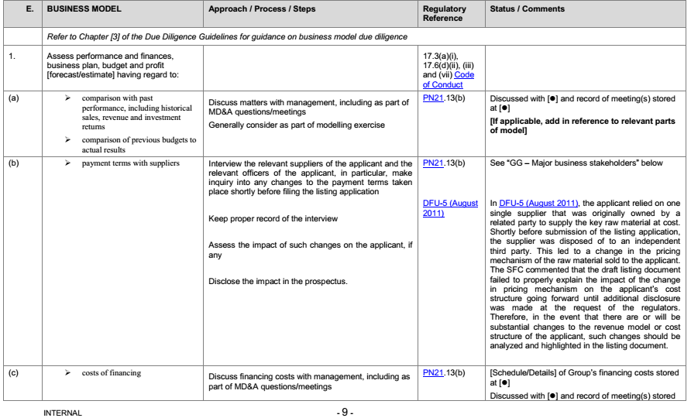

- Please refer to the extract of an example of a sponsor due diligence work plan
- Section 1(b) – “payment terms with suppliers”
- Section 1(b) refers to a SFC dual filing updates (DFU-5 (August 2011)) in which the applicant relied on one single supplier that was originally owned by a related party to supply the key raw material at cost.
- Shortly before submission of the listing application, the supplier was disposed of to an independent third party. This led to a change in the pricing mechanism of the raw material sold to the applicant. The SFC commented that the draft listing document failed to properly explain the impact of the change in pricing mechanism on the applicant’s cost structure going forward until additional disclosure was made at the request of the regulators.
- Therefore, in the event that there are or will be substantial changes to the revenue model or cost structure of the applicant, such changes should be analyzed and highlighted in the listing document.

- For action required to be taken, the plan sets out that the Transaction Team should :
- interview the relevant suppliers of the applicant and the relevant officers of the applicant, in particular, make inquiry into any changes to the payment terms taken place shortly before filing the listing application;
- keep proper record of the interview;
- assess the impact of such changes on the applicant, if any
- disclose the impact in the prospectus.

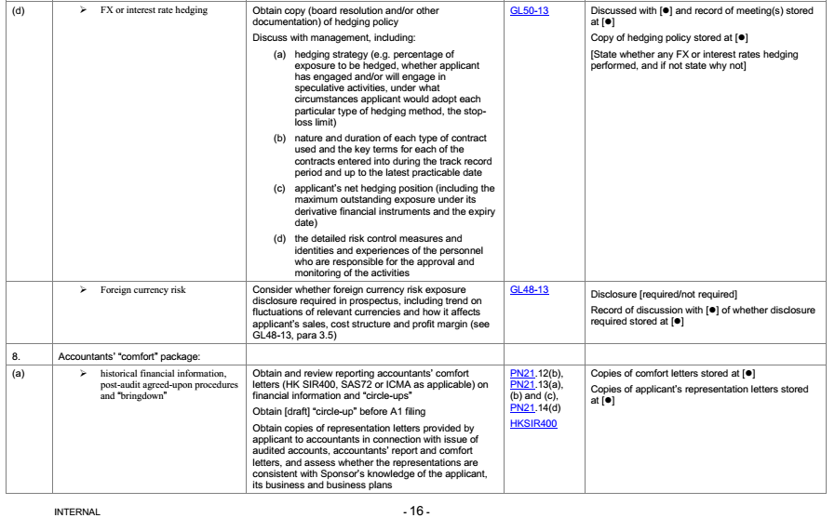

- Please refer to the extract of an example of a sponsor due diligence work plan
- Section 7(d) – “FX or interest rate hedging”
- A guidance letter (GL50-13) issued in January 2013 requires that key areas relating to hedging required to be disclosed under the “Business” section of the prospectus include :
- the hedging strategy;
- nature and duration of each type of contract used and key terms of those contracts;
- applicant’s net hedging position;
- identities and experiences of the personnel responsible for the approval and monitoring of the activities and the risk control measures.

- The due diligence work plan sets out that the following action should be done :
- Obtain copy of the hedging policy and set out in the plan the location of where the copy is kept
- Discuss with the management of the applicant the hedging strategy, nature and duration of each type of contracts, the applicant’s net hedging position and the risk control measures and identities and experiences of personnels responsible for approval and monitoring of the activities
- Make a record of the discussion and set out in the plan the location of where the copy is kept

Contact us




In association with:
Networked with:
Hong Kong Office
12th Floor
Dominion Centre
43 – 59 Queen’s Road East
Hong Kong

Telephone (852) 2905 7888
Fax : (852) 2854 9596
Email : enquiries@charltonslaw.com
Website : http://www.charltonslaw.com

Other locations

China

Beijing Representative Office
3-1703, Vantone Centre
A6# Chaowai Avenue
Chaoyang District
Beijing
People's Republic of China
100020

Telephone: (86) 10 5907 3299
Facsimile: (86) 10 5907 3299
enquiries.beijing@charltonslaw.com

Shanghai Representative Office
Room 2006, 20th Floor
Fortune Times
1438 North Shanxi Road
Shanghai
People's Republic of China
200060

Telephone: (86) 21 6277 9899
Facsimile: (86) 21 6277 7899
enquiries.shanghai@charltonslaw.com

Myanmar

Yangon Office of Charltons Legal Consulting Ltd
161, 50th Street
Yangon
Myanmar
enquiries.myanmar@charltonslaw.com

