Introduction

- In January 2016 The Hong Kong Stock Exchange (Exchange or HKEx) recognised Russia as an acceptable jurisdiction of incorporation for listing applicants (Acceptable Jurisdiction*).

- Russian companies can now apply for primary or secondary listing on the Exchange’s Main Board (Main Board or MB).

- The Exchange considers a range of criteria when determining whether or not an applicant’s jurisdiction is an Acceptable Jurisdiction. The Exchange/SFC have provided detailed guidance on these criteria in a Joint Policy Statement Regarding the Listing of Overseas Companies (JPS).

- The key criteria are:-

- whether or not the law of the applicant’s jurisdiction contains standards of shareholder protection equivalent to those provided in the law of Hong Kong; and

- whether or not there are regulatory co-operation arrangements between the statutory securities regulator(s) in the applicant’s jurisdiction of incorporation and its place of central management and control (if different) and Hong Kong’s Securities and Futures Commission (SFC)

* The Exchange has approved 24 Acceptable Jurisdictions. These are Australia, Brazil, the British Virgin Islands, Canada (Alberta), Canada (British Columbia), Canada (Ontario), Cyprus, France, Germany, Guernsey, the Isle of Man, India, Italy, Japan, Jersey, Republic of Korea, Labuan, Luxembourg, Russia, Singapore, the United Kingdom, the States of California, Delaware and Nevada in the United States. The Exchange also permits listings from Hong Kong, China, Bermuda and the Cayman Islands (the “Recognised Jurisdictions”)

Overview of Russia's Regulatory Regime

- Under Russian law, a Russian company seeking listing in Russia or overseas is required to be incorporated in the form of public joint stock companies (PJSCs).

- Shares of PJSCs may only exist in uncertificated form. This means that Russian companies seeking overseas listing must list in the form of depositary receipts. Russian companies can therefore not list on GEM as the Exchange does not allow depositary receipt listings on GEM.

- Russian companies seeking to list overseas must be listed on a Russian stock exchange.

- The total share capital of a Russian company which can be offered and/or traded outside Russia is limited to a maximum threshold of 25% of its total issued share capital, conditional on the company meeting certain criteria. The number of shares offered overseas is limited to a maximum threshold of 50% of the total number of shares offered in Russia.

International Regulatory Co-operation Measures

- In the past Russia was barred from becoming an Acceptable Jurisdiction due to a lack of bilateral arrangements on regulatory cooperation. Russian participation on the Exchange has been strictly limited.*

- On 16 February 2015, Russia became a full signatory of the IOSCO Multilateral Memorandum of Understanding Concerning Consultation and Cooperation and Exchange of Information (IOSCO MMOU), satisfying the requirement for regulatory co-operation arrangements.

- Where a Russian incorporated issuer has its place of central management and control outside of Russia, comparable international co-operation arrangements must generally also be in place between the securities regulator of that jurisdiction and Hong Kong’s SFC.

* At present there are only 2 Russian-based companies listed on the Exchange: Rusal and IRC Limited. Neither company is incorporated in Russia. Rusal is the only Hong Kong issuer restricted to institutional and professional investors or other investors ordering at least HK$1 million of shares each. The SFC refused to allow retail participation given Rusal’s high debt levels. Several Russian oil giants, e.g. Lukoil, suspended Hong Kong listing plans in 2013. Gazprom was also reported to be considering a Hong Kong listing in 2014 following its June 2014 listing of American Depositary Receipts on the Singapore Stock Exchange

Conformity with JPS’s Shareholder Protection Standards

- The Exchange does not regard Russian shareholder protection standards as materially different to those of Hong Kong., subject to Russian companies meeting the conditions set out in the Exchange’s ‘Country Guide for Russia’ (Country Guide). The Country Guide is to be read in conjunction with the JPS.

- The Country Guide and JPS reiterate many of the key requirements relating to shareholder protection standards contained in the Rules Governing the Listing of Securities on the Stock Exchange of Hong Kong Limited (Listing Rules), although neither the Country Guide nor JPS override the Listing Rules.

- The Country Guide provides ‘conformity guidance’ under the following headings:-

- Auditors' remuneration
- Proceedings at general meetings: Right to speak and vote at general meetings
- Proceedings at general meetings: Appoint proxies or corporate representatives to attend general meetings

- The Exchange further sets out advice is respect of the following practical and operational matters:-

- Conflicts with Hong Kong's rules and regulations
- Directors' Responsibility
- Shareholders' approval of directors' service contracts
- Notifiable Transactions
- Connected Transactions
- Depositary Receipt Programmes
- Share Buy-backs
- Constitutional Documents

Practice and JPS Conformity: Auditors' remuneration

 | JPS | Russian Law
 | Auditors' remuneration must be approved by a majority of an overseas issuer's members or other body that is independent of the board of directors (Board), such as the supervisory board in systems that have a two tier board structure. | Auditors' remuneration must be determined and approved by the Board of the applicant.
Approach of the Exchange under the Country Guide | The Exchange does not regard the difference between the requirements of the two jurisdictions to be material to shareholder protection subject to the applicant's full disclosure of the auditors' remuneration and the applicant adopting practices (either by amending its constitutional documents or internal regulations) requiring the Board's approval of auditors' remuneration to be based on the recommendation of an independent body, such as an audit committee comprising wholly of independent non-executive directors and an independent shareholders' opinion in the form of an "advisory vote".

Practice and JPS Conformity: Proceedings at general meetings - Right to speak and vote at general meetings

 | JPS | Russian Law
 | All members must have the right to speak and vote at a shareholder meeting, except where a member is required under the Listing Rules to abstain from voting to approve the transaction or arrangement. | Russian law does not explicitly provide for shareholders' right to speak at a general meeting. However, in practice, the internal regulations of large Russian companies include this right and relevant procedures.
Approach of the Exchange under the Country Guide | A Russian issuer should establish that its constitutional documents include the right of the shareholders to speak at general meetings.

Practice and JPS Conformity: Proceedings at general meetings –Appointment of proxies or corporate representatives to attend general meetings

 | JPS | Russian Law
 | A recognised Hong Kong clearing house must be able to appoint proxies or corporate representatives to attend general meetings and creditor meetings.  Overseas issuers must notify the Exchange of any restrictions on a Hong Kong investor's right to attend general meetings to vote and/or to appoint proxies. | Shareholders may exercise their right to participate in a general meeting through personal attendance, by having a duly authorised representative attend under a proxy attendance, or by submitting a voting ballot, signed either by a shareholder or its duly authorised representative.  A shareholder is not permitted to appoint multiple proxies or authorised representatives.  Thus, the domestic depositary may vote at a general meeting in compliance with the instructions of depositary receipt holders, but the depositary receipt holders themselves may not be able to attend general meetings to vote and/or appoint proxies.  In order to attend general meetings to vote and/or appoint proxies, holders of depositary receipts would need to withdraw their shares from the depositary facility and hold the shares directly
Approach of the Exchange under the Country Guide | A shareholder's inability to appoint multiple proxies or authorised representatives to attend general meetings and creditor meetings is not regarded by the Exchange as material to shareholder protection.  The jurisdictional difference may be resolved by taking into account the ability of a depositary receipt holder to give instructions to the depositary to participate in general meetings and to vote the underlying shares on his behalf; and the ability to convert depositary receipts to shares and hold them as a shareholder to directly exercise the right to speak and vote at general meetings, and that the amount of time, costs and procedures involved in processing the conversion must be reasonable under the deposit agreement acceptable to the Exchange. Further, the issuer must fully disclose the inability of depositary receipt holders to attend general meetings of the issuer.

Practical and Operational Matters: Conflicts with Hong Kong's rules and regulations and directors' responsibilities

- Conflicts with Hong Kong's rules and regulations

- Under the JPS, overseas issuers are advised to consult the Exchange in cases of potential conflict between the laws and regulations of the issuer's home jurisdiction and Hong Kong's Listing Rules or The Codes on Takeovers and Mergers and Share Buy-backs.

- Directors’ Responsibilities

 | JPS | Russian Law
 | A listed issuer must ensure that its directors accept full responsibility, collectively and individually, for the listed issuer's compliance with the Listing Rules. | As a general rule, directors are responsible towards the shareholders and the company, but not towards third parties. There is no power vested in the Board to take collective responsibility, and the directors must accept the responsibility individually.
Approach of the Exchange under the Country Guide - Russia | A director must contractually undertake to the issuer and the Exchange to accept full responsibility, collectively and individually, for the listed issuer's compliance with the Listing Rules.

Practical and Operational Matters: Shareholders’ Approval of Directors’ Service Contracts

 | JPS | Russian Law
 | Prior shareholder approval is required for directors' service contracts which may last for more than 3 years or provide for more than 1 year's notice of termination or a compensation payment equivalent to more than 1 year's emoluments. | As the Board must be re-elected each year, it would not be feasible for the shareholders to approve these matters. All directors' service contracts must be reviewed and approved by the Remuneration Committee.
Approach of the Exchange under the Country Guide - Russia | The annual re-election of the Board by shareholders provides sufficient shareholder protection safeguard over the employment of directors. The Exchange considers the Rule regarding shareholders' approval of directors' service contracts as inapplicable to Russian companies, and consequently would expect to be prepared to grant a waiver from strict compliance with the Listing Rules.

Practical and Operational Matters: Notifiable Transactions

 | JPS | Russian Law
 | Shareholders' approval is required for a transaction where the relevant percentage ratio is at least 25%, subject to certain exemptions. | Shareholders' approval (by three-quarter majority vote at a general shareholders' meeting) is required for a transaction with a value of at least 50% of the company's book asset value, subject to certain exceptions.  Board approval (by unanimous vote) is required for a transaction with a value of 25% to 50% of the company's book asset value. Where requisite Board approval is not achieved, an ordinary resolution (i.e. 50% plus one vote) at a general shareholders' meeting may approve the transaction.  These are the only circumstances in which a company is permitted to submit material transactions to shareholders for their approval.
Approach of the Exchange under the Country Guide | Differences in shareholder protection standards may be resolved through amendments to the issuer's constitutional documents such as requirements that:  - where shareholders' approval is not required under Russian law, the directors of the issuer must obtain an independent shareholders' opinion in the form of an "advisory vote" for any transaction which would require shareholders' approval under the Listing Rules. Independence of a shareholder should be benchmarked against the Listing Rules' standards; and  - the directors may only approve a transaction where the majority of votes cast by the independent shareholders for the purpose of the advisory vote are in favour of the transaction.

Practical and Operational Matters: Connected Transaction

 | JPS | Russian Law
 | Shareholders' approval at a general meeting is required for a transaction between a connected person and the listed issuer, subject to certain exemptions.  A connected person includes a director, chief executive or substantial shareholder of the listed issuer or any of its subsidiaries, a person who was a director of the listed issuer or any of its subsidiaries in the last 12 months, a supervisor of a PRC issuer or any of its subsidiaries, an associate of any of the above-mentioned persons, a connected subsidiary, or a person deemed to be connected by the Exchange. | Shareholders' approval by an ordinary resolution is required for a transaction between an "interested person" and the company with a value of at least 2% of the company's book asset value, subject to certain exceptions.  Interested persons may include a member of the Board, management board or the CEO/management company, any shareholder which alone or together with its affiliates holds 20% or more of the company's voting shares, any person who can give mandatory instructions to the company, any other persons indicated in the company's constitutional documents, or an associate of any of the above-mentioned persons.  These are the only circumstances in which a company is permitted to submit transactions with an "interested person" to shareholders for their approval.
Approach of the Exchange under the Country Guide - Russia | Differences in shareholder protection standards may be resolved through amendments to the issuer's constitutional documents so that interested persons include each connected person as specified in the Listing Rules, and include the requirements that:  - where shareholder approval is not required under Russian law, the directors of the issuer must obtain an independent shareholders' opinion in the form of an "advisory vote" for any transaction which would require independent shareholders' approval under the Listing Rules. Independence of a shareholder shall be benchmarked against the Listing Rules' standards; and  - the directors may only approve a transaction where the majority of votes cast by the independent shareholders for the purpose of the advisory vote are in favour of the transaction.

Practical and Operational Matters: Depositary Receipt Programmes

 | JPS | Russian Law
 | An overseas issuer must notify the Exchange if the laws and regulations of its home jurisdiction do not recognise a nominee company holding securities on behalf of third parties, for example the HKSCC Nominees that holds listed securities on behalf of Central Clearing and Settlement System (CCASS) participants.  An overseas issuer must notify the Exchange as to who will be recognised as the legal owners of the securities in the issuer's place of incorporation. | A Russian issuer seeking an overseas listing in Hong Kong can only list in the form of depositary receipts on the Main Board.  There is legal uncertainty as to who should be recognised as the legal owners of the securities under Russian law. Typically, depository banks may open "depo" accounts with the National Settlement Depositary which allow them to be treated as nominee holders of the shares in Russian companies and not as direct shareholders. However, under some applicable Russian securities markets laws, depository banks are regarded as shareholders of Russian companies and only they may practically exercise certain shareholders' rights and perform relevant obligations.
Approach of the Exchange under the Country Guide - Russia | The Hong Kong depositary must be a suitably authorised and regulated financial institution acceptable to the Exchange to ensure, inter alia, that the relevant depositary receipts held under CCASS are eligible securities for deposit, clearance and settlement in CCASS. In evaluating suitability, the Exchange will take into account the jurisdiction of incorporation of the Hong Kong depositary. The governing law of the deposit agreement should be either that of Hong Kong or that of a jurisdiction that accords with international practice.  The listing document should include full details of:  - the rights and obligations of depositary receipt holders including how their rights may be enforced against the Russian issuer and/or the Hong Kong depositary in Hong Kong and Russia;  - the associated risks to the Russian issuer and its depositary receipt holders; and  - full details of the clearing and settlement arrangements including how Hong Kong investors (through HKSCC Nominees) will hold the depositary receipts and the roles and responsibilities of any domestic depositary, the Hong Kong depositary and CCASS, including with reference to any applicable Russian rules and regulations.  The deposit agreement is required to be in a form acceptable to the Exchange. Thus, a Russian issuer should early consult the Exchange on the terms of the deposit agreement.

Practical and Operational Matters: Share Buy-backs

 | JPS | Russian Law
 | Shareholders may request the company to buy-back their shares in certain circumstances, including reorganisation of the company, major transactions, amendments to constitutional documents which limit the shareholders' rights or delisting of the company's shares, provided that the requesting shareholder voted against or abstained from voting under such circumstances. The company may not reject such buy-back as it is a statutory requirement (Russian Mandatory Share Buy-back).  Subject to the confirmation of the SFC, the Russian Mandatory Share Buy-back is an exempt share buyback for the purposes of the Hong Kong Share Buy-backs Code. | The requirement for SFC approval of off-market buy-backs may not be in compliance with Russian law, because it would be considered as limiting the rights of the shareholders and the company under Russian law.  The company would need to follow the share buy-back offer requirements under Russian law.  Russian law does not require independent shareholders' approval
Approach of the Exchange under the Country Guide - Russia | The jurisdictional differences between Russia and Hong Kong regarding share buy-back requirements can be resolved by obliging the Russian incorporated issuer to disclose in its listing document the requirements for share buy-back under both jurisdictions and requirements that it must:  - not carry out voluntary off-market buy-back or share buy-back by general offer unless the Hong Kong share buy-back requirements are followed (i.e. seeking the SFC's approval before obtaining an independent shareholders' approval, as well as corporate approvals under Russian law); and  - seek the SFC's confirmation on an exempted transaction regarding any Russian Mandatory Share Buy-back when the circumstances arise.

Practical and Operational Matters: Constitutional Documents

Hong Kong Law (Listing Rules) | Russian Laws, Regulations and Practice | Approach of the Exchange under the Country Guide
Power taken to forfeit unclaimed dividends should not be exercised until at least six years after the date of declaration of the dividend. | The exercise of a power to forfeit dividends is permitted five years after the date of declaration of the dividend. This period cannot be extended. | The difference between the jurisdictions is immaterial to shareholder protection. The requirement under Russian law must be disclosed in the listing document. The Exchange would expect to be prepared to grant a waiver for this item. Under the JPS, an eligible secondary listing applicant is entitled to an "automatic waiver" for this item.
The minimum length of the period for shareholders to lodge their notice with the issuer to nominate a director and for the proposed director to notify the issuer of his willingness to be elected must be at least 7 days. This period cannot commence before the day after the dispatch of the notice of the meeting appointed for such election and must end no later than 7 days prior to the date of such meeting | Notices proposing a person for election as a director are required to be lodged no later than 30 days after the end of the financial year (in the event of an AGM), and no later than 30 days prior to the date of the general meeting (for an EGM).  The notice period for lodgement of notices in the Listing Rules could potentially expire before shareholders receive their notice of meeting. | A Russian issuer's constitutional documents should be amended so as to increase the minimum meeting notice period so that the notice period for lodgement of notices in the Listing Rules will not expire before shareholders receive their notice of meeting.  Under the JPS, an eligible secondary listing applicant is entitled to an "automatic waiver" for this item.
If the Listing Rules require a shareholder to abstain from voting on any particular resolution or restrict the shareholder to voting only for or only against any particular resolution, any votes cast by or on behalf of such shareholder in breach of such requirement or restriction must not be counted. | A shareholder's vote should be counted, except where the shareholder must abstain under Russian law. Where there are differences between Russian law and the Listing Rules, it is not possible to adopt the position under the Listing Rules.  In relation to interested party transactions under Russian law, a Russian company may amend its constitutional documents so that parties regarded as interested in a certain transaction under the Listing Rules will not be permitted to vote, and, if they vote, their vote would not be counted. | A Russian issuer should amend its constitutional documents so that parties regarded as interested in a certain transaction under the Listing Rules will not be permitted to vote, and, if they vote, their vote would not be counted.  An alternative to a constitutional document amendment accepted by the Exchange is the adoption of internal procedures which satisfy the Exchange that the issuer will not carry out any transaction which is the subject matter of the approved resolution, except where the resolution would have still passed if the votes of the interested shareholders under the Listing Rules had not been counted. These procedures must be disclosed in the listing document. Under the JPS, no "automatic waiver" is available to a secondary listing applicant for this item.

Accounting and Accounting Related Requirements

Hong Kong Law (Listing Rules and JPS) | Approach of the Exchange under the Country Guide
Accountants' reports and financial statements of overseas issuers seeking a primary or secondary listing must conform to: (i) the Hong Kong Financial Reporting Standards; or (ii) the International Financial Reporting Standards; or (iii) the general accepted accounting principles of the United States (in the case of secondary listings) | The accounting and auditing related requirements are specified in section 3 of the JPS. There has been no examination of the acceptability of Russian generally accepted accounting practices or Russian auditing standards. In order to use Russian generally accepted accounting practices and auditing standards, a Russian issuer must demonstrate to the Exchange that the Russian standards are comparable to those required in Hong Kong.

Taxation

Russian Law | Approach of the Exchange under the Country Guide
As a general rule, Russian income tax of 15% would be withheld in relation to the dividends payable to overseas shareholders, subject to any applicable double taxation treaties.  Capital gain from sales of securities is taxable at the general corporate income tax rate of 20%, which is subject to a number of exemptions and applicable double taxation treaties. | The Exchange expects a Russian issuer to prominently and fully disclose the following in its listing document:  - details of any Russian taxes (including capital gains tax and withholding tax on dividends), including the applicable rates, investors in its securities will have to pay;  - details of any treaty between Russia and Hong Kong that may affect the taxes payable;  - the effect of holding depositary receipts through CCASS or outside CCASS on any tax payable (where applicable); and  - the procedures for paying capital gains tax and for claiming any tax relief or exemptions  Appropriate disclosure of taxation should be made in at least the "Summary" and "Risk Factors" sections of the issuer's listing document and any sections summarising Russian laws and regulations.

2016 Double Taxation Agreement

- On 18 January 2016 Hong Kong and Russia signed an agreement for the avoidance of double taxation and the prevention of fiscal evasion with respect to taxes on income*(Agreement).

- Agreement comes into force on the completion of ratification procedures in Hong Kong and Russia. If the ratification process completes in 2016, the Agreement will come into force on 1 April 2017 in Hong Kong and on 1 January 2017 in Russia.

- In the absence of a double tax treaty, income earned by Russian residents in Hong Kong is subject to both Hong Kong and Russian tax.

- Agreement is intended to:-

- facilitate business and improve capital flows between Russia and Hong Kong,
- minimise the incidence of double taxation between the two counties,
- and limit fiscal evasion in accordance with international standards on transparency.

* Agreement between the Government of the Hong Kong Special Administrative Region of the People’s Republic of China and the Government of the Russian Federation for the Avoidance of Double Taxation and the Prevention of Fiscal Evasion with Respect to Taxes on Income at http://www.ird.gov.hk/eng/pdf/Agreement_ Russia_HongKong.pdf

- Key Advantages for Hong Kong investors in Russian companies

- Russia’s dividend withholding tax rate will be reduced from 15% to either 10% or 5%. The lower rate applies where the beneficial owner of the dividends is a company which directly holds at least 15% of the company paying the dividends;

- A 0% rate applies if the dividend is paid to the Hong Kong Government, the Hong Kong Monetary Authority, the Exchange Fund or entities wholly or mainly owned by the Hong Kong Government mutually agreed by the competent authorities of Hong Kong and Russia; and

- A capital gain derived by a Hong Kong resident on a disposal of shares in a Russian company will normally be exempt from Russian tax, except where the shares are in a company deriving more than 50% of its asset value from immovable property in Russia which are not listed on a stock exchange recognised by Russia and Hong Kong for this purpose.

- Information Exchange

- Article 25 provides for the exchange of information between the Hong Kong and Russian tax authorities in relation to taxes covered by the Agreement.

- The information which can be exchanged under the Agreement is information that is foreseeably relevant for carrying out the Agreement or to the administration or enforcement of the internal laws of the Contracting Parties concerning taxes.

- The Contracting Party that receives information under the Agreement must treat such information as secret in the same manner as information obtained under internal laws of that Party.
- Information can be disclosed only to persons or authorities concerned with the assessment or collection of, the enforcement or prosecution in respect of, or the determination of appeals in relation to the taxes covered by the Agreement.

- No obligation to share commercially sensitive or otherwise privileged information.

- Any information exchanged cannot be disclosed to any third jurisdiction.

Hong Kong: A Leading International Market
By market capitalisation, Hong Kong is the world’s 8th largest and Asia’s 4th largest (after Japan, Shanghai and Shenzhen) exchange (as at the end of November 2016).
Source: SFC based on data from the World Federation of Exchanges and Bloomberg. Figures for the London Stock Exchange Group include those of Borsa Italiana.
Market Capitalisation of the World's Top Stock Exchanges as of 31 Dec 2016

Rank | Exchange | Market Capitalisation (US$ billion)
1. | US (NYSE Euronext) | 19,573.07
2. | US (Nasdaq OMX) | 7,779.13
3. | Japan (Japan Exchange Group) (Comprises Tokyo and Osaka exchanges) | 5,061.54
4. | China (Shanghai) | 4,103.99
5. | UK (London Stock Exchange Group) | 3,622.41
6. | Europe (NYSE Euronext) | 3,492.59
7. | China (Shenzhen) | 3,216.75
8. | Hong Kong (Includes GEM) | 3,193.24
9. | Canada (Toronto) (Includes TSX Venture) | 2,041.53
10. | Germany | 1,732.27

Source: SFC End of 2016 Market Capitalisation figures for the World’s Top 15 Stock Exchanges. Information reproduced on top 10 only.

HKEx: Top IPO Funds Raising Platform

- The Stock Exchange of Hong Kong (SEHK or the Exchange) was the top IPO market in 2016 in terms of funds raised and number of new listings.

- A total of US$25.1 billion IPO funds was raised in Hong Kong in 2016.

- There were 126* new listings in 2016:

- Main Board - 81
- GEM - 45

* Includes 6 companies which moved their listings from GEM to the Main Board

Source: Hong Kong Exchanges and Clearing Limited and Bloomberg

Total Equity Funds Raised 2015

Rank | Exchange | Total Equity Funds Raised  (US$ million)
1. | NYSE | 127,254
2. | Shanghai Stock Exchange | 126,422
3. | HKEx | 125,021
4. | Euronext | 98,677
5. | Shenzhen Stock Exchange | 75,104
6. | London SE Group | 60,133
7. | Australian Securities Exchange | 44,917
8. | BME Spanish Exchanges | 43,762
9. | TMX Group | 42,328
10. | Japan Exchange Group | 19,756

Source: World Federation of Exchanges (WFE) Monthly Statistics (not including exchanges for which statistics are not available). Figures until 30 November 2015.

Benefits of listing on HKEx

- HKEx - international exchange allowing full access to international investors and listing of foreign companies which meet its requirements

- Strategic position as gateway between Mainland China and rest of the world

- International listing venue of choice for Mainland China companies

- Increasing number of overseas companies listed on HKEx in recent years

- Number of companies listed on HKEx as at 31 December 2016 = 1,973

- 1,713* on the Main Board and
- 260 on the Growth Enterprise Market (GEM)

- Deep primary and secondary market liquidity

- 126 new listings * in 2016 raised HKD 195 billion or US$25.1 billion (Down 26% from 2015)
- Post IPO funds in 2016 = HKD 292 Billion US$37.6 billion (Down 66% from 2015)
- Hong Kong ranked 1nd (overtaking NYSE) in 2016 by IPO funds raised

* Including 6 companies which transferred their listings from GEM to the Main Board. Source: Hong Kong Exchanges and Clearing Limited

Ten Largest Hong Kong IPOs in 2016

 | Company name | Industry | IPO funds raised (HK$bn)
1 | Postal Savings Bank of China Co Ltd - H Shares | Financials - Banks | 59.15
2 | China Resources Pharmaceutical Group Ltd | Consumer Services - Pharmaceuticals | 15.06
3 | China Zheshang Bank Co Ltd - H Shares | Financials - Banks | 15.03
4 | China Merchants Securities Co Ltd - H Shares | Financials - Securities & Brokerage | 10.70
5 | Everbright Securities Co Ltd - H Shares | Financials - Securities & Brokerage | 8.93
6 | BOC Aviation Ltd | Consumer Services - Transportation | 8.74
7 | DFZQ - H Shares | Financials - Securities & Brokerage | 8.37
8 | CSC Financial Co Ltd - H Shares | Financials - Securities & Brokerage | 7.70
9 | Bank of Tianjin Co Ltd - H Shares | Financials - Banks | 7.68
10 | China Development Bank Financial Leasing Co Ltd - H Shares | Financials - Financing | 6.28

Source: Hong Kong Exchanges and Clearing Limited

Ten Largest IPO on the HKEx

 | Company name | Industry | IPO funds raised (HK$bn)
1 | AIA Group Ltd. | Financials | 159.08
2 | Industrial and Commercial Bank of China Ltd. - H Shares | Financials | 124.95
3 | Agricultural Bank of China Ltd. - H Shares | Financials | 93.52
4 | Bank of China Ltd. - H Shares | Financials | 86.74
5 | Glencore International plc | Resources | 77.75
6 | China Construction Bank Corporation - H Shares | Financials | 71.58
7 | Postal Savings Bank of China Co Ltd - H Shares  (listed in 2016) | Financials | 59.15
8 | China Unicom Ltd. | Telecommunications | 43.61
9 | Huatai Securities Co., Ltd. – H Shares | Financials | 38.76
10 | China CITIC Bank Corporation Ltd. - H Shares | Financials | 32.92

Source: Hong Kong Exchanges and Clearing Limited

HKEx Attracts a Diverse Portfolio of Issuers
Number of Main Board IPO by Industry (2016 Q1-Q3)

- Issuers from “Financial Services” sector continue to dominate the new listing markets in 2016 Q1-Q3

- Over one-third of the new Main Board issuers were from the Financial Services industry

Source: PwC

HKEx: A Strong Equity Fund Raising Platform

Total Equity Funds Raised in 2016 (HK$ bn)
- A Strong equity fund raising platform:

- A total equity funds of HK$486.7 billion was raised in 2016.

- Remains top IPO fundraising platform:

- A total amount of HK$195 billion was raised in 2016 – despite a decline of 26% from the previous year, Hong Kong remains the world’s top IPO fundraising platform

- A Strong secondary capital raising market:

- A total of HK$292 billion was raised from post-IPO fundraising activities in 2016

Source: Hong Kong Exchanges and Clearing Limited

HKEx: A Highly Active Stock Exchange

Average Daily Equity Turnover (HK$ m)
- High-level market liquidity:

- HKEx is a highly active stock exchange with a total equity turnover of HK$11,173,111 million in 2016
- The average daily equity turnover was amounted to HK$45,604.5 million
- Deep liquidity is partly driven by a diverse investor base

Source: Hong Kong Exchanges and Clearing Limited, HKEx Cash Market Transaction Survey 2014/15

Gateway to China: Shanghai and Shenzhen Connect

- Shanghai-Hong Kong Stock Connect pilot programme launched in November 2014 allows HK and Mainland Chinese investors to trade shares listed on the other market via the exchange/clearing house in their local market

- Shenzhen-Hong Kong Stock Connect launched in December 2016

- South-bound trading – allows Mainland investors to trade following shares listed on HKEx:

- constituent stocks of Hang Seng Composite LargeCap and MidCap Indexes;
- constituent stocks of Hang Seng Composite SmallCap Index with at least HK$5 billion market capitalisation; and
- all H-shares with corresponding A shares listed on Shanghai Stock Exchange (SSE)

- North-bound trading – allows HK and overseas investors to invest in:

- constituent stocks of SSE 180, SSE 380, SZSE Component and SZSE Small/Mid Cap Innovation Indexes; and
- SSE- and SZSE-listed A shares that have corresponding H shares listed on HKEx

- Trading is subject to Daily Quotas

 | Daily Quota
Northbound Trade | RMB 13 Billion
Southbound Trade | RMB 10.5 Billion

- Quotas apply on “net buy” basis: cross-boundary sales allowed regardless of quota balance

- Mainland investors restricted to institutional investors and individuals holding RMB500,000 in cash & securities

- All HK and overseas investors eligible for North-bound trading

Gateway to China: Shanghai-Hong Kong Stock Connect

 | Northbound Trading | Southbound Trading
Record high trade value (Buy + Sell) | RMB 23.4 Billion (6 Jul 2015) | HKD 26.1 Billion (9 Apr 2015)
Average daily trade value (Buy + Sell) | RMB 6,368 Million | HKD 3,396 Million
Total trade value (Buy + Sell) | RMB 1,471 Billion | HKD 778 Billion
Average daily no. of trades (Buy + Sell) | 185,607 | 51,049
Aggregate quota usage | RMB 120 Billion (40% usage) | RMB 108 Billion (43% usage)
Highest daily quota usage | Daily quota of RMB 8.3 Billion (64% usage) was used on 24 Aug 2015 | Daily quota of RMB 10.5 Billion was used up on 8 Apr 2015 and 9 Apr 2015
No. of trading days | 231 days | 229 days

Benefits of HK listing

- Established legal system based on English common law + regulatory framework = investor confidence

- Numerous tax advantages, currency convertibility, free transferability of securities and no restrictions on capital flow

- Opportunities for overseas companies to raise profile and visibility in China and Asia-Pacific region

- Branding opportunities for companies in the luxury goods sector – attracted listings of high profile companies such as Prada, Coach, Inc., L’Occitane and Samsonite

- China’s position as a major consumer of energy, minerals & metals has attracted mining & natural resource companies

- e.g. Swiss commodities giant Glencore International AG, Russia-based United Company Rusal PLC, Kazakhstan copper miner Kazakhmys PLC and Brazilian metals and mining company Vale S.A.

- Vale S.A = 1st overseas company to list on HKEx in form of Hong Kong Depositary Receipts (HDRs). HDR listings allowed on Main Board (but not GEM)

Overseas listings

Issuer | Country of Operations/  Headquarters | Country of Incorporation | Sector | Year of Listing | Funds Raised  (HK$ billion)
Glencore International plc | Headquartered in Switzerland | Jersey | Natural Resources | May 2011 | 77.75
RUSAL | Russia | Jersey | Natural Resources | January 2010 | 17.39
Mongolian Mining Corporation | Mongolia | Cayman Islands | Natural Resources | October 2010 | 5.81
PRADA SpA | Italy | Italy | Luxury | June 2011 | 19.23
Samsonite International SA | Headquartered in United States | Luxembourg | Luxury Goods | June 2011 | 10.09
L’Occitane | France | Luxembourg | Luxury Goods | May 2010 | 5.5
SECONDARY LISTINGS BY WAY OF INTRODUCTION
Vale SA  (HDR Listing) | Brazil | Brazil | Natural Resources | December 2010
Kazakhyms PLC | Kazakhstan | United Kingdom | Natural Resources | June 2011
Coach, Inc  (HDR Listing) | United States | United States | Luxury Goods | December 2011

Hong Kong’s markets

- Main Board (“MB”)– caters for established companies able to meet its profit or other financial standards

- Growth Enterprise Market (“GEM”) – caters for smaller growth companies, has lower admission criteria and acts as a stepping stone to the Main Board

- The post-listing obligations of GEM and Main Board companies are broadly similar. Key difference - quarterly reporting is mandatory for GEM companies but only recommended for Main Board companies

Key Requirements for MB listing

- Suitability for listing

- Must satisfy Exchange that applicant and its business are suitable for listing

- Operating History and Management

- A Main Board applicant must have a trading record period of, and management continuity for, at least 3 financial years and ownership continuity and control for at least the most recent audited financial year

Exceptions:

- Under the market capitalisation/ revenue test, HKEx may accept a shorter trading record period under substantially the same management if the new applicant can demonstrate that:

- its directors and management have sufficient and satisfactory experience of at least 3 years in the line of business and industry of the new applicant; and
- management continuity for the most recent audited financial year

- Financial Tests – Applicants must meet one of the three financial tests:

 | 1. Profit Test * | 2. Market Cap/Revenue Test | 3. Market Cap/Revenue/  Cashflow Test
Profit | At least HK$50 million in the last 3 financial years (with profits of at least HK$20 million recorded in the most recent year, and aggregate profits of at least HK$30 million recorded in the 2 years before that) | - | -
Market Cap | At least HK$200 million at the time of listing | At least HK$4 billion at the time of listing | HK$2 billion at the time of listing
Revenue | - | At least HK$500 million for the most recent audited financial year | At least HK$500 million for the most recent audited financial year
Cashflow | - | - | Positive cashflow from operating activities of at least HK$100 million in aggregate for the 3 preceding financial years

- For both Tests 2 & 3, only revenue from principal activities (not revenue from incidental activities) will be recognised. Revenue from “book transactions” is disregarded

* Main Board Listing Rule 8.05(1)

Financial Requirement Waivers for Mineral Companies

- New applicant Mineral Companies can obtain a waiver from the financial tests if their directors and senior management together have > 5 yrs’ experience relevant to the exploration and/or extraction activity that Mineral Company is engaged in. Details of such experience must be included in the listing document

- exploration for, and/or extraction of, natural resources account for 25% or more of the company’s total assets, gross revenue or operating expenses of it and its subsidiaries

- Pre-production stage companies seeking a waiver must be able to show a clear path to commercial production

Waivers for non-Mineral Companies

- Exchange may also accept a shorter trading record period and/or may vary or waive the financial standards requirements for:

- newly formed “project” companies (for example a company formed to construct a major infrastructure project); or

- in exceptional circumstances, if the applicant or its group has a trading record of at least 2 financial years and HKEx is satisfied that the applicant’s listing is in the interests of the applicant and its investors

Calculation of Revenue

- only revenue arising from the applicant’s principal activities and not items of revenue or gains arising incidentally will be recognised in Market Capitalisation/Revenue Test and the Market Capitalisation/Revenue/Cashflow Test

- Shares in public hands

- At least 25% of applicant’s total share capital having a market capitalisation at listing of at least HK$50 million must be held by the public

- If listing applicant has more than 1 class of securities, the total securities held by the public on all regulated market(s) including HKEx must be at least 25% of the issuer’s total issued share capital. The class of securities for which listing is sought must not be less than 15% of the issuer’s total issued share capital, having an expected market capitalisation of at least HK$50 million

- HKEx may, at its discretion, accept a lower percentage of between 15% and 25% for issuers with an expected market capitalisation at listing of > HK$10 billion if:

- HKEx is satisfied that the number of securities and their distribution will enable the market to operate properly with a lower percentage;

- the issuer makes appropriate disclosure of the lower prescribed percentage of public float in the listing document;

- the issuer confirms the sufficiency of public float in successive annual reports after listing; and

- a sufficient proportion (to be agreed in advance with HKEx) of any securities to be marketed contemporaneously in and outside Hong Kong, must normally be offered in Hong Kong.

- public float waiver is available only on initial listing

- Minimum number of shareholders

- Minimum number of shareholders at listing – 300

- Not more than 50% of the publicly held shares can be beneficially owned by the 3 largest public shareholders

- Market Capitalisation

- Expected market capitalisation at the time of listing must be >HK$200 million

- Expected market capitalisation of the securities held by the public must be >HK$50 million

- Listings made under Market Capitalisation/Revenue/Cash Flow Test or Market Capitalisation/Revenue Test must have an expected market capitalisation at the time of listing of HK$2 billion or HK$4 billion, respectively

- Market capitalisation at the time of initial flotation is usually ~HK$200 million

- Further issues of securities of a class already listed are not subject to this limit

- In exceptional cases, a lower expected initial market capitalisation may be acceptable, although HKEx will have to be satisfied as to the marketability of the securities

- Working Capital Sufficiency

- For at least the next 12 months from the date of publication of the listing document

- Mineral companies must demonstrate that it has sufficient working capital for 125% of the group’s requirements for the next 12 months including general, administrative and operating costs, property holding costs and the cost of any proposed exploration and/or development.

Listing Hong Kong Depositary Receipts

- Companies can list on the Main Board in form of ordinary shares or depositary receipts (HDRs) representing a given number of underlying shares

- HDRs cannot be listed on the GEM and companies must list ordinary shares

- HDR listing framework was introduced in July 2008

- an initiative to encourage the listing of more foreign companies on HKEx

- Pre-2008: Listing Rules required companies to:

- list in the form of ordinary shares; and

- maintain a share register or a branch of their share register in Hong Kong

- Requirements effectively barred the listing of companies from jurisdictions which prohibit the issue of shares overseas or the maintenance of an overseas share register

- HDRs introduced as a solution aimed at encouraging listing of companies from Russia, India, Taiwan, Kazakhstan, Mongolia and Vietnam

- Currently, only 3 companies have listed HDRs on HKEx – all are secondary listings

- Brazilian mining company, Vale (listed in HK in December 2010) – also listed on the stock exchanges of São Paulo, New York, Paris, and Madrid;

- US luxury handbag and accessories brand, Coach Inc. (listed in HK in December 2011) – primary listing on NYSE; and

- Japanese retail clothing business, Fast Retail-DRS (listed in Hong Kong in March 2014) - primary listing on the Tokyo Stock Exchange

Listing Requirements for HDR Issuers

- Same as those for issuers of shares

- Must satisfy the listing criteria set out in Chapter 8 of Main Board Rules

- No requirement for the issuer to be already listed on an overseas exchange

- Additional requirements set out in Chapter 19B of Main Board Rules

Additional Requirements

- Public Float

- At least 25% of the issuer's total issued share capital must be held by the public at all times

- HKEx may accept a lower public float of 15%-25% for companies with an expected market capitalisation at the time of listing of >HK$10 billion

- Total shares and shares represented by HDRs of the issuer held by the public on both HKEx and any relevant overseas market(s) will count towards the 25% (Rule 19B.08) for HDRs fungible with the underlying shares

- HDR Requirements

- HDRs must be freely transferable

- Securities the HDRs represent must be fully paid & free from all liens and restriction on the right of transfer to the depositary

- HDRs may be issued in respect of newly issued shares and/or in respect of shares placed with a depositary by existing shareholders provided that the issuer applies to be the issuer of such depositary receipts and assumes the obligations and duties imposed on an issuer by the Listing Rules

- Register of HDRs

- An approved share registrar is required to maintain a HK register & transfers of the HDRs

- Only HDRs registered in HK are permitted to be traded on HKEx

- Depositary

- Depositary must:

- be duly incorporated and operate in conformity with its constitutional documents;

- be a suitably authorised and regulated financial institution acceptable to HKEx; and

- have adequate experience in issuing and managing DR programmes in HK or overseas

- Depositaries do not require a depositary licence

- Deposit Agreement

- Issuers are required to enter into a Deposit Agreement with the depositary (acting as the agent of the issuer for the benefit of HDR holders)

- Agreement should

- stipulate rights, duties and obligations of the depositary, issuer, HDR holders, and custodian and to set out the fee structure of the depositary

- define the procedures for the replacement or removal of the depositary and/or the custodian and should specify the procedures for amending the agreement

- Governing law of agreement must be HK law or any other law that is generally used in accordance with international practice

- Number of Authorised HDRs

- HDRs seeking to list on the Main Board can represent any number of shares

- Issuer may apply to list a greater number of HDRs than will be issued for capital raising to allow for future conversions of the underlying shares into HDRs

- Any combination of HDRs issued for capital raising or issued as a result of conversion of underlying shares will be permitted and listing approvals will be given for specific purposes and amounts

- No further application for listing HDRs is required for the creation of listed HDRs resulting from the conversion of shares into HDRs

- No further listing of HDRs is needed for any further issue of shares, provided that the original amount of listed HDRs is not exceeded

- Depositary will monitor the level of outstanding HDRs on a day-to-day basis

- Conversion of shares into HDRs will be rejected if this would cause the number of authorised HDRs to be exceeded

- Listing must be sought for all further issues of HDRs in excess of the amount of HDRs already listed

- Rights of HDR Holders

 | Rights of shareholders | Rights of HDR Holders
Nature of rights | reinforced by statute in the issuer's jurisdiction of incorporation | - contractual  - arise from the deposit agreement
Restrictions | local laws may prohibit foreign investors from holding shares directly | No such restriction

- HDR holders who want to enforce their rights as shareholders may choose to convert their HDRs into shares of the issuer

- Exercise of voting rights: depositary will send information on resolutions and voting procedures to the HDR holders and will pass the HDR holders' voting instructions back to the issuer

Listing Mining and Natural Resources Companies

- Qualifying a Mineral Company may earn the listing applicant a waiver from the requirement to meet the financial tests of Main Board Rule 8.05:

- Major Activities (whether directly or through a subsidiary company):

- include exploration for, and/or extraction of, natural resources such as minerals or petroleum; and

- representing 25% or more of the total assets, gross revenue or operating expenses of the applicant and its subsidiaries.

- directors and senior management, taken together, have >5 years’ experience relevant to exploration and/or extraction activity the company is pursuing (Main Board Rule 18.04)

- Detailed in listing documents

Other Key Requirements

- Portfolio of Indicated Resources* or Contingent Resources** Requirement

- applicant should have at least a portfolio of Indicated Resources (in the case of minerals) / Contingent Resources (in the case of petroleum) identifiable an accepted reporting standards and substantiated in the report of an independent expert (a Competent Person)

* based requirement in 2004 Australasian Code for Reporting of Exploration Results, Mineral Resources and Ore Reserves (JORC Code)
** based on requirement in 2007 Petroleum Resources Management System (PRMS)

- Rights of Active Participation - Applicant must demonstrate it has the right to actively participate in the exploration for and/or extraction of resources through:-

- control over a majority (by value) of assets it invested in and adequate rights over the exploration for and/or extraction of resources (usually means interest of >50%) & compulsory full disclosure of details of exploration and/or extraction rights; or

- adequate rights arising under arrangements acceptable to HKEx, giving it sufficient influence in decisions over the exploration for and/or extraction of the resources

- Arrangements which may be acceptable include joint ventures, production sharing contracts or specific government mandates.

- HKEx will adopt a purposive approach to determine what is appropriate in specific circumstances and places the onus on applicants to demonstrate the adequacy of their rights and sufficiency of influence.

Secondary Listing

- A Russian company seeking a secondary listing in Hong Kong will be entitled to certain automatic waivers from the requirements of the Listing Rules provided that:

- It has a market capitalisation of at least US$400 million;
- It has been listed on its primary market for at least 5 years (unless the applicant has a market cap significantly larger than US$400 million); and
- It has a good record of compliance with the rules and regulations of its home jurisdiction and primary market.

- A secondary listing can be achieved by way of introduction - i.e. a listing of shares already in issue on another exchange. The listing of Brazilian Vale SA was a secondary listing by way of introduction of HDRs

* See paragraph 91 of the HKEx/SFC Joint Policy Statement Regarding the Listing of Overseas Companies.

Restrictions Following a New Listing

- Moratorium on Disposal of Shares by Controlling Shareholders

- Controlling shareholder indicated in listing document must not:

- dispose of, or enter into any agreement to dispose of or otherwise create any options, rights, interests or encumbrances in respect of, any of the shares which the listing document shows to be beneficially owned by him during the period commencing on the date by reference to which disclosure of the shareholding of the controlling shareholder is made in the listing document and ending on the date which is 6 months from the date on which dealings in the applicant’s securities commence on HKEx; or

- dispose of, or enter into any agreement to dispose of or otherwise create any options, rights, interests or encumbrances in respect of, any of the shares which the listing document shows to be beneficially owned by him, if such disposal or the exercise or enforcement of such options, rights, interests or encumbrances, would result in him ceasing to be a controlling shareholder in the period of 6 months commencing on the date on which the period referred to above expires.

- Offers for sale included in the listing document are not subject to these restrictions

- As long as minimum public shareholding requirement is met, controlling shareholder may purchase additional shares and dispose of such shares during the relevant periods

- No further Issues of Shares within 6 Months of Listing

- Further issues of shares or securities convertible into shares of a listed issuer, or the entering into of any agreement for such an issue, within 6 months from first day of trading are not allowed except for:

- the issue of shares pursuant to a share option scheme under Chapter 17 of the Listing Rules;
- the exercise of conversion rights attaching to warrants issued as part of the IPO;
- any capitalisation issue, capital reduction or consolidation or sub-division of shares; and
- the issue of shares or securities pursuant to an agreement entered into before the commencement of dealing and disclosed in the issuer’s listing document.

- Restriction on Fundamental Change in the Nature of Business

- An issuer may not effect any acquisition, disposal or other transaction or arrangement (or series thereof) leading to a fundamental change in principal business activities described in its listing document 12 months after listing

- Waiver may be granted if:

- the circumstances are exceptional; and
- transaction is approved by a resolution of the issuer’s independent shareholders (any controlling shareholder, or if none any chief executive or directors, and their associates must abstain from voting in favour)

The Listing Process

- Appointment of a Sponsor

- Applicant must appoint one or more sponsors

- Sponsors must:

- be corporate finance advisers holding relevant SFC licences;
- be independent of the applicant from the date of submission of the listing application until the date of listing; and
- comply strictly with the Listing Rules relating to sponsors

- Sponsors’ duties:

- preparing the issuer for listing, the submission of the application for listing;
- dealing with HKEx on all matters concerning the application; and
- ensuring issuer’s suitability to list, that information contained in the prospectus is complete and accurate in all material respects and that the issuer’s directors will be able to honour their obligations under the Listing Rules post-listing

- Applying to List

- Sponsor will submit:

- the listing application form (Form A1)
- a draft of the listing document which must be substantially complete except for information which can only be incorporated at a later date (the Application Proof)
- all supporting documents; and
- the listing application fee

- Submission time:

- at least two months after the signing of the sponsor engagement letter
- if there is more than one sponsor, two months after the date the last sponsor to be appointed signed the engagement letter

- Others requirements:

- Application Proof must be published on HKEx’s website
- information contained in the Application Proof, the Form A1 and other documents submitted with Form A1 is required to be substantially complete, except for information that, by its nature, can only be finalised and included at a later date

- Return of application:

- HKEx may return application if information is not considered to be substantially complete
- Return of an application will be published on HKEx’s website (showing names of applicant and sponsor(s), date of decision to return application (Return Decision)
- Refund of initial list fees if first comment letter has not been issued

- Re-application:

- Resubmission of Form A1 and a new Application Proof 8 weeks after the date of the Return Decision

- Significance of requirement:

- sponsor’s due diligence process should be completed before application submission
- directors of the applicant should ensure that information in the Application Proof (and the final form listing document) is accurate and complete in all material respects and is not misleading or deceptive

The Listing Process – Conduct of Due Diligence

- Directors of a listing applicant are primarily responsible for ensuring that the information included in the company’s listing document is accurate and complete in all material respects and not misleading

- Any person who authorises the issue of a listing prospectus containing information that is untrue or misleading in a material respect is criminally liable unless he can prove that he had reasonable grounds to believe that the information was true

- Company directors may be liable to compensate any person who suffers loss by reason of relying on an untrue statement.

- Listing Rules and Paragraph 17 of the Code of Conduct for Persons Licensed by or Registered with the Securities and Futures Commission (Code of Conduct) impose obligations on the listing applicant’s sponsor(s) to conduct due diligence on the listing applicant’s group in order to ensure information in the listing prospectus is true and complete in all material respects

- Paragraph 17.4(a) of the Code of Conduct - sponsors should:

- perform all reasonable due diligence before submitting a listing application except in relation to matters that by their nature can only be dealt with at a later date
- ensure that all material information as a result of due diligence on the listing applicant has been included in the Application Proof

Sponsors’ Obligations

- Standard: sponsor must (cont’d):

- satisfy itself as to matters such as:

- the suitability of the listing applicant and its business for listing. (Factors HKEx considers are set out in Guidance Letter GL68-13);
- that the listing applicant satisfies the criteria for listing;
- that the applicant has established procedures, systems and controls for complying with the Listing Rules;
- that the applicant’s directors collectively and individually have the experience, qualifications and competence required for a director of a HK-listed company

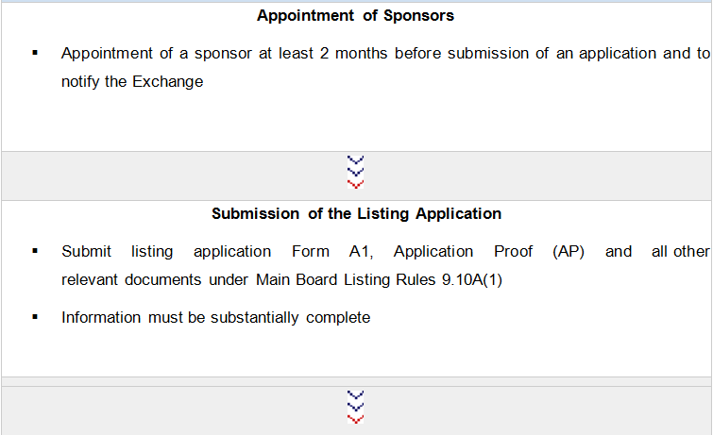
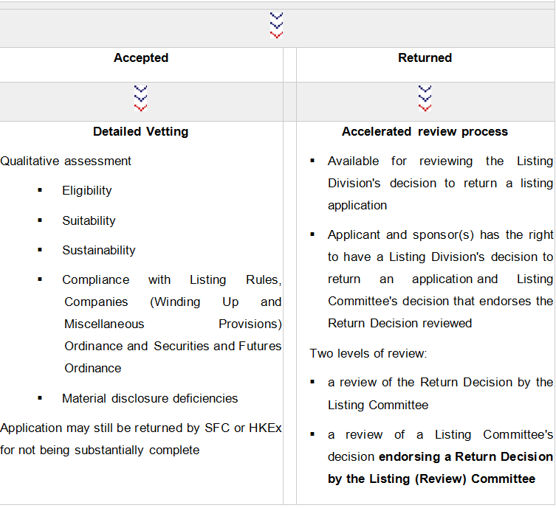

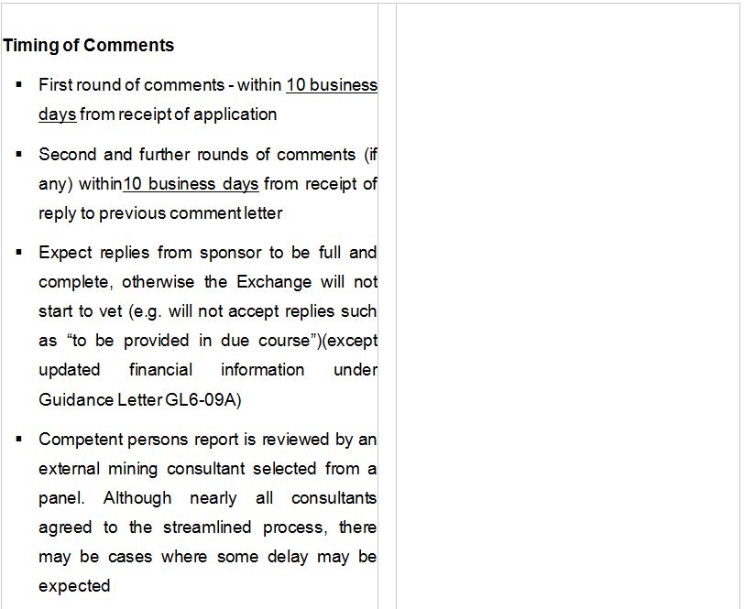
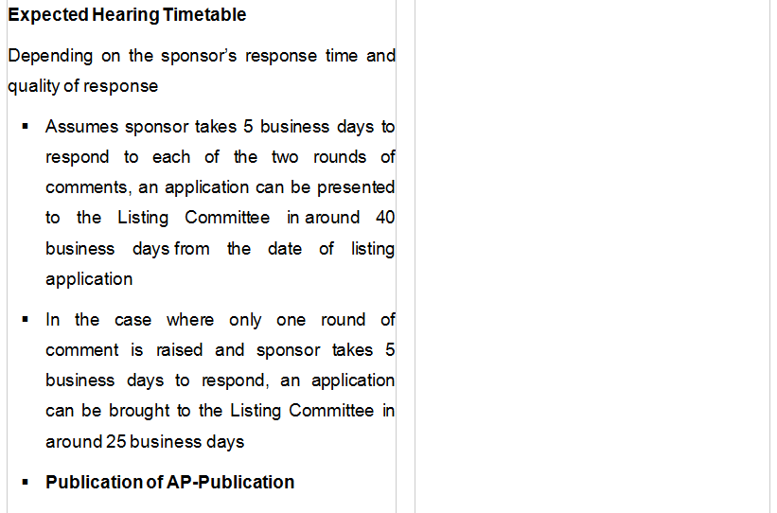

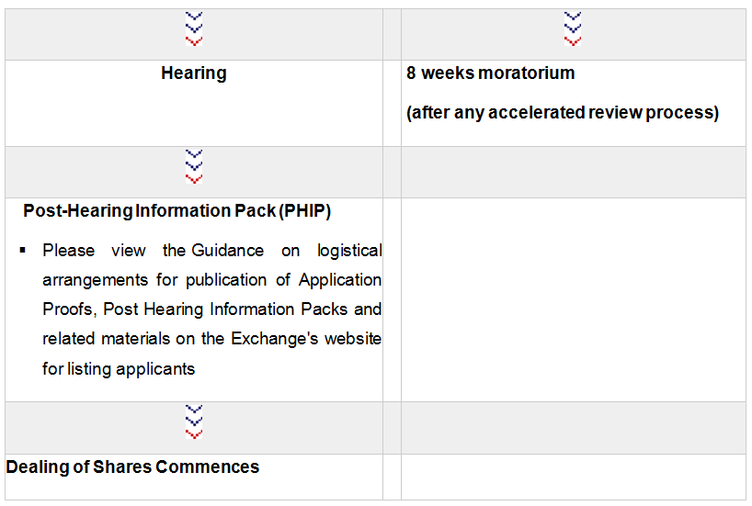

Charltons

- Charltons’ extensive experience in corporate finance makes us uniquely qualified to provide a first class legal service

- Charltons have representative offices in Shanghai, Beijing and Yangon

- Charltons was named the “Corporate Finance Law Firm of the Year in Hong Kong ” in the Corporate Intl Magazine Global Award 2014

- “Boutique Firm of the Year” was awarded to Charltons by Asian Legal Business for the years 2002, 2003, 2006, 2007, 2008, 2009, 2010, 2011, 2012, 2013, 2014, 2015 and 2016.

- “Hong Kong's Top Independent Law Firm” was awarded to Charltons in the Euromoney Legal Media Group Asia Women in Business Law Awards 2012 and 2013

- “Equity Market Deal of the Year” was awarded to Charltons in 2011 by Asian Legal Business for advising on the AIA IPO

Contact Us


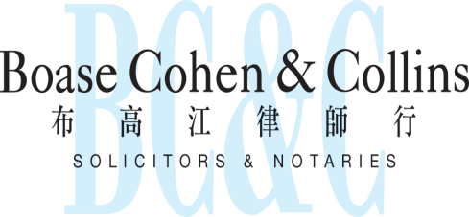

In association with:
Networked with:
Hong Kong Office

12th Floor
Dominion Centre
43 – 59 Queen’s Road East
Hong Kong

Telephone (852) 2905 7888
Fax : (852) 2854 9596
Email : enquiries@charltonslaw.com
Website : www.charltonslaw.com

Other Locations

China

Beijing Representative Office
3-1703, Vantone Centre
A6# Chaowai Avenue
Chaoyang District
Beijing
People's Republic of China
100020

Telephone: (86) 10 5907 3299
Facsimile: (86) 10 5907 3299
enquiries.beijing@charltonslaw.com

Shanghai Representative Office
Room 2006, 20th Floor
Fortune Times
1438 North Shanxi Road
Shanghai
People's Republic of China
200060

Telephone: (86) 21 6277 9899
Facsimile: (86) 21 6277 7899
enquiries.shanghai@charltonslaw.com

Myanmar

Yangon Office of Charltons Legal Consulting Ltd
161, 50th Street
Yangon
Myanmar
enquiries.myanmar@charltonslaw.com

