Hong Kong – a leading international market

- By market capitalisation, Hong Kong is the world’s 7th largest and Asia’s 3rd largest (after Japan & Shanghai) exchange
- In terms of IPO funds raised, Hong Kong ranked 3rd worldwide in 2014 (after NYSE and LSE Group) and in world’s top 5 for 13 consecutive years

Source: Data from World Federation of Exchanges (as at end of 31 December 2014). Figures for the London Stock Exchange Group include those of Borsa Italiana.

Why List in Hong Kong?
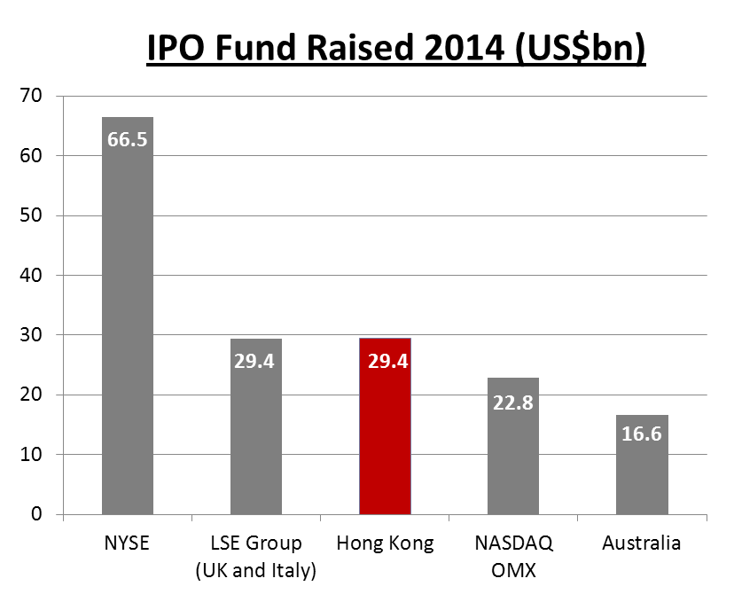
Source: World Federation of Exchange (WFE) website

- No. 1 International Financial Centre in Asia
- Access to Mainland Chinese investors currently through Qualified Domestic Institutional Investor programme
- Shanghai-Hong Kong Stock Connect launched in November 2014 allows Mainland Chinese investors to invest directly in HK listed stocks for the 1st time. Programme helps broaden investor base and add liquidity to HK market adding momentum to the market

World Top Five in IPO Funds Raised
(HK$ billion)
- Ranked top 5 globally for 13th year in a row since 2002
- Active secondary market

Source: Hong Kong Exchanges and Clearing Limited

Ten Largest IPOs on the HKEx

 | Company name | Industry | IPO funds raised (HK$bn)
1 | AIA Group Ltd. | Financials | 159.08
2 | Industrial and Commercial Bank of China Ltd. - H Shares | Financials | 124.95
3 | Agricultural Bank of China Ltd. - H Shares | Financials | 93.52
4 | Bank of China Ltd. - H Shares | Financials | 86.74
5 | Glencore plc | Resources | 77.75
6 | China Construction Bank Corporation - H Shares | Financials | 71.58
7 | China Unicom Ltd. | Telecommunications | 43.61
8 | China CITIC Bank Corporation Ltd. - H Shares | Financials | 32.92
9 | China Mobile Ltd. | Telecommunications | 32.67
10 | China Minsheng Banking Corp., Ltd. - H Shares | Financials | 31.23

Source: Hong Kong Exchanges and Clearing Limited

Ten Largest Hong Kong IPOs in 2014

 | Company name | Industry | IPO funds raised (HK$bn)
1 | Dalian Wanda Commercial Properties Co., Ltd. - H Shares | Properties & construction | 28.80
2 | CGN Power Co., Ltd. - H Shares | Utilities | 28.21
3 | HK Electric Investments and HK Electric Investments Ltd. -SS | Utilities | 24.13
4 | WH Group Ltd. | Consumer goods | 18.31
5 | BAIC Motor Corporation Ltd. - H Shares | Consumer goods | 11.03
6 | Shengjing Bank Co., Ltd. - H Shares | Financials | 10.40
7 | China CNR Corporation Ltd. - H Shares | Industrials | 10.03
8 | Harbin Bank Co., Ltd. - H Shares | Financials | 8.77
9 | Luye Pharma Group Ltd. | Healthcare | 6.81
10 | Tianhe Chemicals Group Ltd. | Materials | 5.80

Source: Hong Kong Exchanges and Clearing Limited

Gateway to Mainland China

 | Unit | Total | Mainland Enterprise | % of Total
As at 31 December 2014
No. of listed companies | Number | 1,752 | 876 | 50%
Market capitalisation | HK$bn | 25,072 | 15,078 | 60%
As of 31 December 2014
Total equity funds raised | HK$bn | 935.8 | 693.9 | 74%
- IPO funds raised | HK$bn | 227.7 | 195.1 | 86%
- Post IPO funds raised | HK$bn | 708.1 | 498.8 | 71%
Average daily equity turnover | HK$bn | 51.2 | 36.2 | 71%
Source: Hong Kong Exchanges and Clearing Limited

Strong Market Liquidity

(HK$ m)
Source: Hong Kong Exchanges and Clearing Limited

Selected International Listings

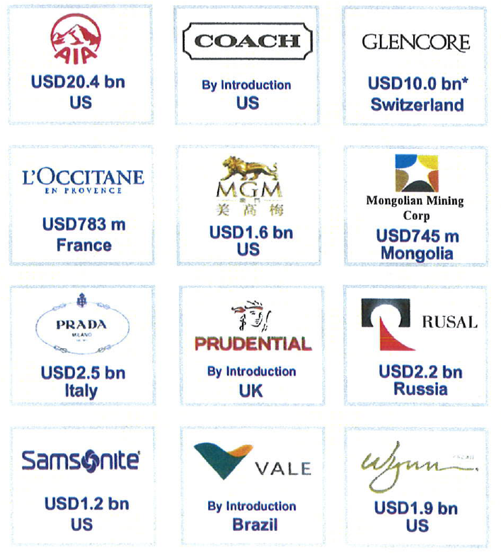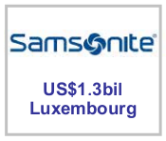
Source: Hong Kong Exchanges and Clearing Limited

Key Drivers for International Listings

- Transparent and Efficient Listing Regime
- Critical Mass of World’s Leading Brand Names
- Alignment of Issues’ Growth Drivers and Shareholders
- Asia / China Nexus
- Global Investor Base

Selected Secondary Listings on HKEx

- Manulife Financial
- SouthGobi Resources
- Vale S.A.
- Glencore International
- Kazakhmys
- CapitaMalls Asia
- Coach, Inc.

Source: Hong Kong Exchanges and Clearing Limited

Secondary Listing on HKEx

Company Name | Country of Incorporation | Listing Date on HKEx | Primary Exchange
Manulife Financial | Canada | 27 Sep 1999 | Toronto
SouthGobi Resources | Canada | 29 Jan 2010 | Toronto
Midas Holding | Singapore | 6 Oct 2010 | Singapore
Vale S.A. | Brazil | 8 Dec 2010 | Brazil
SBI Holdings | Japan | 14 Apr 2011 | Tokyo & Osaka
Glencore International | Jersey | 25 May 2011 | London
Kazakhmys | England & Wales | 29 Jun 2011 | London
CapitaMalls Asia | Singapore | 18 Oct 2011 | Singapore
Coach, Inc. | Maryland, US | 1 Dec 2011 | New York
Fast Retailing Co., Ltd. | Japan | 5 Mar 2014 | Tokyo
Source: Hong Kong Exchanges and Clearing Limited

Hong Kong’s Markets

- Main Board – caters for established companies able to meet its profit or other financial requirements.
- Growth Enterprise Markets (“GEM”) – a second board for smaller growth companies. Has lower admission criteria and provides a stepping stone to Main Board listing.

Overseas Companies: Eligibility for Listing

- Attracting more overseas companies to list in Hong Kong is one of the Exchange’s key policy initiatives.
- The Main Board and GEM Listing Rules allow the listing of companies incorporated in Hong Kong, China, Bermuda and the Cayman Islands (the “Recognised Jurisdictions”)
- Companies incorporated in other jurisdictions may list on the Exchange if they can demonstrate to the Exchange that their jurisdiction of incorporation has standards of shareholder protection which are at least equivalent to those provided in Hong Kong.
- Secondary listings are permitted on the Main Board (but not GEM) if the exchange of the applicant’s primary listing provides standards of shareholder protection equivalent to those provided in Hong Kong.

Overseas Companies: Eligibility for Listing

- In order to be eligible to list in Hong Kong, companies not incorporated in a Recognised Jurisdiction must either establish that their jurisdictions of incorporation provide comparable standards of shareholder protection to Hong Kong or amend their constitutional documents to provide the required standards of shareholder protection.
- The key shareholder protection standards required are set out in the Joint Policy Statement Regarding the Listing of Overseas Companies issued by HKEx and the SFC, which was updated on 27 September 2013 (the “Joint Policy Statement”).
- The HKEx has approved 21 jurisdictions as acceptable places of incorporation (the “Acceptable Jurisdictions”). These are Australia, Brazil, the British Virgin Islands, Canada (Alberta), Canada (British Columbia), Canada (Ontario), Cyprus, France, Germany, Guernsey, the Isle of Man, Italy, Japan, Jersey, Republic of Korea, Labuan, Luxembourg, Singapore, the United Kingdom, the States of California and Delaware in the United States.
- Guidance on meeting the required standards of shareholder protection for each Acceptable Jurisdiction is currently set out in the listing decision which approved the relevant jurisdiction. HKEx proposes to issue a Country Guide for each Acceptable Jurisdiction before the end of 2013 which will incorporate this guidance and replace the relevant listing decision. Companies incorporated in an Acceptable Jurisdiction should refer to these documents.
- If a company is not incorporated in a Recognised Jurisdiction, the Joint Policy Statement also requires that the statutory securities regulator of the overseas company’s jurisdiction of incorporation and place of central management and control (if different) must:
- be a full signatory of the IOSCO Multilateral Memorandum of Understanding Concerning Consultation and Cooperation and the Exchange of Information; or
- have entered into a bilateral agreement with the SFC to provide for mutual assistance and exchange of information for the purpose of enforcing and securing compliance with the laws and regulations of the relevant jurisdiction and Hong Kong. The HKEx may exempt certain companies from this requirement, subject to the SFC’s consent.
- Factors which the HKEx takes into account in determining an overseas company’s place of central management and control are:
- where its senior management direct, control and coordinate the company’s activities;
- where its principal books and records are kept; and
- where its business operations or assets are located.

Principal Listing Requirements

 | Main Board |  |  |  | GEM
Financial Tests | Applicants must meet one of 3 financial tests below: |  |  |  | A GEM applicant must have :  - positive cash flow from operating activities of >HK$20 million (US$2.6 million) in aggregate for the 2 preceding financial years; and  - market cap of >HK$100 million (US$13 million) at the time of listing.
Financial Tests |  | Profit Test | Market Cap/ Revenue Test | Market Cap/ Revenue / Cash flow Test
Financial Tests | Profit | Proﬁt in respect of the most recent financial year of not less than HK$20,000,000 and, in respect of the two preceding years, be in aggregate of not less than HK$30,000,000
Financial Tests | Market Cap | At least HK$200 million (US$26 million) at the time of listing | At least HK$4 billion (US$515 million) at the time of listing | HK$2 billion (US$257 million) at the time of listing
 | Revenue | – | At least HK$500 million (US$64 million) for the most recent audited financial year | At least HK$500 million (US$64 million) for the most recent audited financial year
 | Cash flow | – | – | Positive cash flow from operating activities of at least HK$100 million (US$13 million) in aggregate for the 3 preceding financial years

 | Main Board | GEM
Public Float | - At least 25% of the issuer's total issued share capital must be held by the public at all times.  - The market capitalisation at the time of listing of the publicly held shares must be at least HK$50 million (US$6.4 million) (for Main Board issuers) and HK$30 million (US$3.8 million) (for GEM issuers).  The Exchange has a discretion to accept a lower percentage of between 15% and 25% for issuers with an expected market capitalisation at the time of listing of over HK$10 billion (US$1.3 billion).
Spread of Shareholders | - There must be a minimum of 300 public shareholders at the time of listing | - There must be at least 100 public shareholders (which can include employee shareholders) at the time of listing.
Spread of Shareholders | At the time of listing, not more than 50% of the publicly held securities can be beneficially owned by the 3 largest public shareholders

Other Listing Requirements

- Accountants’ Report: A listing document must include an accountant report on the financial information for the track record period. The latest period reported on must end no more than 6 months before the date of the listing document.
- Independent non-Executive Directors: Must be at least 3: one must have appropriate professional qualifications or accounting or related financial management expertise. From 31 December 2012, INEDs must make up at least 1/3 of the Board.
- Authorised Representatives: Must be at least 2: either 2 directors or a director and the company secretary.
- Share Registrar: Issuer must employ an approved share registrar in HK to maintain register of members.
- Audit Committee: Must be made up of non-executive directors only; have 3 or more members; one must have appropriate professional qualifications or accounting or related financial management expertise; majority of members must be INEDs.
- Remuneration Committee: Majority of members (incl. Chairman) must be INEDs.
- Process Agent for Overseas Issuer: An overseas company must appoint a person authorised to accept service of process and notices on its behalf in Hong Kong.
- Compliance Adviser: Newly listed companies must appoint a Compliance Adviser for the period starting on the listing date and ending on the date of publication of results for the first full financial year commencing after listing (for MB issuers) and on the date of publication of results for the second full financial year commencing after listing (for GEM issuers).
- Compliance Officer (for GEM issuers only): GEM issuers must appoint one of their executive directors as a compliance officer.

Documents Required to be Submitted in Support of a MB Listing Application
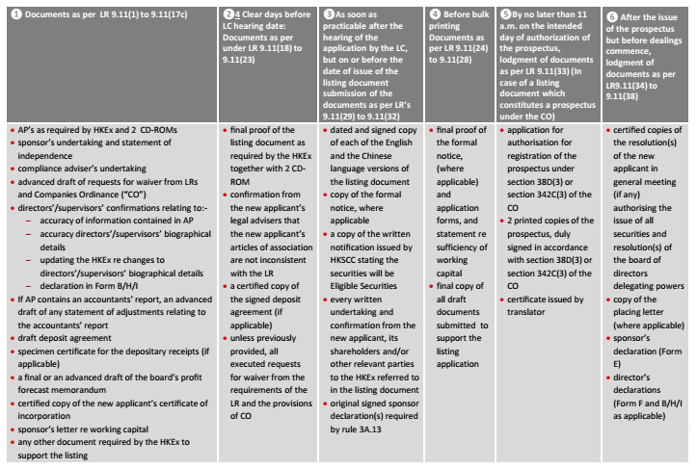

IPO timeline
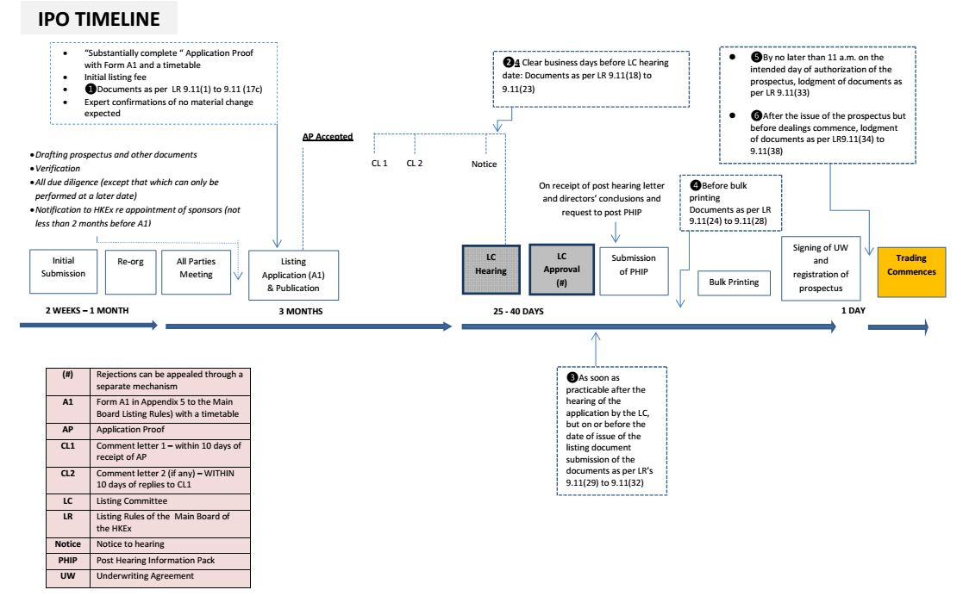

Charltons

- Charltons’ extensive experience in corporate finance makes us uniquely qualified to provide a first class legal service
- Charltons have representative offices in Shanghai, Beijing and Yangon
- Charltons was named the “Corporate Finance Law Firm of the Year in Hong Kong ” in the Corporate Intl Magazine Global Award 2014
- “Boutique Firm of the Year” was awarded to Charltons by Asian Legal Business for the years 2002, 2003, 2006, 2007, 2008, 2009, 2010, 2011, 2012, 2013, 2014 and 2015
- “Hong Kong's Top Independent Law Firm” was awarded to Charltons in the Euromoney Legal Media Group Asia Women in Business Law Awards 2012 and 2013
- “Equity Market Deal of the Year” was awarded to Charltons in 2011 by Asian Legal Business for advising on the AIA IPO
- Excellent links and networks with law firms worldwide.
- Julia Charlton was named a “Leading Lawyer” by Asia Law & Practice for the years 2002, 2003, 2006, 2007, 2008, 2009, 2010, 2011, 2012, 2013, 2014 and 2015.
- “Asian Restructuring Deal of the Year” 2000 awarded to Charltons by International Financial Law Review for their work with Guangdong Investment Limited.
- Finalist for China Law & Practice’s “Deal of the Year (M&A)” 2007 for the work on Zijin Mining Group Co Ltd.’s bid for Monterrico Metals plc.

Practice Areas

- Capital Markets
- listing on the Hong Kong, Shanghai, Shenzhen, London and Luxembourg stock exchanges
- IPOs and placings
- global offerings and GDRs
- Corporate and Commercial
- Mergers and Acquisitions
- Joint ventures
- Stock exchange advisory
- Corporate governance
- Stock options
- Employment law
- Investment Funds: China and Offshore
- unit funds and mutual funds approval/ investment companies
- authorised and unauthorised funds
- stock exchange listing (including Hong Kong, Dublin, London, Cayman, Bermuda stock exchanges)
- closed-end and open-ended structures
- hedge funds
- Securities
- Compliance and disclosure
- Dealing and advisory authorisations in Hong Kong and Mainland China
- Options
- Mergers and Acquisitions
- Hong Kong Code on Takeovers and Mergers
- Public offerings
- Reverse takeovers
- Private acquisitions
- Due diligence in China and elsewhere in Asia
- Derivatives
- Structuring listed and unlisted derivatives
- Placings on Hong Kong and Luxembourg listed warrants and other structured products
- Compliance and regulatory
- Restructuring
- Schemes of arrangement
- Workouts
- Corporate recovery
- Asset injections
- Private Equity and Venture Capital
- Optimum PRC and offshore structures
- Preferred stock financing
- PRC regulations
- Exit Strategies
- Investment
- China investment regulations
- Vietnam investment regulations
- structuring a major foreign direct investment projects
- evaluation and due diligence

Professional Experience

- Charltons has considerable experience in helping companies to list on the Main Board and the GEM Board of the Hong Kong Stock Exchange.
- Extensive experience in China

The Charltons Team

- The team is composed of individuals with the following knowledge and skills:
- A detailed knowledge of Hong Kong law and practice in relation to IPOs and equity fund raising transactions of public companies.
- Extensive experience of providing legal services for Hong Kong and PRC-related IPO transactions.
- In depth knowledge of the Listing Rules of both GEM and the Main Board of the Hong Kong Stock Exchange.
- Depth and range of experience in advising companies in connection with IPO and Listing transactions.

Team Profile: Julia Charlton

- Julia Charlton – Partner
- Julia, LL.B (1st class Honours), A.K.C (Kings College, London) was admitted as a solicitor in England & Wales in 1985 and has practised as a solicitor in Hong Kong since 1987.
- Julia is a member of the Listing Committee of the Stock Exchange of Hong Kong Limited and the Takeovers Panel and the Takeovers Appeal Panel of the SFC.
- Julia was named a “Leading Lawyer” by Asia Law & Practice for the years 2002, 2003, 2006, 2007, 2008, 2009, 2010, 2011, 2012, 2013, 2014 and 2015.
- Julia was named a “Leading Advisor” by Acquisition International for 2013.
- Julia was also named the “Capital Markets Lawyer of the Year – Hong Kong” in the Finance Monthly Global Awards 2014.
- Julia has extensive experience in China work and is a Mandarin speaker.

Recent IPO Experience

- Medicskin Holdings Limited (listed on the GEM of the SEHK in December 2014, Charltons acted as the Hong Kong legal adviser to the company)
- Orient Securities International Holdings Limited (listed on the GEM of the SEHK in January 2014, Charltons acted as the Hong Kong legal adviser to the sponsor)
- Mastercraft International Holdings Limited (listed on the GEM of the SEHK in July 2012, Charltons acted as the Hong Kong legal adviser to the sponsor)
- Branding China Group Limited (listed on the GEM of the SEHK in April 2012, Charltons acted as the Hong Kong legal adviser to the sponsor)
- AIA Group Ltd. (listed on the Main Board of the SEHK in October 2010, Charltons acted as the Hong Kong legal adviser to AIG, a shareholder)
- United Company RUSAL Plc (listed on the Main Board of the SEHK in January 2010, Charltons acted as the Hong Kong legal adviser to the controlling shareholder)
- China Titans Energy Technology Group Co., Limited (listed on the Main Board of the SEHK in May 2010, Charltons acted as the Hong Kong legal adviser to the sponsor)

Other IPO Experience

- Mingfa Group (International) Company Limited (listed on the Main Board of the SEHK in November 2009, Charltons acted as the Hong Kong legal adviser to the company)
- Greens Holdings Limited (listed on the Main Board of the SEHK in November 2009, Charltons acted as the Hong Kong legal adviser to the company)
- China All Access (Holdings) Limited,
- sponsored by Guotai Junan Capital Limited
- listed on the Main Board of the Exchange in September 2009, Charltons acted as the Hong Kong legal adviser to the sponsor
- China Tianyi Fruit Holdings Limited (listed on the Main Board of the SEHK in July 2008, Charltons acted as the Hong Kong legal adviser to the sponsor)
- China High Speed Transmission Equipment Group Co., Ltd.
- sponsored by Morgan Stanley
- listed on the Main Board of the Exchange in 2007, Charltons acted on behalf of the company
- with market capitalisation on listing of approximately HK$2,442,000,000 (US$313,600,000)
- Zhejiang Shibao Co., Ltd., (listed on the GEM in May 2006, Charltons acted as the Hong Kong legal adviser to the company)
- Fu Ji Food and Catering Services Holding Ltd. (listed on the Main Board of the SEHK in December 2004, Charltons represented the strategic investor)
- China Fire Safety Enterprise Group Holdings Ltd. (listed on the GEM of the SEHK in September 2002, Charltons represented the strategic investor)
- Shanghai Fudan-Zhangjiang Bio-Pharmaceutical Co. Ltd. (listed on GEM of the Exchange in August 2002, Charltons acted as the Hong Kong legal adviser to the sponsor)
- Tianjin TEDA Biomedical Engineering Co. Ltd. (listed on GEM of the Exchange in June 2002, Charltons acted as the Hong Kong legal adviser to the sponsor)
- Zheda Lande Scitech Ltd. (listed on GEM of the Exchange in May 2002, Charltons acted as the Hong Kong legal adviser to the company)
- TradeEasy Holdings Ltd. (listed on GEM of the Exchange in March 2002, Charltons acted as the Hong Kong legal adviser to the company) (it is now renamed as Merdeka Resources Holdings Limited)
- E. Bon Holdings Ltd. (listed on the Main Board of the Exchange in April 2000, Charltons acted as the Hong Kong legal adviser to the sponsor)
- Great Wall Technology Co. Ltd. (listed on the Main Board of the Exchange in August 1999, Charltons acted as the Hong Kong legal adviser to the company) (the then market capitalisation was valued approximately at HK$3,772,890,000)

The Regulatory Regime for IPO Sponsors

- The sponsors regulatory regime includes :
- Prospectus liabilities
- The amended Companies Ordinance clearly states that sponsors have both civil and criminal liabilities for misstatements in prospectus.
- New Paragraph 17 of the Code of Conduct for Persons Licensed by or Registered with the Securities and Futures Commission (the “Code of Conduct”)
- And higher standards applicable to IPO sponsors, emphasising the standard of due diligence and requirements in relation to the recording of the work undertaken.
- Listing Rules by the HKEx covering listing timetable, guidance materials and templates.
- Paragraph 17 of the Code of Conduct sets out the outcomes expected by the SFC, but does not address how such outcomes are to be achieved.
- In order to help sponsors and other IPO participants better understand the revised standards contained in the Code of Conduct, Charltons acted as the co-ordinating law firm in relation to the publication of the Hong Kong Sponsors Due Diligence Guidelines (“Due Diligence Guidelines”) produced jointly by leading Hong Kong law firms, two of the Big Four accounting firms and more than 40 banks or financial advisory businesses.
- In addition to drafting the Due Diligence Guidelines, Charltons is responsible for managing and leading the publication of the Due Diligence Guidelines.
- The Due Diligence Guidelines can be downloaded for free at www.duediligenceguidelines.com, a web site created and managed by Charltons.
- The Due Diligence Guidelines are 762 pages long and were completed over a year of extensive consultation.
- A number of international and PRC investment banks in Hong Kong, medium-sized local sponsors and professional institutions (e.g. CCB International (Holdings) Limited, Linklaters and KPMG) were involved in the consultation process.
- The Due Diligence Guidelines include chapters on :
- Knowing the Listing Applicant and its Management
- Verification Practice
- Business Model
- Interviews of Major Business Stakeholders
- Controlling Shareholders’ Relationship with the Listing Applicant
- Connected Persons and Connected Transactions
- Financials
- Internal Controls
- Material Contracts
- Biological Assets

Contact Us

Hong Kong Office
12th Floor
Dominion Centre
43 – 59 Queen’s Road East
Hong Kong

Tel: (852) 2905 7888
Fax: (852) 2854 9596
Email: enquiries@charltonslaw.com
Website: http://www.charltonslaw.com

China

Beijing Representative Office
3-1703, Vantone Centre
A6# Chaowai Avenue
Chaoyang District, Beijing
People's Republic of China, 100020

Tel: (86) 10 5907 3299
Fax: (86) 10 5907 3299
Email: enquiries.beijing@charltonslaw.com

Shanghai Representative Office
Room 2006, 20th Floor
Fortune Times
1438 North Shanxi Road
Shanghai, People's Republic of China, 200060

Tel: (86) 21 6277 9899
Fax: (86) 21 6277 7899
Email: enquiries.shanghai@charltonslaw.com

Myanmar

Yangon Office of Charltons Legal Consulting Ltd
161, 50th Street
Yangon, Myanmar
Email: enquiries.myanmar@charltonslaw.com

Contact us


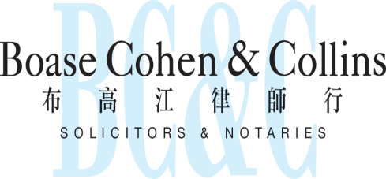

In association with:
Networked with:
Hong Kong Office
12th Floor
Dominion Centre
43 – 59 Queen’s Road East
Hong Kong

Telephone (852) 2905 7888
Fax : (852) 2854 9596
Email : enquiries@charltonslaw.com
Website : http://www.charltonslaw.com

Other locations

China

Beijing Representative Office
3-1703, Vantone Centre
A6# Chaowai Avenue
Chaoyang District
Beijing
People's Republic of China
100020

Telephone: (86) 10 5907 3299
Facsimile: (86) 10 5907 3299
enquiries.beijing@charltonslaw.com

Shanghai Representative Office
Room 2006, 20th Floor
Fortune Times
1438 North Shanxi Road
Shanghai
People's Republic of China
200060

Telephone: (86) 21 6277 9899
Facsimile: (86) 21 6277 7899
enquiries.shanghai@charltonslaw.com

Myanmar

Yangon Office of Charltons Legal Consulting Ltd
161, 50th Street
Yangon
Myanmar
enquiries.myanmar@charltonslaw.com

