Stock Exchange Rankings

By Market Capitalisation

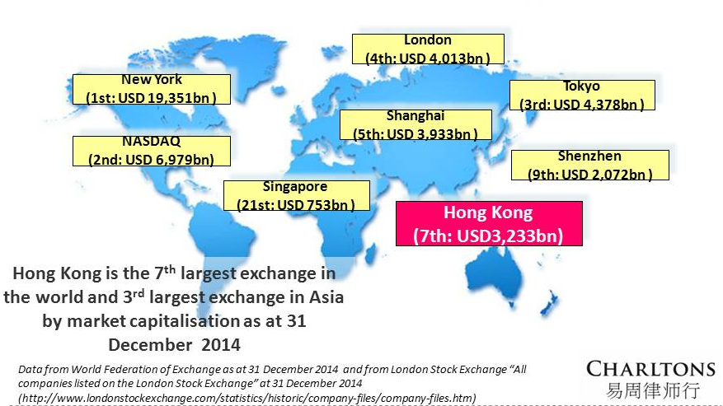

Hong Kong Stock Exchange (HKEx) is the world’s 7th largest stock exchange

3r^{d} largest in Asia after Japan and Shanghai

market capitalisation of HK$ 25,071.8 billion (US$ 3,233 billion at end 2014)

Shanghai Stock Exchange (SSE) ranked 5th

market capitalisation of US$ 3,933 billion

Shenzhen Stock Exchange (SZSE) ranked 9th

market capitalisation of US$ 2,072 billion

Source: Data from World Federation of Exchanges as at 31 December 2014

By IPO Fund Raising

Hong Kong ranked 3rd (after NYSE and LSE Group) in 2014

HKEx raised US$ 29.3 billion (up 33% on the US$ 21.8 billion raised in 2013)

Number of IPOs

Hong Kong ranked 3rd in 2014

115 new listings (excluding transfers from Growth Enterprise Market to Main Board)

Hong Kong ranked in the world’s top five IPO exchanges and as top Asian exchange for IPOs for the past 13 years

Source: Data from HKEx Market Statistics 2014 & 2013

PRC Exchanges

The China Securities and Regulatory Commission (CSRC) controls both the flow of listings and IPO pricings on SSE and SZSE

SSE and SZSE were closed for IPOs from Nov 2012 to Jan 2014

The exchanges were reopened in 2014 for 7 months¹

SSE raised US$ 5.2 billion in 39 IPOs

SZSE raised US$5.8 billion in 76 IPOs

Ernst & Young 2014 Q4 Global IPO Trends

In Q4 2014, most China IPOs rose the maximum 44% allowed on 1st day of trading

In 2010-2013, Shanghai Composite index (SCI) was among the world’s worst performing stock markets

In 2014, SCI became the world’s best performing major stock market

rose almost 53%

broke 3,000 points in early December for 1st time since 2011

The rally in equities occurred mainly in Q4 2014 due to number of factors

People’s Bank of China announced decision to cut interest rates in November 2014 for 1st time in 2 years

Government-led structural reform

Implementation of Shanghai-Hong Kong Stock Connect which opened Shanghai’s A-share market to foreign investors for the first time

Rally in Mainland-listed A shares fuelled by China’s retail investors who account for some 80% of trading

Record numbers of securities trading accounts were opened in 2014 - one week in November 2014 saw 370,000 new trading accounts opened

China’s IPO market is expected to be robust in 2015

200 new listings expected on the Mainland exchanges, raising about RMB 130 billion (US$20.9 billion) in 2015

Source: Price Waterhouse Coopers 2014 Market Review

CSRC Policies

IPO reform is key priority for CSRC

CSRC has announced plans to replace the existing application-and-approval system with a registration mechanism

Listing applicants will be required to disclose information about earnings and operations

Pricing of IPO shares will be determined by the market

If implemented, the proposed market-based IPO regime is expected to give a further boost to the A share market

SSE and SZSE do not yet allow foreign companies to list

Huge back-log of Chinese companies waiting for approval to list on SSE and SZSE

Hong Kong Stock Exchange

HKEx is international listing venue of choice for Mainland Chinese companies due to:

faster listing process

access to international capital

HKEx ended 2014 on a high note with IPO pricing improving in 4th quarter

44% of Q4 IPOs priced at upper end of indicative range (up from 35% in Q3)

Optimistic forecast for HKEx in 2015

PwC predicts HKEx will be in world’s top 3 exchanges for IPOs in 2015

120 new listings expected to raise HK$200 billion (US$25.8 billion)

Bulk of new listings to be small- and medium-sized enterprises

Retail, consumer goods and financial services expected to dominate

(Price Waterhouse Coopers 2014 Market Review)

Attractiveness of HK listing enhanced by HK deep liquidity

Facilitates post-listing fund raising by HK-listed companies

In 2014, listed companies raised HK$708 billion (US$91 billion) in follow-on offerings

Link with Mainland China

Hong Kong Stock Exchange: Chinese Company Listings

Hong Kong has long been the preferred international listing venue for Mainland Chinese companies looking for access to funds in the international capital markets

822 Chinese companies listed on the HKEx (56% of total market capitalisation)

In 2014, 4 out of the top 5 companies by IPO funds raised in Hong Kong were Mainland Chinese companies

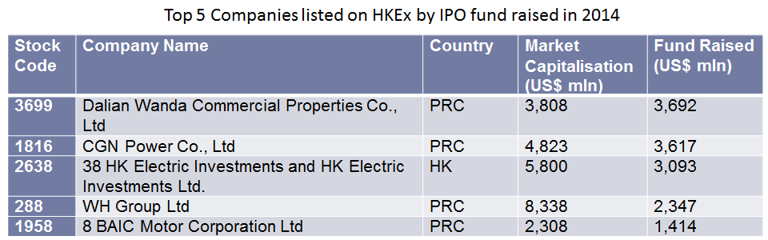

Link with Mainland China

Hong Kong Stock Exchange

HKEx = leading international stock market

Allows full access to overseas investors and provides a listing venue for overseas companies that meet its listing requirements

Offers overseas companies access to Chinese capital

HKEx positioning itself as gateway for Mainland Chinese to invest internationally

First step - Launch of Shanghai-HK Stock Connect on 17 Nov 2014

Shanghai-HK Stock Connect

Shanghai-HK Stock Connect enables:

Hong Kong and international investors to buy Shanghai-listed stocks

Northbound trading link (from HK to PRC) allows trading in constituent stocks of the SSE 180 and SSE 380 Indexes

Mainland professional investors to buy Hong Kong-listed stocks

Southbound link (from PRC to HK) permits trading in the constituent stocks of HKEx’s Hang Seng Composite LargeCap and MidCap Indexes

(“professional investor” = someone with RMB 500,000 in cash/securities)

Trading in companies with dual listings on the Shanghai and Hong Kong stock exchanges is also allowed through the link

Only secondary market trading is allowed under the programme so investors cannot yet subscribe in IPOs on either market

Northbound trading and Southbound trading are subject to separate aggregate and daily quotas

Hong Kong and international investors can trade up to RMB 13 billion (HK$16.4 billion) a day in Shanghai-listed A shares

Mainland investors can trade up to RMB 10.5 billion a day in Hong Kong stocks

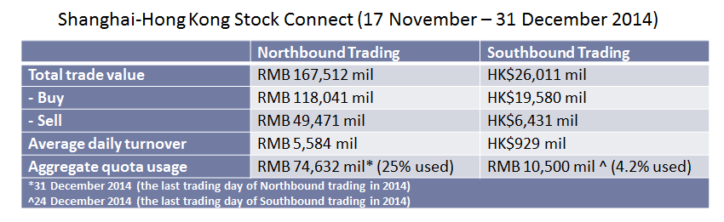

Originally expected that HKEx's lower valuations of companies dual-listed in Shanghai and HK would see Chinese investors rush to buy HK-listed Mainland companies (i.e. H shares)

However, net Northbound purchases of Shanghai-listed shares have significantly exceeded net Southbound purchases

International investors bought a net RMB 68 billion of Shanghai shares since the link’s Nov. 17 debut, out of a limit of RMB 300 billion

Mainland investors purchased a net RMB 13.1 billion of Hong Kong-listed shares out of aggregate quota of RMB 250 billion

Expected that Northbound trade will increase as more overseas funds obtain regulatory approvals to invest in A shares

Importance of Shanghai-HK Stock Connect:

It represents a major step in the opening of China’s capital markets to foreign investors

It helps further the internationalisation of the RMB

Access to Chinese capital increases the attractiveness of HKEx

The Exchange has stated that:

the programme is scalable in size, scope and market in the future

cross-border capital raising may eventually be permitted under the programme, subject to SFC and CSRC regulatory approvals

Requirement for Mainland investors to be “professional investors” is expected to be relaxed

If current restriction on shares’ eligibility for trading under Southbound link is relaxed, this will be very attractive to overseas companies

New Developments

Hong Kong and international investors will soon be allowed to conduct covered short-selling of A-shares under the Northbound link

HKEx carried out a system test for the short-selling service over the weekend of 10 and 11 January 2015, and aims to allow short selling in Q1 2015

Hong Kong Stock Exchange’s update on 6 January 2015

In March, HKEx plans to implement a new system so that institutional investors who hold A shares through custodians will no longer need to transfer their A shares to brokers the day before they want to sell in order to comply with China’s pre-trade checking requirement

Many overseas fund managers are currently prevented from trading A shares through the Northbound link as their rules prevent compliance with this requirement

The requirement is contrary to standard international practice which allows settlement within 2 days after sale which is followed in Hong Kong and other leading markets

Shenzhen-HK Stock Connect

A stock connect between Shenzhen and Hong Kong may also be implemented in the near future

SZSE announced that Shenzhen and Hong Kong will seek regulatory approvals once their plans are “mature”

A trading link with SZSE would allow foreign investors access to some of China’s most dynamic private companies in the technology and health-care industries

Mutual Recognition of Funds Scheme

A scheme providing for the mutual recognition of funds authorised in Hong Kong and the Mainland is in its final stages

The MRF scheme is expected to allow Hong Kong-domiciled funds authorised by the SFC to be sold in the Mainland, while Mainland funds authorised by the CSRC will be allowed to be sold in Hong Kong

First scheme providing for mutual recognition of funds between the Mainland and a foreign market

Consistent with the goals of developing Hong Kong as an offshore RMB centre and an international asset management centre set out in China's 12th Five-Year Plan

Speech given by Alexa Lam, deputy chief executive officer of Hong Kong's Securities and Futures Commission (SFC), at a conference in October 2014

Weighted Voting Rights

Issue - whether listings should continue to be restricted to companies with “one share one vote” (OSOV) structure, a rule in place since 1989

Top IPO exchange in 2014 was NYSE, for the 3rd year in a row

raised US$66.4 billion

driven by the world’s largest IPO ever, of Chinese internet company, Alibaba Group, which raised US$25 billion in September 2014

Alibaba’s first choice listing venue was Hong Kong, but Alibaba’s governance structure would have contravened the Exchange’s OSOV principle

a group of Alibaba’s founders and senior management members are given the exclusive right to nominate a simple majority of its board members despite a single class of ordinary shares with OSOV

Concept Paper

HKEx published a Weighted Voting Rights Concept Paper for consultation in August 2014

whether Hong Kong should change its Listing Rules to accommodate companies with dual share and other weighted voting rights structures

Arguments

+ve:

Allow Hong Kong to recover its competitive position as the international fund raising market of choice for Mainland Chinese companies, given the recent popularity of the NYSE and NASDAQ for listing Chinese tech stocks

WVR structures are particularly common among tech companies. The OSOV principle effectively prevents Hong Kong listing of many Chinese tech companies (e.g. Alibaba, Baidu, JD.com Inc. and Weibo Corp) which list in the US where WVR structures are not an obstacle to listing

-ve:

Investor protection concerns (allayed to a degree by Hong Kong's already comprehensive regulation of connected and related party transactions and the provisions of the Takeovers Code requiring equal treatment of shareholders in takeover situations)

Consultation period ended in November 2014 and conclusions are expected soon

Key attractions for overseas companies

Key advantages of Hong Kong as a listing venue

established legal system based on English common law

regulatory framework on a par with other international finance centres

tax advantages, currency convertibility, free transferability of securities and no restrictions on capital flow

abundancy of international investment banks, law firms and accountancy firms facilitates company listings

opportunity to raise corporate profile and visibility in China and the rest of the Asia-Pacific

1,752 companies were listed on HKEx at the end of December 2014

1,548 were listed on the Exchange’s Main Board

A key attraction of the Hong Kong market is the depth of liquidity in both its primary and secondary markets

122 new listings on HKEx (including transfers from the Main Board to GEM) raised US$29.3 billion in 2014 (an increase of 35% compared to 2013)

Hong Kong is a popular listing venue for luxury goods sector companies (e.g. Coach, L’Occitane and Samsonite) looking to raise profile in Asia

In 2011, Prada raised US$ 2.14 billion by listing 20% of its share capital on HKEx

China’s position as a major consumer of energy, minerals and metals has also attracted a number of mining and natural resource companies to list in Hong Kong

Energy companies listed in Hong Kong include: Swiss commodities giant Glencore International AG, Russia-based United Company Rusal PLC, Kazakhstan copper miner Kazakhmys PLC and Brazilian metals and mining company Vale S.A.

Vale S.A was also the first company to list on the Exchange in the form of depositary receipts (HDRs).

HKEx’s Listing Rules allow overseas companies to list on its Main Board (but not on GEM) in the form of HDRs rather than ordinary shares

Purpose is to allow the Hong Kong listing of companies from jurisdictions which restrict the movement of shares abroad or prohibit an overseas share register or splitting of the share register

Eligibility of Overseas Listing Applicants

The Listing Rules provide for the listing of companies incorporated in Hong Kong, the PRC, the Cayman Islands and Bermuda (“Recognised Jurisdictions”)

HKEx has also accepted companies from 21 other jurisdictions (“Acceptable Jurisdictions”) for listing and the list is expected to expand in the future

List of Acceptable Jurisdictions:

Australia, Brazil, the British Virgin Islands, Canada (Alberta), Canada (British Columbia), Canada (Ontario), Cyprus, France, Germany, Guernsey, the Isle of Man, Italy, Japan, Jersey, the Republic of Korea, Labuan, Luxembourg, Singapore, the United Kingdom and the states of California and Delaware in the United States of America

The HKEx Markets

The HKEx has 2 markets:

the Main Board

caters for established companies seeking to raise funds for growth

financial thresholds:

HK$20 million profit in the most recent financial year, aggregate profits of HK$30 million in the 2 financial years before that and market capitalisation of HK$200 million at the time of listing; or

Revenue of HK$500 million for the most recent audited financial year and market capitalisation of HK$4 billion at the time of listing; or

Revenue of HK$500 million for the most recent audited financial year, positive cashflow from operating activities of HK$100 million in aggregate for the 3 preceding financial years and market capitalisation of HK$2 billion at the time of listing

the Growth Enterprise Market (GEM)

caters for smaller growth companies

lower entry requirements:

positive cashflow generated from operating activities in the ordinary and usual course of business of at least HK$20 million in aggregate for the 2 financial years immediately preceding listing; and

market capitalisation of at least HK$100 million at listing

Secondary Listing in Hong Kong

Joint Policy Statement Regarding the Listing of Overseas Companies (JpS) sets out HKEx’s policy requirements for accepting overseas listing applicants

Published by HKEx and the SFC

Updated in September 2013 to clarify and streamline the listing process

Key requirements:

the standards of shareholder protection available to shareholders of the overseas listing applicant must be equivalent to HK shareholder protection standards; and

must be regulatory co-operation arrangements in place between the statutory securities regulator(s) in the applicant’s jurisdiction of incorporation and its place of central management and control (if different) and the SFC

JpS sets out “automatic” waivers for secondary listing applicants from many Listing Rules and corporate governance requirements

Charltons

Charltons’ extensive experience in corporate finance makes us uniquely qualified to provide a first class legal service

Charltons have representative offices in Shanghai, Beijing and Yangon

Charltons was named the “Corporate Finance Law Firm of the Year in Hong Kong ” in the Corporate Intl Magazine Global Award 2014

“Boutique Firm of the Year” was awarded to Charltons by Asian Legal Business for the years 2002, 2003, 2006, 2007, 2008, 2009, 2010, 2011, 2012, 2013, 2014 and 2015

“Hong Kong's Top Independent Law Firm” was awarded to Charltons in the Euromoney Legal Media Group Asia Women in Business Law Awards 2012 and 2013

“Equity Market Deal of the Year” was awarded to Charltons in 2011 by Asian Legal Business for advising on the AIA IPO

Disclaimers

The information contained herein has not been independently verified by Charltons.

Charltons does not accept responsibility or liability for any loss or damage suffered or incurred by you or any other person or entity however caused (including, without limitation, negligence) relating in any way to this presentation including, without limitation, the information contained in or provided in connection with it, any errors or omissions from it however caused (including without limitation, where caused by third parties), lack of accuracy, completeness, currency or reliability or you, or any other person or entity, placing any reliance on this presentation, its accuracy, completeness, currency or reliability. Charltons does not accept any responsibility for any matters arising out of this presentation.

As a Hong Kong legal adviser, Charltons is only qualified to advise on Hong Kong law and we express no views as to the laws of any other jurisdictions.

Contact us


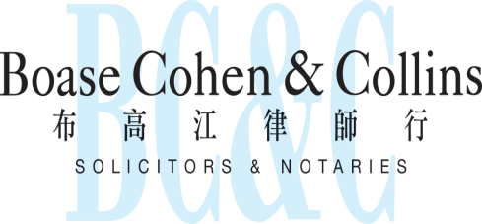

In association with:
Networked with:
Hong Kong Office
12th Floor
Dominion Centre
43 – 59 Queen’s Road East
Hong Kong

Telephone (852) 2905 7888
Fax : (852) 2854 9596
Email : enquiries@charltonslaw.com
Website : http://www.charltonslaw.com

Other locations

China

Beijing Representative Office
3-1703, Vantone Centre
A6# Chaowai Avenue
Chaoyang District
Beijing
People's Republic of China
100020

Telephone: (86) 10 5907 3299
Facsimile: (86) 10 5907 3299
enquiries.beijing@charltonslaw.com

Shanghai Representative Office
Room 2006, 20th Floor
Fortune Times
1438 North Shanxi Road
Shanghai
People's Republic of China
200060

Telephone: (86) 21 6277 9899
Facsimile: (86) 21 6277 7899
enquiries.shanghai@charltonslaw.com

Myanmar

Yangon Office of Charltons Legal Consulting Ltd
161, 50th Street
Yangon
Myanmar
enquiries.myanmar@charltonslaw.com

comments made by Premier Li Keqiang on 4 January 2015

