Initial Public Offering (IPO)

Listing on the Stock Exchange of Hong Kong Limited
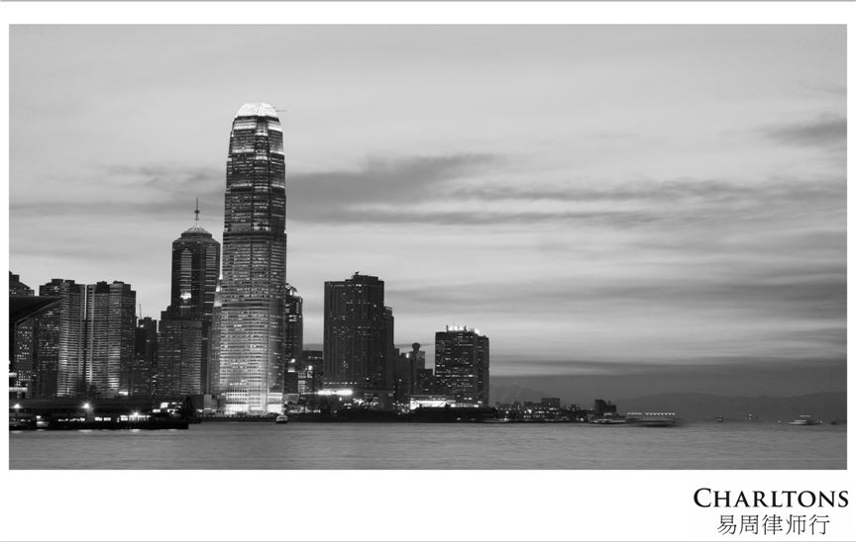

www.charltonslaw.com

Hong Kong: A Leading International Stock Market
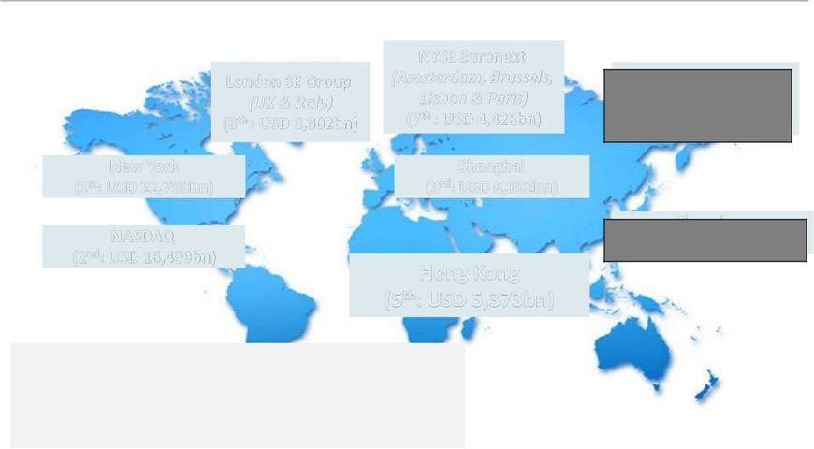

 |  |  |  |  |  | NYSE Euronext
 | London SE Group |  |  |  | (Amsterdam, Brussels,
 |  | (UK & Italy) |  |  |  | Lisbon & Paris)
 | (8th : USD 3,302bn) |  |  |  |  | (7th : USD 4,428bn)
New York |  |  |  |  |  | Shanghai
(1st: USD 22,799bn) |  |  |  |  |  | (3rd: USD 6,092bn)
NASDAQ
(2nd: USD 16,439bn)
 |  |  |  |  |  | Hong Kong
 |  |  |  |  | (5th: USD 5,373bn)

By market capitalisation, Hong Kong is the world’s 5th largest and Asia’s 3rd largest exchange (after Shanghai and Japan) as at the end of September 2020.

Japan Exchange Group

(Tokyo & Osaka)
(4th: USD 6,075bn)

Shenzhen
(6th: USD 4,535bn)

Source: SFC based on data from the World Federation of Exchanges and Bloomberg. Figures for Hong Kong includes the GEM board; figures for the London SE Group include those of London Stock Exchange and Borsa Italiana; figures for the NYSE Euronext include those of Euronext Amsterdam, Euronext Brussels, Euronext Lisbon and Euronext Paris; and figures for the Japan Exchange Group includes those of Tokyo Stock Exchange and Osaka Securities Exchange.

1

HKEx: Top IPO Funds Raising Platform
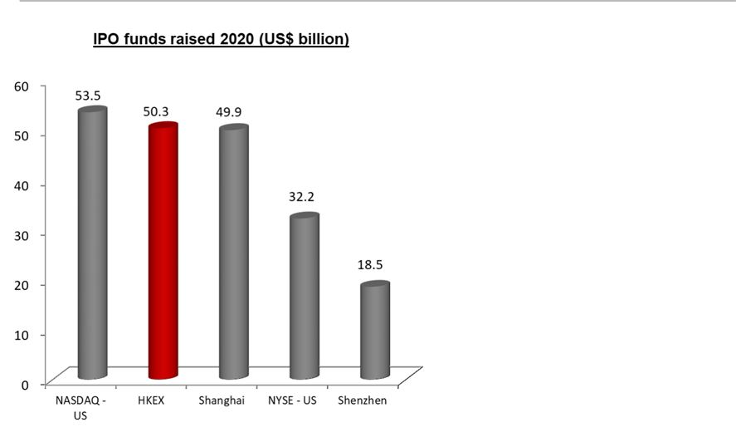

- The Stock Exchange of Hong Kong (SEHK or the HKEx or the Exchange) was the second largest IPO market in 2020 in terms of funds raised.

- A total of US$50.3 billion IPO funds was raised in Hong Kong in 2020.

- There were 154 new listings in 2020:

- Main Board – 146 o GEM – 8

Source: Hong Kong Exchanges and Clearing Limited and KPMG
2

Ten Largest Hong Kong IPOs in 2020


 |  |  | IPO funds raised
 | Company name | Industry | (HK$bn)
1 | JD.com | TMT | 34.6
2 | JD Health International Inc. | Healthcare / Life Sciences | 31.0
3 | NetEase, Inc. | TMT | 24.3
4 | Yum China Holdings Inc. | Consumer Markets | 17.3
5 | China Bohai Bank Co., Ltd. | Financial Services | 15.9
6 | GDS Holdings Limited | TMT | 14.9
7 | Evergrande Property Services Group Limited | Industrial | 14.3
8 | Hangzhou Tigermed Consulting Co., Ltd. | Healthcare / Life Sciences | 12.3
9 | China Resources Mixc Lifestyle Services Limited | Consumer Markets | 12.3
10 | New Oriental Education & Technology Group Inc. | Education | 11.6

Source: Hong Kong Exchanges and Clearing Limited and KPMG

3

Ten Largest IPOs on the HKEx


 |  |  | IPO funds raised
 | Company name | Industry | (HK$bn)
1 | AIA Group Ltd. | Financials – Insurance | 159.08
2 | Industrial and Commercial Bank of China Ltd. – H Shares | Financials – Banks | 124.95
3 | Alibaba Group Holding Ltd. - SW | Information Technology - Software & | 101.20
 |  | Services
4 | Agricultural Bank of China Ltd. – H Shares | Financials – Banks | 93.52
5 | Bank of China Ltd. – H Shares | Financials – Banks | 86.74
6 | China Construction Bank Corporation – H Shares | Financials – Banks | 71.58
7 | Postal Savings Bank of China Co Ltd – H Shares | Financials – Banks | 59.15
8 | China Tower Corporation Ltd – H Shares | Telecommunications – Satellite & | 58.80
 |  | Wireless Communication
9 | Budweiser Brewing Co. APAC Ltd. | Consumer Staples - Food & Beverages | 45.08
10 | China Unicom (Hong Kong) Ltd. | Telecommunications – | 43.61
 |  | Telecommunication Services

Source: Hong Kong Exchanges and Clearing Limited

4

HKEx Attracts a Diverse Portfolio of Issuers
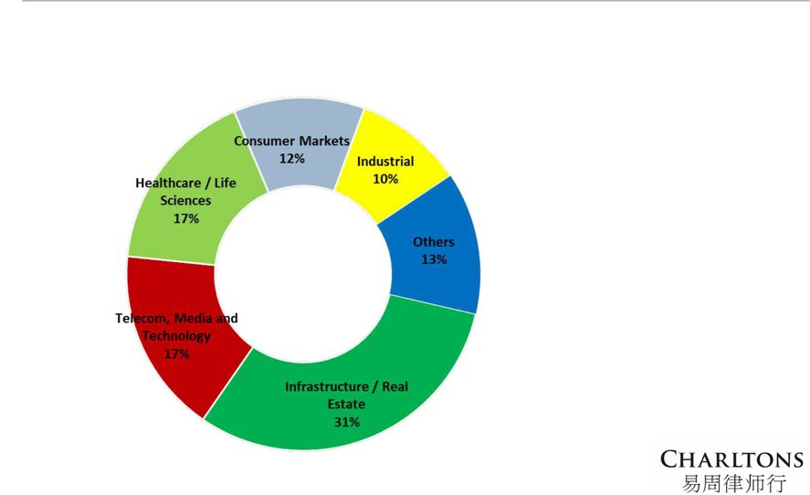

Number of Main Board IPOs by Sector (2020)





Issuers from the
Infrastructure / Real Estate sector dominate the new listing markets in 2020.

Over one-quarter of the new Main Board issuers were from the Infrastructure / Real Estate sector.

Source: KPMG

5

HKEx: A Strong Equity Fund Raising Platform

Total Equity Funds Raised in 2020 (up to 30 Nov) (HK$ bn)

 A strong equity fund raising platform:
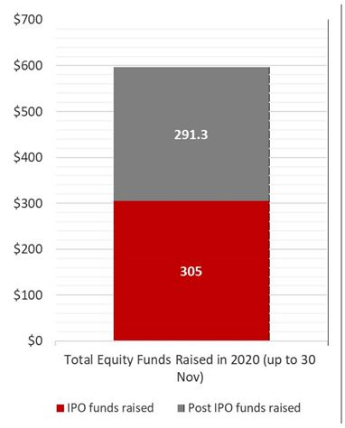

o A total of HK$596.3 billion in equity funds was raised in 2020 as at 30 November 2020.

 Remains a top IPO fundraising platform:

o A total amount of HK$305 billion was raised in 2020 as at 30 November 2020.

 A strong secondary capital raising market:

o A total of HK$291.3 billion was raised from post-IPO fundraising activities in 2020 as at 30 November 2020.

Source: Hong Kong Exchanges and Clearing Limited

6

HKEx: A Highly Active Stock Exchange

Average Daily Equity Turnover (HK$ m)


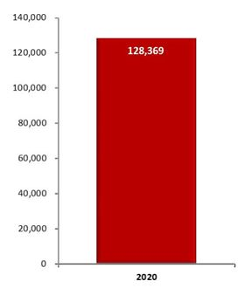

o

o

o

High-level market liquidity:

HKEx is a highly active stock exchange with a total equity turnover of HK$29,011.5 billion in 2020 as at 30 November 2020.

The average daily equity turnover was HK$128,369 million.

Deep liquidity is partly driven by a diverse investor base.
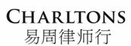

Source: Hong Kong Exchanges and Clearing Limited

7

HKEx: Diverse Investor Base

Distribution of Cash Market Trading Value by Origin (2016)
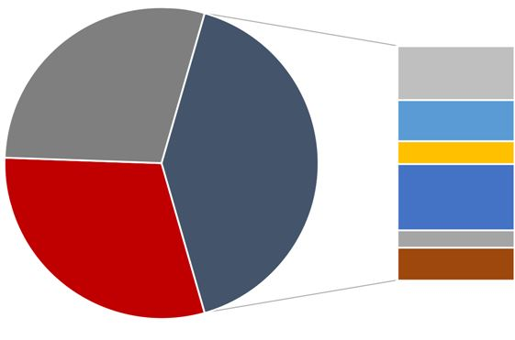

Exchange Participant (EP)
principal trading
28.9% | Overseas investors
Local investors | (retail + institutional)
Local investors | 41.1%
(retail + institutional)
30.0%

^ others includes investors from Australia, Japan, Taiwan and the rest of the world

Source: Hong Kong Exchanges and Clearing Limited, HKEx Cash Market Transaction Survey 2016

US – 8.1%

UK – 9.3%

Europe (excluding UK) –

5.4%

Mainland China – 8.7%

Singapore – 3.3%

Others^ – 5.4%

8

HKEx: Primary Financing Platform for Mainland Enterprises


 |  |  |  |  | Mainland | % of
 |  |  | Unit | Total | Enterprise^ | Total
 | As at 30 November 2020
 | No. of listed companies |  | No. | 2,528 | 1,308 | 51.7%
 | Market capitalisation |  | HK$bn | 45,739.8 | 36,589.3 | 80.0%
 | As at 30 November 2020
 | Total equity funds raised |  | HK$bn | 596.3 | 510.1 | 79.0%
 | - IPO funds raised |  | HK$bn | 305.0 | 300.6 | 98.6 %
 | - Post IPO funds raised |  | HK$bn | 291.3 | 209.5 | 71.9%

- Given its diverse investor base, HKEx has been the primary financing platform for Chinese enterprises that seek to go international.

- Chinese companies account for over 50% of Hong Kong’s listed market in terms of number of listed companies and over 80% in terms of market capitalisation.

^ refers to H-share companies, red chip companies and Mainland private enterprises

Source: Hong Kong Exchanges and Clearing Limited
9

Hong Kong: a Bridge between China and the World

Advantages to List International Companies in Hong Kong

Access to Mainland Chinese investors, currently through:

- Qualified Domestic Institutional Investor (QDII) scheme: allowing Chinese institutional investors to invest in offshore capital markets

- China-Hong Kong Stock Connect: Shanghai-Hong Kong Stock Connect and Shenzhen-Hong Kong Stock Connect were launched in November 2014 and October 2016 respectively, allowing Mainland Chinese investors to invest directly in Hong Kong listed stocks. The stock connect schemes facilitate the broadening of Hong Kong’s investor base and add liquidity to the Hong Kong market adding momentum to the market

Raise company’s reputation and brand awareness in China and other Asian markets

- Strong and sound legal and regulatory framework: Hong Kong’s legal system is based on English common law, providing a solid foundation for companies to raise funds and confidence to investors.

- World’s freest economy: adopting a free market policy with no capital flow restrictions , Hong Kong ranked first from 1995 to 2019 in relation to the Index of Economic

Freedom.

Source: Heritage Foundation/Wall Street Journal, Hong Kong Exchanges and Clearing Limited

10

Selected International Listings in Hong Kong

Sisram Medical |  | Samsonite
 |  |  |  | Kazakhmys |  | Prada
USD 112 m |  | USD 1.25 bn |  | introduction |  | USD 2.1 bn

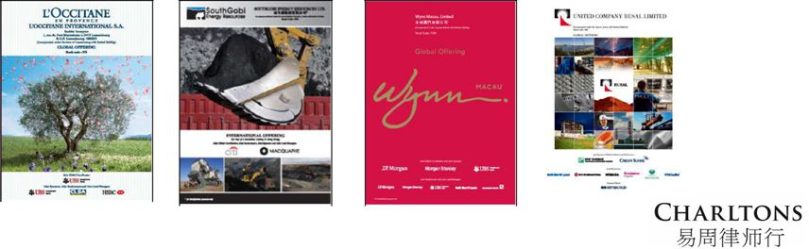
L’OCCITANE |  |  |  |  | Rusal
L’OCCITANE |  | South Gobi |  | Wynn | Rusal
L’OCCITANE |  | South Gobi |  | Wynn | USD 2.2 bn
USD 783m |  | USD 439m |  | USD 1.9 bn | USD 2.2 bn

Source: Hong Kong Exchanges and Clearing Limited ₁₁

HK IPO Market – 2020

Despite the COVID-19 pandemic impacting global IPO markets, Hong Kong’s IPO market performed well in 2020, with the Hong Kong Stock Exchange taking second place in terms of IPO funds raised (US$50.3 billion – an increase of 24.5% compared to 2019). This is largely attributable to a number of secondary listings by overseas-listed Chinese companies, such as JD.com, NetEase and Yum China.

There is an increasing number of US-listed Chinese-based companies returning for secondary listings in Hong Kong. During 2020, nine US-listed Chinese-based companies have completed secondary listings, raising a total of HKD 131.3 billion, representing approximately 34 percent of funds raised.

In terms of sectors, infrastructure and real estate continue to dominate the market, accounting for 31% of all IPOs, followed by TMT and healthcare/life sciences (both accounting for 17% of all IPOs and ranking co-first in terms of funds raised).

Notable IPOs in 2020 included the HK$ 34.6 billion IPO of JD.com, a Chinese supply chain-based technology and service provider, the HK$ 31.0 billion IPO of JD Health International Inc., one of the largest online healthcare platform in China, the HK$24.3 billion IPO of NetEase, Inc., a Chinese mobile game and e-commerce company, and the HK$17.3 billion IPO of Yum China Holdings, Inc, one of the largest restaurant company in China.

Source: KPMG, Deloitte and EY publications
12

HK IPO Market – Outlook

- Market sentiment for 2021 is likely to be driven a number of uncertainties including COVID-19 and Sino-US relations, however Hong Kong is expected to retain its position as one of the top exchanges globally in terms of IPO proceeds.

- This is in view of the increasing numbers of overseas-listed Chinese companies looking to Hong Kong for secondary listings, a trend which is most notable among US-listed Chinese tech companies owing to geopolitical tensions and post-IPO performances.

- The healthcare/life sciences industry is expected to remain one of the major contributors to the Hong Kong IPO market with the pandemic having created the need for robust healthcare services and capital investments.

- Hong Kong also has the potential to be bolstered by a number of factors including:

  - the expected increase in Chinese “take-private” deals and possible subsequent relisting in Hong Kong or Shanghai

  - HKEx’s Consultation Paper on Corporate WVR Beneficiaries, which would allow corporates to benefit from WVR

  - the launch of the wealth management connect scheme in the Greater Bay Area

Source: KPMG, Deloitte and EY publications

13







Hong Kong’s Markets

Main Board – caters for established companies able to meet its profit or other financial requirements.

GEM – a second standalone market for small and mid-sized companies, and has lower admission criteria than Main Board listings.

The post-listing obligations of GEM and Main Board companies are broadly similar. Key difference – quarterly reporting is mandatory for GEM companies but only recommended for Main Board companies

14

Accepted Jurisdictions





The Main Board and GEM Listing Rules allow the listing of companies incorporated in Hong Kong, China, Bermuda and the Cayman Islands

The Exchange has accepted 28 jurisdictions as acceptable jurisdictions of incorporation –

- Austria, Australia, Brazil, the British Virgin Islands, Canada (Alberta, British Columbia and Ontario), Cyprus, England & Wales, France, Germany, Guernsey, India, Ireland, Israel, the Isle of Man, Italy, Japan, Jersey, Republic of Korea, Labuan, Luxembourg, Netherlands, Russia, Singapore, the United States (State of California, State of Delaware and State of Nevada).

15

Principal Listing Requirements


 | Main Board | GEM
Operating | A Main Board applicant must have a trading record of not | A GEM applicant must have a trading
History and | less than 3 financial years with: | record of at least 2 full financial years
Management | i.management continuity for at least the 3 preceding | with:
 | i.management continuity for at least the 3 preceding | a.substantially the same management
 | financial years; and | a.substantially the same management
 | ii.ownership continuity and control for at least the most | for the 2 preceding financial years;
 | ii.ownership continuity and control for at least the most | and
 | recent audited financial year. | and
 | recent audited financial year. | b.continuity of ownership and control
 | Exception: | b.continuity of ownership and control
 | Exception: | for the preceding full financial year.
 | Under the market capitalization/revenue test, the
 | Exchange may accept a shorter trading record period under
 | substantially the same management if the new applicant
 | can demonstrate that:
 | a.its directors and management have sufficient and
 | satisfactory experience of at least 3 years in the line of
 | business and industry of the new applicant; and
 | b.management continuity for the most recent audited
 | financial year.

16

Principal Listing Requirements (Cont’d)


 |  |  |  |  |  | Main Board |  |  |  |  | GEM
Financial | Applicants must meet one of 3 financial tests below: |  |  |  |  |  |  |  | A GEM applicant must
Tests |  |  |  |  |  |  |  |  | have :
Tests |  | 1. | Profit Test |  |  | 2. Market Cap/ | 3. Market Cap/ |  | have :
 |  |  |  |  |  | Revenue Test | Revenue / Cash |  | a.positive cash flow from
 |  |  |  |  |  |  | flow Test
 |  |  |  |  |  |  | flow Test |  | operating |  | activities of |  | at
 | Profit | Profit in respect of |  |  |  |  |  |  |  |  |  |  | at
 | Profit |  |  |  |  |  |  |  | least | HK$30 |  | million
 |  | the | most | recent |  |  |  |  | (US$3.8 |  | million) |  | in
 |  | financial year of not |  |  |  |  |  |  | aggregate |  | for | the | 2
 |  | less |  | than |  |  |  |  | preceding financial years;
 |  | HK$20,000,000 and, |  |  |  |  |  |  | and
 |  | in | respect | of | the
 |  | two preceding years, |  |  |  |  |  |  | b.market cap of at least
 |  | be | in aggregate |  | of |  |  |  | HK$150 million (US$19
 |  | not | less | than |  |  |  |  | million) at the time of
 |  | HK$30,000,000 |  |  |  |  |  |  | listing.
 | Market | At | least | HK$500 |  | At least HK$4 billion | HK$2 | billion
 | Cap | million |  | (US$64 |  | (US$515 million) at | (US$257 million) at
 |  | million) at the time |  |  |  | the time of listing | the time of listing
 |  | of listing

17

Principal Listing Requirements (Cont’d)


 |  |  |  | Main Board |  |  |  |  |  | GEM
Financial | Applicants must meet one of 3 financial tests below: |  |  |  |  |  |  | A GEM applicant must
Tests |  | 1. | Profit Test | 2. Market Cap/ |  | 3. Market Cap/ |  | have :
 |  |  |  | Revenue Test |  | Revenue / Cash |  | a.positive cash flow from
 |  |  |  |  |  | flow Test
 |  |  |  |  |  |  |  | operating |  | activities of |  | at
 | Revenue |  | – | At least HK$500 |  | At least | HK$500 |  |  |  |  | at
 | Revenue |  |  |  |  |  |  | least | HK$30 |  | million
 |  |  |  | million | (US$64 | million | (US$64 | (US$3.8 |  | million) |  | in
 |  |  |  | million) for the most |  | million) for the most |  | (US$3.8 |  |  |  | in
 |  |  |  |  |  |  |  | aggregate |  | for | the | 2
 |  |  |  | recent | audited | recent | audited
 |  |  |  |  |  |  |  | preceding financial years;
 |  |  |  | financial year |  | financial year
 |  |  |  |  |  |  |  | and
 |  |  |  |  |  |  |  | b.market cap of at least
 | Cash |  | – | – |  | Positive cash flow
 |  |  | – | – |  |  |  | HK$150 | million (US$19
 | flow |  |  |  |  | from | operating | HK$150
 |  |  |  |  |  | from | operating | million) | at the time of
 |  |  |  |  |  | activities of at least |  | million)
 |  |  |  |  |  |  |  | listing.
 |  |  |  |  |  | HK$100 | million | listing.
 |  |  |  |  |  | (US$13 million) in
 |  |  |  |  |  | aggregate for the 3
 |  |  |  |  |  | preceding | financial
 |  |  |  |  |  | years



18

Principal Listing Requirements (Cont’d)


 | Main Board | GEM
Public Float |  At least 25% of the issuer's total issued share capital must be held by the public at all times.
 |  The market capitalisation at the time of listing of the publicly held shares must be at least
 | HK$125 million (US$16 million) (for Main Board issuers) and HK$45 million (US$5.8 million) (for
 | GEM issuers).
 |  The Exchange has a discretion to accept a lower percentage of between 15% and 25% for
 | issuers with an expected market capitalisation at the time of listing of over HK$10 billion
 | (US$1.3 billion).
Spread of |  There must be a minimum of 300 public    | There must be at least 100 public
Shareholders | shareholders at the time of listing | shareholders (which can include employee
 |  | shareholders) at the time of listing.
 |  At the time of listing, not more than 50% of the publicly held securities can be beneficially
 | owned by the 3 largest public shareholders

19

Other Listing Requirements

- Accountants’ Report: A listing document must include an accountants’ report on the financial information for the track record period. The latest period reported on must end no more than 6 months before the date of the listing document.

- Independent non-Executive Directors: INEDs must make up at least 1/3 of the Board. The minimum number of INEDs is three, and one must have appropriate professional qualifications or accounting or related financial management expertise.

- Authorised Representatives: Issuers must appoint two authorised representatives – either 2 directors or a director and the company secretary.

- Share Registrar: Issuers must employ an approved share registrar in Hong Kong to maintain register of members.

- Audit Committee: Issuers must establish an audit committee made up of non-executive directors only. It must have a minimum of three members, at least one of whom must be an INED with appropriate professional qualifications or accounting or related financial management expertise. The majority of members must be INEDs, and it must be chaired by an INED.

- Remuneration Committee: Issuers must establish a remuneration committee chaired by an INED and comprising a majority of INEDs.

- Process Agent for Overseas Issuer: An overseas company must appoint a person authorised to accept service of process and notices on its behalf in Hong Kong.

- Compliance Adviser: Newly listed companies must appoint a compliance adviser for the period starting on the listing date and ending on the date of publication of results for the first full financial year commencing after listing (for MB issuers) and on the date of publication of results for the second full financial year commencing after listing (for GEM issuers).

- Compliance Officer (for GEM issuers only): GEM issuers must appoint one of their executive directors as a compliance officer.

20

The Regulatory Regime for IPO Sponsors

- A company seeking listing on the Exchange must appoint one or more sponsors to assist with its listing application.

o

o

Only corporate finance advisers licensed by the SFC to conduct sponsor work are permitted to act as sponsors.

At least one sponsor must be independent of the company.

- The sponsor acts as the primary channel of communication between the listing applicant and the Exchange, and is responsible for ensuring that the sponsor’s obligations under the Listing Rules are discharged.

21

The Regulatory Regime for IPO Sponsors

- A sponsor’s main responsibilities to a new applicant are:

o

o

o

o

o

o

o

to be closely involved in the preparation of the applicant’s listing documents

to conduct reasonable due diligence inquiries to put itself in a position to give the Sponsor’s Declaration

to submit the listing application and all supporting documents on behalf of the applicant

to ensure that there is no unauthorised publication or leakage of publicity material or price sensitive information about a new applicant prior to the the Listing Committee meeting (in the case of Main Board applicants) or Listing Division hearing (in the case of GEM applicants)

to use reasonable endeavours to address all matters raised by the Exchange in connection with the listing application

to accompany the applicant to meetings with the Exchange unless otherwise requested by the Exchange

to comply with the terms of the undertaking and statement of independence given to the Exchange pursuant to the Listing Rules

22

The Regulatory Regime for IPO Sponsors (cont’d)

- The responsibilities and obligations of sponsors in relation to a new listing application (including as to due diligence) are set out in paragraph 17 of the SFC’s Code of Conduct for Persons Licensed by or Registered with the SFC (“Code of Conduct”).

- Paragraph 17 of the Code of Conduct sets out the outcomes expected by the SFC, but does not address how such outcomes are to be achieved.

- In order to help sponsors and other IPO participants better understand the revised standards contained in the Code of Conduct, Charltons acted as the co-ordinating law firm in relation to the publication of the Hong Kong Sponsors Due Diligence Guidelines (“Due Diligence Guidelines”) produced jointly by leading Hong Kong law firms, two of the Big Four accounting firms and more than 40 banks or financial advisory businesses.

- In addition to drafting the Due Diligence Guidelines, Charltons is responsible for managing and leading the publication of the Due Diligence Guidelines.

- The Due Diligence Guidelines can be downloaded for free at www.duediligenceguidelines.com, a web site created and managed by Charltons.
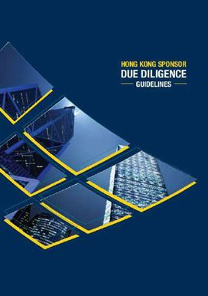

23

The Regulatory Regime for IPO Sponsors (cont’d)

- The Due Diligence Guidelines include chapters on:

  - Knowing the Listing Applicant and its Management

  - Verification Practice

  - Business Model

  - Interviews of Major Business Stakeholders

  - Controlling Shareholders’ Relationship with the Listing Applicant

  - Connected Persons and Connected Transactions

  - Financial

  - Internal Controls

  - Distributors, Franchisees and Consignees

  - Material Contracts

  - Environmental

  - Mineral Companies

  - Biological Assets

24

Documents Required to be Submitted in Support of a MB Listing Application
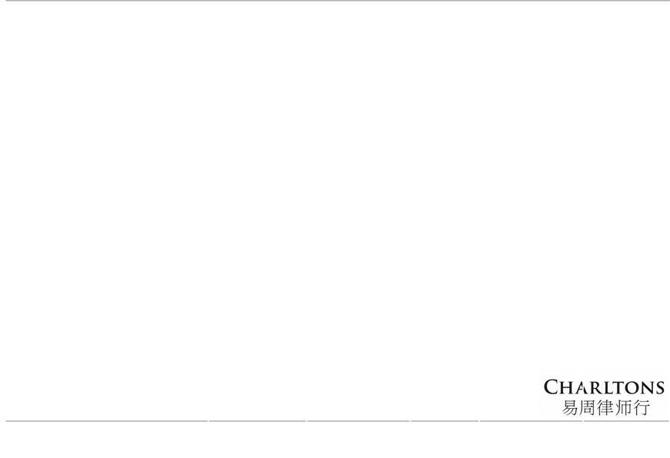

 | Together with Listing Application Form (Form |  | At least 4 clear | As soon as |  | Before bulk | By 11 a.m. on the |  | As soon as
A1) – Documents as per Listing Rules (“LR”) 9.11(1) |  |  | business days before | practicable after the | printing of the |  | intended day of | practicable fter the
❶ |  |  | ❷ | ❸ | ❹ |  | ❺
to 9.11(17c) |  |  | the expected Listing | hearing of the | listing |  | authorisation of the | ❻
 |  |  | Committee hearing | application by the | document – |  | prospectus – | issue of the
 |  |  |  |  |  |  |  | prospectus but
 |  |  | date – Documents as | Listing Committee, but | Documents as |  | Documents as per LR | before dealings
 |  |  | per LR 9.11(18) to | on or before the date of | per LR 9.11(24) |  | 9.11(33) (in case of a | commence –
 |  |  | 9.11(22) | issue of the listing | to 9.11(28a) |  | listing document which | Documents as per
 |  |  |  | document – Documents |  |  | constitutes a prospectus | LR 9.11(34) to
 |  |  |  | as per LR 9.11(29) to |  |  | under the CWUMPO) | 9.11(38)
 |  |  |  | 9.11(32)
• Application Proof (“AP”) as required by HKEx and 2 |  |  | • final proof of the | • dated and signed copy | • final proof of |  | • application for | • certified copies of
CD-ROMs |  |  | listing document as | of each of the English | the formal |  | authorisation for | the resolution(s)
• sponsor’s undertaking and statement of |  |  | required by the HKEx | and the Chinese | notice, |  | registration of the | of the new
independence |  |  | together with 2 CD- | language versions of | (where |  | prospectus under | applicant in
• compliance adviser’s undertaking |  |  | ROM | the listing document | applicable) |  | section 38D(3) or | general meeting
• advanced draft of requests for waiver from LRs |  |  | • confirmation from | • copy of the formal | and |  | section 342C(3) of the | (if any)
and Companies (Winding Up and Miscellaneous |  |  | the new applicant’s | notice, where | application |  | CWUMPO | authorising the
Provisions) Ordinance (“CWUMPO”) |  |  | legal advisers that | applicable | forms, and |  | • 2 printed copies of the | issue of all
• directors’/supervisors’ confirmations relating to: |  |  | the new applicant’s | • a copy of the written | statement re |  | prospectus, duly | securities, and
 | - | accuracy of information contained in AP | articles of association | notification issued by | sufficiency of |  | signed in accordance | resolution(s) of
 | - | accuracy of directors’/supervisors’ | are not inconsistent | HKSCC stating the | working |  | with section 38D(3) or | the board of
 |  | biographical details | with the LR | securities will be | capital |  | section 342C(3) of the | directors
 | - updating the HKEx re any changes in |  | • a certified copy of | Eligible Securities | • copies of the |  | CWUMPO | delegating powers
 |  | directors’/supervisors’ biographical details | the signed deposit | • every written | listing |  | • certificate issued by | • copy of the
 | - declaration in Form B/H/I |  | agreement (if | undertaking and | agreement (if |  | translator | placing letter
• if AP contains an accountants’ report, an advanced |  |  | applicable) | confirmation from the | applicable) |  |  | (where applicable)
draft of any statement of adjustments relating to |  |  | • unless previously | new applicant, its | • final copy of |  |  | • sponsor’s
the accountants’ report |  |  | provided, all | shareholders and/or | all draft |  |  | declaration (Form
• draft deposit agreement, specimen certificate for |  |  | executed requests | other relevant parties | documents |  |  | E)
depositary receipts & legal opinion (if applicable) |  |  | for waiver from the | to the HKEx referred to | submitted to |  |  | • directors’
• a final or an advanced draft of the board’s profit |  |  | requirements of the | in the listing document | support the |  |  | declarations
forecast memorandum |  |  | LR and the provisions | • original signed sponsor | listing |  |  | (Forms F and
• certified copy of certificate of incorporation |  |  | of CWUMPO | declaration(s) required | application |  |  | B/H/I as
• sponsor’s letter re working capital |  |  |  | by LR 3A.13 |  |  |  | applicable)
• any other document required by the HKEx to |  |  |  |  |  |  |  |  |  | 25
support the listing |  |  |  |  |  |  |  |  |  | 25

IPO timeline
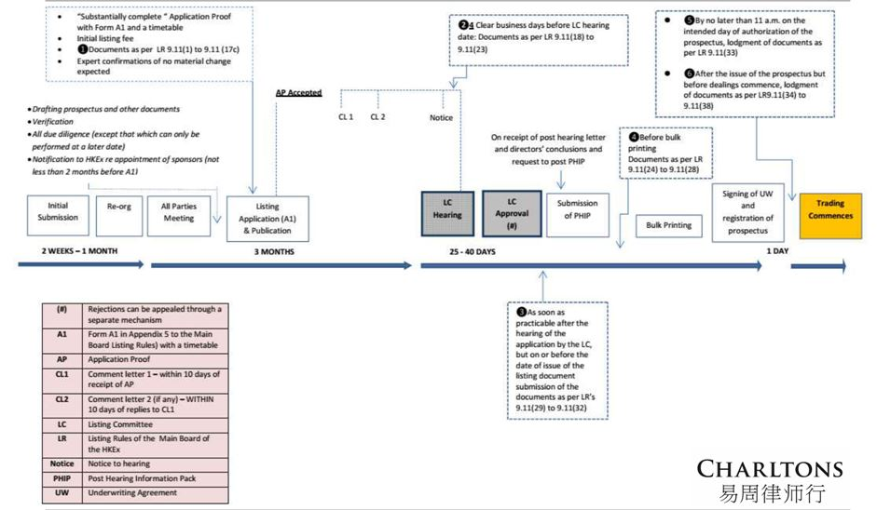

26

Charltons


- Charltons’ extensive experience in corporate finance makes us uniquely qualified to provide a first class legal service





Charltons have representative offices in Shanghai, Beijing and Yangon

Charltons was named the “Corporate Finance Law Firm of the Year in Hong Kong ” in the Corporate Intl Magazine Global Award 2014

- “Boutique Firm of the Year” / “Boutique Transactional Law Firm of the Year” was awarded to Charltons by Asian Legal Business for the years 2002, 2003, 2006 to 2017 (inclusive) and 2020

- “Hong Kong's Top Independent Law Firm” was awarded to Charltons in the Euromoney Legal Media Group Asia Women in Business Law Awards 2012 and 2013

- “Equity Market Deal of the Year” was awarded to Charltons in 2011 by Asian Legal Business for advising on the AIA IPO

27

Charltons – Directory Listings / Recommendations
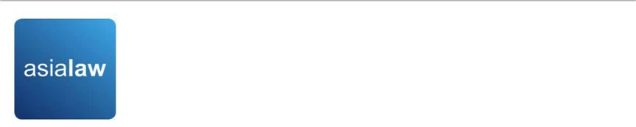

- Asialaw Profiles 2021
  - Capital markets - Highly recommended

  - Corporate and M&A - Highly recommended

  - Investment funds - Highly recommended

  - Private equity - Highly recommended

  - Banking and financial services - Recommended

  - Technology and telecommunications - Recommended

  - Regulatory - Recommended

- Chambers and Partners
  - Corporate/M&A: Independent Hong Kong Firms - Band 3

- Chambers Ranked Individuals
  - Julia Charlton - Capital Markets: Equity (International firms) China - Recognised Practitioner

  - Julia Charlton - Corporate/M&A: Independent Hong Kong Firms - Band 3

  - Clinton Morrow - Corporate/M&A: Independent Hong Kong Firms - Recognised Practitioner

- IFLR1000
  - Capital markets : Equity - Other notable

  - M&A - Other notable

- IFLR1000 Ranked Individuals
  - Julia Charlton - Highly regarded



28

Charltons


- Excellent links and networks with law firms worldwide.

- Julia Charlton was:

  - named a “Leading Lawyer” by Asia Law & Practice for the years 2002, 2003, 2006-2020 (inclusive)

  - awarded ‘Hong Kong Capital Markets Lawyer of the Year’ by Finance Monthly Global Awards 2014.

  - named a ‘Leading Advisor’ by Acquisition International for 2013.

  - awarded the American Chamber of Commerce of Hong Kong / South China Morning Post Women of Influence: Professional of the Year 2008.

  - finalist of Veuve Clicquot Business Woman Award 2018 Hong Kong
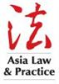



29



















Practice Areas


Capital markets

Corporate and commercial

Securities

Mergers and acquisitions

Investment funds: China and offshore

Derivatives

Restructuring

Venture capital

Investment

30

- Capital Markets

  - Global offerings and GDRs

  - IPOs and Placings

  - Listing on the Hong Kong, Shanghai, Shenzhen, London and Luxembourg stock exchanges

- Corporate and Commercial

  - Mergers and Acquisitions

  - Joint ventures

  - Stock exchange advisory

  - Corporate governance

  - Stock options

  - Employment law

- Securities

  - Compliance and disclosure

  - Dealing and advisory authorisations in Hong Kong and Mainland China

  - Options

- Investment Funds: China and Offshore

  - Authorised and unauthorised funds

  - Stock exchange listing (including Hong Kong, Dublin, London, Cayman, Bermuda stock exchanges)

  - Closed-end and open-ended structures

  - Hedge funds

Practice Areas

- Mergers and Acquisitions

  - Hong Kong Code on Takeovers and Mergers

  - Public offerings

  - Reverse takeovers

  - Private acquisitions

  - Due diligence in China and elsewhere in Asia

- Derivatives

  - Structuring listed and unlisted derivatives

  - Placings on Hong Kong and Luxembourg listed warrants and other structured products

  - Compliance and regulatory

- Restructuring

  - Schemes of arrangement

  - Workouts

  - Corporate recovery

  - Asset injections

- Investment

  - China investment regulations

  - Structuring a major foreign direct investment projects

  - Evaluation and due diligence

- Private Equity and Venture Capital

  - Optimum PRC and offshore structures

  - Preferred stock financing

  - PRC regulations

  - Exit Strategies

31

Our services

Our services include:


- As the company’s lawyer, principal responsibilities include, inter alia:

ο

ο

ο

ο

ο

ο

ο

ο

advising the company on the relevant listing and regulatory requirements in Hong Kong

advising on any reorganisation plans and share option schemes

assisting the company to prepare all relevant documents for the listing, including the prospectus (upon request), deeds, directors’ undertakings, service contracts, appointment letters, committee terms of reference, waiver applications, connected transaction analysis and submissions and other applicable documents

issuance of legal opinions

assisting the company to prepare for due diligence to be conducted by the sponsor

conducting directors’ training

coordinating with legal adviser of relevant jurisdictions liaising with the Stock Exchange on behalf of the company

32

Our services


- As the sponsor’s lawyer, principal responsibilities include, inter alia:

ο

ο

ο

ο

ο

ο

ο

ο

advising the sponsor and underwriters on the relevant Hong Kong legal and regulatory requirements in connection with the proposed listing

assisting the sponsor to conduct due diligence on the company

reviewing due diligence documents and conducting verification of the prospectus and coordinating with the auditor in relation to verification of financial information

preparing the listing application, submissions, checklists and other documents required to be submitted

Preparing documentation and advising on the marketing, underwriting, syndication, stabilization etc. of the share offering

preparing sections of the prospectus

preparing response to regulators over vetting process

reviewing all documents and disclosures prepared by the company’s lawyer

33

The Charltons Team

The team is composed of individuals with the following knowledge, skills and experience:

- A detailed knowledge of Hong Kong law and practice in relation to IPOs and equity fund raising transactions of public companies.

- Extensive experience in providing legal services for Hong Kong and PRC-related IPO transactions.

- In depth knowledge of the Listing Rules of both GEM and the Main Board of the Hong Kong Stock Exchange.

- Depth and range of experience in advising companies in connection with IPO and listing transactions.

34

Team Profile: Julia Charlton

Julia Charlton – Partner


- Julia, LL.B (1st class Honours), A.K.C (Kings College, London) was admitted as a solicitor in England & Wales in 1985 and has practised as a solicitor in Hong Kong since 1987.

- Julia is a member of the Takeovers Panel and the Takeovers Appeal Panel of the SFC, and served the maximum permitted term as a member of the Listing Committee of the Stock Exchange of Hong Kong Limited for six years from 2012 to 2018.

- Julia was named a “Leading Lawyer” by Asia Law & Practice for the years 2002, 2003, and 2006 to 2017.

- Julia was named a “Leading Advisor” by Acquisition International for 2013.

- Julia was also named the “Capital Markets Lawyer of the Year – Hong Kong” in the Finance Monthly Global Awards 2014.

- Julia has extensive experience in China work and is a Mandarin speaker.

35

Team Profile: Calvin Ho

Calvin Ho – Partner


- Calvin, Bachelor of Laws (LL.B) & Bachelor of Commerce (B.Com) (University of Melbourne), was admitted as solicitor in Hong Kong since 2009

- Calvin is a capital markets lawyer who regularly advises on IPOs, spin-offs, pre-IPO consultations, review and appeals as well as other related matter. Selected experience include:

  - advised AIA Group Limited (1299) in connection with regulatory aspects of listing on the Main Board (Equity Market Deal of the Year, 2011 ALB Awards Hong Kong)





advised United Company RUSAL Plc (486), one of the world’s largest aluminium company, on legal and regulatory aspects of its listing on Main Board as well as post-listing transactions (including very substantial transactions, redomiciliation etc.) and other ongoing legal and compliance issues

advised on successful listing of True Partner Capital Holdings Limited (8657), Fu Shek Financial Holdings Ltd (2263) Excalibur Global Financial Holdings (8350), Zhi Sheng Group Holdings Ltd (8370), Medicskin Holdings Limited (8307), China Singyes New Materials Holdings Ltd (8073) etc. and transfer of listing of from GEM to Main Board of KVB Kunlun Holdings Limited (6877)

36

Professional Experience

- Charltons has considerable experience in advising companies or sponsors in relation to listings on the Main Board or the GEM of the Hong Kong Stock Exchange, and has extensive experience in bringing both private and state-owned Chinese enterprises to market

- The following slides sets out selected IPO experience of Charltons. In addition to these IPOs, Charltons is often considered specialists in the field and is often engaged to advise on complex IPO-related matters, some of which involves extensive consultations, negotiations and dialogue with the Hong Kong regulators. By way of example, recently, we have been involved in:

  - advised the proposed spin-off on the Main Board of the steel processing, distribution and recycling businesses from the listed parent company engaged in real estate and property development, involving complex issues leading to appeals on various levels of the Listing Committee of the Stock Exchange

  - advised on the proposed spin-off on the Main Board of reproductive healthcare services business of a financial conglomerate which involved technical regulatory and valuation issues requiring extensive consultation with the Stock Exchange

37

Professional Experience

- advised as HK counsel and regulatory specialist in connection with the proposed listing on Main Board (and subsequently proposed U.S. listing) of Bitmain, the largest cryptocurrency mining hardware company and operator of mining pools involving highly complex regulatory advice and due diligence

- advised on the proposed spin-off on the Main Board of application software services business from the parent company engaged in solutions and integration services which involved extensive negotiation with Stock Exchange on valuation and delineation issues

- currently advising on the possible relaunch of an IPO by a financial services provider which has attempted and failed to list on the Main Board (previously on GEM) of the Stock Exchange due to complex regulatory issues

- currently advising the sponsor on due diligence enquiries from the regulators concerning an lapsed listing application on the Main Board by a cement producer involving technical issues

As capital market lawyers, we are also heavily involved in post-listing compliance and regulatory issues as well as restructurings and privatisations involving listed entities. For example, we advised the managing director in relation to the privatisation of Hopewell, and is currently advising on a number of other privatisations, redomiciliation and restructurings involving prominent listed groups. 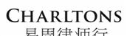

38

Examples of IPO Experience
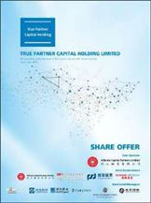

- True Partner Capital Holding Limited (listed on the the GEM of the SEHK in October 2020), Charltons acted as the Hong Kong legal adviser to the sponsor and underwriters)

- Fu Shek Financial Holdings Limited (listed on the Main Board of the SEHK) in February 2020, Charltons acted as Hong Kong legal adviser to sponsor and underwriters)

- Tianli Education International Holdings Limited (listed on the Main Board of the SEHK in July 2018, Charltons acted as the Hong Kong legal adviser to the sponsor and underwriters)
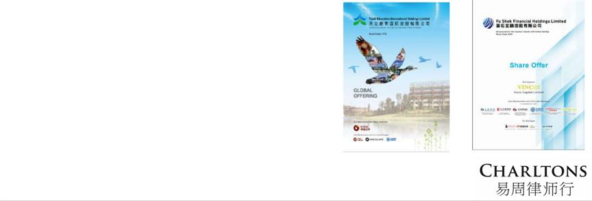

39

Examples of IPO Experience
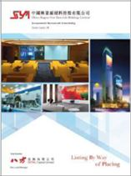

- Excalibur Global Financial Holdings Limited (listed on the GEM of the SEHK in January 2018, Charltons acted as the Hong Kong legal adviser to the sponsor and underwriters)

- China Singyes New Materials Holdings Limited (listed on the GEM of the SEHK in June 2017, Charltons acted as the Hong Kong legal adviser to the sponsor and underwriters in connection with spins-off and listing)

- Tree Holdings Limited (listed on the GEM of the SEHK, Charltons acted as the Hong Kong legal adviser to the sponsor and underwriters)
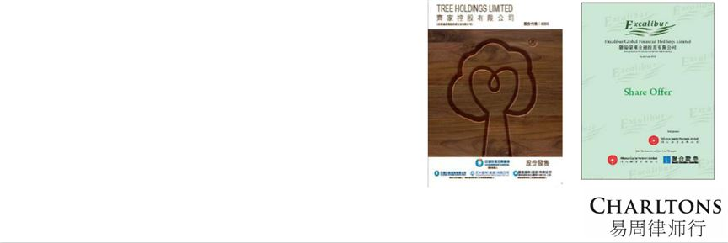

40

Examples of IPO Experience
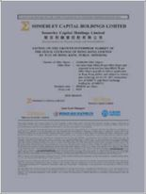

- Somerley Capital Holdings Limited (listed on the GEM of the SEHK in March 2017, Charltons acted as the Hong Kong legal adviser to the company)

- Zhi Sheng Group Holdings Limited (listed on the GEM of the SEHK in January 2017, Charltons acted as the Hong Kong legal adviser to the sponsor and underwriters)

- Medicskin Holdings Limited (listed on the GEM of the SEHK in December 2014, Charltons acted as the Hong Kong legal adviser to the company)
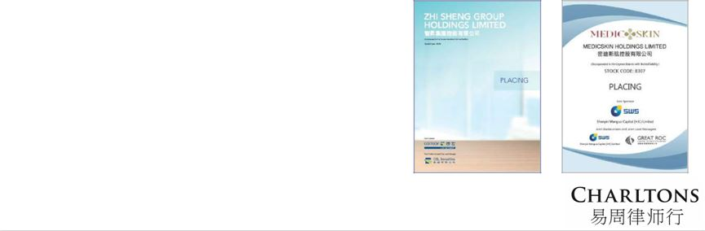

41

Examples of IPO Experience
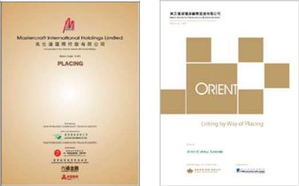

- Orient Securities International Holdings Limited (listed on the GEM of the SEHK in January 2014, Charltons acted as the Hong Kong legal adviser to the sponsor and underwriters)

- Mastercraft International Holdings Limited (listed on the GEM of the SEHK, Charltons acted as the Hong Kong legal adviser to the sponsor and underwriters)

- Branding China Group Limited (listed on the GEM of the SEHK, Charltons acted as the Hong Kong legal adviser to the sponsor and underwriters)

- AIA Group Ltd. (listed on the Main Board of the SEHK , Charltons acted as the Hong Kong legal adviser to AIG, the controlling shareholder)
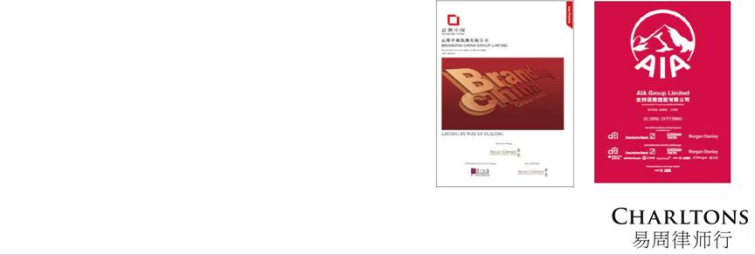

42

Examples of IPO Experience

- United Company RUSAL Plc (listed on the Main Board of the SEHK, Charltons acted as the Hong Kong legal adviser to the controlling shareholder)

- China Titans Energy Technology Group Co., Limited (listed on the Main Board of the SEHK , Charltons acted as the Hong Kong legal adviser to the sponsor and underwriters)

- Mingfa Group (International) Company Limited (listed on the Main Board of the SEHK , Charltons acted as the Hong Kong legal adviser to the company)

- Greens Holdings Limited (listed on the Main Board of the SEHK, Charltons acted as the Hong Kong legal adviser to the company)
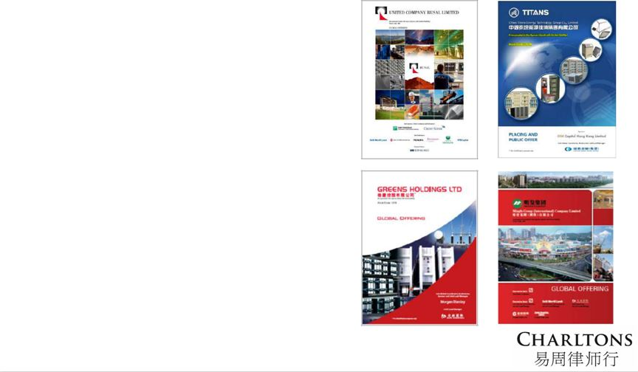

43

Examples of IPO Experience
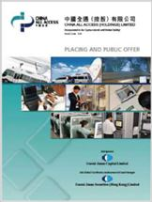

  - China All Access (Holdings) Limited (listed on the Main Board of the SEHK, Charltons acted as the Hong Kong legal adviser to the sponsor and underwriters)

- China Tianyi Fruit Holdings Limited (listed on the Main Board of the SEHK, Charltons acted as the Hong Kong legal adviser to the sponsor and underwriters)

- China High Speed Transmission Equipment Group Co., Ltd. (listed on the Main Board of the SEHK, Charltons acted on behalf of the company)

- Zhejiang Shibao Co., Ltd. (listed on the GEM of the SEHK, Charltons acted as the Hong Kong legal adviser to the company)

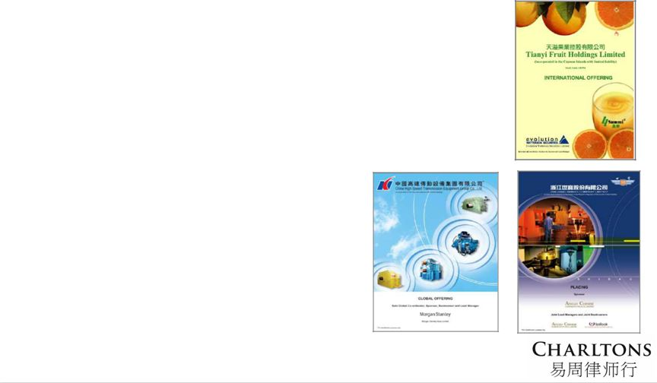

44

Other IPO Experience

- Fu Ji Food and Catering Services Holding Ltd. (listed on the Main Board of the SEHK, Charltons represented the strategic investor)

- China Fire Safety Enterprise Group Holdings Ltd. - previously named Fujian Wanyou Fire Safety Technology Holdings Ltd. - (listed on the GEM of the SEHK, Charltons represented the strategic investor)

- Shanghai Fudan-Zhangjiang Bio-Pharmaceutical Co. Ltd. (listed on GEM of the SEHK, Charltons acted as the Hong Kong legal adviser to the sponsor)

- Tianjin TEDA Biomedical Engineering Co. Ltd. (listed on GEM of the SEHK, Charltons acted as the Hong Kong legal adviser to the sponsor)

- Zheda Lande Scitech Ltd. (listed on GEM of the SEHK, Charltons acted as the Hong Kong legal adviser to the company)

- Merdeka Resources Holdings Ltd. - previously named TradeEasy Holdings Ltd. - (listed on GEM of the SEHK, Charltons acted as the Hong Kong legal adviser to the company)

- E. Bon Holdings Ltd. (listed on the Main Board of the SEHK, Charltons acted as the Hong Kong legal adviser to the sponsor)

- Great Wall Technology Co. Ltd. (listed on the Main Board of the SEHK, Charltons acted as the Hong Kong legal adviser to the company)

45

Contact Us

Hong Kong

12th Floor, Dominion Centre 43 – 59 Queen’s Road East Hong Kong

Telephone: (852) 2905 7888

Facsimile: (852) 2854 9596

Email: enquiries@charltonslaw.com
Website: www.charltonslaw.com

China

Beijing Representative Office

3-1703, Vantone Centre
A6# Chaowai Avenue
Chaoyang District
Beijing

People's Republic of China 100020

Telephone: (86) 10 5907 3299
Facsimile: (86) 10 5907 3299

Email: enquiries.beijing@charltonslaw.com

Myanmar

Yangon Office of Charltons Legal Consulting Ltd

161, 50th Street
Yangon
Myanmar

Email: enquiries.myanmar@charltonslaw.com

Shanghai Representative Office

Room 2006, 20th Floor
Fortune Times
1438 North Shanxi Road
Shanghai
People's Republic of China

200060

Telephone: (86) 21 6277 9899
Facsimile: (86) 21 6277 7899

Email: enquiries.shanghai@charltonslaw.com

In association with:-
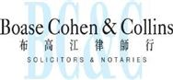

Networked with:-
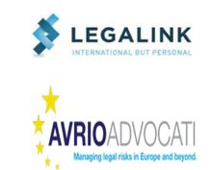

46

