________________________________________________________________

The 10 most important things to know about
Reverse Takeovers (RTOs) of Hong Kong listed companies

________________________________________________________________

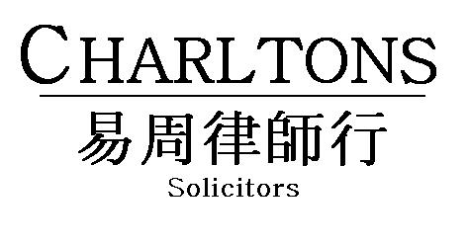

Hong Kong | Shanghai | Beijing | Yangon

www.charltonslaw.com
The 10 Most Important Things To Know About Reverse Takeovers (RTOs) of HK Listed Companies

- What is a Reverse Takeover?

An RTO is broadly defined as an acquisition (or series of acquisitions) of assets by a listed issuer which attempts to achieve a listing of the acquired assets and a means to circumvent the Listing Rules' requirements for a new listing applicant. This is a principle based test.

- Is there a specific definition of Reverse Takeover?

No. The Listing Rules only set out the bright line tests for two specific types of RTOs which are transactions involving a change in control (i.e. 30%) of a listed issuer and a very substantial acquisition (“VSA”) (i.e. acquisition(s) where any percentage ratio is 100% or more) from the incoming controlling shareholder at the time of the change in control or within the following 24 months.

A VSA which falls within the bright line tests constitutes an RTO and will require the listed issuer to follow the procedures for a new listing applicant.

- Are there any other circumstances that can give rise to an RTO?

Yes. If a VSA transaction falls outside the bright line tests (e.g. where there is no change in control), the Exchange will apply the principle based test to assess whether the acquisition constitutes an attempt to list the assets acquired and circumvent the requirements for new listings.

Hence, a listed issuer's disposal of its existing business and acquisition of a totally new business may be regarded as an RTO even if there is no change in control.

- What are the consequences of entering a VSA within the bright line tests?

Where the VSA falls within either of the bright line tests in Listing Rule 14.06(6)(a) and (b) (GEM Rule 19.06(6)(a) and (b)), the transaction will be treated as an RTO and the Exchange will treat the listed issuer proposing the RTO as a new listing applicant irrespective of whether the assets acquired meet the requirements for a new listing. If the new listing requirements cannot be met, the transaction will not be able to proceed. The Exchange will only grant a waiver if it considers that circumvention of the new listing requirements is not a material concern: this is more likely to be the case where the VSA involves an acquisition closely related to the issuer’s principal business (e.g. a business expansion). Waivers are unlikely to be granted where the issuer is a listed shell.
Where a waiver is granted, the Exchange generally insists on an enhanced level of disclosure in the circular to shareholders where the acquisition is very material to the issuer or will result in a fundamental change in the issuer’s business. This approach set out in the Listing Committee’s 2009 Report brought the Exchange’s standards for VSA circulars closer to that required for IPO prospectuses.

- What are the consequences of an RTO being treated as a new listing application?

Where the Exchange treats the listed issuer proposing an RTO as a new listing applicant:

- the enlarged group or the assets to be acquired must be able to meet the financial criteria for a new listing;

- the enlarged group must meet all other basic listing conditions;

- the listed issuer must issue a listing document containing virtually all the information required for a new listing applicant and the information required for a VSA;

- an initial listing fee is payable;

- the listed issuer must appoint a sponsor which must conduct due diligence;

- the new listing must be approved by the Exchange’s Listing Committee (or its Listing Division where the issuer is listed on GEM); and

- the RTO must be conditional on shareholders' approval in general meeting.

- What are the consequences of a VSA outside the bright line tests?

Where there is no change in control, the Exchange will treat a VSA which attempts to list the assets acquired and circumvent the new listing requirements as an RTO only if it considers the VSA to be an “extreme case”.
The Exchange considers the following factors in determining whether a VSA is an extreme case:

- the size of the acquisition relative to the size of the issuer;

- the quality of the acquired business – whether it can meet the trading record requirements for a new listing, or whether it is unsuitable for listing (e.g. an early stage mineral exploration company);

- the nature and scale of the issuer’s business before the acquisition (a key question is whether it is merely a listed shell);

- any fundamental alteration to the issuer’s principal business (e.g. the existing business would be discontinued or very immaterial to the enlarged group’s operations post acquisition);

- any other events and transactions (past, proposed or intended) which, together with the acquisition, form a series of arrangements designed to circumvent the RTO Rules (e.g. a disposal of the issuer’s original business simultaneously with a very substantial acquisition); and

- any issue to the vendor of Restricted Convertible Securities which would provide it with de facto control of the issuer. Restricted Convertible Securities are highly dilutive convertible securities with a conversion restriction mechanism (e.g. restriction from conversion that would cause the securities holder to hold 30% interest or higher) which avoids triggering a change of control under the Code on Takeovers and Mergers.
The Exchange will not apply the RTO Rules to a VSA within the principle based test which it does not consider to be extreme. The Exchange may nevertheless require the issuer to prepare a transaction circular under an enhanced disclosure and vetting approach.
- How does the Exchange Treat a VSA which is an extreme case?

Where the Exchange considers a VSA to be an “extreme case” by reference to the criteria set out in paragraph 6 above, it will treat it as an extreme very substantial acquisition (“extreme VSA”) where:
- the assets to be acquired can meet the minimum profit requirement under Rule 8.05 (the positive cash flow requirement under GEM Rule 11.12A); and
- circumvention of the new listing requirements is not a material concern.
Extreme VSAs are presented to the Listing Committee for its decision. Transactions which are not extreme VSAs (i.e. because the assets to be acquired cannot meet the requirements for new listings) will be treated as RTOs and will not be able to proceed since the new listing requirements are not satisfied.
If the Listing Committee determines that the RTO Rules apply to an extreme VSA, the issuer will be treated as a new listing applicant and will be subject to the listing requirements for new applicants (see paragraph 5 above).

If the Listing Committee determines that the RTO Rules will not apply to an extreme VSA, the issuer will be required to:

- prepare a transaction circular under an enhanced disclosure and vetting approach; and

- appoint a financial adviser to conduct due diligence on the acquisition.

The transaction also needs to follow the requirements for VSAs under Chapter 14 (GEM Chapter 19) including the requirement for shareholders’ approval.

The Exchange has said that acquisitions of new businesses or assets are more likely to be treated as new listings since enhanced disclosure is likely to be of limited use given that there will be little in the way of track record or operating history.

- Can the RTO Rules be circumvented by deferring disposal of the existing business until after the asset injection to the listed issuer following a change of control, thus avoiding the asset injection’s classification as a VSA?

No, the Listing Rules provide that a listed issuer cannot dispose of an existing business within 24 months of a change of control if: (a) there has been an injection of assets from the new controlling shareholder; and (b) taking into account the disposal(s), the asset injection (or series of injections) from the new controlling shareholder before and after the change in control would have resulted in a VSA, unless the assets acquired after the change of control can meet the requirements for a new listing. If not, the transaction will be treated as an application for a new listing.

- What are the RTO Rules’ implications for a listed issuer proposing an RTO of mineral or petroleum assets?

A listed issuer which acquires mineral or petroleum assets in an RTO will become a "Mineral Company" for the purposes of the Listing Rules. If the transaction is treated as an RTO which is subject to the requirements for a new listing, the assets acquired or enlarged group must meet the additional criteria for listing new applicant Mineral Companies set out in Chapters 18 and 18A of the Main Board and GEM Rules, respectively, in addition to the basic listing conditions.

- What are the Takeovers Code implications of an RTO?

An offer to acquire 30% or more of the voting rights of a Hong Kong listed company will trigger the obligation under Rule 26 of the Takeovers Code to make a general offer to all shareholders of the target company on the same terms in the absence of a waiver from the SFC Executive. Rule 25 further prohibits an offeror and its associates from offering favourable conditions to one or more shareholders which are not available to all the other shareholders.

Summary of RTO Assessment Process and Requirements

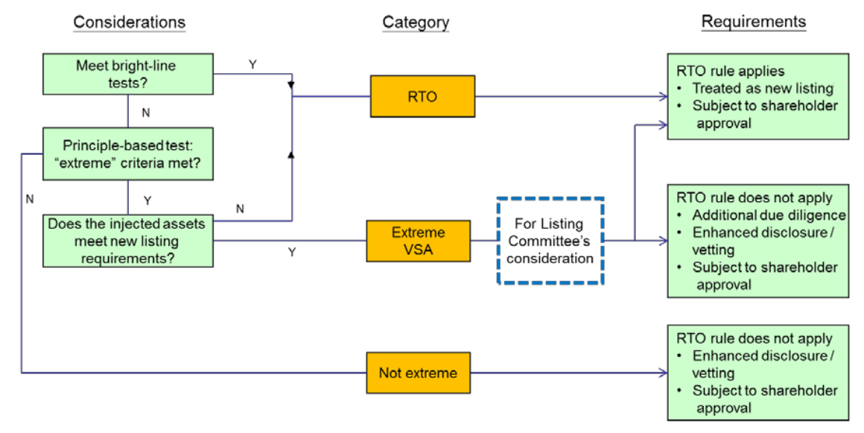
JULY 2014
This note is provided for information purposes only and does not constitute legal advice. Specific advice should be sought in relation to any particular situation. This note has been prepared based on the laws and regulations in force at the date of this note which may be subsequently amended, modified, re-enacted, restated or replaced.

Rule 14.06(6) of the Main Board Listing Rules and Rule 19.06(6) of the GEM Listing Rules.
Paragraphs (a) and (b) of Rules 14.06(6) and 19.06(6) of the Main Board and GEM Rules, respectively.
Exchange Guidance Letter HKEx-GL78-14 at paragraph 7.
See the Exchange’s Listing Decision 75-1 of October 2009.
As set out in Main Board Rule 8.05 and GEM Rule 11.12(A).
Exchange Guidance Letter HKEx-GL78-14 at paragraph 7.
Exchange Guidance Letter HKEx-GL78-14 at paragraph 7.
Ibid. at paragraph 30.
The term “extreme VSA” has the same meaning as the term “borderline case” which was used in the discussions about reverse takeovers in the 2009, 2010 and 2013 Listing Committee Annual Reports.
Exchange Guidance Letter HKEx-GL78-14 at paragraph 8.
Exchange Guidance Letter HKEx-GL78-14 at paragraph 9. Where the acquisition involves natural resources and a competent person’s report and valuation report are prepared under Chapter 18 of the Rules (Chapter 18A of the GEM Rules), the Listing Committee may not apply additional due diligence requirements.
See Main Board Rules 14.92 and 14.93 and GEM Rules 19.92 and 19.93 and the Listing Committee’s 2008 Annual Report.
See also the Exchange’s Listing Decision LD7-2011.
Main Board Rule 18.11 and GEM Rule 18A.11.

