________________________________________________________________________________

Statutory Regime for the Disclosure of Price Sensitive Information – The Implications for Listed Companies and their Directors

_________________________________________________________________________________

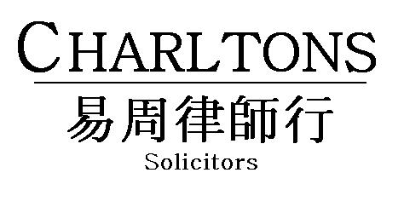

Hong Kong | Shanghai | Beijing | Yangon

www.charltonslaw.com

CONTENTS

I. INTRODUCTION 1
II. NEW STATUTORY REGIME FOR DISCLOSURE OF PRICE SENSITIVE INFORMATION 3
1. Highlights of the PSI Disclosure Regime 3
2. Key Features of the PSI Disclosure Regime 3
3. Definition of Inside Information 4
4. Timing of disclosure 7
5. Manner of Disclosure 8
6. The Safe Harbours 8
7. SFC’s Power to Grant Waivers 10
8. Liability of Officers under the New Regime 10
9. Investigation and enforcement 12
10. Sanctions 12
11. Civil Liability – Private Right of Action 12
III. PROPOSED LISTING RULE AMENDMENTS RESULTING FROM THE NEW STATUTORY DISCLOSURE OBLIGATION 13
1. Introduction 13
2. Jurisdiction over PSI vests with the SFC 13
3. General obligation of disclosure to be deleted 13
4. The Exchange will continue to monitor the market 13
5. Other changes 16
IV. STOCK EXCHANGE PROPOSALS TO ALLOW THE RELEASE OF PSI DURING TRADING HOURS SUBJECT TO TRADING HALT IMPLEMENTATION 17
1. Background 17
2. Current arrangements 17
3. Proposed arrangements 18
V. INSIDER DEALING CASES IN HONG KONG 20
VI. INSIDER INFORMATION CASES IN THE UK 20
1. UK Provisions 20
2. Recent UK FSA rulings 20
3. Implications of the rulings 21
VII. GELTL V DAIMLER: ECJ RULING OF JUNE 2012 23
1. Geltl v Daimler AG 23
2. Relevant Provisions 24
3. Legal Process 24
4. ECJ Ruling and Interpretation 25
VIII. RECENT HONG KONG CASES INVOLVING DISCLOSURE OF INFORMATION REGARDED AS “STATE SECRETS” UNDER PRC LAW 25
1. SFC Proceedings Against Ernst & Young for failure to hand over audit working papers due to potential breach of PRC law on Guarding State Secrets 25
2. Suspension of Trading in shares of China High Precision Automation due to non-disclosure on grounds of information constituting State Secrets 25
ANNEXURE 27

THE STATUTORY PSI REGIME: IMPLICATIONS FOR LISTED COMPANIES AND THEIR DIRECTORS AND OFFICERS

INTRODUCTION

The statutory regime for the disclosure of price sensitive information (PSI), called “inside information” under the new regime, takes effect since 1 January 2013. Disclosure of PSI has long been governed by the non-statutory Listing Rules (under Chapter 13 of the Main Board Rules and Chapter 17 of the GEM Rules). Since 1 January this year, the obligation to disclose PSI becomes a statutory obligation under the new Part XIVA of the SFO. Breach of this obligation is a civil offence for which listed companies and their directors may be liable on conviction to a fine of up to HK$8 million.

By way of background, this statutory backing for listed companies’ obligation to disclose PSI has been a long time in the making. Companies’ obligations under the Listing Rules used to be contractual obligations that they undertook to the Exchange to fulfill. They did not have the force of statute and did not give the Exchange statutory regulatory powers. Accordingly, the Exchange’s disciplinary powers were limited: it had no power to impose fines, but might publicly or privately censure firms in breach, and in extreme cases might suspend or cancel the listing of an issuer’s securities.

A number of major jurisdictions which previously followed the non-statutory approach moved to a statutory approach in recent years and empowered their statutory agencies and courts to take statutory action against those breaching the rules. The UK transferred its listing regulatory role from the London Stock Exchange to the Financial Services Authority (FSA) which recast the listing requirements as statutory rules with statutory enforcement. Likewise Australia and Singapore have given their listing rules “statutory backing”.

In Hong Kong, concerns were expressed about the lack of “regulatory teeth” in the Listing Rules. The Government and the SFC have already taken a number of initiatives aimed at strengthening regulation of listed companies. In 2003, the “dual filing” regime was established under the Securities and Futures (Stock Market Listing) Rules (SMLR) under the Securities and Futures Ordinance. This imposes criminal liability on listing applicants and listed issuers who intentionally or recklessly disclose materially false or misleading information to the public.

In 2004, proposals were put forward to build on the dual filing regime and codify the most important Listing Rule obligations into subsidiary legislation. The SFC would then be responsible for enforcing those provisions while the Exchange would continue to receive listing applications and administer the listing process as the frontline regulator of listed companies.

To that end, the SFC published a consultation paper in January 2005 (the Consultation Paper on Proposed Amendments to the Securities and Futures (Stock Market Listing) Rules) proposing the statutory codification of the following 3 areas of issuers’ obligations under the Listing Rules:

- Disclosure of price-sensitive information;
- Publication of annual and interim financial reports
- Disclosure and shareholders’ approval requirements for Notifiable and Connected Transactions
Respondents to the consultation had concerns that importing the detailed requirements of the listing rules into Statute could reduce flexibility making it difficult for the rules to be amended expeditiously in response to market needs. There were also concerns that an unintentional breach of the detailed requirements could be subject to severe statutory sanctions. As a result, the Consultation Conclusions published in February 2007 put forward an alternative approach: the statutory listing requirements would comprise a set of general principles representing issuers’ fundamental obligations. These would be supplemented by ancillary provisions set out in a schedule to the SFC facilitating easier amendment of the requirements if and when necessary. Non-compliance with the new general principles was proposed to constitute “market misconduct’ under Parts XIII and XIV SFO and subject to one of three types of sanction in serious cases: SFC disciplinary action, civil proceedings before the Market Misconduct Tribunal or criminal prosecution.

In the event, the Consultation Conclusions were not implemented. Although the SFC claimed to have received widespread support for the proposals, there were certainly concerns with making the disclosure of PSI a statutory obligation. The perceived difficulty arises from the lack of certainty as to the definition of what constitutes PSI: what is PSI is a matter of professional judgment in the particular circumstances of any given case. Thus, of the 3 areas proposed for statutory codification, disclosure of PSI was probably the most problematic and controversial.

Nevertheless, while there have not yet been any further moves to codify issuers’ financial reporting and notifiable and connected transaction disclosure obligations, the SFC seems intent upon codifying the obligation to disclose PSI.

The Exchange conducted two consultations: one on amending the Listing Rules to avoid overlap with Part XIVA; the other on allowing the publication of PSI during trading hours subject to the implementation of short trading halts to allow the market to digest the information disclosed.

The definition of “inside information” under the new statutory regime is the same as the definition of “relevant information” – which forms the basis of the offence of insider dealing under Parts XIII and XIV of the SFO. Hence the information which listed companies are required to announce under the new statutory disclosure obligation is the same information which, if possessed by a listed company’s directors and other insiders, prohibits them from dealing in the company’s securities under the insider dealing offences in Parts XIII and XIV SFO.

Probably the greatest difficulty facing listed companies, their directors and advisers resulting from the transition to a statutory disclosure regime, is the difficulty of determining with certainty whether any given information falls within the definition of inside information. This is a matter of judgement. An error of judgement used to attract, at worst, disciplinary actions from the Exchange. Under the new regime, it could cost up to HK$ 8 million.

This note covers:

- The key features of the new statutory disclosure regime;
- The amendments to the Listing Rules aims at avoiding overlap with the new statutory disclosure obligation; and
- The Exchange’s proposal to allow disclosure of PSI during trading hours.

By way of illustration of the difficulty of determining whether information constitutes “price sensitive information”, we will also be looking at:

- Insider dealing cases in Hong Kong and the circumstances in which information has been considered to constitute PSI (or relevant information the term currently used in the SFO);
- Cases in the UK and the EU on information deemed to constitute “inside information” for the purposes of the EU disclosure requirements, embodied in the UK in the FSA’s Disclosure and Transparency Rules; and
- A recent European Court of Justice ruling in the case of Geltl v Daimler (June 2012).

NEW STATUTORY REGIME FOR DISCLOSURE OF PRICE SENSITIVE INFORMATION

Highlights of the PSI Disclosure Regime

The new regime creates a statutory obligation on corporations to disclose PSI to the public, as soon as reasonably practicable after PSI has come to their knowledge. Breaches of the PSI disclosure requirement will be dealt with by the Market Misconduct Tribunal (MMT) which is able to impose a number of civil sanctions including a maximum fine of HK$8 million on the corporation and on its directors and chief executive in certain circumstances. The new statutory regime seeks to counter allegations that the existing Listing Rules’ framework lacks “regulatory teeth” and reflects developments in other international markets.

Under the amended SFO, the Securities and Futures Commission (the SFC) will be able to directly institute proceedings before the MMT to enforce the PSI disclosure requirement and to deal with the six types of market misconduct under Part XIII SFO with effect from 4 May 2012. Previously only the Financial Secretary could institute proceedings before the MMT.

The SFC has published Guidelines on Disclosure of Inside Information (SFC Guidelines) to assist corporations to comply with the new disclosure obligation. These were published in June 2012 and are available on the SFC website.

The SFC also provides an informal consultation service to assist corporations in understanding the new requirements for an initial period of 24 months.

The Amendment Ordinance also made certain consequential amendments to the SFO. These include amending the definition of “business day” to exclude Saturdays. This affects (among others) the timing of giving notices of interests under the disclosure of interests regime in Part XV SFO.

Key Features of the PSI Disclosure Regime

The key features of the new regime include:

- The adoption of the concept of “relevant information” used under the insider dealing regime to define PSI (called "inside information" in the SFO);
- The application of an objective test in determining whether information is “inside information” - whether a reasonable person, acting as an officer of the corporation, would consider that the information is inside information in relation to the corporation;
- An obligation on a corporation to disclose “inside information” as soon as reasonably practicable after it comes to the knowledge of the corporation (i.e. after the information has, or ought reasonably to have, come to the knowledge of an officer of the corporation in the course of performing functions as an officer of the corporation);
- An obligation on the directors and officers of a corporation to take all reasonable measures to ensure that proper safeguards exist to prevent the corporation breaching the statutory disclosure requirement;
- For directors and officers of a corporation to be individually liable for the corporation’s breach of the statutory disclosure obligation, if they are in breach of the obligation referred to above or if the corporation’s breach is a result of any intentional, reckless or negligent conduct on their part;
- The provision of safe harbours for legitimate circumstances where non-disclosure or late disclosure is permitted;
- The SFC is able to rely on its powers under the SFO to investigate suspected breaches and to institute proceedings directly before the MMT;
- The MMT is able to impose a range of civil sanctions, including a fine of up to HK$8 million on the corporation, a director or chief executive of the corporation and disqualification of a director or officer for up to 5 years; and
- A corporation or officer found to have breached the statutory disclosure requirement may be liable to pay compensation to any person who has suffered financial loss as a result of the breach (provided it is fair, just and reasonable that it/he should do so).

Definition of Inside Information

The amended SFO uses the term “inside information” to refer to the PSI which a corporation must disclose. “Inside information” is defined in Section 307A SFO as:

“specific information” that:

- is about:

- the corporation;
- a shareholder or officer of the corporation; or
- the listed securities of the corporation or their derivatives; and

- is not generally known to the persons who are accustomed or would be likely to deal in the listed securities of the corporation but would if generally known to them be likely to materially affect the price of the listed securities.

Key elements of the definition

The three key elements of the definition are that:

- the information must be specific;

- the information must not be generally known to that segment of the market which deals or which would likely deal in the corporation’s securities; and

- the information would, if generally known be likely to have a material effect on the price of the corporation’s securities.

The SFC Guidelines provide guidance as to how these terms have been interpreted by the MMT in the past.

Specificity of Information

- The information must be capable of being identified, defined and unequivocally expressed.

Information regarding a corporation’s affairs will be sufficiently specific if “it carries with it such particulars as to a transaction, event or matter, or proposed transaction, event or matter, so as to allow that transaction, event or matter to be identified and its nature to be coherently understood”.

- The information need not be precise.

Information may be specific even though the particulars or details are not precisely known. For example, information that a corporation is in financial difficulty or proposes to conduct a share placing would be regarded as specific even if the details are not known.

- Information on a transaction that is only contemplated or under negotiation (and not yet subject to a final agreement (formal or informal)) can be specific information.

To constitute specific information, a proposal should be beyond the stage of a vague exchange of ideas or a “fishing expedition”. If negotiations or contracts have occurred, there should be a substantial commercial reality to the negotiations which should be at the stage where the parties intend to negotiate with a realistic view to achieving an identifiable goal.

- Mere rumours, vague hopes or worries, wishful thinking and unsubstantiated conjecture are not specific information.

Information not generally known

The SFC Guidelines note that rumours, media speculation and market expectation about an event or circumstances of a corporation cannot be equated with information which is generally known to the market. There is a clear distinction between the market having actual knowledge of a hard fact which has been properly disclosed by the corporation and speculation or expectation as to an event or circumstances which will require proof.

In determining whether information the subject of media comments or analysts’ reports or carried by news service providers is generally known, the corporation should consider the accuracy, completeness and reliability of the information disseminated and not only how widely the information has been disseminated. Where the information disseminated is incomplete or there are material omissions or there are doubts as to its bona fides, the information cannot be regarded as generally known and the corporation is required to make full disclosure.

Information that is likely to have a material effect on the price of the listed securities

Whether inside information is likely to materially affect the price of a corporation’s securities is judged based on whether the inside information would influence persons who are accustomed to or would be likely to deal in the corporation’s shares, in deciding whether or not to buy or sell such shares. The test is necessarily a hypothetical one since it must be applied at the time the information becomes available.

The SFC Guidelines set out the following non-exhaustive list of possible examples of inside information

- Changes in performance, or the expectation of the performance, of the business or its financial condition;
- Changes in financial condition, e.g. cashflow crisis, credit crunch;
- Changes in directors and (if applicable) supervisors and their service contracts;
- Changes in auditors or any other information related to the auditors’ activity;
- Changes in the share capital, e.g. new share placing, bonus issue, right issue, share split, share consolidation and capital reduction;
- Takeovers and mergers (corporations will also need to comply with the Takeovers Codes that include specific disclosure obligations);
- Purchase or disposal of equity interests or other major assets or business operations;
- Filing of winding up petitions, the issuing of winding up orders or the appointment of provisional receivers or liquidators’;
- Legal disputes and proceedings;
- Revocation or cancellation of credit lines by one or more banks;
- Changes in value of assets (including advances, loans, debts or other forms of financial assistance);
- Insolvency of relevant debtors;
- Reduction of real properties’ values;
- Physical destruction of uninsured goods;
- New licences, patents, registered trademarks;
- Decrease or increase in value of financial instruments in portfolio which include financial assets or liabilities arising from futures contracts, derivatives, warrants, swaps protective hedges, credit default swaps;
- Decrease in value of patents or rights or intangible assets due to market innovation
- Receiving acquisition bids for relevant assets;
- Innovative products or processes;
- Changes in expected earnings or losses;
- Orders received from customers, their cancellation or important changes;
- Withdrawal from or entry into new core business area;
- Changes in the investment policy;
- Changes in the accounting policy;
- Ex-dividend date, changes in dividend payment date and amount of dividend, changes in dividend policy;
- Pledge of the corporation’s shares by controlling shareholders; or
- Changes in a matter which was the subject of a previous announcement.

Timing of disclosure

A corporation must disclose PSI to the public as soon as reasonably practicable after any inside information has come to its knowledge (section 307B(1) SFO). Inside information has come to the corporation’s knowledge if:

- the inside information has, or ought reasonably to have, come to the knowledge of an officer of the corporation in the course of performing functions as an officer of the corporation; and

- a reasonable person, acting as an officer of the corporation, would consider that the information is inside information in relation to the corporation (section 307B(2) SFO).

Corporations must therefore have effective systems and procedures in place to ensure that any material information which comes to the knowledge of any of their officers is promptly identified and escalated to the board to determine whether it needs to be disclosed.

Meaning of “as soon as reasonably practicable”

According to the SFC Guidelines, “as soon as reasonably practicable” means that the corporation should immediately take all steps that are necessary in the circumstances to disclose the information to the public. The necessary steps that the corporation should immediately take before the publication of an announcement may include: ascertaining sufficient details; internal assessment of the matter and its likely impact; seeking professional advice where required and verification of the facts (paragraph 40 of the SFC Guidelines).

The corporation must ensure that the information is kept strictly confidential until it is publicly disclosed. If the corporation believes that the required degree of confidentiality cannot be maintained or that there may have been a breach of confidentiality, it should immediately disclose the information to the public (paragraph 41 of the SFC Guidelines). The SFC Guidelines also raise the possibility of a corporation issuing a “holding announcement” to give the corporation time to clarify the details and likely impact of an event before issuing a full announcement.

Who is an “officer”?

The term "officer" is defined widely to include a director, manager or secretary of a corporation or any other person involved in its management (Part 1 of Schedule 1 to the SFO).

In the context of the PSI disclosure regime, a “manager” generally connotes a person who, under the immediate authority of the board, is charged with management responsibility affecting the whole or a substantial part of the corporation. A secretary refers to a company secretary.

Also, it is clarified that the formulation that “in the course of performing functions as an officer of the corporation” confines discloseable PSI to that which becomes known in situations where the officer is acting in capacity as an officer. In other words, information known in circumstances outside the course of performing functions as an officer of the corporation will not be caught under the new regime.

Manner of Disclosure

Disclosure of inside information must be made in a manner that can provide for equal, timely and effective access by the public to the information disclosed (section 307C(1) SFO). Section 307C(2) provides that publication of inside information via the electronic publication system operated by HKEx will meet the requirements for provision of equal, timely and effective access.

The SFC Guidelines also provide that corporations can use additional means to disseminate the information such as press releases issued through news or wire services, press conferences in Hong Kong and/or posting an announcement on their own websites. Such measures are however of themselves unlikely to satisfy the requirements of section 307C(1) SFO.

The SFC Guidelines further provide that where a corporation is listed on more than one stock exchange, it should ensure that inside information is disclosed to the public in Hong Kong at the same time as it is released to the overseas markets. If inside information is released to an overseas market while the Hong Kong market is closed, the corporation should issue an announcement in Hong Kong before the Hong Kong market opens for trading.

The information contained in an announcement of inside information must be complete and accurate in all material respects and not be misleading or deceptive (whether by omission or otherwise).

The Safe Harbours

Section 307D SFO provides four safe harbours to permit corporations to not disclose or delay disclosing inside information. Except for Safe Harbour A, corporations may only rely on the safe harbours if they have taken reasonable precautions to preserve the confidentiality of the inside information and the inside information has not been leaked.

Safe Harbour A: When disclosure would breach an order by a Hong Kong court or any provisions of other Hong Kong statutes

This grants a safe harbour to corporations if they are prohibited from disclosing inside information under a Hong Kong court order or any Hong Kong statute.

Safe Harbour B: When the information relates to an incomplete proposal or negotiation

The SFC Guidelines give the following examples:

- when a contract is being negotiated but has not been finalised;
- when a corporation decides to sell a major holding in another corporation;
- when a corporation is negotiating a share placing with a financial institution; or
- when a corporation is negotiating the provision of financing with a creditor.

The SFC Guidelines note that where a corporation is in financial difficulty and is negotiating with third parties for funding, reliance on this safe harbour will mean that it will not be necessary to disclose the negotiations. The safe harbour does not however allow the corporation to withhold disclosure of any material change in its financial position or performance which led to the funding negotiations and, to the extent that this is inside information, should be the subject of an announcement.

Safe Harbour C: Where the information is a trade secret

There is no statutory definition of trade secret. However the SFC Guidelines provide that a “trade secret” generally refers to proprietary information owned by a corporation:

(a) used in a trade or business of the corporation;
(b) which is confidential (i.e. not already in the public domain);
(c) which, if disclosed to a competitor, would be liable to cause real or significant harm to the corporation’s business interests; and
(d) the circulation of which is confined to a limited number of persons on a need-to-know basis.
Trade secrets may concern inventions, manufacturing processes or customer lists. However a trade secret does not cover the commercial terms and conditions of a contractual agreement or the financial information of a corporation, which cannot be regarded as proprietary information or rights owned by the corporation.

Safe Harbour D: When the Government’s Exchange Fund or a Central Bank provides liquidity support to the corporation

Under this safe harbour, no disclosure is required for information concerning the provision of liquidity support from the Exchange Fund of the Government or from an institution which performs the functions of a central bank (including one located outside Hong Kong) to the corporation or any member of its group. The purpose of this safe harbour is to ward off financial contagion. It resembles a similar stability ensuring liquidity support mechanism employed in the UK.

Safe Harbour Condition of Confidentiality

Except for Safe Harbour A, the safe harbours are only available if and so long as:

- the corporation takes reasonable precautions for preserving the confidentiality of the information; and

(b) the confidentiality of the information is preserved.

If confidentiality is lost or the information is leaked, the safe harbour will cease to be available and the corporation must disclose the inside information as soon as practicable.
However, if confidentiality is lost, the corporation will not be regarded as in breach of the disclosure requirement in respect of inside information if it can show that it:

- has taken reasonable measures to monitor the confidentiality of the information in question; and

- made disclosure as soon as reasonably practicable, once it became aware that the confidentiality of the information had not been preserved.

Guidance on dealing with media speculation, market rumours and analysts’ reports

The guidance on dealing with media speculation, market rumours and analysts’ reports set out in the SFC Guidelines includes the following:

- Generally, corporations are not obliged to respond to media speculation, market rumours or analysts’ reports;

- If, however, a corporation has inside information and relies on a safe harbour to withhold disclosure, media speculation, market rumours or analysts’ reports about the corporation that are largely accurate and based on the inside information, make it likely that confidentiality has been lost. In that case, the safe harbour will no longer be available and the corporation must make the inside information publicly available;

- If a corporation does not have inside information, but media reports or market rumours carry false or untrue information, the corporation is not required to make any further disclosure under the SFO. The Stock Exchange may however require a corporation to provide disclosure or clarification which is not required under the SFO. If a corporation wishes to respond to market rumours, it should do so by publication of an announcement rather than by a remark to a single publication or press release; and

- Corporations should ensure that no inside information is provided when responding to analysts’ questions or reviewing analysts’ reports.

SFC’s Power to Grant Waivers

The SFC is empowered to grant waivers where the disclosure of PSI in Hong Kong would be prohibited under a court order or legislation of another jurisdiction or would contravene a restriction imposed by a law enforcement agency or government authority in another jurisdiction (section 307E(1) SFO). The SFC will grant waivers on a case-by-case basis and may attach conditions.

During an application for a waiver, confidentiality must be maintained. Should an information leakage occur, the corporation would be obliged to suspend trading prior to making a disclosure. The waiver application fee will be HK$24,000.

Liability of Officers under the New Regime

The officers of a corporation are required to take all reasonable measures to ensure that proper safeguards exist to prevent the corporation’s breach of the PSI disclosure requirement (section 307G(1)). Although an officer’s breach of this provision is not actionable of itself, an officer will be regarded as having breached the PSI disclosure obligation if the listed corporation has breached such obligation and either:

- the breach resulted from the officer’s intentional, reckless or negligent conduct; or

- the officer has not taken all reasonable measures to ensure that proper safeguards exist to prevent the breach (section 307G(2) SFO).

In relation to officers’ obligation to take all reasonable measures to ensure the existence of proper safeguards, the SFC Guidelines focus on the responsibility of officers, including non-executive directors, to ensure that appropriate systems and procedures are put in place and reviewed periodically to enable the corporation to comply with the disclosure requirement. Officers with an executive role will also have a duty to oversee the proper implementation and functioning of the procedures and to ensure the detection and remedy of material deficiencies in a timely manner. The particular needs and circumstances of the listed corporation should be taken into account in establishing appropriate systems and procedures. The SFC Guidelines provide a non-exhaustive list of examples of systems and procedures which listed corporations should consider implementing.

Key examples of reasonable measures to prevent breach of the disclosure requirement (non-exhaustive) (as set out in the SFC Guidelines)

- Establish controls for monitoring business and corporate developments and events so that any potential inside information is promptly identified and escalated.
- Establish periodic financial reporting procedures so that key financial and operating data is identified and escalated in a structured and timely manner.
- Maintain and regularly review a sensitivity list identifying factors or developments which are likely to give rise to the emergence of inside information.
- Authorize one or more officer(s) or an internal committee to be notified of any potential inside information and to escalate any such information to the attention of the board.
- Restrict access to inside information to a limited number of employees on a need-to-know basis. Ensure employees who are in possession of inside information are fully conversant with their obligations to preserve confidentiality.
- Ensure appropriate confidentiality agreements are in place when the corporation enters into significant negotiations.
- Develop procedures to review presentation materials in advance before they are released at analysts’ or media briefings.
- Record briefings and discussions with analysts or the media afterwards to check whether any inside information has been inadvertently disclosed.
- Develop procedures for responding to market rumours, leaks and inadvertent disclosures.
- Provide regular training to relevant employees to help them understand the corporation’s policies and procedures as well as their relevant disclosure duties and obligations.

Investigation and enforcement

The SFC’s powers of investigation under section 182 SFO has been extended to allow it to investigate any suspected breach of the statutory disclosure requirement. The SFC can also institute enforcement proceedings before the MMT directly without referring the matter to the Financial Secretary in respect of suspected breaches of the statutory disclosure requirement and in cases of civil market misconduct offences under Part XIII SFO.

Sanctions

The MMT is able to impose one or more of the following penalties:

- a fine of up to HK$8 million on the corporation, a director or chief executive (but not officers) of the corporation;
(b) disqualification of the director or officer from being a director or otherwise involved in the management of a corporation for up to five years;
(c) a “cold shoulder” order on the director or an officer (i.e. the person is deprived of access to market facilities for dealing in securities, futures contracts and other investments) for up to five years;
(d) a “cease and desist” order on the corporation, director or officer (i.e. an order not to breach the statutory disclosure requirement again);
- an order that any body of which the director or officer is a member be recommended to take disciplinary action against him; and
- payment of costs of the civil inquiry and/or the SFC investigation by the corporation, director or officer.
To try and prevent the occurrence of further breaches of the disclosure requirement, the MMT may additionally require:

- the appointment of an independent professional adviser to review the corporation’s procedures for disclosure of PSI and advise it on matters relating to compliance; and

- the officer to undertake a training programme approved by the SFC on compliance with Part XIVA SFO, directors’ duties and corporate governance.

Civil Liability – Private Right of Action

A corporation or officer found to be in breach of the statutory disclosure obligation may be found liable to pay compensation to any person who has suffered financial loss as a result of the breach in separate proceedings brought by such person under Section 307Z SFO. The corporation or officer will be liable to pay damages provided that it is fair, just and reasonable that it/he should do so. A determination by the MMT that a breach of the disclosure requirement has taken place or identifying a person as being in breach of the requirement will be admissible in evidence in any such proceedings to prove that the disclosure requirement has been breached or that the person in question has breached that requirement. The courts may also impose an injunction in addition to or in substitution for damages.

PROPOSED LISTING RULE AMENDMENTS RESULTING FROM THE NEW STATUTORY DISCLOSURE OBLIGATION

Introduction

Following the enactment of the Securities and Futures (Amendment) Ordinance 2012, the Exchange consulted on proposed amendments to the Listing Rules. The purpose of the proposed Rule amendments was to eliminate overlap between the new statutory disclosure obligation and the Listing Rule requirements.

The SFC has the power to enforce the new statutory disclosure regime set out in new Part XIVA of the amended SFO. The Exchange remains responsible for maintaining an orderly, informed and fair market. In short, the Exchange ceases to have jurisdiction over disclosure of PSI.

Jurisdiction over PSI vests with the SFC

MB Rule 13.05 has been amended to state that the SFC is responsible for enforcement of the new statutory disclosure regime. The Rule refers to the Guidelines on Disclosure of Inside Information (the Guidelines) published by the SFC and note that the Exchange will not give any guidance as to the interpretation or operation of the statutory disclosure obligations under Part IVA SFO or the Guidelines.

However, where the Exchange is aware of a possible breach of the statutory disclosure obligation, it will refer it to the SFC. The Exchange will not take any disciplinary action itself unless the SFC considers it inappropriate to pursue the matter under the SFO and the Exchange considers action under the Rules for a possible breach of the Rules to be appropriate.

Listed issuers are required to announce PSI which is required to be disclosed under the SFO. They must also copy to the Exchange any application to the SFC for a waiver from the requirement to disclose PSI and the copy of the SFC’s decision whether to grant such waiver (MB Rule 13.09(2)(b)).

The amended Rule moves to MB Rule 13.10B the previous obligation to announce information released by the issuer to any other stock exchange on which its securities are listed and information released by an issuer’s overseas listed subsidiary to another stock exchange which is discloseable by the issuer under the Rules.

General obligation of disclosure to be deleted

To avoid overlap with the statutory disclosure requirements of the SFO, most of Main Board Rule 13.09 has been removed. The former Main Board Rule 13.09 related to the disclosure of information necessary to enable the Exchange, shareholders and the public to appraise the position of an issuer group or which might be reasonably expected materially to affect the market activity in and the price of its securities.

The Exchange will continue to monitor the market

Although responsibility for the enforcement of the disclosure regime rests with the SFC, the Exchange remains responsible under Section 21 SFO for maintaining an orderly, informed and fair market in securities that are traded on the Exchange. Accordingly, the Exchange continues to monitor the market and media and where necessary, will require trading suspensions under the Rules. Accordingly, the mechanism to monitor the market by making enquiries of listed issuers regarding unusual trading movements, the possible development of a false market in the trading of an issuer’s securities and of any other matters under MB Rule 13.10 remains.

Under the revised version of these Rules, if the Exchange makes an enquiry, an issuer will be required to respond promptly to the Exchange’s enquiries in one of the following two ways:

- provide to the Exchange and, if requested by the Exchange, announce any information relevant to the subject matter(s) of the enquiries available to it; or

- if appropriate, and if requested by the Exchange, confirm with an announcement that, the directors, having made due enquiry, are not aware of any information that is or may be relevant to the subject matter(s) of the enquiries, or of any inside information which needs to be disclosed under the SFO.

The standard form of the announcement in response to an enquiry has been revised and is set out in Note 1 to Main Board Rule 13.10. The revised form reads as follows:

“This announcement is made at the request of The Stock Exchange of Hong Kong Limited.

We have noted [the recent increases/decreases in the price [or trading volume] of the [shares/warrants] of the Company] or [We refer to the subject matter of the Exchange’s enquiry]. Having made due enquiry, we confirm that we are not aware of [any reasons for these price [or volume] movements] or [relevant information concerning the subject matter of the Exchange’s enquiry] or of any information which must be announced to correct or to prevent a false market in the Company’s securities or of any information which must be announced to correct or to prevent a false market in the Company’s securities or of any inside information under Part XIVA of the Securities and Futures Ordinance that needs to be disclosed.

This announcement is made by the order of the Company. The Company’s Board of Directors collectively and individually accept responsibility for the accuracy of this announcement.”

The revised standard announcement requires directors to make “due enquiry” into the relevant matter before issuing the announcement and require inclusion of that confirmation in the announcements. The revised standard form announcement also excludes the confirmation previously required that there are no negotiations or agreements relating to intended acquisitions or realisations which are discloseable under the Rules on notifiable transactions or connected transactions.

A couple of points to note about the revised form Rule 13.10:

- as under the former Rule 13.09, the Exchange can make enquiries of an issuer and require the publication of an announcement, with respect to any unusual movements in the price or trading volume of its listed securities or any other matters;

- under revised Rule 13.10, the Exchange is able, additionally, to make enquiries and require an announcement to be published in relation to “the possible development of a false market” in listed securities;

- Under revised Rule 13.10 directors have to confirm in any announcement that, having made due enquiry, they are not aware of:

- any information that is or may be relevant to the subject matter of the Exchange’s enquiry;

- any information which must be announced to correct or to prevent a false market in the Company’s securities; or

- any inside information under Part XIVA of the SFO.

The confirmations in (b) and (c) as to the absence of information necessary to correct or prevent a false market and the non-existence of discloseable inside information do not appear to require that the relevant information is relevant to the subject matter of the Exchange’s enquiry. In the case of (b) in particular, this raises a question as to the expected scope of directors’ “due enquiry” – for example how far does the Rule require directors to “search” for incorrect information with the potential to create a false market which may be circulating in the media or market?

The Exchange also reserves the right to direct a trading halt of an issuer’s securities if an announcement (as set out in Rule 13.10) cannot be made promptly (new Note 2 to MB Rule 13.10).

If any confirmation in the standard announcement is discovered to be false, the Exchange will refer the matter to the SFC.

Regardless of whether the Exchange has made an enquiry, listed issuers are required to disclose information to correct or prevent a false market. The obligation to disclose PSI has been amended to clarify that the obligation requires disclosure not only of information necessary to avoid the creation of a false market but also of information necessary to correct a false market (as set out in MB Rule 13.09(1)(b)). The requirement to publish periodic announcements of developments during the suspension of trading in a listed issuer’s securities on the Main Board are kept as set out in the new MB Rule 13.24A.

The following provisions which exist previously as notes to Rules are kept and escalated to become full-fledged Rules:

- MB Rule 13.06A / GEM Rule 17.07A – the requirement to maintain strict confidentiality of inside information until it is announced;
- MB Rule 13.06B / GEM Rule 17.07B – the requirement not to divulge information so as to privilege the dealing position(s) of any person(s); and
- MB Rule 13.24B / GEM Rule 17.26A – the requirement that an issuer must make an announcement if:
  - an event occurs that would have caused any assumptions of a profit forecast to have been materially different; or
  - income or loss generated by some previously undisclosed activity outside the issuer’s ordinary and usual course of business contributes materially to the profits for the period of the profit forecast.

Other changes

Changes in terms

The terms “inside information”, “Inside Information Provisions” and “trading halt” are added as new defined terms in the Interpretation sections of the Rules. References to “price sensitive information” are replaced by the term “inside information” to be consistent with the SFO. “Inside Information Provisions” refers to Part XIVA of the SFO. Trading halts are a new concept on which the Exchange has concluded its consultation.

Additionally, “Exchange Listing Rules” are known as “Listing Rules” or “Rules” on the Main Board and “GEM Listing Rules” are known as “GLR” or “Rules” on the GEM. The SFO is known as the “Ordinance” on both the Main Board and the GEM. The term “general disclosure obligation” is no longer used.

Debt issues

According to the former MB Rule 37.44, where debt securities are guaranteed, the guarantor must announce immediately any information that is necessary for investors to appraise the position of the guarantor which may have a material effect on its ability to meet its obligations. The new statutory disclosure obligation under the SFO only imposes an obligation on the issuer. The Exchange therefore clarified in the Listing Rules and the Listing Agreement that a guarantor has an obligation to announce any information which may have a material effect on its ability to meet its obligations under the debt securities (see new MB Rule 37.47A, paragraph 2A in MB Appendices 7C to 7E and 7H).

Guidance materials

The Exchange has published guidance materials in respect of the obligation to disclose price sensitive information under the Listing Rules which are available on its website. These include the Guide on Disclosure of Price Sensitive Information (January 2002), the letter of 31 October 2008 in respect of recent economic developments and the disclosure obligations of listed issuers, and some of the no further disciplinary action (guidance) letters published in 2008 and 2009. Given the deletion of MB Rules 13.09(1)(a) and (c) and the related notes, these guidance materials were repealed with effect from 1 January 2013.

Trading halts

The SFO does not specify whether a trading halt is required pending the disclosure of PSI. Therefore, new Rules require listed issuers to request a trading halt if (i) there is PSI to be disclosed and an announcement cannot be made promptly; or (ii) PSI may have been leaked where it is the subject of an application to the SFC for a waiver to comply with the statutory disclosure obligation or where it is exempt from the statutory disclosure obligation (except if the exemption concerns disclosure prohibited by foreign law or court order). The new requirement is set out under MB Rule 13.10A.

The term “trading halts” in the revised Rules refers to an interruption of trading in an issuer’s securities requested or directed pending disclosure of information under the Rules and extending for no more than two trading days.

STOCK EXCHANGE PROPOSALS TO ALLOW THE RELEASE OF PSI DURING TRADING HOURS SUBJECT TO TRADING HALT IMPLEMENTATION

Background

The Exchange has consulted previously on the possible implementation of trading halts. In a 2002 consultation on a proposal to publish announcements on the Exchange website, a majority of respondents supported the release of PSI during trading halts in trading hours. The Exchange conducted a consultation on this proposal in 2007, but decided to study the effectiveness of the morning/lunch time publication windows system (which was newly implemented by the Exchange then) before pursuing the proposal.

In 2009, The Exchange considered again allowing the release of PSI during trading halts, but concluded that its implementation would leave investors with insufficient time to react to PSI disclosures. Additionally, the Exchange’s trading system would need to be upgraded to handle trading halts of securities that have many related derivative products. This upgrade occurred following a criminal hacking incident in August 2011, which caused a suspension in the trading of seven equity securities and related derivative products. The market can now operate continuously in the event of a disruption of news dissemination.

The Exchange has several reasons in support of the implementation of trading halts for PSI disclosures. The proposals would:

- bring Hong Kong into line with international market practices. Appendix II to the Consultation Paper provides the Exchange’s summary of comparable arrangements in Australia, Germany, Singapore and the United States;
- help investors in derivative products to close out the opening position rather than bear risk overnight;
- provide more accurate intraday prices in securities as price discovery would occur soon after the halt; and
- avoid putting Hong Kong investors at a disadvantage by providing PSI in a more timely manner and keeping the duration of any trading halt to a minimum. Presently, an investor at a market that has implemented trading halts is able to respond more quickly to PSI as it would be released during trading hours in that market and trading would resume shortly after the release.

Arrangements under the former Rules

Under the former Rules, PSI may be published on the Exchange’s website only during three publication windows:

- from 6:00 am to 8:30 am;
- from 12:00 pm to 12:30 pm; and
- from 4:15 pm to 11:00 pm (6:00 pm to 8:00 pm on a public holiday before the next business day).
If an issuer failed to publish PSI when a disclosure obligation is triggered, trading in its securities (and related options, futures and structured products) would be suspended until the trading session following the publication of the PSI announcement. Mid-trading session suspensions were possible, but would be usually avoided and reserved for unexpected events. Most trading suspensions lasted over half a day.
There is a 30 minute period between the close of the publication window and the beginning of the trading session to allow investors to process the published PSI. The vast majority of PSI releases occurred in the evening publication window. In the securities market, orders entered before a suspension of trading remained in the order book and could be cancelled during the suspension period, but if trading did not resume on the same day, the outstanding orders would be cancelled automatically after market close. In the options and futures market, all outstanding orders would be cancelled automatically once trading in the underlying securities was suspended.

New arrangements

The Exchange adopts a trading halt regime. PSI announcements can be published on the Exchange’s website during trading hours subject to a short trading halt. Trading halts has a minimum duration of 30 minutes and a maximum duration of two days. The Exchange believes that 30 minutes provides a balance between allowing investors to digest the published PSI and allowing them the opportunity to trade accordingly. Trading resumes only on the quarter hour or the half hour.

The Exchange will notify investors of any upcoming trading halts through various Exchange system channels. These will include the Exchange website, where a separate information page will inform investors of such information as the time of commencement of the halt, its duration and when it will be lifted.

The Exchange has stated that they will take market readiness into account (particularly any necessary changes to the trading systems of Exchange participants) before implementing a trading halt regime. One of the questions in the Exchange’s consultation was on the amount of lead time that would be necessary after the relevant system specifications are available to prepare for the implementation of trading halts.

The Exchange believes that 30 minutes provides a balance between allowing investors to digest the published PSI and allowing them the opportunity to trade accordingly. Trading will resume only on the quarter hour or the half hour. A minimum of 30 minutes of trading will occur after the resumption of trading, including a 10 minute single price auction session. This means that resumption of trading will never occur after 3:30 pm on a normal trading day or after 11:30 am on a half-day; resumption of trading will occur at the beginning of the following trading day instead.

Listed issuers who request trading halts are expected to have their PSI announcements ready for publication as soon as practicable. If the issuer fails to publish the PSI announcement within the two days, the trading halt will lapse and the halt will become a suspension of trading. The former rules on PSI announcements and suspensions will then apply until the PSI announcement is made. Trading will then resume in the next trading session.

Results announcements

Board meeting dates are currently required to be published at least seven clear business days before the meeting so that investors would know when to expect results announcements. Suspensions are thus not generally necessary for the publication of results announcements under the existing arrangements.

Due to the large volume of results announcements, particularly during certain periods of the year, the Exchange proposes that results announcements should be published during the publication windows under the former Rules as far as possible. The Exchange may however grant a trading halt for the publication of a results announcement in special circumstances.

Issuers dually listed on the London Stock Exchange

Five issuers that are dually listed on the London Stock Exchange have obtained waivers to publish PSI on the Exchange website during trading hours without a trading halt. The purpose of these waivers is to avoid restricting Hong Kong investors from trading in the securities of those issuers while investors in London are able to do so; there is no trading halt regime in the UK. The Exchange maintains these waivers for those five issuers.

Outstanding orders

All outstanding orders for the securities and their related derivative warrants and callable bull and bear contracts will be cancelled upon a trading halt. The Exchange sees this arrangement as preferable, since retail investors do not usually keep track of the publication of announcements constantly. Cancelling all outstanding orders will serve as a precautionary measure to avoid situations where uninformed retail investors would keep orders based on a price that does not take the published PSI into account while other more informed investors would be able to cancel their orders. This will help minimise market disputes.

Price discovery

To facilitate price discovery, a 10-minute single price auction will occur once a trading halt is lifted. Where a PSI announcement is made during the lunch publication window (i.e. between 12:00 pm and 12:30 pm), the single price auction will occur at the beginning of the afternoon trading session, regardless of whether the issuer requested a trading halt.
The mid-session auction applies to the securities market only and comprise:

- 7 minutes of order input (when at-auction orders and at-auction limit orders may be inputted);
- 1 minute of pre-order matching (when only at-auction orders may be inputted);
- 1 minute of order matching (when orders would be matched in type, price and priority); and
- 1 minute of blocking (when all unmatched at-auction orders are cancelled and unmatched at-auction limit orders are converted into limit orders and carried into the trading session).

Structured products will also trade in the mid-session auction once a trading halt of the underlying stock is lifted. Liquidity providers of structured products will be exempted from providing quotes during the auction session upon lifting of a trading halt.

Market makers of the Exchange’s stock options and futures who have been consulted indicated that they will make a market upon completion of the price determination of the underlying stocks. Accordingly, the mid-session auction mechanism will not apply to the Exchange’s stock options/futures market. Continuous trading of related stock options and stock futures will be resumed only upon completion of the mid-session auction of underlying stock.

INSIDER DEALING CASES IN HONG KONG

When is information likely to have a material effect on the price of listed securities?

The SFC Guidelines on Disclosure of Inside Information (as set out in the Annex to this note) include in Annex B, a summary of information which Hong Kong tribunals (the Insider Dealing Tribunal and the Market Misconduct Tribunal which replaced it) have found in the past to constitute information likely to have a material effect on the price of relevant companies’ listed securities. Please see page 29 below.

INSIDER INFORMATION CASES IN THE UK

UK Provisions

“Inside information” is information that is not generally available and that:

- is likely to have a significant effect on the price of the company's shares or other securities

- a reasonable investor would be likely to use as part of the basis of any investment decision.

Under the Financial Services Authority’s (“FSA”) Disclosure and Transparency Rules (“DTRs”) an issuer must notify a Regulatory Information Service as soon as possible of any inside information which directly concerns it without delay (DTR 2.2.1R) unless certain exceptions apply, which are outlined in DTR 2.5R.

Listing Principle 4 of the Listing Rules states that a listed company must communicate information to holders and potential holders of listed equity securities in such a way as to avoid the creation or continuation of a false market in such securities.

There have been a number of instances of the FSA imposing fines for a failure to announce inside information without delay, pointing to a growing restlessness on the part of the FSA with issuers who breach the disclosure requirements and demonstrating that the circumstances justifying delay in disclosure are extremely few (see DTR 2.5R).

Recent UK FSA rulings

Wolfson Microelectronics PLC (January 2009)

On 10 March 2008 a key customer decided it would not be pursuing certain orders, representing a loss to Wolfson’s forecast revenue of 8%. It was expected this would be made up by additional orders for existing products from the same customer. It was also considered that the market would overreact and that a confidentiality agreement with the customer would prevent disclosure. Initially, investor relations advisers thought no announcement was needed. The company’s lawyers and brokers were eventually consulted and both disagreed. Wolfson was fined £140,000 for the 16 day delay.

Entertainment Rights PLC (January 2009)

Entertainment Rights and a subsidiary had entered into a distributorship agreement in the USA. A variation to the agreement, which came into effect on 10 July 2008, would impact on the company's estimated 2008 profits by US$13.9 million. The company considered that there would be future opportunities to remove the impact of the variation and delayed disclosure accordingly. It was fined £245,000 for a 78-day delay.

Woolworths Group PLC (June 2008)

Woolworths was fined £350,000 for a 29-day delay in announcing inside information. A Woolworths subsidiary had renegotiated a supply contract with Tesco in 2005 and the retrospective discount agreed caused a reduction of £8 million in its 2006/07 profits. The FSA said that there was no percentage threshold below which an effect on the price of a company's shares could not be regarded as a “significant effect”.

Pace Micro Technology PLC (January 2005)

On 8 January 2002, Pace announced its interim results but failed to reveal that its trade credit insurance for future deliveries to one of its largest customers had been withdrawn. The regulator held that because two annual reports had previously stated that a credit insurance programme existed, the loss of cover was material and did affect “the import” of the interim results announcement. Moreover, on 4 February, Pace revised its previous revenue forecast for the year to 1 June 2002 from £524m to £455m but failed to inform the market. The company argued that its earnings expectations had not changed as the lost sales would have produced little or no profit. On 5 March a statement was made – by which time expectations had fallen to £350m. The share price fell by 67% .The Company was fined £450,000 for breaching the two rules.

Universal Salvage PLC (May 2004)

Universal Salvage had a rolling contract which was responsible for 40% of turnover and could be terminated on three months’ notice. The board was told on 20 March 2002 that the contract was to end. The company thought this was a negotiating ploy and raised a number of arguments against the decision. After consideration by the contractee, confirmation of the loss was received on 16 April. It took four working days to receive advice from the company’s financial adviser. On the adviser’s recommendation, an announcement followed the next day and the share price fell by 55%. For the delay of five working days, the company was fined £90,000 whilst the Chief Executive was fined £10,000 as he was ‘knowingly concerned’ in the breach and was best placed to take the required steps notify the market yet failed to do so.

Implications of the rulings

Good news cannot offset bad news

All inside information, both good and bad, must be disclosed to the market as soon as possible (subject to the limited ability to delay disclosure under DTR 2.5.1R) and considered independently. Good and bad information cannot be offset against one another in any circumstance to justify non-disclosure. In particular, bad news cannot be offset against “a mere hope of positive news in the future”. The market not the issuer should determine the effect of the information. Any activity to this effect on behalf of a company hampers an investor’s ability to make informed decisions and risks distorting the market value of a company’s shares.

The cases of Wolfson Microelectronics and Entertainment Rights illustrate such a point. Both were fined: £140,000 and £245,000 respectively. Wolfson had learned from its customer that they expected increased demand for the existing products which had not been terminated, offsetting some of the loss of revenue. Yet Entertainment Rights had no such reassurances or mitigating positive news and merely expected future opportunities to arise. This may have contributed to the larger fine levied upon Entertainment Rights.

Fall in share price away from its “true value” does not excuse non-disclosure

The market’s reaction to information should not be a primary concern of the issuer in considering whether or not to release that information. An issuer’s refusal to disclose price sensitive information on the basis that it could cause the issuer’s share price to fall or that a diminished share price would not represent the true value of a company does not excuse a delay. Any failure to notify the market of material information creates a false market for a company’s shares for that period, regardless of whether or not the company regards the pre-disclosure share price as reflecting the “true market value”.

Such behaviour was highlighted by the FSA in the Wolfson case. Wolfson believed there would be an overreaction in the market to the terminated contracts and not enough focus on the expected rise in demand for those remaining. Investors would fail to understand the true value of the company if the information was released and this would create a false market. The FSA ruled that the value of a company is up to the market to decide and not the company itself. The suspicion that the share price would fall only serves to highlight that such information would be used by a reasonable investor as part of his investment decision and therefore constitutes inside information. It was the failure to disclose such information that resulted in a false market for a company’s shares, not the actual disclosure.

Confidentiality agreements cannot justify non-disclosure

An issuer cannot use confidentiality agreements with their clients as a reason to avoid disclosing inside information. The disclosure obligations contained in the DTRs overrule any contractual requirements in agreements with third parties. A well-drafted contract should in any event allow for announcements required by law or by a regulator; names can always be anonymised and the text agreed with the other party.

Wolfson was again criticised by the FSA for such an excuse. The company argued that the non-disclosure agreement with the customer prohibited it from releasing the news. Such an argument simply does not hold up against the authorities and steps must be taken when drafting contracts to avoid follow-on actions from business partners.

There is no set figure that can define a “significant effect”

Whether the inside information is likely to have a “significant effect” on the share price is not determined by any set percentage or figure. It will vary from issuer to issuer and must be assessed according to the test of whether the information is of a kind which a reasonable investor would be likely to use as part of the basis of his investment decision.

Woolworths believed that the renegotiated contract with Tesco and the accompanying reduction in projected profits of £8 million was too low to be significant with respect to the share price. The FSA disagreed and such a ruling makes it very difficult for companies to gauge how much is “significant”. Issuers must err on the side of caution and consult professional advisers immediately if there is any doubt.

All material information must be released

Developments which some would not consider price-sensitive could still be seen as inside information by the FSA. Any information released or previously released cannot be misleading. Thus a company must disclose any developments likely to affect the import of information already released.

Pace Micro Technology was judged by the FSA to have omitted material information. The regulator held that because two annual reports had previously stated that a credit insurance programme existed for large customers, the loss of cover was material and did affect “the import” of the interim results announcement. The decision not to disclose to the market that revenue, but not profit, forecasts had been revised downwards was also deemed to be inside information. The FSA accepted that Pace had not acted recklessly or deliberately but had simply come to the wrong conclusion about what was material. The regulator still issued a large fine of £450,000.

An issuer must seek timely professional advice

If there is any doubt over whether information should be released, professional advice should be sought as a matter of urgency. There is no excuse for any delay in seeking this advice and therefore no excuse in withholding material information from the market due to impediments in liaising with advisors. Professional advice must be from legal advisers and corporate brokers or sponsors, not investment relations personnel. An issuer, not their advisers, is primarily responsible for complying with the rules.

Not only did Universal Salvage wait two days after the contract termination was confirmed to seek professional advice but, due their usual contact not being available and a lack of urgency, a meeting to discuss the matter was scheduled two business days after contact was made. It was only then that advice was given to disclose to the market and the statement was made twenty four hours later. Such delays were deemed unacceptable by the FSA, regardless of why they were caused. Entertainment Rights and Photo-Me International received similar criticism for not seeking legal and/or broker advice immediately whilst Wolfson Electronics were condemned for substituting appropriate professional consultation for advice from investor relations personnel who wrongly recommended not to disclose.

GELTL V DAIMLER: ECJ RULING OF JUNE 2012

Geltl v Daimler AG

In April 2005, Mr Schrempp, Chairman of the Board of Management of Daimler AG, began considering the possibility of resigning his appointment before 2008, the date then fixed for his resignation. Over a period of two months Mr Schrempp informed other board members and employees of this desire. On 10 July, the head of communications began preparing a press release, a public statement and a letter to employees. On 18 July, Mr Schrempp and the Chairman of the Supervisory Board agreed to propose the early retirement at the meeting of the Supervisory Board on 28 July. At this meeting at approximately 9:50 am, it was resolved that Mr Schrempp would step down at the end of the year. By 10.32 am the market was informed and the company’s share price rose roughly 17.6%. Numerous investors who had sold shares prior to the announcement initiated proceedings for damages.

Relevant Provisions

Article 1(1) of Directive 2003/6/EC of the European Parliament and of the Council provides that:

“Inside information” shall mean information of a precise nature which has not been made public, relating, directly or indirectly, to one or more issuers of financial instruments or to one or more financial instruments and which, if it were made public, would be likely to have a significant effect on the prices of those financial instruments or on the price of related derivative financial instruments.

Article 1 of Commission Directive 2003/124 provides that:

- For the purposes of applying point 1 of Article 1 of Directive 2003/6/EC, information shall be deemed to be of a precise nature if it indicates a set of circumstances which exists or may reasonably be expected to come into existence or an event which has occurred or may reasonably be expected to do so and if it is specific enough to enable a conclusion to be drawn as to the possible effect of that set of circumstances or event on the prices of financial instruments or related derivative financial instruments.

- For the purposes of applying point 1 of Article 1 of Directive 2003/6/EC, “information which, if it were made public, would be likely to have a significant effect on the prices of financial instruments or related derivative financial instruments” shall mean information a reasonable investor would be likely to use as part of the basis of his investment decisions.

The German version of Article 1 of Directive 2003/124, based on which the reference to the ECJ was made, refers to "sufficient probability" rather than reasonable expectation.

Legal Process

The Higher Regional Court, Stuttgart, ruled in favour of Daimler. On appeal, the German Federal Court of Justice referred to Court of Justice of the European Union (“ECJ”) two questions on the interpretation of inside information, namely:

- Can intermediate steps which have already been taken and which are connected with bringing about a future set of circumstances or future event constitute precise information for the purposes of applying Article 1(1) of Directive 2003/6 and Article 1(1) of Directive 2003/124?

- For the purposes of Article 1(1) of Directive 2003/124:

  - does “reasonable expectation” require that the probability be assessed as preponderant or significant?; and

  - does the reference to “set of circumstances which ... may reasonably be expected to come into existence or an event which... may reasonably be expected” to occur, imply that the degree of probability required depends on the extent of the consequences for the issuer and that, where the likelihood of their affecting share prices is significant, it is sufficient that the occurrence of the future circumstance or event be uncertain but not improbable?

ECJ Ruling and Interpretation

The ECJ replied that, in the case of a protracted process intended to bring about a particular circumstance or event, not only may that future circumstance or event be regarded as precise information, but also the intermediate steps of the process connected to bringing it about. An intermediate step in a protracted process may in itself constitute a set of circumstances or an event in the meaning normally attributed to those terms. This interpretation does not hold true only for those steps which have already occurred, but also concerns steps which may reasonably be expected to occur.

The ECJ also held that the notion of a set of circumstances or event which exists or occurred or may reasonably be expected to come into existence or occur refers to future circumstances or events from which it appears, on the basis of an assessment of the factors at the time, that there is a realistic prospect that they will come into existence or occur. It is, accordingly, not necessary that proof be made out of a high probability of the circumstances or events in question coming into existence or occurring. The magnitude of their possible effect on the prices of the financial instruments concerned is immaterial in the interpretation of that notion.

Adopting a strict application of the definition of inside information to all possible, including intermediate, events which may fall subject to the regime is not surprising. If the information would be likely to be used by a “reasonable investor” as part of the basis of the investor's investment decision it must be disclosed.

RECENT HONG KONG CASES INVOLVING DISCLOSURE OF INFORMATION REGARDED AS “STATE SECRETS” UNDER PRC LAW

SFC Proceedings Against Ernst & Young for failure to hand over audit working papers due to potential breach of PRC law on Guarding State Secrets

The SFC recently commenced proceedings against Ernst & Young in the Court of First Instance for failing to produce specified accounting record relating to its work on the listing of Standard Water Limited. Standard Water withdrew its application for listing after Ernst & Young resigned as reporting accountants upon the discovery of inconsistencies in some of the company’s documents.

Ernst & Young did not comply with the SFC’s request because it claimed that the relevant records were held in Mainland China by Ernst & Young Hua Ming, its joint venture partner, and were unavailable. They then claimed that they were prevented by PRC legal restrictions from producing the documents. Specifically, Ernst & Young claimed that the documents in question may be the subject of claims based on the PRC law on state secrecy, meaning they required the consent of certain Mainland authorities first before giving the relevant documents to the SFC.

The SFC requested the assistance of the Mainland authorities but Ernst & Young did not produce the required documents to the Mainland authority. The case is still being heard in the High Court.

Suspension of Trading in shares of China High Precision Automation due to non-disclosure on grounds of information constituting State Secrets

The SFC suspended the shares of China High Precision Automation Group Limited from trading on 22 August 2012. China High Precision had refused to provide certain information to KPMG, its former reporting accountants, after they discovered inconsistencies in their records. The SFC is concerned that if Mainland companies are allowed to withhold information and documents from scrutiny by citing restrictions imposed by state secrecy laws in the PRC, auditing and regulatory functions cannot be carried out. If such companies are allowed into the Hong Kong market it could harm Hong Kong’s reputation for corporate transparency. Now that the statutory disclosure regime is to come into effect, there may be future conflicts between Hong Kong law and PRC law in this area of disclosure of information. It is hoped that the outcome of the Ernst & Young case will help resolve the uncertainty surrounding the conflict between disclosure requirements set out in the SFO and the PRC law on state secrets. The case is still being heard in the High Court.

It’s worth noting that the new statutory regime provides an exemption from the disclosure obligation where this would breach provisions of Hong Kong laws and regulations, but not those of any overseas jurisdiction. In the latter case, however, the SFC will have the power to waive potential breaches of the obligation if disclosure would result in a breach of overseas laws and regulations.

AUGUST 2013

This note is provided for information purposes only and does not constitute legal advice. Specific advice should be sought in relation to any particular situation. This note has been prepared based on the laws and regulations in force at the date of this note which may be subsequently amended, modified, re-enacted, restated or replaced.

ANNEXURE

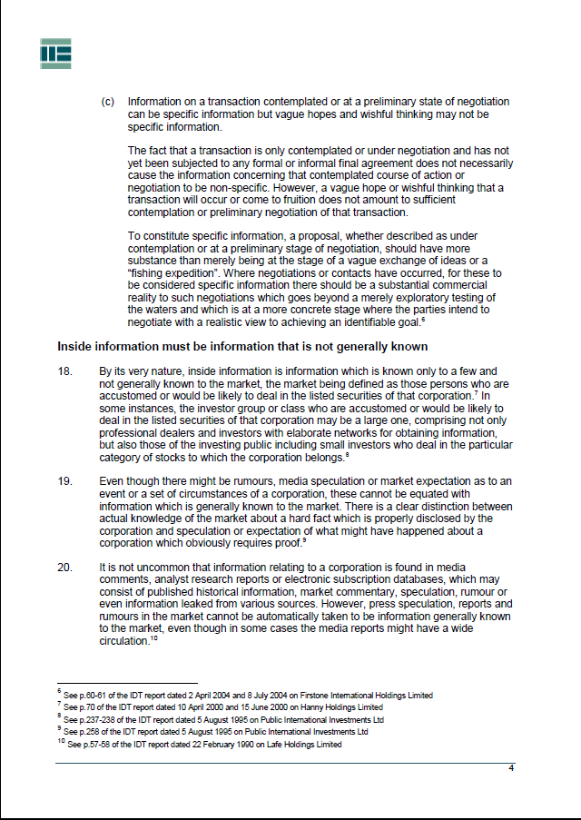

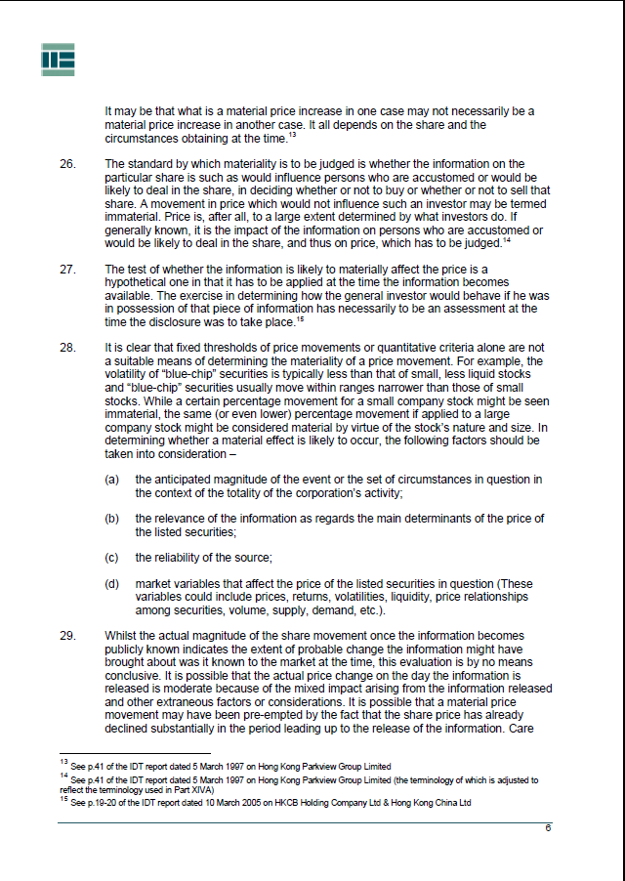

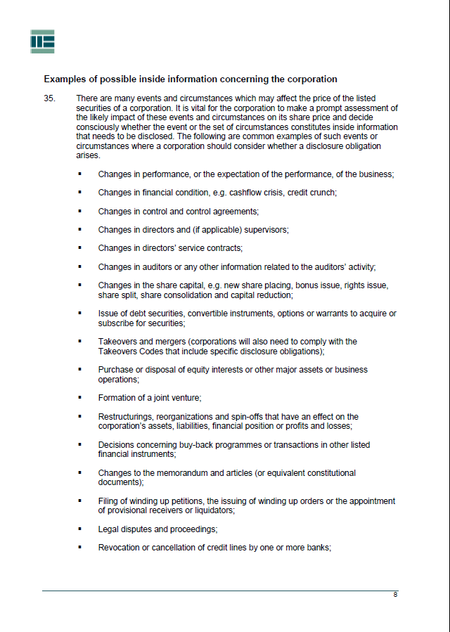

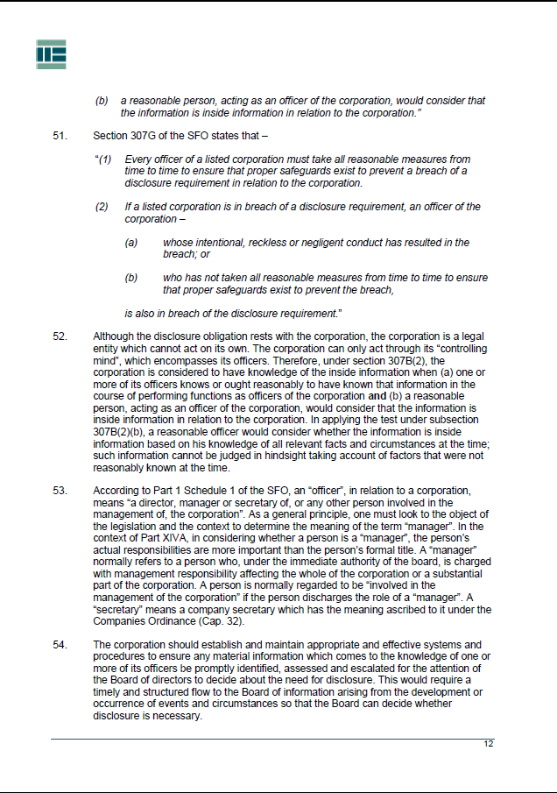

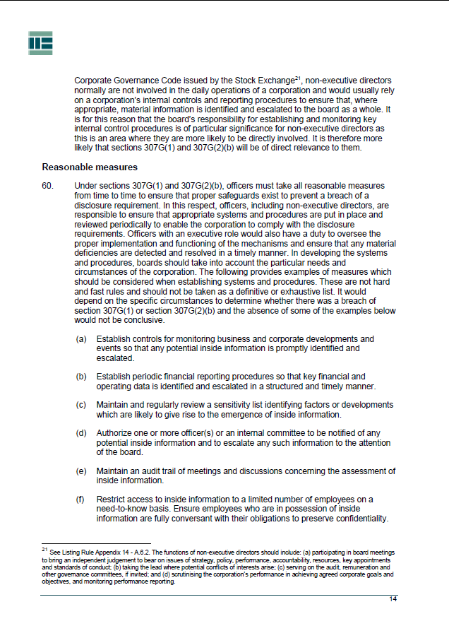

The six types of market misconduct are insider dealing, false trading, price rigging, disclosure of information about prohibited transactions, disclosure of false or misleading information inducing transactions and stock market manipulation.
“Business day” is defined in Part 1 of Schedule 1 to the SFO.

