 | - Charltons’ extensive experience in corporate finance makes us uniquely qualified to provide a first class legal service  - Charltons have representative offices in Shanghai, Beijing and Yangon  - Charltons was named the “Corporate Finance Law Firm of the Year in Hong Kong ” in the Corporate Intl Magazine Global Award 2014  - “Boutique Firm of the Year” / “Boutique Transactional Law Firm of the Year” was awarded to Charltons by Asian Legal Business for the years 2002, 2003 and 2006 to 2017 (inclusive)  - “Hong Kong's Top Independent Law Firm” was awarded to Charltons in the Euromoney Legal Media Group Asia Women in Business Law Awards 2012 and 2013  - “Equity Market Deal of the Year” was awarded to Charltons in 2011 by Asian Legal Business for advising on the AIA IPO
Charltons
Charltons – Directory Listings / Recommendations
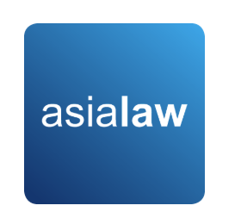  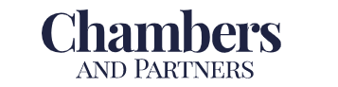  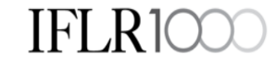 | - Asialaw Profiles 2021  - Capital markets - Highly recommended  - Corporate and M&A - Highly recommended  - Investment funds - Highly recommended  - Private equity - Highly recommended  - Banking and financial services - Recommended  - Technology and telecommunications - Recommended  - Regulatory – Recommended  - Chambers and Partners  - Corporate/M&A: Independent Hong Kong Firms - Band 3  - Chambers Ranked Individuals  - Julia Charlton - Capital Markets: Equity (International firms) China - Recognised Practitioner  - Julia Charlton - Corporate/M&A: Independent Hong Kong Firms - Band 3  - Clinton Morrow - Corporate/M&A: Independent Hong Kong Firms - Recognised Practitioner  - IFLR1000  - Capital markets : Equity - Other notable  - M&A - Other notable  - IFLR1000 Ranked Individuals  - Julia Charlton - Highly regarded
Charltons
   | - Excellent links and networks with law firms worldwide.  - Julia Charlton was:  - named a “Leading Lawyer” by Asia Law & Practice for the years 2002, 2003, 2006-2020 (inclusive)  - awarded ‘Hong Kong Capital Markets Lawyer of the Year’ by Finance Monthly Global Awards 2014.  - named a ‘Leading Advisor’ by Acquisition International for 2013.  - awarded the American Chamber of Commerce of Hong Kong / South China Morning Post Women of Influence: Professional of the Year 2008.  - finalist of Veuve Clicquot Business Woman Award 2018 Hong Kong
Practice Areas
- Capital markets  - Corporate and commercial  - Securities  - Mergers and acquisitions  - Investment funds: China and offshore  - Derivatives  - Restructuring  - Venture capital  - Investment | 

- Capital Markets  - Global offerings and GDRs  - IPOs and Placings  - Listing on the Hong Kong, Shanghai, Shenzhen, London and Luxembourg stock exchanges  - Corporate and Commercial  - Mergers and Acquisitions  - Joint ventures  - Stock exchange advisory  - Corporate governance  - Stock options  - Employment law  - Securities  - Compliance and disclosure  - Dealing and advisory authorisations in Hong Kong and Mainland China  - Options  - Investment Funds: China and Offshore  - Authorised and unauthorised funds  - Stock exchange listing (including Hong Kong, Dublin, London, Cayman, Bermuda stock exchanges)  - Closed-end and open-ended structures  - Hedge funds | - Mergers and Acquisitions  - Hong Kong Code on Takeovers and Mergers  - Public offerings  - Reverse takeovers  - Private acquisitions  - Due diligence in China and elsewhere in Asia  - Derivatives  - Structuring listed and unlisted derivatives  - Placings on Hong Kong and Luxembourg listed warrants and other structured products  - Compliance and regulatory  - Restructuring  - Schemes of arrangement  - Workouts  - Corporate recovery  - Asset injections  - Investment  - China investment regulations  - Structuring a major foreign direct investment projects  - Evaluation and due diligence  - Private Equity and Venture Capital  - Optimum PRC and offshore structures  - Preferred stock financing  - PRC regulations  - Exit Strategies
Professional Experience
- We have extensive experience in mergers & acquisitions in the local region as well as at a global level. We act for a number of investment banks, listed corporations, private companies, and have been substantially involved in a wide range of high-level international mergers and acquisitions.
- We will designate a dedicated and experienced team to deliver first class legal services tailored to international clients.
- Founded in Hong Kong, we have deep roots and knowledge of Chinese language and culture as well as a global perspective across international borders. Over the years, we have also established excellent links and networks with law firms worldwide.
- With our three representative offices in Shanghai, Beijing and Yangon, and our experience working on numerous transactions in China, we have strong connections in China and have cultivated friendships with law firms with corporate and commercial practices throughout the PRC.

The Charltons Team
Our team is experienced in:
  - Conducting due diligence in Hong Kong and China
  - Structuring, negotiating and coordinating public and private M&A transactions
  - Coordinating multi-jurisdictional legal advice in M&A transactions

Team Profile: Julia Charlton
Julia Charlton – Partner  - Julia, LL.B (1st class Honours), A.K.C (Kings College, London) was admitted as a solicitor in England & Wales in 1985 and has practised as a solicitor in Hong Kong since 1987.  - Julia is a member of the Listing Committee of the Stock Exchange of Hong Kong Limited and the Takeovers Panel and the Takeovers Appeal Panel of the SFC.  - Julia was named a “Leading Lawyer” by Asia Law & Practice for the years 2002, 2003, 2004, 2005, 2006, 2007, 2008, 2009, 2010, 2011, 2012, 2013, 2014, 2015, 2016 and 2017.  - Julia was named the “Capital Markets Lawyer of the Year – Hong Kong” in the Finance Monthly Global Awards 2014.  - Julia was also named a “Leading Advisor” by Acquisition International for 2013.  - Julia has extensive experience in China work and is a Mandarin speaker. | 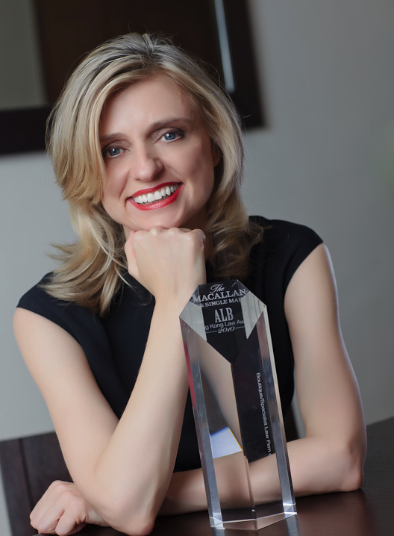

TEAM PROFILE
Calvin Ho – Partner  - Bachelor of Laws (LL.B) (University of Melbourne)  - Bachelor of Commerce (B.Com) (University of Melbourne)  - Postgraduate Certificate in Laws (P.C.LL.)(City University of Hong Kong)  - Admitted as a solicitor in Hong Kong since 2009  - Calvin’s practice focuses on corporate finance and commercial transactions, representing clients in a wide variety of industry sectors.  - Languages: English, Cantonese and Mandarin  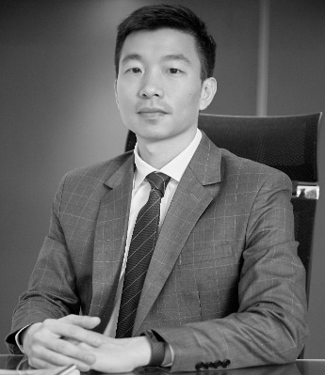 | Clinton Morrow – Partner  - Bachelor of International Business (B.Int.Bus) Griffith University.  - Bachelor of Laws (LL.B)(Hons.) Griffith University.  - Admitted as a solicitor in Queensland, Australia since 2007 and Hong Kong since 2013.  - Justice of Peace in Queensland, Australia since 2005  - Clinton was named as a “Rising Star Lawyer” in Corporate/Mergers and Acquisitions by Asialaw Leading Lawyers 2016 and 2017  - Clinton’s practice areas include company commercial, corporate finance and capital markets  - Languages: English  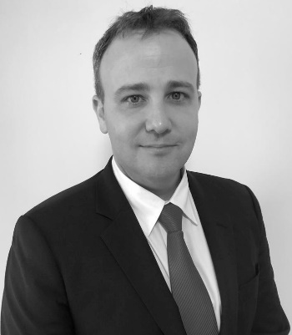

Our Involvement
As your Hong Kong legal adviser, we will be involved in:
  - Drafting, negotiating and advising on all key legal deal documentation
  - Advising on deal structure
  - Coordinating due diligence
  - Coordinating tender processes (in the case of auction sales)
  - Advising on executive and employee compensation, post-closing integration and transition
  - Advising on merger control and antitrust issues
  - Preparing market and regulatory announcements
Our M&A Experience
Our recent M&A experience includes:
  - Advised Somerley Capital Holdings on the potential acquisition of Environmental Investment Services Asia Limited a SFC stock brokerage firm
  - Advised two separate investor groups (“Investors”) on the investment in a fund (“Fund”) for the acquisition of three properties (with a total gross floor area of retail spaces of approximately 300,000 sq. ft. and car parking spaces) in Tseung Kwan O, Hong Kong, managed by fund managers, sub-managers and property managers
  - Advised MTC Group Holdings Limited in relation to the share sale of its wholly owned subsidiary MTC International Coffee Group Ltd and the related sale by MTC Group Pty Limited of its business to Sucafina SA
  - Advised Shandong Xinhua Pharmaceutical Company with regards to a continuing connected transaction and notifiable transaction in relation to the acquisition of assets from the controlling shareholder group
  - Advising on the partial disposal of a licensed asset management group based in Hong Kong to an international French bank
- Advising a PRC based hospital and pharmaceutical group in respect of a US$175m pre-IPO equity investment by a North American based pension fund
- Advising a major PRC State owned mining company listed on the Shanghai and HK Stock Exchanges on the acquisition of an ASX listed gold producer, and the acquisition of the entire interest of Long Province Resources Limited, the owner of gold mining assets in China’s Gansu province
- Advising a major US retailer in connection with acquisition of interests in a PRC and Asian based online retailer who are engaged in online sales of branded goods
- Advising the Hong Kong Stock Exchange listed target company, Seamless Green on a hostile takeover offer which was unsuccessful
- Advising a HK listed PRC mining company on the proposed disposal of a major copper project in Peru to Glencore International AG
  - Advised on a complex two-step acquisition of the Kainantu Gold and Copper Project in Papua New Guinea from Barrick Gold Corporation
  - Advised on the sale of the Dermot Group, a VPN market leader in the PRC, to the NASDAQ listed 21Vianet Group, Inc.
  - Advised a Hong Kong listed company on its major disposal of an associate US automobile dealership group to a NYSE listed company
  - Advised a Hong Kong and Shenzhen dual listed pharmaceutical company on successfully gaining control of another PRC pharmaceutical company
  - Advised Hong Kong listed Paladin Limited on successfully resisting a hostile takeover

- Advising a UK company on the equity swap involving the disposal of coal and anthracite projects in Tajikistan for equity interests in Kaisun Energy Group Limited, a HK listed company
- Advising a major Vietnamese group on the acquisition of the HK holding company owning five prestigious hotels in Vietnam
- Advising a Chinese Mining Consortium on the takeover of Monterrico Metals plc, a company listed on AIM with mining assets in Peru
- Advising a major insurance loss adjuster on the asset and business acquisition of GAB Robins, a group specialising in insurance appraisals in Hong Kong and Taiwan
- Advising a major PRC State owned mining company listed on the Shanghai and HK Stock Exchange on its takeover bid for Indophil Resources ML, an Australian publicly listed company and an explorer and developer of gold and copper-gold opportunities in the Asia-Pacific region, in particular, the Philippines
- Advising a major PRC State owned mining company listed on the Shanghai and HK Stock Exchange on its acquisition of Commonwealth British Minerals Limited, a joint venture between Avocet Mining Plc and the Tajikistan government to explore, exploit and develop gold deposits and other minerals in Tajikistan
- Advising a major PRC State owned mining company listed on the Shanghai and HK Stock Exchange on a possible tender offer to purchase a major gold-copper project in Chile
- Advising a major PRC State owned mining company listed on the Shanghai and HK Stock Exchange on its acquisition of 60% participation interest in Altynken Limited Liability Company which engages in gold explorations projects in the Kyrgyz Republic
- Advising the major shareholders of a HK listed company in connection with a restructuring mandatory unconditional cash offer and reverse takeover
- Advising a HK GEM board listed company in respect of successfully defending a hostile takeover attempt by a shareholder of the company

Contact Us
Hong Kong Office  12th Floor  Dominion Centre  43 – 59 Queen’s Road East  Hong Kong | 
  Telephone:  Fax:  Email:  Website: | (852) 2905 7888  (852) 2854 9596  enquiries@charltonslaw.com  http://www.charltonslaw.com

OTHER LOCATIONS
CHINA  Beijing Representative Office  3-1703, Vantone Centre  A6 Chaowai Avenue  Chaoyang District  Beijing  People's Republic of China  100020  Telephone: (86) 10 5907 3299  Facsimile: (86) 10 5907 3299  enquiries.beijing@charltonslaw.com  MYANMAR  Yangon Office of Charltons Legal Consulting Ltd  161, 50th Street  Yangon  Myanmar  enquiries.myanmar@charltonslaw.com  https://www.charltonsmyanmar.com/ | Shanghai Representative Office  Room 2006, 20th Floor  Fortune Times  1438 North Shanxi Road  Shanghai  People's Republic of China  200060  Telephone: (86) 21 6277 9899  Facsimile: (86) 21 6277 7899  enquiries.shanghai@charltonslaw.com

In association with:-
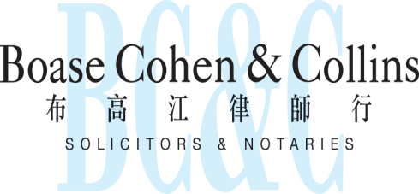

Networks with:-


