The Licensing Regime under
The Securities and Futures Ordinance

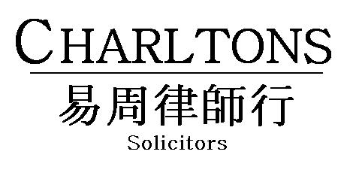

Hong Kong | Shanghai | Beijing | Yangon

www.charltonslaw.com

1. INTRODUCTION 1
2. ‘SINGLE LICENCE’ REGIME 1
3. REGULATED ACTIVITIES 1
4. DEFINITIONS OF REGULATED ACTIVITIES AND GENERAL EXEMPTIONS 1
5. DEFINITIONS OF REGULATED ACTIVITIES AND SPECIFIC EXEMPTIONS 4
6. LICENCE TYPES 9
7. APPROVAL CRITERIA 10
8. RESPONSIBLE OFFICERS 11
9. MANAGERS IN CHARGE OF CORE FUNCTIONS 11
10. REGISTERED INSTITUTIONS 14
11. TEMPORARY LICENCES 15
12. PROVISIONAL LICENCES 17
13. CONDUCT OUTSIDE HONG KONG 17
14. RELAXATION OF REQUIREMENTS IN RELATION TO FUND MANAGERS 18
15. LICENSING REQUIREMENTS FOR HONG KONG PRIVATE EQUITY FIRMS 21
16. SFC LICENSING REQUIREMENTS FOR HONG KONG FAMILY OFFICES 23
17. PENALTIES FOR BREACH OF PART V 23
18. RESTRICTION ON SUBSTANTIAL SHAREHOLDINGS IN LICENSED CORPORATIONS 24
19. DISCIPLINARY REGIME 24
Annex A 28
Annex B 29
Annex C 31
Annex D 32
Annex E 33
Annex F 37
Annex G 41

THE LICENSING REGIME UNDER THE SECURITIES AND FUTURES ORDINANCE

INTRODUCTION

The licensing and registration of persons operating in Hong Kong’s securities and futures markets and non-bank retail leveraged foreign exchange market is dealt with in Part V of the Securities and Futures Ordinance (the ‘SFO’) which came into effect on 1 April 2003. The SFO is administered by the Securities and Futures Commission (the ‘SFC’).

‘SINGLE LICENCE’ REGIME

Part V of the SFO establishes a ‘single licence’ regime whereby a person requires only one licence or registration to conduct different types of regulated activities. The only exception to the single licence arrangement is that securities margin financiers and their representatives must conduct their business through a separate corporation (Section 118(1)(d)) and therefore require a separate licence.

REGULATED ACTIVITIES

There are ten types of ‘regulated activities’ which are as follows:

Type 1: Dealing in Securities
Type 2: Dealing in Futures Contracts
Type 3: Leveraged Foreign Exchange Trading
Type 4: Advising on Securities
Type 5: Advising on Futures Contracts
Type 6: Advising on Corporate Finance
Type 7: Providing Automated Trading Services
Type 8: Securities Margin Financing
Type 9: Asset Management
Type 10: Providing Credit Rating Services

In order to retain flexibility to accommodate new products and services, Section 142 of the SFO entitles the Financial Secretary to amend the list of regulated activities and their definitions contained in Schedule 5 of the SFO.

In summary, the SFO prohibits any person from carrying on a business (or holding himself out as carrying on a business) in a regulated activity unless an appropriate authorisation has been granted or an exemption or exclusion applies (Section 114(1) and (2)). Certain persons are excluded from the licensing/registration requirements of Part V SFO in the definitions of the regulated activities in Part 2 of Schedule 5.

DEFINITIONS OF REGULATED ACTIVITIES AND GENERAL EXEMPTIONS

There are a number of general exemptions from the definitions of regulated activities which are detailed below. In sections 4 and 5 of this note, the terms ‘licence’ and ‘licensed’ include the terms ‘registration’ and ‘registered’ respectively, unless otherwise specified.

INCIDENTAL EXEMPTION

A corporation may not be required to be licensed for certain regulated activities if such activities are performed wholly incidental to its carrying out of other regulated activities for which it is already licensed. This is the case in the following circumstances:

Licensed for Type 1 Regulated Activity (Dealing in Securities)

A corporation licensed for Type 1 regulated activity does not need to be licensed for regulated activities Type 4 (advising on securities), Type 6 (advising on corporate finance) or Type 9 (asset management) provided that such activities are carried out wholly incidental to its securities dealing business. This exemption is normally available to stock brokers who provide investment advice or manage discretionary accounts for their securities clients.

Licensed for Type 2 Regulated Activity (Dealing in Futures Contracts)

A corporation licensed for Type 2 regulated activity does not need to be licensed for regulated activities Type 5 (advising on futures contracts) or Type 9 (asset management) provided that such activities are carried out wholly incidental to its futures dealing business. This exemption is normally available to futures brokers who provide investment advice or manage discretionary accounts for their futures clients.

Licensed for Type 9 Regulated Activity (Asset Management)

A corporation licensed for Type 9 regulated activity does not need to be licensed for regulated activities Type 1 (dealing in securities) or Type 2 (dealing in futures contracts) provided that such activities are carried out solely for the purposes of its asset management business. This exemption is normally available to fund managers who place trade orders to dealers in the course of managing their clients’ securities or futures contracts portfolios.

In addition, a Type 9 licensed corporation which provides a service of managing a portfolio of securities or futures contracts under a collective investment scheme and gives advice or issues analyses or reports in relation to securities or futures contracts solely for the purposes of providing the collective investment schemes that it manages, is exempted from the requirement to be licensed for regulated activity Type 4 (advising on securities) or Type 5 (advising on futures contracts), as the case may be. The exemption allows fund managers to introduce their products to the market without having to obtain a separate licence for advising on their products. For instance, a Type 9 licensed fund manager who intends to market the funds under his management may first provide certain investment advice or related research results to prospective investors to demonstrate his expertise in the area without being licensed for Type 4 or Type 5.

ADVISING GROUP COMPANY EXEMPTION

A corporation is not required to be licensed for Type 4 (advising on securities), Type 5 (advising on futures contracts), Type 6 (advising on corporate finance) or Type 9 (asset management) regulated activity if it provides the related investment advice or services solely to its wholly owned subsidiaries, its holding company holding all of its issued shares, or to other wholly owned subsidiaries of that holding company.

In Relation to Advisory Activities

The exemption should not be applied to a corporation advising its group company in respect of that group company’s client assets. However, where the investment advice and/or related research reports are provided to the group company for its own consumption, notwithstanding that the group company may rely, in whole or in part, on such advice/research reports to service its clients, the above exclusion will still apply if the advice/research reports are issued to the clients by the group company in its own name and that group company has assessed the corporation’s input before issuing such advice/research reports.

In Relation to Asset Management Activities

The exemption is only applicable to a corporation providing asset management service to its group company (on a wholly owned basis) in respect of that group company’s assets. It should not be read as applying to the management of assets belonging to the group company’s clients. Managing assets belonging to third parties would constitute “asset management” and attract a licensing requirement.

PROFESSIONAL ADVISERS’ EXEMPTION

Solicitors, counsel and professional accountants are not required to be licensed for Type 4 (advising on securities), Type 5 (advising on futures contracts), Type 6 (advising on corporate finance) or Type 9 (asset management) regulated activity where they provide such advice or services wholly incidental to their professional practice.

TRUST COMPANY EXEMPTION

In Relation to Dealing in Securities

A trust company registered under Part VIII of the Trustee Ordinance is not required to be licensed for Type 1 regulated activity (dealing in securities) if it acts as an agent for a collective investment scheme in distributing application forms, redemption notices, conversion notices and contract notes, receiving money and issuing receipts on behalf of its principal.

In Relation to Investment Advisory Activities

A trust company registered under Part VIII of the Trustee Ordinance is not required to be licensed for Type 4 regulated activity (advising on securities), Type 5 (advising on futures contracts), Type 6 (advising on corporate finance) or Type 9 (asset management) regulated activity if it provides such investment advice or services wholly incidental to the discharge of its duties as a trustee.

In Relation to Asset Management Activities

If a trustee company acting as trustee of a discretionary trust has appointed an appropriate person to manage the portfolio or in practice acts on professional advice in carrying out its duties as trustee, it would not be required to be licensed. However, if the provision of portfolio management services becomes a separate or distinct business of the trustee company, it is unlikely that the trustee company could rely on the wholly incidental exemption and it would have to apply for a licence for Type 9 regulated activity.

BROADCASTER/JOURNALIST EXEMPTION

A person who gives advice on securities, futures contracts or corporate finance or issues related analyses or reports through:

- a newspaper, magazine, book or other publication which is made generally available to the public; or

- television or radio broadcast for reception by the public, whether on subscription or otherwise,

is not required to be licensed for regulated activities Type 4 (advising on securities), Type 5 (advising on futures contracts) or Type 6 (advising on corporate finance).

DEFINITIONS OF REGULATED ACTIVITIES AND SPECIFIC EXEMPTIONS

TYPE 1: DEALING IN SECURITIES

‘Dealing in securities’ means making or offering to make an agreement with another person, or inducing or attempting to induce another person to enter into or offer to enter into an agreement to:

- acquire, dispose of, subscribe for or underwrite securities; or

- secure a profit to any of the parties from the yield of securities or by reference to fluctuations in the value of securities.

There are many exclusions to the definition in Schedule 5 which, in addition to the exemptions referred to under Section 4 above, include:

- performing the act through a corporation licensed or an authorised institution registered for Type 1 regulated activity (subject to restrictions on intermediaries acting between investors and securities dealers for profit);

- as principal, performing the act by way of dealing with a ‘professional investor’ (whether acting as principal or agent). For the purposes of this exemption, professional investors include only those persons within paragraphs (a) to (h) of the definition of ‘professional investor’ in Part 1 of Schedule 1 to the SFO (‘Schedule 1 professionals’) which is summarised at Annex A to this note. Professional investors do not include the categories of investors referred to in the Securities and Futures (Professional Investors) Rules (which include high net worth individuals and corporations with a portfolio of HK$8 million or more or total assets of HK$40 million or more) for the purposes of this exemption;

- as principal, acquiring, disposing of, subscribing for or underwriting securities; and

- the related dealing activities carried on by an approved money broker within the meaning of section 2(1) of the Banking Ordinance where each of the parties to the transaction is an authorised financial institution for whom the broker acts.

TYPE 2: DEALING IN FUTURES CONTRACTS

‘Dealing in futures contracts’ means:

- making or offering to make an agreement with another person to enter into, or to acquire or dispose of a futures contract;

- inducing or attempting to induce another person to enter into, or offer to enter into, a futures contract; or

- inducing or attempting to induce another person to acquire or dispose of a futures contract.

In addition to the exclusions referred to in Section 4, there are a number of specific exclusions from the definition including:

- performing the act through a corporation licensed or an authorised institution registered for Type 2 regulated activity (subject to restrictions on intermediaries acting between investors and futures dealers for profit);

- as principal, performing the act in relation to a futures contract not traded on a recognised futures market by way of dealing with a ‘professional investor’ (whether acting as principal or agent). For the purposes of this exemption, the definition of professional investors is limited to Schedule 1 professionals and does not include investors referred to in the Securities and Futures (Professional Investors) Rules.

TYPE 3: LEVERAGED FOREIGN EXCHANGE TRADING

‘Leveraged foreign exchange trading’ means:

- entering into or offering to enter into, or inducing or attempting to induce a person to enter into or to offer to enter into, a leveraged foreign exchange contract;

- providing any financial accommodation to facilitate foreign exchange trading or to facilitate an act referred to in (i) above; or

- entering into or offering to enter into, or inducing or attempting to induce a person to enter into, an arrangement with another person, on a discretionary basis or otherwise, to enter into a contract to facilitate an act referred to in (i) or (ii) above.

A ‘leveraged foreign exchange contract’ is defined as a contract or arrangement the effect of which is that one party agrees to:

  - make an adjustment between himself and another according to the value of one currency is relation to another;

  - pay an amount or deliver a quantity of any commodity to another determined by reference to the change in value of one currency in relation to another; or

  - deliver to another at an agreed future time an agreed amount of currency at an agreed consideration.

The definition of ‘leveraged foreign exchange trading’ accordingly covers any foreign exchange trading (which need not be leveraged) and the provision of financial accommodation to facilitate it. Currency caps, swaps, collars, floors and options and spot foreign exchange contracts (if the payments are made in the future) are generally within the definition.

The exemptions include:

  - a contract or arrangement entered into by a corporation:

    - the principal business of which does not include dealing in currency in any form;

    - for the purpose of hedging its exposure to currency exchange risks in connection with its business; and

    - with another corporation (paragraph (ii) of the definition);

  - a contract executed on a specified futures exchange by or through a person licensed or registered for regulated activity Type 2 or is wholly incidental to one or more such contracts (paragraph (vi) of the definition);

  - a contract or arrangement that is wholly incidental to one or more transactions in ‘specified debt securities’ (being specified types of debt securities including those issued by the Government and by issuers with a qualifying credit rating for any of their debt securities)(paragraph (xi) of the definition);

  - a contract or arrangement entered into by an authorised institution (paragraph (xii) of the definition); and

  - a contract or arrangement entered into by a corporation:

    - that has a qualifying credit rating* or has such a rating for any of its debt instruments or is the wholly owned subsidiary of such a corporation or partnership; and

    - whose principal business is not in leveraged foreign exchange spot transactions or the average principal amount of each such transaction entered into by the corporation, calculated for each financial year of the corporation, is not less than HK$7.8 million (Section 3 Securities and Futures (Leveraged Foreign Exchange Trading – Exemption) Rules)

* Note: A ‘qualifying credit rating’ is defined as a Moody’s Investors Service rating of A3 or above for long term debt or Prime-3 or above for short term debt or a Standard & Poor’s rating of A or above for4 long term debt or A-3 or above for short term debt (Schedule 1 Parts 1 and 5).

TYPE 4: ADVISING ON SECURITIES

‘Advising on securities’ means giving advice or issuing analyses or reports on the timing or terms on which particular securities should be acquired or disposed of.

The exemptions from the definition (which are detailed under Section 4 above) include (i) the incidental exemption for licensed securities dealers; (ii) the advising group company exemption; (iii) the professional advisers’ exemption; (iv) the trust company exemption; and (v) the broadcaster/journalist exemption. Also excluded from the definition is the giving of advice by a licensed asset manager, solely for the purposes of carrying on fund management activities pertaining to collective investment schemes under his management.

TYPE 5: ADVISING ON FUTURES CONTRACTS

‘Advising on futures contracts’ means giving advice or issuing analyses or reports on the timing or terms on which particular futures contracts should be entered into.

The exemptions are similar to those for advising on securities and include (i) the incidental exemption for licensed futures dealers; (ii) the advising group company exemption; (iii) the professional advisers’ exemption; (iv) the trust company exemption; and (v) the broadcaster/journalist exemption.

TYPE 6: ADVISING ON CORPORATE FINANCE

‘Advising on corporate finance’ means giving advice:

- in relation to listing rules made by the Hong Kong Stock Exchange or the SFC or the Code on Takeovers, Mergers and Share Repurchases;

- concerning any offer to dispose of securities to the public, any offer to acquire securities from the public, or the acceptance of any such offer (but only if the advice is given generally to holders of securities or a class of securities); or

- to a listed corporation or public company, its subsidiary or its officers or shareholders, concerning corporate restructuring in respect of securities (including the issue, cancellation or variation of any rights attaching to securities).

The exemptions detailed at Section 4 include (i) the advising group company exemption; (ii) the incidental exemption for licensed securities dealers; (iii) the professional advisers’ exemption; (iv) the trust company exemption; and (v) the broadcaster/journalist exemption.

TYPE 7: PROVIDING AUTOMATED TRADING SERVICES

‘Automated trading services’ are services provided by means of electronic facilities (not being facilities provided by a recognised exchange company or recognised clearing house), whereby:

- offers to sell or purchase securities or futures contracts are regularly made or accepted;

- persons are regularly introduced or identified to others in order that they may negotiate or conclude sales or purchases of securities or futures contracts; or

- such transactions may be novated, cleared, settled or guaranteed.

Providers of electronic trading platforms such as trade matching or settlement systems will generally fall within the definition.

It should be noted that the SFO contains 2 separate regimes for the licensing of providers of automated trading services. The Part V provisions cover persons who additionally perform traditional broker/dealer functions. There is a separate regime under Part III SFO providing for the authorisation of ATS providers by the SFC which is for those persons providing mainly automated trading services. Hence, on-line brokers will generally be licensed under Part V whereas electronic exchanges and automated trading systems are required to obtain authorisation under Part III.

TYPE 8: SECURITIES MARGIN FINANCING

‘Securities margin financing’ means providing financial accommodation to facilitate the acquisition, or the continued holding, of securities listed on any stock market, whether or not those or other securities are pledged as security for the accommodation. A corporation licensed for regulated activity Type 8 is prohibited from carrying on any other business other than business which is necessarily incidental to its securities margin financing business (Section 118(d)).

The definition of securities margin financing however excludes the provision of financial accommodation by a person licensed or registered for Type 1 regulated activity (dealing in securities) in order to facilitate acquisitions or holdings of securities by the person for his clients (paragraph (iii) of the Schedule 5 definition). A corporation licensed for regulated activity Type 1 does not therefore need to be separately licensed for Type 8 regulated activity in order to carry on securities margin financing. It must however satisfy a more stringent financial resources requirement: the minimum paid-up share capital requirement for a Type 1 licensed corporation is HK$10 million if it conducts securities margin financing and HK$5 million if it does not. This exemption is normally relied upon by stockbrokers who also provide margin financing facilities to their securities clients. In addition, authorised financial institutions are not required to be registered for Type 8 regulated activity to carry out securities margin financing.

There are further exemptions for the provision of financial accommodation:

- that forms part of an arrangement to underwrite or sub-underwrite securities;

- by collective investment schemes that are corporations:

  - that are or hold themselves out as being primarily engaged in the business of investing, reinvesting or trading in any property (including securities and futures contracts); and

  - the shares in which are exclusively, or primarily, redeemable;

- by an individual to a company in which he holds 10% or more of its issued share capital to facilitate acquisitions or holdings of securities; or

- by an intermediary by way of effecting an introduction between a person and a related corporation of the intermediary in order that the corporation may provide the person with financial accommodation.

TYPE 9: ASSET MANAGEMENT

‘Asset management’ means providing a service of managing a portfolio of securities or futures contracts for another person. It also covers the management of SFC authorised real estate investment trusts. This category of regulated activity regulates fund managers and fund management houses.

TYPE 10: PROVIDING CREDIT RATING SERVICES

‘Providing credit rating services’ is defined as:

- preparing credit ratings:

- for dissemination to the public, whether in Hong Kong or elsewhere; or

- with a reasonable expectation that they will be so disseminated; or

- preparing credit ratings:

- for distribution by subscription, whether in Hong Kong or elsewhere; or

- with a reasonable expectation that they will be so distributed.

‘Credit ratings’ are opinions, expressed using a defined ranking system, primarily regarding the creditworthiness of: (i) a person other than an individual; (ii) debt securities; (iii) preferred securities; or (iv) an agreement to provide credit.

Providing credit rating services does not however include:

- person, provided that the credit rating is provided only to that person and is neither intended for dissemination to the public or distribution by subscription in Hong Kong or elsewhere, and is not reasonably expected to be so disseminated or distributed; or

- gathering, collating, disseminating or distributing information concerning the indebtedness or credit history of any person.

These exclusions are intended to ensure that no SFC licensing requirement applies in relation to the operation of internal credit rating systems (e.g. banks’ internal systems for assessing counterparty risk) and private credit ratings prepared to an individual order. Also excluded from the licensing requirement are the sharing or analyzing of consumer or commercial credit data (such as through consumer or commercial credit reference agencies).

LICENCE TYPES

Under Part V of the SFO, persons engaging in one or more regulated activities are required to apply to the SFC for a licence, unless they have been exempted or can rely on one of the exclusions. There are 2 types of licence: corporate licences and representative licences.

Corporate Licences

Any corporation carrying on one or more regulated activities must apply to the SFC for a licence. Only companies incorporated in Hong Kong or an overseas company registered with the Companies Registry of Hong Kong can be licensed to carry on a regulated activity.

Representative Licences

Any individual who carries on one or more regulated activities on behalf of a licensed corporation is required to apply for approval as a ‘licensed representative’ accredited to that corporation. A licensed representative may be accredited to more than one licensed corporation.

If a licensed representative ceases to act for on behalf of the licensed corporation to which he is accredited, he has a period of 180 days to apply for the transfer of his accreditation to a new licensed corporation (Section 123(1)). If he does not apply for transfer of his accreditation within the 180 day period, his licence will be deemed to have been revoked on his ceasing to act for the licensed corporation.

If a licensed representative ceases to act for his principal, the principal must notify the SFC within 7 days and the representative must return his licence to the SFC within the same period. Failure to comply by the principal, or failure to comply without reasonable excuse by the representative, is an offence liable on conviction to a fine.

APPROVAL CRITERIA

Part V of the SFO sets out various criteria to be met by an applicant for a corporate or representative licence. The most important of these is that the SFC must be satisfied that the applicant is a fit and proper person to be licensed for the regulated activity (Sections 116(3) and 120(3)). Section 129 sets out matters to be taken into account by the SFC in determining an applicant’s ‘fitness and properness’ which include the applicant’s financial status, qualifications and experience, ability, reputation, character, reliability and financial integrity. The SFC’s Fit and Proper Guidelines and Guidelines on Competence made under Section 399 SFO provide further details as to the matters considered by the SFC in determining the fitness and properness of an applicant.

In addition to fitness and properness, the SFC is also required to consider certain other matters, including, in the case of corporations, their ability, if licensed, to comply with the financial resources rules and the adequacy of their insurance coverage in respect of prescribed risks (Section 116(3)).

APPROVAL CRITERIA FOR CORPORATIONS

Competence

The SFC must be satisfied that a licensed corporation has a proper business structure, good internal control systems and qualified personnel to ensure the proper management of risks.

Financial Resources

Depending on the type(s) of regulated activity for which a corporation is licensed, it must maintain at all times paid-up share capital and liquid capital in amounts at least equivalent to those specified in the Securities and Futures (Financial Resources) Rules. If a corporation applies to be licensed for more than one regulated activity, the minimum paid-up share capital and liquid capital that must be maintained is the highest amount required among those regulated activities. A table summarising the minimum paid-up share capital and liquid capital requirements for each type of regulated activity is set out at Annex B to this note.

Insurance

The Securities and Futures (Insurance) Rules (the ‘SFIR’) set out the insurance requirements applicable to corporations licensed for certain regulated activities. A corporation licensed for regulated activity Type 1 (dealing in securities), Type 2 (dealing in futures contracts) or Type 8 (securities margin financing) is required to take out and maintain insurance against specific risks for specified amounts when the SFC approves a master policy of insurance applicable to it. Licensed corporations who are not exchange participants or whose licences are subject to a condition that they may not hold client assets are exempt from this requirement (section 3 of the SFIR).

APPROVAL CRITERIA FOR LICENSED REPRESENTATIVES

A person applying to be approved as a licensed representative (other than a responsible officer the approval requirements for which are detailed at section 8 below) must demonstrate that he has the requisite basic understanding of the market in which he is to work as well as the laws and regulatory requirements applicable to the industry. In assessing a person’s eligibility to be licensed as a representative, the SFC will have regard to the three basic elements mentioned in the table set out at Annex C to this note.

RESPONSIBLE OFFICERS

In addition to requiring persons carrying on regulated activities to obtain a ‘representative licence’, Part V also introduces a ‘responsible officer’ concept. In relation to each regulated activity for which a corporation is licensed, there must be at least one ‘responsible officer’ of the licensed corporation who is available at all times to supervise the business of the regulated activity (Section 118(1)).

Every licensed corporation is required by Section 125 to have at least 2 persons who have been approved by the SFC as ‘responsible officers’ in relation to each of its regulated activities. At least one of those persons must be an executive director (defined as a director who actively participates in, or is responsible for directly supervising, the business of a regulated activity for which a corporation is licensed (Section 113(1)) of the licensed corporation. In addition, every executive director of a licensed corporation is required to be approved by the SFC as a ‘responsible officer’ in relation to the regulated activity in which he participates or supervises.

Approval Criteria for Responsible Officers

An individual applying for approval as a licensed representative and a responsible officer is required to demonstrate that he has sufficient authority to supervise the business of the regulated activity within the licensed corporation. The individual must also possess appropriate skills, knowledge and experience to properly manage and supervise the relevant regulated activity and must meet the requirements set out in the table at Annex D.

Additional competence requirements apply if a person wishes to be licensed to conduct regulated activities in relation to matters falling within the ambit of a particular code issued by the SFC, e.g. the Codes on Takeovers and Mergers and Share Repurchases or the Code on Real Estate Investment Trusts.

MANAGERS IN CHARGE OF CORE FUNCTIONS

The SFC’s Circular to Licensed Corporations Regarding Measures for Augmenting the Accountability of Senior Management issued in December 2016 requires licensed corporations to:

- appoint a Manager-in-Charge of each of eight core functions;

- ensure that the Managers-in-Charge of any core functions that comprise regulated activities are licensed as responsible officers; and

- inform the SFC of their management structure and notify the SFC of any changes to that structure within 7 business days of the change.

Managers-in-Charge of Core Functions

A Manager-in-Charge is an individual who is appointed to be principally responsible (alone or with others) for managing one of the following eight Core Functions of a licensed corporation:

- Overall Management Oversight;
- Key Business Line;
- Operational Control and Review;
- Risk Management;
- Finance and Accounting;
- Information Technology;
- Compliance; and
- Anti-Money Laundering and Counter-Terrorist Financing.

Depending on its scale of operations and control measures, a licensed corporation may appoint one Manager-in-Charge to be responsible for several Core Functions and/or appoint two or more Managers-in-Charge to manage a single Core Function jointly. The board of directors is responsible for delegating authority and responsibilities among the Managers-in-Charge and other members of the company’s senior management; the SFC does not mandate any particular organizational or governance structure.

Whether an individual is a Manager-in-Charge depends on his/her apparent or actual authority. A person may be a Manager-in-Charge if one or more of the following applies:

- he/she occupies a position within the corporation which is of sufficient authority to enable the individual to exert a significant influence on the conduct of that Core Function;

- he/she has authority to make decisions (e.g. assume business risks within pre-set parameters or limits) for that Core Function;

- he/she has authority to allocate resources or incur expenditure in connection with the particular department, division or functional unit carrying on that Core Function; and

- he/she has authority to represent the particular department, division or functional unit carrying on that Core Function (e.g. in senior management meetings or in meetings with outside parties).

The SFC expects a Manager-in-Charge to have sufficient seniority to carry out his/her responsibilities. He/she should:

- be able to report directly to; and

- be accountable for the performance or achievement of the business objectives set by,

the company’s board of directors or to the Manager-in-Charge who assumes the overall management oversight function of the company.

Managers-in-Charge may or may not be employees of the licensed corporation. They may or may not be licensed by the SFC (unless their duties include performing a regulated activity, which requires them to be licensed). However, since they hold positions of authority within the licensed corporation, they must not be external parties that provide outsourced services. Licensed corporations must ensure that any person it employs or appoints to conduct its business is fit, proper and qualified to act in his/her capacity.

Managers-in-Charge might also need to be Responsible Officers

Managers-in-Charge of the Overall Management Oversight function or the Key Business Line function must be licensed as responsible officers in respect of the regulated activities that they oversee, because they would normally be responsible for supervising or participating actively in these regulated activities. The SFC does not expect Managers-in-Charge of other core functions to be licensed as responsible officers, and not every responsible officer needs to be a Manager-in-Charge.

A Manager-in-Charge of Overall Management Oversight must satisfy the industry experience tests under the SFC’s Guidelines on Competence in order to be licensed as a responsible officer. The SFC will consider the applicant’s overall career history within the industry, his/her proposed activities and the licensed corporation’s resources including systems and expertise.

Even if he/she has not had any experience in conducting or supervising a regulated activity directly, an applicant who has held a senior position to manage a control or operational function (e.g. risk management, compliance, etc.) for a long time may still be approved as a responsible officer for that regulated activity, subject to appropriate licensing conditions. A typical licensing condition for such a situation would be to require the applicant to work together with another fully competent responsible officer. A waiver from that licensing condition under section 134(1) of the SFO may be sought after accumulating sufficient experience in the relevant regulated activity.

Appendices D and E to the SFC’s Guidelines on Competence provide for exemptions from the recognised industry qualification requirement and the local regulatory framework paper requirement.

Documentation of Management Structure

The board of directors must approve a formal document (the ‘Management Structure Documentation’) setting out the licensed corporation’s management structure, including the roles, responsibilities, accountability and reporting lines of its senior management personnel. Where more than one Manager-in-Charge is responsible for a core function, the Management Structure Documentation must contain sufficient details regarding the responsibilities of each of those Managers-in-Charge. The board of directors must ensure that each Manager-in-Charge has acknowledged his/her appointment as a Manager-in-Charge and the particular core function(s) for which he/she is principally responsible. The SFC may request that the Management Structure Documentation be made available for its review.

When a corporation applies for a licence under section 116(1) of the SFO, it must submit an organisational structure chart in its application. This chart must include the following information on the corporation’s Managers-in-Charge:

- full name;
- identification information;
- job title indicating the individual’s position and particular business or operational area (e.g. CEO, CIO, Head of Risk Management, etc.);
- place of residence;
- the core function(s) for which he/she is responsible; and
- the job title(s) of the person(s) to whom he/she reports within the corporation and, if applicable, within the corporate group.

Changes to a licensed corporation’s appointment of Managers-in-Charge or any changes to the particulars of a Manager-in-Charge must be communicated to the SFC within 7 business days of the change. A new organisational structure chart must be submitted to the SFC in the case of a new appointment, cessation of appointment or any change in item (e) or (f) in the list above in respect of a Manager-in-Charge.

REGISTERED INSTITUTIONS

  - Authorised financial institutions (i.e. banks, restricted licence banks and deposit taking companies authorised under the Banking Ordinance) are required to be registered with the SFC if they wish to carry on one or more regulated activities, with the exception of Type 3 (leveraged foreign exchange trading) and Type 8 (securities margin financing) activities (Section 119(1)). An authorised financial institution may therefore carry out regulated activities Types 3 and 8 without being registered under the SFO.

Applications for registration from authorised financial institutions are referred by the SFC to the Hong Kong Monetary Authority (the ‘HKMA’) (Section 119). The HKMA will then advise the SFC as to whether it considers the applicant to be a fit and proper person for registration for the relevant regulated activity. Any registration of an authorised financial institution by the SFC may be made subject to reasonable conditions.

  - Executive Officers of Registered Institutions

Section 125(2) of the SFO requires that a registered institution must have complied with Section 71D of the Banking Ordinance in appointing at least 2 executive officers responsible for directly supervising the conduct of each business conducted by the registered institution that constitutes a regulated activity. Those executive officers are further required to be in compliance with the provisions of Section 71C of that Ordinance.

The HKMA’s prior written consent is required before a person may become an executive officer of a registered institution (Section 71C Banking Ordinance). Such approval is subject to the HKMA being satisfied that the person is a fit and proper person to be an executive officer of the institution and has sufficient authority within it to be an executive officer. The HKMA’s consent may be made subject to such conditions as it considers proper.

The SFO further requires that, in relation to each regulated activity for which a registered institution is registered, there must be at least one executive officer of the registered institution available at all times to supervise the business of such regulated activity (Section 119(8)).

  - Relevant Individuals of Registered Institutions

Section 20 of the Banking Ordinance requires registered institutions to register with the HKMA the following information:

- the name and business address of every ‘relevant individual’;

- the capacity in which each ‘relevant individual’ is engaged in relation to a ‘regulated function’ in a regulated activity;

- the date on which each relevant individual was first so engaged; and

- such other particulars as the HKMA thinks fit.

A ‘relevant individual’ of a registered institution is an individual who performs any ‘regulated function’ in a regulated activity for or on behalf of, or by an arrangement with, the institution, other than work ordinarily performed by an accountant, clerk or cashier.

A ‘regulated function’ is any function performed for or on behalf of, or by an arrangement with, the registered institution relating to the regulated activity, other than work ordinarily performed by an accountant, clerk or cashier.

Section 119(8) SFO further requires that any person whose name is registered under Section 20 of the Banking Ordinance must be a fit and proper person to be engaged in the relevant regulated activity.

  - Fitness and Properness

The fitness and properness of registered institutions, their substantial shareholders, directors, chief executive, managers (as defined in Section 2(1) of the Banking Ordinance), executive officers and relevant individuals is considered and determined by the HKMA having regard to the criteria set out in Section 129 SFO and the SFC’s Fit and Proper Guidelines and Guidelines on Competence.

TEMPORARY LICENCES

Part V of the SFO enables the SFC to grant temporary licences to overseas corporations and representatives to conduct one or more of regulated activities Types 1, 2, 4, 5, 6 and 10 in Hong Kong (Sections 117 and 121).

Temporary licences may be granted for a maximum period of 3 months. If the applicant has held a temporary licence before, the total approved period of the respective licences cannot exceed 6 months in any period of 24 months.

Both corporate and individual applicants are prohibited from holding any client assets in conducting any regulated activity.

  - Corporate Applicants

The conditions to be satisfied for the grant of a temporary licence to a corporate applicant are as follows:

- the applicant must carry on a business principally outside Hong Kong in an activity which, if carried on in Hong Kong, would constitute the regulated activity;

- it seeks to be licensed for the regulated activity solely in order to carry on such activity in Hong Kong;

- the applicant establishes that it has a valid authorisation to carry on its business in the overseas jurisdiction from a regulator in that jurisdiction which the SFC is satisfied that the overseas regulator:

    - performs similar regulatory functions to the SFC; and

    - may investigate and take disciplinary action against the applicant in respect of its conduct in Hong Kong;

- it satisfies the SFC that it is a fit and proper person to be licensed for the regulated activity;

- it has nominated for approval by the SFC at least one individual to be available at all times to supervise the business of the regulated activity for which the corporation is to be licensed; and

- an application has been lodged under Section 130(1) for approval of premises to be used by the applicant for keeping records or documents required under the SFO.

  - Individual Applicants

An individual may apply for a temporary licence to carry on one or more of regulated activities types 1, 2, 4, 5, 6 and 10 for:

  - a corporation licensed under Section 116 to which he is accredited; or

  - a corporation licensed under Section 117 (i.e. an overseas corporation holding a temporary licence) to which he is accredited.

The conditions to be satisfied for the grant of such a licence are as follows:

  - the applicant must carry on an activity outside Hong Kong which, if carried on in Hong Kong, would constitute carrying on the regulated activity;

  - the applicant establishes that it has a valid authorisation to carry on that activity in the overseas jurisdiction from a regulator in that jurisdiction which the SFC is satisfied that the overseas regulator:

- performs similar regulatory functions to the SFC; and

- may investigate and take disciplinary action against the applicant in respect of its conduct in Hong Kong.

  - in the case of an applicant for a licence to conduct a regulated activity for a licensed corporation, the licensed corporation must belong to the same group of companies as the corporation for which the applicant is authorised to act outside Hong Kong;

  - an applicant for a licence to carry on a regulated activity for an overseas corporation holding a temporary licence can only apply to conduct a regulated activity specified in that licence; and

  - he is a fit and proper person to be so licensed for the regulated activity.

It is a condition of a temporary licence granted to an individual that he must at all times keep the SFC informed of his contact details and must notify the SFC of any change to them within 14 days.

PROVISIONAL LICENCES

Part V of the SFO also provides that an individual who has applied for a representative licence may be granted a provisional licence to conduct the regulated activities the subject of his application pending the outcome of his application for a full licence (Section 120(2)).

The individual is still required to demonstrate that he is a fit and proper person to be licensed for the relevant regulated activity. The SFC is entitled to revoke a provisional licence at any time having regard to the interests of the investing public. Otherwise, a provisional licence is deemed to be revoked upon the grant or refusal of the licence applied for (Section 120(9)).

CONDUCT OUTSIDE HONG KONG

The scope of the licensing regime extends to activities carried on outside Hong Kong. Section 115 provides that:

- if a person actively markets, whether by himself or through another and whether in Hong Kong or from outside Hong Kong, any services to the public of Hong Kong; and

- those services would constitute a regulated activity if provided in Hong Kong,

then the provision of those services is regarded as carrying on a business in that regulated activity and the person marketing such services is regarded as holding himself out as carrying on a business in the regulated activity. The provision and marketing of such services will therefore require a licence under Section 114. Likewise, if the provision of those services involves the performance by an individual of any function which, if performed in Hong Kong in relation to a regulated activity, would constitute a regulated function, that individual is also required to be licensed.

The SFC maintains a register which is open to the public of licensed persons and registered institutions which indicates, among other things, the regulated activities which they are permitted to carry on and the names of their responsible officers and licensed representatives.

RELAXATION OF REQUIREMENTS IN RELATION TO FUND MANAGERS
The SFC issued a circular on 11 June 2007 (the ‘Circular’) which is at Annex E to this Note setting out initiatives for simplifying and streamlining its licensing process for fund managers.
The initiatives in the Circular are directed primarily at overseas hedge fund managers. However, the SFC states in the Circular that it intends to apply similar principles to the licensing of fund managers generally where they will only be serving professional investors and it is warranted by the circumstances of the particular case. The initiatives outlined in the Circular came into effect on 11 June 2007.

  - Streamlined licensing process for UK or US licensed/registered hedge fund managers

An expedited licensing process will apply to firms that are already licensed or registered by the US SEC or the UK FSA as investment managers or advisers if they have a good compliance track record and serve only professional investors (or have parent companies that satisfy the first two of these requirements). Significantly, ‘professional investors’ for these purposes are professional investors as defined in Schedule 1 to the Securities and Futures Ordinance and the additional categories of professionals prescribed by the Securities and Futures (Professional Investor) Rules. High net worth individuals (i.e. individuals with a portfolio of at least HK$8 million) and large corporate investors (i.e. companies with a portfolio of HK$8 million or total assets of HK$40 million) are therefore included in the definition of ‘professional investors’ for these purposes.

On submission to the SFC of a set of completed licence application forms relevant to a firm’s intended business activities in Hong Kong, the SFC will commence a streamlined review process focusing on key areas of operations such as risk management, valuation, internal controls and management of conflicts of interest.

Firms that are not licensed or registered in the US or UK as investment managers or advisers, but which have proven track records (or have parent companies with proven track records), may also benefit from the streamlined review process.

All licensing applications are considered by the SFC are considered on a case-by-case basis.

  - Clarification of competence requirements for Responsible Officers

The SFO requires every licensed company to have at least two Responsible Officers approved by the SFC for each of the regulated activities for which it is licensed. In addition, every executive director of a licensed corporation must be approved by the SFC as a responsible officer and every licensed corporation must have at least one RO who is an executive director. An ‘executive director’ is a director who actively participates in, or who is responsible for directly supervising, the business of a regulated activity for which a corporation is licensed (Section 113 SFO).

The SFC’s Guidelines on Competence further require that a responsible officer must have at least 3 years’ relevant industry experience over the 6 years immediately preceding the date of his/her application to the SFC for approval as a responsible officer.

To cater for an increasing number of overseas hedge fund managers applying for a licence for Type 9 Regulated Activity (asset management) the SFC has clarified its requirements for responsible officers of an overseas hedge fund manager applying for a Type 9 licence which are:

- Physical presence of responsible officers in Hong Kong

At least one of the responsible officers must be based in Hong Kong and immediately contactable at all times by the SFC and the hedge fund manager’s staff working from its Hong Kong office. If only one RO is based in Hong Kong, he/she must not be subject to the ‘non-sole’ condition, which means that the individual must have industry experience that the SFC considers to be directly relevant to hedge fund management (see further at paragraph (b) below).

- ‘Relevant industry experience’

The SFC will recognise a broader range of industry experience as satisfying the relevant industry experience requirement for responsible officers of hedge fund managers. Experience acquired from asset management, proprietary trading, research, private equity, special situations, and experience in dealing with other alternative investments will be considered as industry experience directly relevant to hedge fund management.

Experience acquired by individuals in sales, marketing or risk management of hedge funds will however be considered as experience indirectly relevant to hedge fund management business. The SFC will therefore only accept individuals with indirectly relevant experience as responsible officers if a licensing condition known as the ‘non-sole’ condition is imposed at the time of their approval. The imposition of a non-sole condition means that where a responsible officer (without directly relevant industry experience) actively participates in or directly supervises the business for which the firm is licensed, he must do so under the advice of another RO who is not subject to the ‘non-sole’ condition.

- Exemption from the local regulatory examination

An individual may be exempted from meeting the local regulatory examination requirement for responsible officers if the following conditions are met:

- the person has over 8 years of industry experience in recognised markets (i.e. Specified Futures and Stock Exchanges identified in Parts 2 and 3 of Schedule 1 of the SFO). Alternatively, the person must already be registered or licensed in the UK or US for investment management or advisory business;

- the firm serves only professional investors (see above);

- the firm is able to confirm that regulatory and compliance support will be provided to the person; and

- the person takes a post-licensing refresher course on local regulations.

  - Exemption from licensing requirement for providing intra-group investment advice

The Circular reminds overseas hedge funds that the SFO exempts Hong Kong based firms from being licensed where they merely provide research to their group companies outside Hong Kong. It notes that some overseas hedge fund managers only wish to set up an investment research operation in Hong Kong, to provide research on securities in Asia to their group companies outside Hong Kong.

A firm may be exempt (under the SFO) from the obligation to be licensed to carry on business in Type 4 (advising on securities) and/or Type 5 Regulated Activity (advising on futures contracts) if it is only advising on securities and/or futures contracts to any of its wholly owned subsidiaries, its holding company that wholly owns the firm or other wholly owned subsidiaries of that holding company (‘group companies’).

The SFC will normally regard an overseas hedge fund manager as being able to rely on this exemption if its Hong Kong office only provides investment advice/research reports to its group companies outside Hong Kong. However, the group companies must assess the advice or reports before issuing any of the material to clients in their own name.

Where a hedge fund manager sends out research analysis and/or provides investment advice to external clients, it may be required to obtain a licence to carry on business in Type 4 or 5 Regulated Activity. Hedge fund managers that carry on the business of portfolio management of securities and/or futures contracts in Hong Kong must obtain a licence to carry on business in Type 9 Regulated Activity.

  - Office Space

The SFC does not specifically prescribe the type of office space that hedge fund managers may occupy and they make no distinction between business centres or serviced offices and other types of business accommodation.

Licensed firms may choose their preferred business premises and should ensure that their business premises are, at all times, suitable for the purposes for which they are being used. In particular, firms must satisfy themselves that the business premises occupied by them are appropriately secure and that confidential/non-public information (such as price sensitive information) and client privacy will be sufficiently safeguarded against unauthorised access or leakage.

Further guidance as to the suitability of business premises is available in the FAQs posted on the SFC website.

LICENSING REQUIREMENTS FOR HONG KONG PRIVATE EQUITY FIRMS

On 7 January 2020, the SFC published a circular which is at Annex F to this Note providing guidance on the licensing obligations of private equity firms (“Hong Kong private equity firms”).

  - Licensing requirements for Hong Kong private equity firms’ general partners

Private equity funds are often established as limited partnerships whose general partner is ultimately responsible for the private equity fund’s management and control. Given the general partner’s role in managing the private equity fund, it will generally need to be licensed for SFC Type 9 regulated activity (asset management) if its activities in Hong Kong constitute asset management business (as defined in the SFO). Individuals performing asset management activities in Hong Kong on behalf of the general partner must also be licensed as representatives accredited to the licensed general partner, and two individuals need to be approved as the general partner’s responsible officers for its asset management business.

A general partner will not however need to be licensed if it delegates all its asset management functions to another entity which holds a Type 9 licence or registration. In these circumstances, the unlicensed general partner must ensure that it does not represent to any prospective investor that it manages a private equity fund in Hong Kong because doing so would breach section 114 of the SFO, which prohibits any unlicensed person from holding himself out as carrying on a business in a regulated activity.

  - Hong Kong private equity funds’ investment committee members
It is quite common for Hong Kong private equity firms licensed for SFC Type 9 regulated activity to establish investment committees in Hong Kong. Members of an investment committee who play a dominant role in making investment decisions for the funds, whether on an individual or joint basis, are generally required to be licensed as representatives, and where appropriate, should also be approved as responsible officers.

Those investment committee members who have no voting right or veto power for investment decisions and whose primary role is to provide input from a legal, compliance or internal control perspective, are generally not required to be licensed by the SFC.

  - Hong Kong private equity funds’ investments in private company securities
“Asset management” as defined in the SFO includes, amongst other things, the provision of a service of managing a portfolio of securities or futures contracts for another person. The SFO’s definition of “securities” however excludes the shares and debentures of a company that is a private company under section 11 of the Companies Ordinance (Cap. 622), that is, a private company incorporated in Hong Kong.

Many Hong Kong private equity funds set up special purpose vehicles (“SPVs”) in Hong Kong or overseas to hold investments. In determining whether an investment portfolio of a private equity fund comprises securities or futures contracts for the purpose of SFC Type 9 regulated activity, the SFC will consider the composition of the entire investment portfolio. If a private equity fund’s underlying investments held though an SPV are “securities” under the SFO (even if the SPV is carved out), or the SPV shares themselves are “securities”, the SFC will regard the management of the portfolio as “asset management” and the private equity firm must be licensed for SFC Type 9 regulated activity.

  - Hong Kong private equity funds’ offering co-investment opportunities
If a Hong Kong private equity firm offers investment opportunities to other persons allowing them to enter into securities transactions alongside the private equity fund, the Hong Kong private equity firm is generally required to be licensed for SFC Type 1 regulated activity (dealing in securities). This is because the act of offering co-investment opportunities would likely be regarded as inducing other persons to enter into securities transactions, which constitutes dealing in securities as defined in Part 2 of Schedule 5 to the SFO.

However, a private equity firm that holds a Type 9 licence will not need to be licensed for Type 1 regulated activity if it offers the co-investment opportunities solely for the purposes of carrying on Type 9 (by virtue of the carve-out from the definition of “dealing in securities” in sub-paragraph (xiv) of the definition in Part 2 of Schedule 5 to the SFO). Thus, if offering co-investment opportunities is an integral part of the private equity fund’s fundraising to secure capital to invest in its underlying projects, the private equity firm would not be required to be licensed for SFC Type 1 regulated activity.

  - Fund marketing activities by Hong Kong private equity firms
Fund marketing activities generally constitute “dealing in securities” - SFC Type 1 regulated activity. Accordingly, a Hong Kong private equity firm carrying on a business in such activities would generally be required to be licensed for SFC Type 1 regulated activity unless an exemption under the SFO applies. For example, a private equity firm which is already licensed for SFC Type 9 regulated activity, will be able to market the funds it manages without being additionally licensed for SFC Type 1 regulated activity, as long as the related fund marketing activities are conducted by the Hong Kong private equity firm solely for the purposes of carrying on its asset management activities, that is, SFC Type 9 regulated activity.

  - Industry experience requirements for responsible officers of Hong Kong private equity firms
The SFC adopts a pragmatic approach when assessing whether a Hong Kong private equity firm’s applicant for approval as a responsible officer has the relevant industry experience to satisfy the competence requirements under the SFC’s Guidelines on Competence, and will recognise a broad range of experience so long as the applicant can demonstrate its relevance to his or her proposed duties. Examples of the types of industry experience the SFC will consider include:

- the conduct of research, valuation and due diligence of companies in related industries;
- the provision of management consulting and business strategy advice to companies in related industries;
- management and monitoring of a private equity fund’s underlying investments in the best interests of fund investors; and
- structuring corporate transactions, such as management buyouts and privatisations.
The SFC also accepts private equity firm experience gained in a non-regulated situation. It will consider experience in an overseas jurisdiction where the related private equity activities are not regulated, as well as relevant experience in a private equity firm which operates in Hong Kong and is exempted from the licensing requirement. For example, such experience may involve conducting research in Hong Kong solely for use by the private equity firm’s holding company.

SFC LICENSING REQUIREMENTS FOR HONG KONG FAMILY OFFICES

On 7 January 2020, the SFC published a circular which is at Annex G to this Note providing guidance on the licensing obligations of family offices (“Hong Kong family offices”) which intend to carry out asset management or other services in Hong Kong.

As the Hong Kong licensing regime under the SFO is activity-based, there is no specific licensing regime for family offices. If the services provided by a family office are regulated activities under the SFO, it must apply for an SFC licence to carry on those activities, unless they are exempt or carved-out from the licensing regime. A family office is not required to be licensed with the SFC if its services do not constitute any regulated activity or fall within an exemption or carve-out. Family offices must however take care to ensure that they do not hold themselves out as carrying on a business in a regulated activity, which is an offence under the SFO.

If a company or family office is set up as a business to manage assets which include securities or futures contracts, it will need to hold a licence for SFC Type 9 regulated activity (asset management which is defined as real estate investment scheme management and securities or futures contract management), unless an exemption applies. The licensing implications of providing asset management services in Hong Kong do not hinge on whether clients are families. Therefore, the relationships amongst the beneficiaries of a family trust or between family members are not relevant in determining whether an SFC licence is required.

If a family office intends to provide other services such as acquiring financial assets following instructions made by the family, it should review whether these services fall within the definition of any of the other types of regulated activities such as SFC Type 1 regulated activity (dealing in securities), and whether it needs to be licensed for such activities.

PENALTIES FOR BREACH OF PART V

Any person who, without reasonable excuse, carries on a business in a regulated activity or holds himself out as carrying on such a business without being licensed or registered to do so under the SFO is guilty of an offence under Section 114(8). That offence carries maximum penalties of a fine of $5,000,000 and 7 years’ imprisonment and a further fine of $100,000 for every day during which the offence continues. Likewise, any individual who performs any regulated function in relation to a regulated activity carried on as a business or holds himself out as performing such function without being appropriately licensed or registered commits an offence. The maximum penalties for that offence are a fine of $1,000,000 and 2 years’ imprisonment and a further fine of $10,000 for each day during which the offence continues.

RESTRICTION ON SUBSTANTIAL SHAREHOLDINGS IN LICENSED CORPORATIONS

Section 131 provides that the SFC’s prior consent is required for a person to become or continue to be a ‘substantial shareholder’ in a corporation licensed under Section 116 SFO. For these purposes a person will be a ‘substantial shareholder’ of a corporation under Section 6 of Schedule 1 if he, either alone or with associates:

- holds an interest in shares of the corporation:-

  - equal to 10% or more of the corporation’s issued share capital; or

  - which entitles him, either alone or with his associates and whether directly or indirectly, to control 10% or more of the voting power at general meetings; or

- holds shares in any other corporation which entitles him, either alone or with his associates and whether directly or indirectly, to control the exercise of 35% or more of the voting power at general meetings of that other corporation, or of a further corporation, where that other corporation is itself entitled, alone or with its associates and whether directly or indirectly, to control 10% or more of the voting power at general meetings of the first corporation.

DISCIPLINARY REGIME

Part IX SFO sets out the disciplinary powers of the SFC and the categories of persons subject to such powers.

  - Liability of Officers

Under sections 194 and 196 of the SFO, the SFC has disciplinary powers to sanction a ‘regulated person’ who is:

- guilty of misconduct; or

- considered by the SFC not to be a fit and proper person to be or to remain the same type of regulated person.

The definition of a ‘regulated person’ is broad. In the case of licensed corporations, it includes the licensed corporation, its responsible officers (which include all executive directors) and any person involved in the management of the licensed corporation, irrespective of whether they are licensed (Section 194(7)). In the case of a registered institution, ‘regulated persons’ include the registered institution, its executive officers, any person involved in the management of the business which constitutes a regulated activity for which the institution is registered and any person registered with the HKMA under Section 20 of the Banking Ordinance as a person who conducts a regulated activity on behalf of the registered institution.

‘Misconduct’ is defined as:

- a contravention of the provisions of the SFO or of any subsidiary legislation made under it;

- a contravention of any of the terms and conditions of any licence or registration under the SFO;

- a contravention of any condition imposed under the SFO or under certain provisions of the Banking Ordinance; or

- an act or omission relating to the carrying on of a regulated activity which, in the opinion of the SFC, is or is likely to be prejudicial to the interest of the investing public or to the public interest.

With respect to misconduct within paragraph (d) above, depending on how broadly the term "relating to" is interpreted, responsible officers, licensed representatives and senior management members may face SFC disciplinary action with respect to business activities which are not "regulated activities" for which they are licensed, if they are considered to be "related to" the conduct of a corporation's regulated business activities.

The Securities and Futures Appeal Tribunal's (SFAT) decision with respect to Moody's Investors Service Hong Kong Limited (Moody's) and its publication of its "Red Flags for Emerging-Market Companies: A Focus on China" (the Red Flags Report). Moody's is licensed for regulated activity Type 10 - providing credit rating services. Moody’s argued that the preparation of the report was not a regulated activity for which Moody's was licensed and the Code of Conduct (which the SFC alleged it had breached) did not therefore apply.

However, the SFAT found that, whether or not this was Moody's intention, the Red Flags Report constituted a credit rating and that its publication was a regulated activity. It went on to say that even if it was wrong on this point, the Red Flags Report was intended to be read "as amplifying and supplementing Moody's ratings … and became part and parcel of Moody's ratings themselves" and thus fell within the definition of "regulated activity" as it was connected to Moody's licensed activities.

  - Sanctions Available

The sanctions available to the SFC include a power to impose on any regulated person a maximum fine of the greater of $10,000,000 or 3 times the amount of profit made or loss avoided by the regulated person as a result of the misconduct. Other sanctions include:

  - the revocation or suspension of a licensed corporation’s licence or the registration of a registered institution in respect of all or part of the regulated activities for which it is licensed or registered;

  - the revocation or suspension of a person’s approval as a responsible officer;

  - a public or private reprimand; and

  - a prohibition order preventing a licensed corporation or registered institution from applying to be licensed or registered or preventing an individual from applying for approval as a responsible officer of a licensed corporation or as an executive officer or relevant individual of a registered institution, in each case for a period specified by the SFC.

The Banking Ordinance also contains provisions entitling the HKMA, after consulting the SFC, to withdraw or suspend the consent granted to an executive officer (Section 71C(4)) and to remove a relevant individual from the register (Section 58A(1)), in both cases either indefinitely or for a specified period. These powers arise where the relevant individual has been guilty of misconduct or if the HKMA is no longer satisfied as to their fitness and properness. The Banking Ordinance definition of ‘misconduct’ for these purposes includes the breach of any provisions of the SFO which apply to the executive officer or relevant individual, conduct which in the opinion of the SFC is, or is likely to be, prejudicial to the interest of the investing public or to the public interest and, in the case of executive officers, breach of any condition attached to the HKMA’s consent. In the case of an executive officer, a misconduct (as defined in the SFO) committed by a registered institution as a result of conduct which occurred with his consent or connivance or which was attributable to neglect on his part, is also regarded as the misconduct of the executive officer (Section 71C(13)).

  - Officers’ Criminal and Civil Liability

The disciplinary sanctions the SFC can impose under section 193 SFO are civil in nature.

Officers of licensed corporations or registered institutions may be criminally liable where the licensed corporation/registered corporation is found guilty of an offence under the SFO, and the offence is proved to have been aided, abetted, counselled, procured or induced by, or committed with the consent or connivance of, or attributable to any recklessness of, any officer of the corporation/registered institution (section 390(1) of the SFO). "Officers" include a director, manager or secretary, or any other person involved in management.

Similarly, where a licensed corporation or registered institution is found to have committed civil misconduct and that misconduct occurred with the consent or connivance of, or which was attributable to any neglect on the part of, a responsible officer or a person involved in the management of the business of a licensed corporation, or an executive officer or a person involved in the management of any regulated activity of a registered institution, then that individual will also be regarded as guilty of the misconduct (Section 193(2)).

May 2020
This note is provided for information purposes only and does not constitute legal advice. Specific advice should be sought in relation to any particular situation. This note has been prepared based on the laws and regulations in force at the date of this note which may be subsequently amended, modified, re-enacted, restated or replaced.

Annex A

THE DEFINITION OF ‘PROFESSIONAL INVESTOR’ FOR THE PURPOSES
OF PART V OF THE SECURITIES AND FUTURES ORDINANCE

‘Professional investors’ are defined in Schedule 1 to the SFO as:

- any exchange company, clearing house, exchange controller or investor compensation company recognised under the SFO or any person authorised under the SFO to provide automated trading services;

- any intermediary (i.e. an SFO licensed corporation or registered institution), or any other person carrying on the business of providing investment services which is regulated under the law of any place outside Hong Kong;

- any authorised financial institution (i.e. a bank, restricted licence bank or deposit taking company authorised under the Banking Ordinance) or any bank which is not an authorised financial institution but is regulated under the law of any place outside Hong Kong;

- any insurer authorised under the Insurance Companies Ordinance or any other person carrying on insurance business and regulated under the law of any place outside Hong Kong;

- (i) any collective investment scheme authorised under the SFO; or

(ii) any scheme which is similarly constituted under the law of any place outside Hong Kong and, if it is regulated under the law of that place, is permitted to be operated under that law,

or any person who operates such scheme;

- any scheme registered under the Mandatory Provident Fund Schemes Ordinance, or its constituent fund, or any person who is an approved trustee or service provider of such registered scheme or who is an investment manager of such registered scheme or constituent fund;

- (i) a registered scheme under the Occupational Retirement Schemes Ordinance;

(ii) or an offshore scheme as defined under that Ordinance which, if regulated under the law of the place where it is domiciled, is permitted to be operated under the law of such place,

or an administrator of any such scheme as defined in that Ordinance; and

- any government (other than a municipal government authority), any institution which performs the functions of a central bank, or any multilateral agency.

Annex B

Minimum paid-up share capital and liquid capital requirements

The table below summarises the minimum paid-up capital and liquid capital that a licensed corporation is required to maintain for each type of regulated activity.

Regulated activity | Minimum paid-up  share capital | Minimum  liquid capital
Type 1 –
(a) in the case where the corporation is an approved introducing agent or a trader | Not applicable | $500,000
(b) in the case where the corporation provides securities margin financing | $10,000,000 | $3,000,000
(c) in any other case | $5,000,000 | $3,000,000
Type 2 –
- in the case where the corporation is an approved introducing agent¹, a trader² or a futures non-clearing dealer | Not applicable | $500,000
(b) in any other case | $5,000,000 | $3,000,000
Type 3 –
(a) in the case where the corporation is an approved introducing agent¹ | $5,000,000 | $3,000,000
(b) in any other case | $30,000,000 | $15,000,000
Type 4 –
(a) in the case where in relation to Type 4 regulated activity, the corporation is subject to the licensing condition that it shall not hold client assets | Not applicable | $100,000
(b) in any other case | $5,000,000 | $3,000,000
Type 5 –
(a) in the case where in relation to Type 5 regulated activity, the corporation is subject to the licensing condition that it shall not hold client assets | Not applicable | $100,000
(b) in any other case | $5,000,000 | $3,000,000
Type 6 –
(a) in the case where the corporation acts as a sponsor:  - hold client assets  - not hold client assets | $10,000,000  $10,000,000 | $3,000,000  $100,000
- in the case where the corporation does not act as a sponsor:  - hold client assets  - not hold client assets | $5,000,000  Not applicable | $3,000,000  $100,000
Type 7 – | $5,000,000 | $3,000,000
Type 8 – | $10,000,000 | $3,000,000
Type 9 –
(a) in the case where in relation to Type 9 regulated activity, the corporation is subject to the licensing condition that it shall not hold client assets | Not applicable | $100,000
- in any other case | $5,000,000 | $3,000,000
Type 10 –  - in the case where in relation to Type 9 regulated activity, the corporation is subject to the licensing condition that it shall not hold client assets  - in any other case | Not applicable  $5,000,000 | $100,000  $3,000,000

Annex C

Test of competence for licensed representatives

Basic elements |  |  | Can be compensated by
 | Academic qualification | Passes in English or Chinese, and Mathematics in HKCEE or equivalent | - Degree in Accounting, Business Administration, Economics, Finance or Law; or other degree (with passes in at least two courses in the above disciplines); or  - Internationally recognised professional qualifications in Law, Accounting or Finance; or  - An additional 2 years of relevant industry experience for lacking either (1) or (2); or  - An additional 5 years of relevant industry experience for lacking both (1) and (2).
 | Industry qualification | Passed relevant the recognised industry qualifications
 | Regulatory knowledge | Passed relevant the recognised local regulatory framework papers | Applicant may apply for exemption from taking the recognised local regulatory framework paper if he satisfies the exemption criteria as set out in Appendix E of the Guidelines on Competence.

Note: A representative licensed for Type 3 regulated activity (leveraged foreign exchange trading) who handles discretionary account activities has to obtain an additional 3 years of direct foreign exchange trading experience in the inter-bank foreign exchange market or currency futures market, or its equivalent over the past 6 years.

Annex D

Test of competence for responsible officers

Basic elements |  |  | Can be compensated by
 | Academic qualification | Passed one of the recognised industry qualifications | - Degree in Accounting, Business Administration, Economics, Finance or Law; or other degree (with passes in at least two courses in the above disciplines); or  - Internationally recognised professional qualifications in Law, Accounting or Finance2; or  - Passes in English or Chinese, and Mathematics in Hong Kong Certificate of Education Examination (‘HKCEE’) or equivalent1 plus an additional 2 years of relevant industry experience3; or  - An additional 5 years of relevant industry experience for lacking both (1) and (2).
 | Industry experience | Generally, possesses 3 years of relevant industry experience over the 6 years immediately prior to the date of application | Not applicable
 | Management experience | Has a minimum of 2 years’ proven management skill and experience | Not applicable
 | Regulatory knowledge | Passed relevant the recognised local regulatory framework papers | Applicant may apply for exemption from taking the recognised local regulatory framework paper if he satisfies the exemption criteria as set out in Appendix E of the Guidelines on Competence.

Annex E

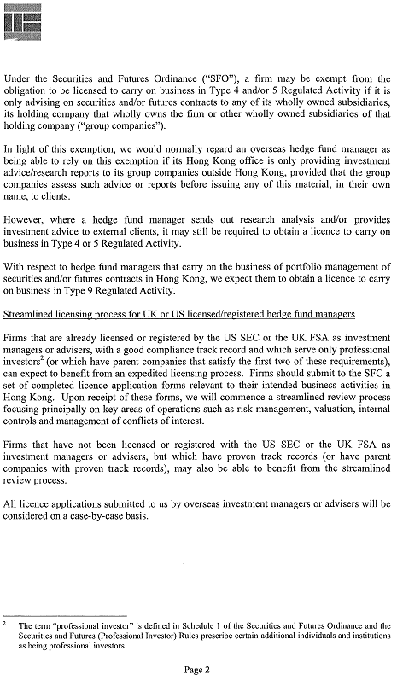
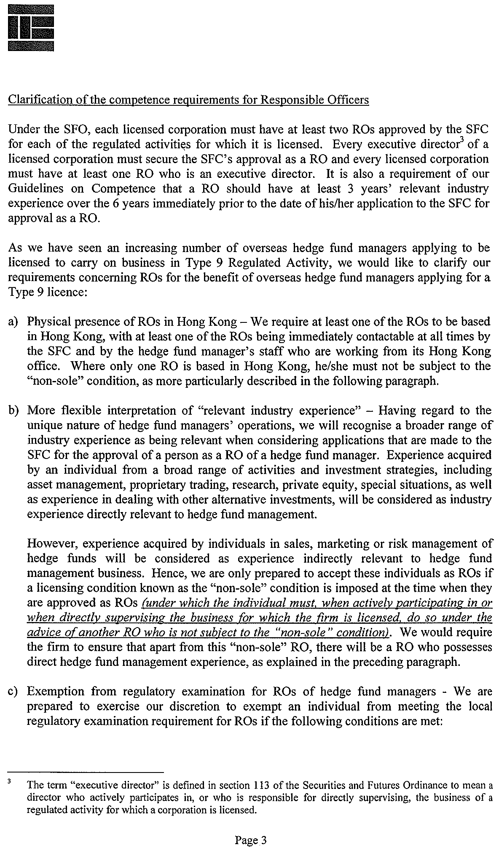
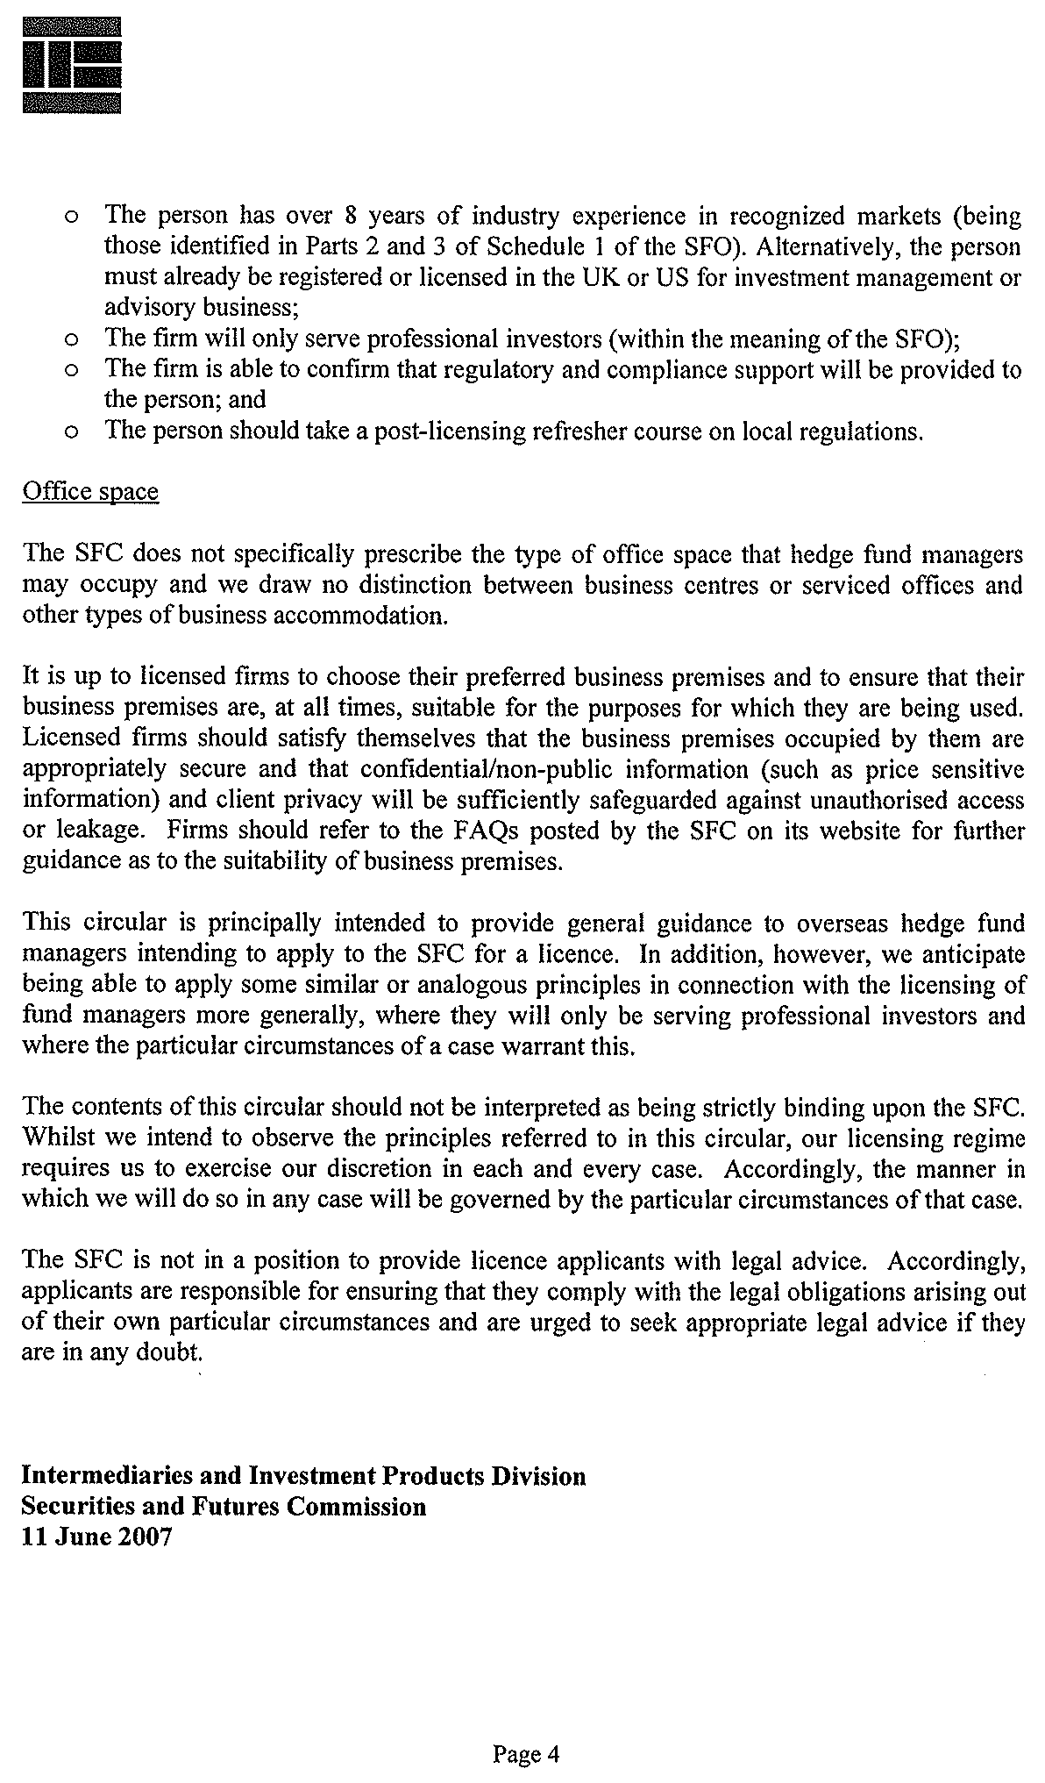

Annex F

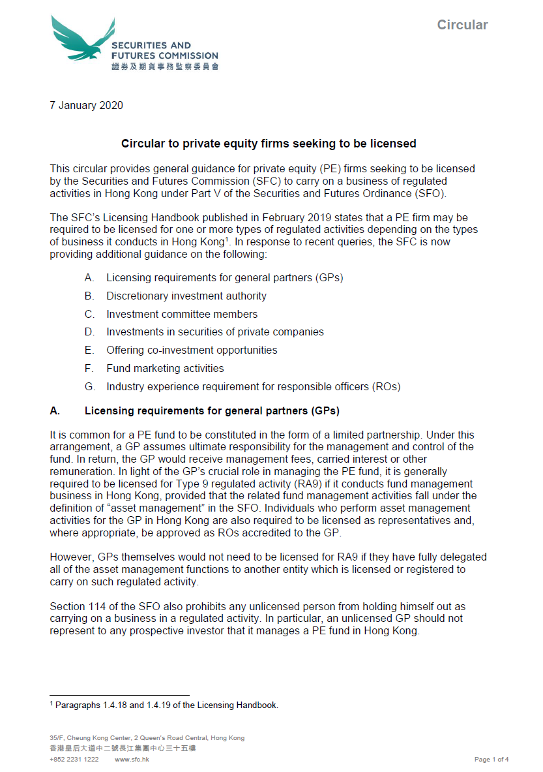
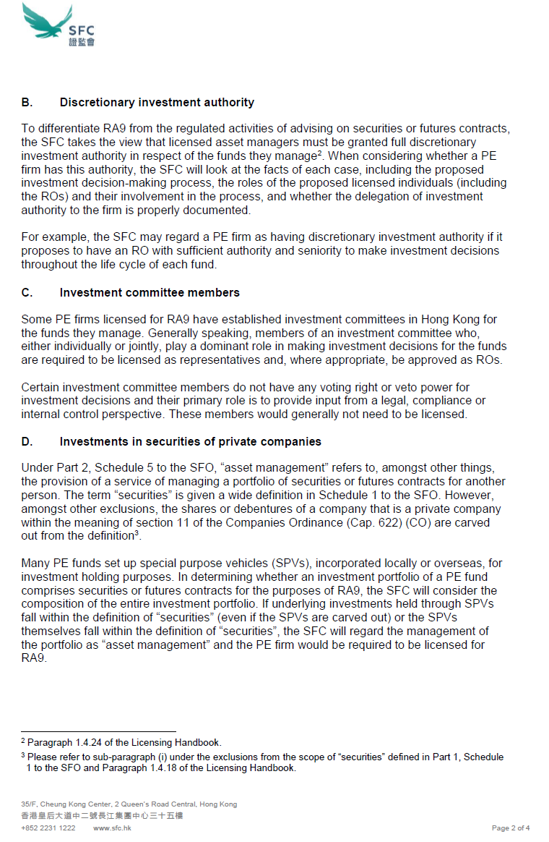

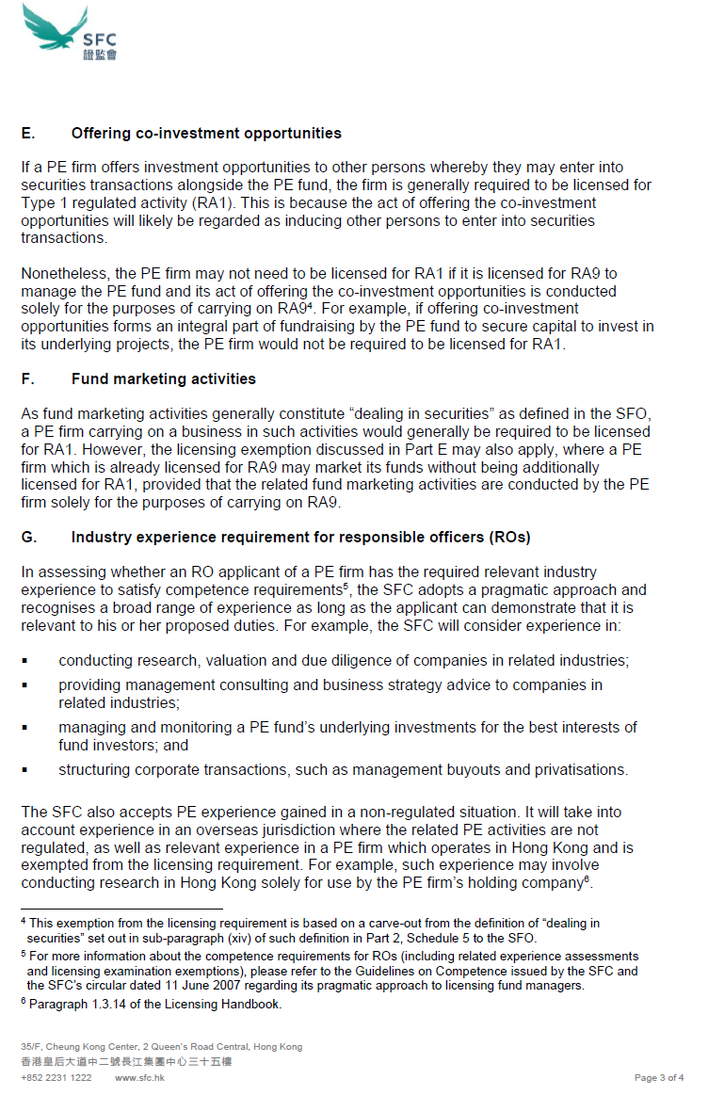



Annex G

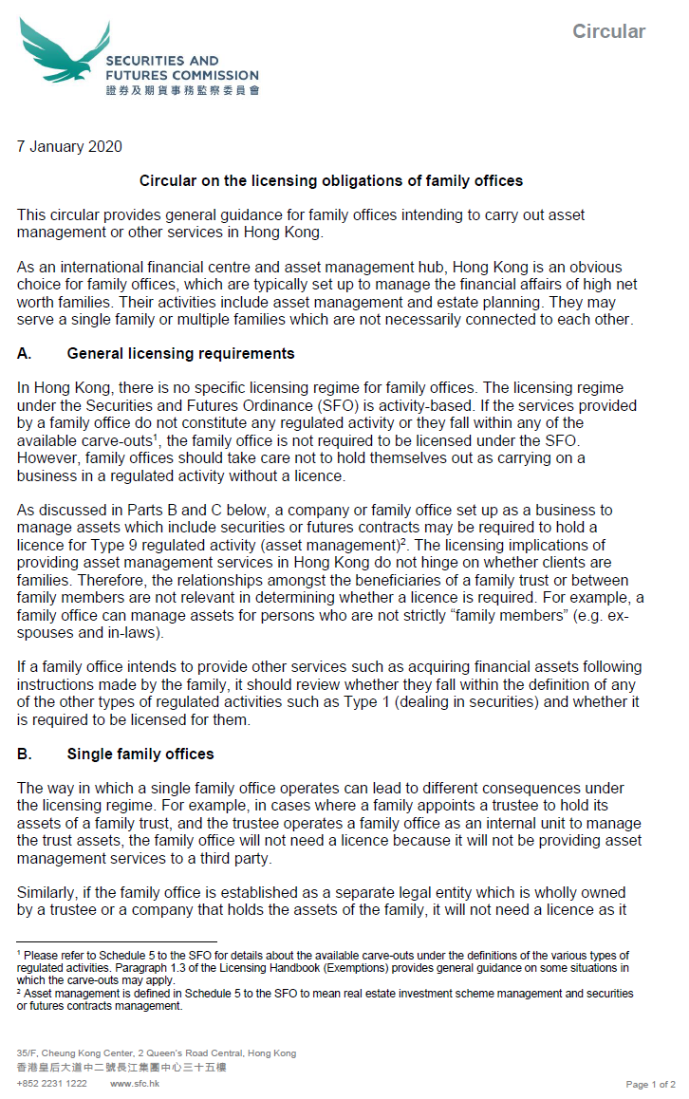
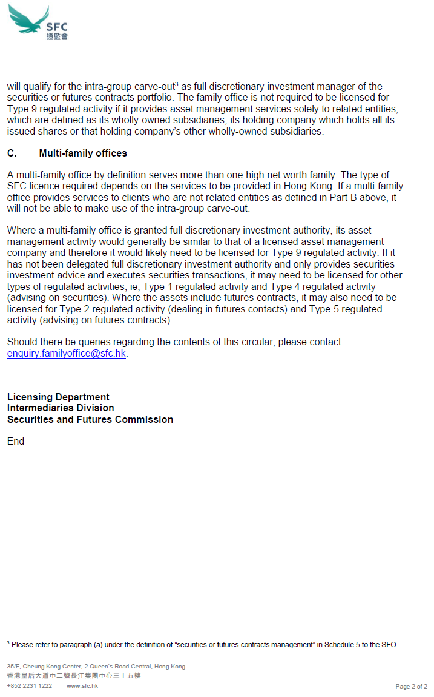

SFC. “Circular to Licensed Corporations Regarding Measures for Augmenting the Accountability of Senior Management”. 16 December 2016. Available at http://www.sfc.hk/edistributionWeb/gateway/EN/circular/intermediaries/licensing/doc?refNo=16EC68.
‘Approved introducing agent’ means a licensed corporation approved as such under section 58(4) of the Securities and Futures (Financial Resources) Rules.
‘Trader’ means a licensed corporation licensed for Type 1 or Type 2 regulated activity which does not hold client assets or handle clients’ orders and, in carrying on the regulated activity for which it is licensed, conducts no business other than effecting, or offering to effect, dealings in securities, futures contracts or options contracts for its own account.
‘Futures non-clearing dealer’ means a licensed corporation licensed for Type 2 regulated activity which is an exchange participant of a recognised futures market, but is not a clearing participant of a recognised clearing house.
All high school public examinations (such as university entry examinations) will be recognised as equivalent to HKCEE.
Internationally recognised professional qualifications in Finance include Chartered Financial Analyst, Certified International Investment Analyst and Certified Financial Planner.
2 1 All high school public examinations (such as university entry examinations) will be recognised as equivalent to HKCEE.
1 2 Internationally recognised professional qualifications in Finance include Chartered Financial Analyst, Certified International Investment Analyst and Certified Financial Planner.
3 In assessing the relevance of an applicant’s experience, the SFC will consider the role and functions to be undertaken by the applicant and whether the applicant possesses the recognised industry qualifications. Experience gained in Hong Kong or elsewhere that is closely related to the functions to be performed will be recognised.

