Connected Transactions

Introduction

- The rules on connected transactions are set out in Chapter 14A of the Main Board Listing Rules International listing venue of choice for Mainland China companies

- Their objectives are:

- to ensure that a listed issuer takes into account the interests of shareholders as a whole when it or one of its subsidiaries enters into connected transactions; and

- to provide safeguards against the directors, chief executive and substantial shareholders (or their associates) taking advantage of their positions. This is achieved by the general requirement of independent shareholders’ approval for connected transactions.

Amendments to Connected Transaction Rules

- Chapter 14A was last amended on 1 July 2014

- Chapter 14A can be viewed at: http://www.hkex.com.hk/eng/rulesreg/listrules/mbrulesup/Documents/mb_contxn_1407.pdf

- Generally, a connected transaction is any transaction between a listed issuer or any of its subsidiaries and a connected person

- For classification purposes, the Exchange may aggregate a series of transactions that are completed over a 12-month period or are otherwise related (Rule 14A.81)

- Factors which the Exchange takes into account in determining whether connected transactions should be aggregated are whether they:

- are entered into by the listed issuer with the same party or parties connected/associated with one another

- involve the acquisition or disposal of securities or an interest in one particular company or group of companies;

- involve the acquisition or disposal of parts of one asset; or
- together lead to substantial involvement by the listed issuer in a business activity not previously part of its principal business activities (Rule 14A.82).

- The Exchange may consider aggregating continuing connected transactions with a single connected person (Rule 14A.83).

- A connected transaction can also be a notifiable transaction. If so, the listed issuer must comply with both Chapters 14 and 14A of the Main Board Listing Rules.

Definition of “Transaction”

- The term “transaction” for the purposes of the connected transaction requirements includes the following, regardless of whether any such transaction is of a revenue nature and entered into in the ordinary and usual course of the group’s business:

- any transaction involving an option to acquire or dispose of assets or to subscribe for securities

- entering into or terminating finance or operating leases;

- granting an indemnity or a guarantee or providing financial assistance;

- entering into a joint venture in any form;

- issuing new securities of the issuer or its subsidiaries;

- provision or receipt of services;

- sharing of services ;

- providing or acquiring raw materials, intermediate products and finished goods; and

- a qualified property acquisition (Rule 14A.24).

- Continuing connected transactions are connected transactions involving the provision of goods or services or financial assistance, which are carried out on a continuing or
recurring basis and are expected to extend over a period of time.

Definition of “Connected Person”

- The term “connected person” includes:

- a director, chief executive or substantial shareholder (holding 10% or more of the voting rights) of the listed issuer or any of its subsidiaries, or an associate of any such persons;
Persons connected with the listed issuer’s “insignificant subsidiaries” are not connected persons. An “insignificant subsidiary” is a subsidiary of the issuer whose total assets, profits and revenues are less than:

- 10% under the percentage ratios for each of the three preceding financial years; or

- 5% under the percentage ratios for the latest financial year (Rule 14A.66)

- a person who was a director of the listed issuer or any of its subsidiaries in the past 12 months, or an associate of such a person; or

- a connected subsidiary – i.e. a non-wholly owned subsidiary of the listed issuer where any connected person(s) of the listed issuer (other that at the level of its subsidiaries) are entitled to exercise, or control the exercise of, 10% or more of the voting power at general meetings of the non-wholly owned subsidiary or a subsidiary of such a non-wholly owned subsidiary

- Note: A wholly-owned subsidiary of a listed issuer is not a connected person

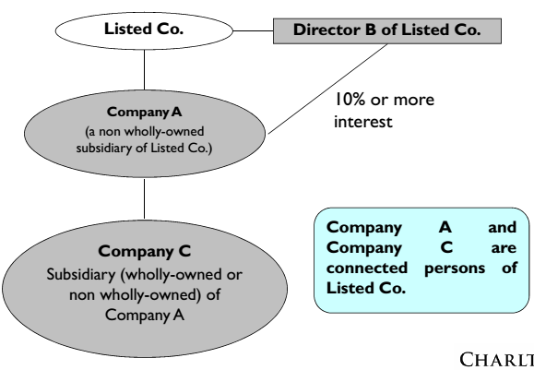

Definition of “Associate of an individual”

- The associates of a connected person who is an individual include:

- his spouse, his (or his spouse’s) child (natural or adopted) or step-child under the age of 18 (each an “immediate family member”);

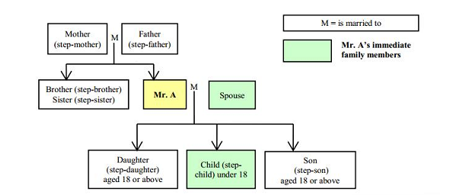
- the trustees, acting in their capacity as trustee of any trust of which the individual or his immediate family member is a beneficiary or, in the case of a discretionary trust, is (to his knowledge) a discretionary object (the “trustees”)
However, the trustees of an employee share scheme or occupational pension scheme are not “associates” of a connected person if :

- the scheme is established for a wide scope of participants; or

- the connected persons’ interests in the scheme are together less than 30% (Rule 14A.18(1))

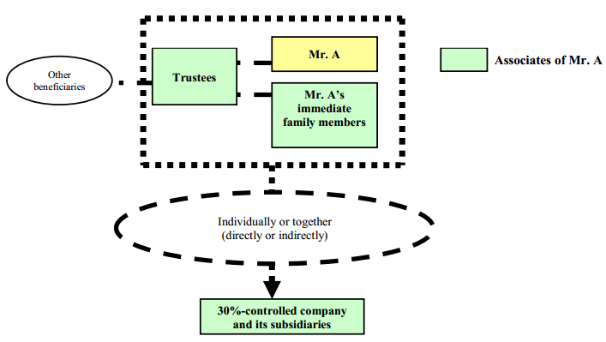

- a company in which in which the individual, his immediate family members and/or the trustees (individually or together) control 30% or more of the voting power or control board composition, and any subsidiary of such company;

An entity is excluded from the definition of associate if the interests of the connected person and his associates in the entity (other than those held through the issuer) are together less than 10%
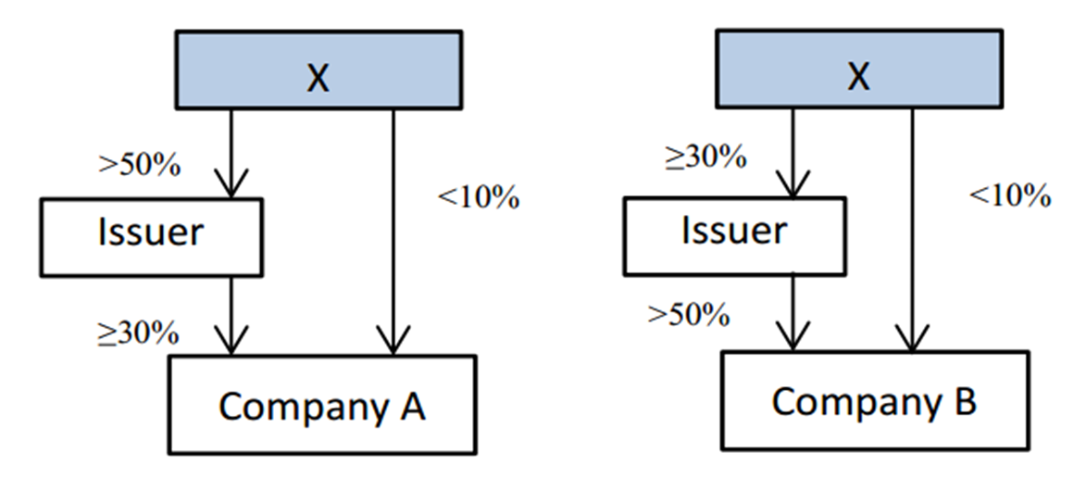

- a person cohabiting with him as a spouse, or his child, step-child, parent, step-parent, sibling or step-sibling (each a “family member”)

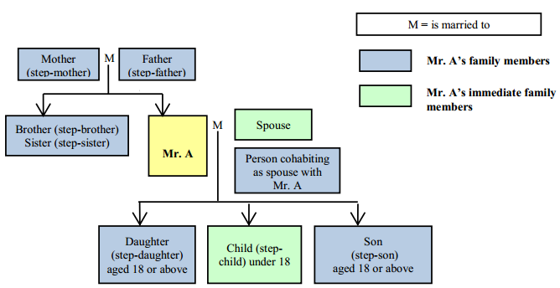

- a company in which the family members (individually or together), or the family members together with the individual, his immediate family members and/or the trustees control the exercise of 50% or more of the voting power or control the composition of a majority of the board of directors, and any of its subsidiaries (Rule 14A.12(2)(b))

- a parent-in-law, brother-in-law, sister-in-law, son-in-law, daughter-in-law, grandparent, grandchild, uncle, aunt, nephew, niece or cousin of the connected person (each a “relative”) whose association with the connected person is such that, in the opinion of the Exchange, the proposed transaction should be subject to the connected transaction requirements; or

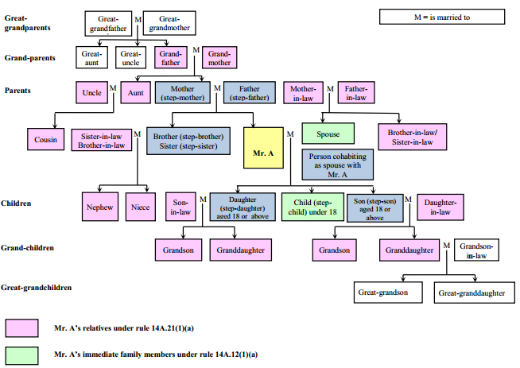

- a company in which the relatives (individually or together) or the relatives together with the connected person, the trustees, his immediate family members and/or family members control > 50% of the voting power or control board composition, and any of its subsidiaries, whose association with the connected person is such that, in the opinion of the Exchange, the proposed transaction should be subject to the connected transaction requirements.

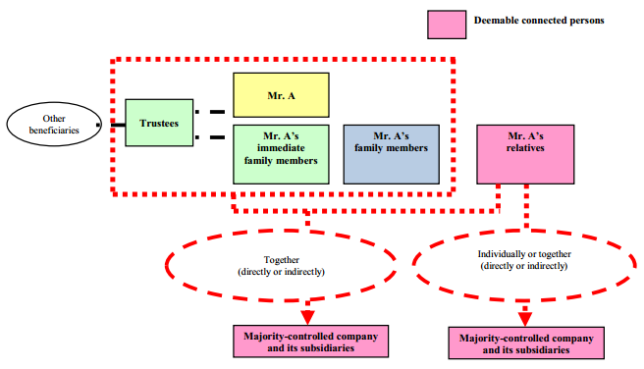
Definition of “Associate of a Company”

- The associates of a connected person which is a company include:

- its subsidiary, holding company, or fellow subsidiary of such a holding company (together “group companies”);

- the trustees of any trust of which the company is a beneficiary or, to its knowledge, discretionary object (the “trustees”;

- a company in which the company, the group companies and/or the trustees (individually or together), can:

- exercise or control the exercise of 30% or more of the voting power at general meetings; or
- control the composition of a majority of the board of directors; and

- a subsidiary of a company in (c).

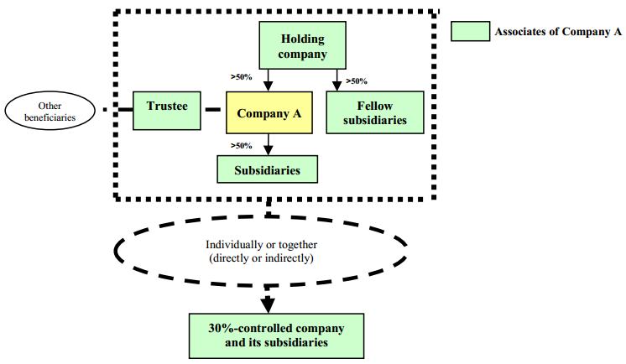

Definition of "Deemed Connected Person"

- The Exchange has the power to deem a person or entity as an issuer’s connected person where the person or entity:

- has entered, or proposes to enter, into:

- a transaction with the group; and

- an agreement, arrangement, understanding or undertaking (whether formal or informal and whether express or implied) with respect to the transaction with a director, chief executive or substantial shareholder of the issuer or any of its subsidiaries or person who was a director within the previous 12 months; and

- should, in the Exchange’s opinion, be considered as a connected person.

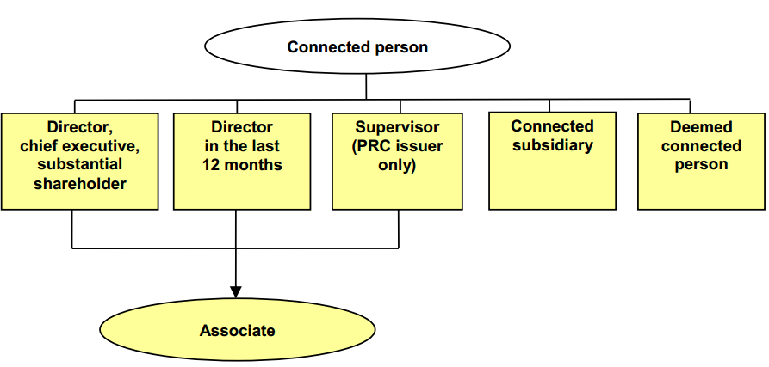

Connected Transactions

Connected Transaction where there is no transaction with a connected person

Acquisition of interest in a company in which a Controller has an interest (Rule 14A.28)

- A group acquiring an interest in a company (the “target company”) from a person who is not a connected person is a connected transaction if the target company’s substantial shareholder :

- is (or is proposed to be) a controller (i.e. a director, chief executive or controlling shareholder of the listed issuer); or

- is, or will, as a result of the transaction, become, an associate of a controller or a proposed controller of the listed issuer.

- Acquiring the target company’s assets is also a connected transaction if the assets account for 90% or more of the target company’s net assets or total assets

- The Exchange may aggregate the interests of the controller and his/its associates in the target company to determine if they are together the target company’s shareholder. Rule 14A.28 does not apply to a listed issuer’s acquisition if the controller or his/its associates are together a substantial shareholder of the target only because of their indirect shareholdings in the target company held through the listed issuer’s group (Rule 14A.30).

Financial Assistance

- Financial assistance includes granting credit, lending money, providing security for, or guaranteeing a loan (Rule 14A.06(17) & 14A.24(4)).

- Financial assistance provided by a listed issuer or its subsidiaries will constitute a connected transaction where it is provided to:

- a connected person; or
- a Commonly Held Entity.

- Financial assistance provided to a listed issuer or its subsidiaries will constitute a connected transaction where it is provided by:

- a connected person; or
- a Commonly Held Entity.

Commonly Held Entities

- A company whose shareholders include:

- a member of the listed issuer’s group; and
- a connected person(s) at the issuer level who (individually or together) can exercise or control the exercise of 10% or more of the voting power at the company’s general meeting. This 10% excludes any indirect interest held by the person(s) through the listed issuer. (Rule 14A.27) (“Commonly Held Entity”)

Options involving Connected Persons

Options granted by listed group to a connected person

- The grant, acquisition, transfer, termination, exercise or non-exercise of an option involving a listed issuer or its subsidiaries and a connected person is a connected transaction and is classified by reference to the percentage ratios (except the profits ratio) (Rule 14A.24(2))

- Termination of an option is a “transaction” unless termination is in accordance with the terms of the original agreement and there is no payment of any penalty, damages or other compensation

- If the listed group grants an option to a connected person and exercise of the option is not at the listed group’s discretion:

- on grant of the option, transaction is classified as if the option had been exercised. The percentage ratios are calculated based on the consideration (which includes both the premium and exercise price of the option), the value of the underlying assets and the revenue attributable to the assets (Rule 14A.79(1));

- the issuer must announce any exercise or transfer of the option if the grant of the option was announced;

- if the grant of the option is required to be announced, the issuer must announce the expiry of the option or notification from the option holder that the option will not be exercised (Rule 14A.61).

Options acquired by listed group from a connected person

- If the listed group acquires/accepts an option from a connected person, where the option is exercisable at the listed group’s discretion :

- on acquisition by, or grant of the option to, the group only the premium is taken for the purpose of the percentage ratios. Where the premium represents 10% or more of the sum of the premium + the exercise price, the value of the underlying assets + the revenue attributable to such assets + the premium and the exercise price are used for the purpose of the percentage ratios;

- on exercise of the option by the group, the exercise price, value of the underlying assets + the revenue attributable to such assets are used for the purpose of the percentage ratios;

- non-exercise or termination of the option or transfer of the option to a 3rd party are treated as if the option was exercised. The exercise price, value of the underlying assets, the revenue attributable to such assets and (if applicable) the consideration for transferring the option, or the amount receivable or payable by the group for terminating the option, are used for the purpose of the percentage ratios

- The Rules provide an alternative test for classifying transfer, non-exercise or termination of options based on the asset and consideration ratios using the higher of:

- i. for a put option held by the listed issuer’s group, the exercise price less the value of the assets subject to the option; or

ii. for a call option held by the listed issuer’s group, the value of the assets subject to the option less the exercise price; and

- the consideration or amount payable or receivable by the issuer group.

- An issuer may adopt the alternative classification test if the value of the option assets is readily ascertainable and the issuer is able to provide:

- a valuation of the option assets prepared by an independent expert using generally acceptable methodologies;

- a confirmation from the INEDs and an independent financial adviser that the transfer, termination or non-exercise of the option is fair and reasonable and in the interests of the listed issuer and its shareholders as a whole.

- If an issuer adopts the alternative method, it must announce the transfer, termination or non-exercise of the option with the views of the INEDs and independent
financial adviser.

Joint Ventures and Classification

Joint Venture Arrangements involving Connected Persons

- The entering into of any arrangement or agreement involving the formation of a joint venture entity in any form, such as a partnership or company or any other form of joint venture arrangement, by a listed issuer and a connected person constitutes a connected transaction (Rule 14A.24(5)).

Classification of Connected and Continuing Connected Transactions

- Connected and continuing connected transactions fall into 3 categories:

- Non-exempt transactions;

- Transactions exempt from the reporting, announcement and independent shareholders’ approval requirements (“wholly exempt” transactions); and

- Transactions exempt from the independent shareholders’ approval requirement only (but subject to the reporting and announcement requirements) (“partially exempt” transactions).

Requirements for Connected Transaction

Written agreement requirement

- The listed issuer must enter into a written agreement with all relevant parties in respect of the connected transaction.

Reporting requirements

- The listed issuer’s next published annual report and accounts must include the details of the connected transaction specified in Rule 14A.71:

- the transaction date;
- the transaction parties and a description of their connected relationship;
- a brief description of the transaction and its purpose;
- total consideration and terms; and
- the nature and extent of the connected person’s interest.

Notification and announcement requirement

- The listed issuer must notify the Exchange as soon as possible after the terms of the connected transaction have been agreed upon and publish an announcement as soon as possible (Rule 14A.35 and 14A.68).

Independent shareholders’ approval requirement

- Connected transactions and continuing connected transactions must be approved by the issuer’s independent shareholders. Voting on the resolution approving the connected transaction must be by way of poll.

- Any shareholder with a material interest in the transaction(s) must abstain from voting (Rule 14A.36, 14A.70(12))

Independent board committee and financial adviser requirements

- An independent board committee (consisting only of INEDs) must be established to advise shareholders as to:

- whether the terms of the connected transaction are fair and reasonable;

- whether the transaction is in the interests of the listed issuer and the shareholders as a whole;

- whether the connected transaction is on normal commercial terms and in the issuer’s ordinary and usual course of business; and

- how to vote, taking into consideration the views of the independent financial adviser
(Rule 13.39(6)(a)).

- An independent financial adviser must be appointed to advise the independent board committee and independent shareholders on the matters set out above (Rule 13.39(6)(b)).

Written Independent Shareholders’ Approval

- The Exchange may waive the general meeting requirement and accept a written independent shareholders’ approval if:

- no shareholder of the issuer would be required to abstain from voting if a general meeting were held; and

- the written independent shareholders’ approval is obtained from a shareholder or closely allied group of shareholders who (together) hold more than 50% of the voting rights in general meeting. (Rule 14A.37)

Shareholders’ Circular Requirement

- The listed issuer must send a circular to shareholders:

- at the same time as it gives notice of the general meeting to approve the transaction; or

- if the transaction is to be approved by way of written shareholders’ approval from a shareholder or closely allied group of shareholders, within 15 business days of publication of the announcement (Rule 14A.46 and 14A.48).

- The shareholders’ circular must comply with the contents requirements of Rules 14A.69(1) to (4), 14A.42, 14A.43, 14A.45 and 14A.70 and must include the letter from the independent board committee and the independent financial adviser’s opinion.
Requirements for Continuing Connected Transactions

Additional requirements for continuing connected transactions

- The written agreement governing the transaction must be on normal commercial terms and be for a fixed period, usually not exceeding 3 years.

- If special circumstances require a longer period, the issuer must appoint an independent financial adviser to explain why the agreement requires a longer period and that it is normal business practice for agreements of this type to be of a longer duration (Rule 14A.52).

- The reporting requirements must be followed for each subsequent financial year during which the listed issuer undertakes the continuing connected transaction.

Annual cap requirement for continuing connected transactions

- The listed issuer must set a maximum aggregate annual cap expressed in monetary terms, the basis of which must be disclosed.

- The annual cap must be determined by reference to previous transactions and figures or be based on reasonable assumptions if no previous transaction exists.

- The annual cap must be approved by shareholders if the continuing connected transaction requires shareholder approval (Rule 14A.53).

- If the annual cap is exceeded, or if the relevant agreement is renewed or its terms are changed materially, the listed issuer must re-comply with the reporting, announcement and independent shareholders’ approval requirements (Rule 14A.54).

Annual review requirements for continuing connected transactions

- Each year, the listed issuer’s INEDs must review the continuing connected transactions and confirm in the annual report and accounts that the transactions have been entered into:

- in the ordinary and usual course of business of the group;

- either on normal commercial terms or terms no less favourable to the listed issuer than those available to/from independent third parties; and

- in accordance with the governing agreement on terms that are fair, reasonable and in the interests of the shareholders as a whole.

- Each year, the auditors must provide a letter to the board of directors confirming whether anything has come to their attention that causes them to believe that the continuing connected transactions:

- have not been approved by the issuer’s board of directors;

- were not, in all material respects, in accordance with the group’s pricing policies if the transactions involve provision of goods or services by the group;

- were not entered into, in all material respects, in accordance with the relevant agreement governing the transactions; and

- have exceeded the annual cap.

Exemptions

Exemptions from Connected Transaction Requirements

Wholly exempt connected transactions

- Connected transactions exempt from the reporting, announcement and independent shareholders’ approval requirements include, but are not limited to:

- intra-group transactions
- de minimis transactions
- certain issues of new securities
- purchase of own securities
- directors’ service contracts
- provision of director’s indemnity or purchase of director’s insurance
- sharing of administrative services
- buying or selling of consumer goods or services
- transactions with associates of a passive investor

Intra-group transactions

- Transactions between a listed issuer and a non wholly-owned subsidiary or between its non wholly-owned subsidiaries where:

- none of the subsidiaries concerned are connected persons;

- no connected persons at the issuer level exercise or control the exercise of 10% or more of the voting power at any general meeting of any of the subsidiaries concerned (Rule 14A.18); and

- Transactions between the issuer’s non wholly-owned subsidiary of which a connected person of the issuer (at the issuer level) controls 10% or more of the voting power at any general meeting of such subsidiary and any of its subsidiaries which are connected persons only by virtue of being the subsidiaries of such non wholly-owned subsidiary or where the transaction is between any of these subsidiaries (Rule 14A.17).

De minimis transactions

- Transactions on normal commercial terms where each or all of the percentage ratios except the profits ratio is/are:

- < 0.1%;

- < 1% and the transaction is a connected transaction only because the connected person is connected by virtue of its relationship(s) with one or more of the listed issuer’s subsidiaries; or

- < 5% and the total consideration is less than HK$3 million (Rule 14A.76(1)).

- This exemption does not apply to the issue of new securities by an issuer to a connected person.

Certain issues of new securities

- Issues of new securities by a listed issuer or its subsidiaries to a connected person are wholly exempt where:

- the connected person receives a pro rata entitlement to securities in its capacity as shareholder;

- securities are issued under a Chapter 17 share option scheme or under a share option scheme existing before the issuer was listed for which approval for listing was granted at the time of listing;

- the connected person subscribes for securities in a rights issue or open offer:

- through excess application (under Rule 7.21(1) or 7.26A(1)); or

- in his or its capacity as an underwriter or sub-underwriter of the rights issue or open offer, and Rule 7.21 or 7.26A (arrangements to dispose of excess securities) has been complied with; or

- securities are issued under a “top-up placing and subscription” where:

- the new securities are issued to the connected person: (i) after such connected person has reduced its holding in the same class of securities by placing them to 3rd parties who are not its associates under a placing agreement; and (ii) within 14 days after the date of the placing agreement;

- the number of new securities issued to the connected person does not exceed the number of securities placed by it; and

- the new securities are issued at a price not less than the placing price. The placing price may be adjusted for the expenses of the placing. (Rule 14A.92(4)).

Purchase of own securities

- Share repurchases by a listed issuer or its subsidiary from a connected person on a recognised stock exchange are wholly exempt from the connected transaction requirements (unless the connected person knowingly sells shares to the listed issuer)(Rule 14A.94(1).

- Share repurchases under a general offer made under the Code on Share Buy-backs are also wholly exempt (Rule 14A.94(2)).

Directors’ service contracts

- Entering into of a service contract by a director of the listed issuer or one of its subsidiaries.

Sharing of administrative services

- Sharing of administrative services between a listed issuer and a connected person on a cost basis if the costs are identifiable and are allocated to the parties involved on a fair and equitable basis.

Provision of director’s indemnity or purchase of director’s insurance

- The provision of an indemnity to, or the purchase of insurance for, a director of the issuer or its subsidiaries will be exempt from the connected transaction rules if:

- the indemnity/insurance is for liabilities that may be incurred in the course of the director performing his duties; and

- the indemnity/insurance is in a form allowed under the laws of Hong Kong, and, where the company providing or purchasing the insurance is incorporated outside Hong Kong, the laws of the company’s place of incorporation (Rules 14A.91 and 14A.96).

- E.g. if under the terms of a director’s service contract, a listed company will indemnify him against liabilities arising from negligence, default and breach of duty by the director, the listed company will not be able to rely on the exemption for directors’ indemnities because the Companies Ordinance does not allow a director to be indemnified against negligence, default or breach of duty.

Nor can the listed company rely on the exemption for directors’ service contracts under Rule 14A.95 in respect of a director’s indemnity or insurance which is not exempt under Rule 14A.91 or 14A.96 (FAQ 19 of FAQ Series 28)

Buying or selling consumer goods or services

- A group buying consumer goods or services as a customer from, or selling consumer goods or services to, a connected person on normal commercial terms in the ordinary and usual course of business is wholly exempt if :

- the goods or services are of a type ordinarily supplied for private use or consumption;

- the goods or services are for the buyer’s own consumption or use. and not be:

- processed into buyer’s products or for resale; or

- used by the buyer for any of its businesses or contemplated businesses. This condition does not apply if the buyer is the group and there is an open market and transparency in the pricing of the goods or services;

- they are used/consumed by the buyer in the same state as bought;

- the transaction is on no more favourable terms to the connected person, or no less favourable terms to the group, than those available to or from independent third parties.

Transactions with associates of a passive investor

- a connected transaction of a revenue nature in the ordinary and usual course of the listed group’s business and on normal commercial terms or better is wholly exempt where:

- the transaction is connected only because it involves an associate (the “Relevant Associate”) of a substantial shareholder of the listed issuer; and

- the substantial shareholder is a passive investor in the listed issuer and meets the following criteria:

- it is a sovereign fund, unit trust or mutual fund authorized by SFC/ appropriate overseas authority;

- it has a wide spread of investments other than securities of the issuer and the Relevant Associate;

- it and the Relevant Associate are connected persons only because it is a substantial shareholder of the listed issuer;

- it is not a controlling shareholder of the listed issuer;

- it does not have any representative on the board of directors of the listed issuer, and is not involved in the management of the listed issuer (including any influence over the listed issuer’s management through negative control on material matters); and

- it is independent of the directors, chief executive, controlling shareholder(s) and any other substantial shareholder(s) of the listed issuer.

Partially Exempt Connected Transactions

De minimis transactions

- Connected transactions are exempt from the independent shareholders’ approval requirement (but subject to the reporting and announcement requirements) where:

- the connected transaction is on normal commercial terms or better; and

- all of the percentage ratios except the profits ratio is/are on an annual basis:

- <5%; or

- <25% and the total consideration is less than HK$10 million (Rule 14A.76(2)).

Exemption for connected persons at the subsidiary level

- Transactions with persons connected only at the subsidiary level are exempt from the shareholders’ approval requirement if:

- the transactions are on normal commercial terms or better;

- the transactions are approved by the issuer’s board of directors; and

- the issuer’s INEDs confirm that the terms of the transactions are fair and reasonable, and they are on normal commercial terms and in the interests of the issuer and its shareholders as a whole (Rule 14A.101).

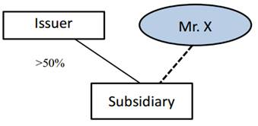

- Subject to fulfilment of the above conditions, transactions between the issuer group and Mr. X will be exempt from the shareholders’ approval requirement.

Exemptions for Financial Assistance

Wholly exempt financial assistance provided by a listed issuer which is a bank

- Financial assistance provided by a listed issuer or its subsidiaries for the benefit of a connected person or Commonly Held Entity is wholly exempt if:

- it is provided on normal commercial terms (or better to the group); and

- each or all of the percentage ratios (except the profits ratio) is/are:

- < 0.1%;

- < 1% and the transaction is connected only because it involves a person connected at the level of the issuer’s subsidiaries; or

- < 5% and the total value of the assistance to the connected person or Commonly Held Entity is < HK$3 million (Rule 14A.87(2)).

Wholly exempt financial assistance provided by a listed issuer which is not a bank

- Financial assistance provided by a listed issuer or its subsidiary which is not a bank for the benefit of a connected person in which it is a shareholder or a Commonly Held Entity is fully exempt if it is:

- provided on normal commercial terms (or better to the group); and

- the assistance provided is proportional to the equity interest directly held by the issuer or its subsidiary in the connected person/ Commonly Held Entity and any guarantee is given on a several basis (Rule 14A.89).

Wholly exempt financial assistance provided to a listed issuer

- Financial assistance provided to a listed issuer or its subsidiary by a connected person or Commonly Held Entity is wholly exempt if it is provided on normal commercial terms or better to the listed issuer and no security is granted over the assets of the listed issuer or its subsidiaries (Rule 14A.90).

Partially exempt financial assistance provided by a listed issuer which is not a bank

- Financial assistance provided by a listed issuer or its subsidiary for the benefit of a connected person or Commonly Held Entity is exempt only from the independent shareholders’ approval requirement if :

- the assistance is provided on normal commercial terms but the assistance is not proportional to the issuer’s or subsidiary’s direct equity interest in the relevant company or guarantees given by the group are not several; and

- each or all of the percentage ratios (except the profit ratio) is/are (i) < 5%; or (ii) < 25% and total value of the assistance to connected person or Commonly Held Entity is < HK$10 million.

Exchange’s Discretion

- In any situation, the Exchange reserves the right to specify that an exemption will not apply to a particular transaction.

- The Exchange may also require that any connected transaction be subject to the independent shareholders’ approval requirements (Rule 14A.75).

Charltons

- Charltons’ extensive experience in corporate finance makes us uniquely qualified to provide a first class legal service

- Charltons have representative offices in Shanghai, Beijing and Yangon

- Charltons was named the “Corporate Finance Law Firm of the Year in Hong Kong ” in the Corporate Intl Magazine Global Award 2014

- “Boutique Firm of the Year” was awarded to Charltons by Asian Legal Business for the years 2002, 2003, 2006, 2007, 2008, 2009, 2010, 2011, 2012, 2013, 2014 and 2015

- “Hong Kong's Top Independent Law Firm” was awarded to Charltons in the Euromoney Legal Media Group Asia Women in Business Law Awards 2012 and 2013

- “Equity Market Deal of the Year” was awarded to Charltons in 2011 by Asian Legal Business for advising on the AIA IPO

Contact us




In association with:
Networked with:
Hong Kong Office
12th Floor
Dominion Centre
43 – 59 Queen’s Road East
Hong Kong

Telephone (852) 2905 7888
Fax : (852) 2854 9596
Email : enquiries@charltonslaw.com
Website : http://www.charltonslaw.com

Other locations

China

Beijing Representative Office
3-1703, Vantone Centre
A6# Chaowai Avenue
Chaoyang District
Beijing
People's Republic of China
100020

Telephone: (86) 10 5907 3299
Facsimile: (86) 10 5907 3299
enquiries.beijing@charltonslaw.com

Shanghai Representative Office
Room 2006, 20th Floor
Fortune Times
1438 North Shanxi Road
Shanghai
People's Republic of China
200060

Telephone: (86) 21 6277 9899
Facsimile: (86) 21 6277 7899
enquiries.shanghai@charltonslaw.com

Myanmar

Yangon Office of Charltons Legal Consulting Ltd
161, 50th Street
Yangon
Myanmar
enquiries.myanmar@charltonslaw.com

