- Chapter 21 Listings
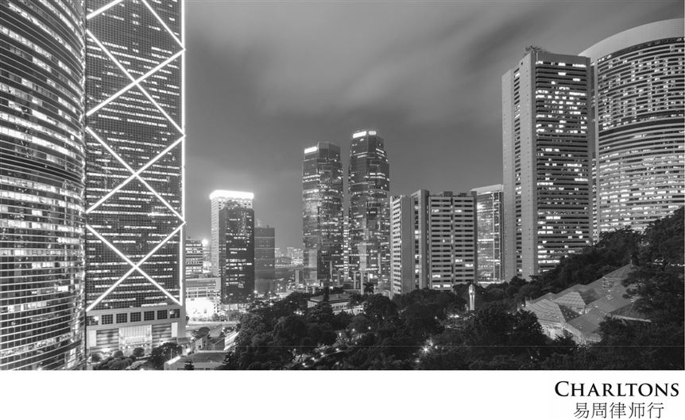

January 2021

www.charltonslaw.com

Index

 |  |  | Page
 | Introduction |  | 3
 | Chapter 20 Listings |  | 4
 | Chapter 21 Listings |  | 5
 Reasons for Listing under Chapter 21 |  |  | 6
 | Restrictive Regime |  | 9
 | Jurisdictional Comparison |  | 16
 | Recent Developments |  | 25

1

Index

 |  |  | Page
 | Issues for Discussion |  | 29
 | About Charltons |  | 30
 | Disclaimers |  | 31

2

Introduction

Issue





Whether there would be real interest in listing funds under Chapter 21

If the Exchange were to implement relevant changes

What we will touch on:









The background to Ch.21

Possible changes to the current regime to attract more funds to list under the Ch.21 regime

Comparable requirements in other fund jurisdictions

The issues for discussion

Current Routes to Listing

- Ch.20 & Ch.21 Main Board Listing Rules

3

Chapter 20 Listings

- Listing of funds authorized by the Securities and Futures Commission (SFC)

- Subject to restrictions in the SFC’s Code on Unit Trusts and Mutual Funds (the UT Code)

  - Investment restrictions

    - fund’s holding of securities of any single issuer cannot exceed 10% of its total net assets (by value)

    - a cap of 10% on the number of ordinary shares a fund can hold in any single issuer

    - a cap of 15% of a fund’s total net asset value on the value of its holding of securities that are not listed, quoted or dealt in on a market

  - Restriction on borrowing

    - a fund cannot borrow more than 25% of its total net asset value

- Excluding Real Estate Investment Trusts (REITS), all Ch.20-listed funds except one are open-ended, including many Exchange Trade Funds (ETFs) in Hong Kong

4

Chapter 21 Listings

- Not authorized by the SFC

- Not subject to the UT Code

- Cannot be marketed or offered to the public in Hong Kong

- Can be offered offshore or to “professional investors” in Hong Kong

- Securities and Futures Ordinances (SFO) definition of “professional investors” includes:

  - Institutional investors

    - including banks, regulated intermediaries, pension funds, insurance companies, authorized funds etc.

  - High net worth investors

    - individuals with a portfolio of at least HK$8 mln (or the foreign currency equivalent)

    - companies with a portfolio of at least HK$8 mln (or the foreign currency equivalent) or total assets of at least HK$40 mln (or its equivalent)

5

Reasons for Listing under Chapter 21

Permanent Capital

 Closed to new capital

 Raised capital is not redeemable by investors

Increased Liquidity

 Tradable on secondary market in the Exchange

 But subject to restriction on board lot size

Transparency

 Ch.21 contains comprehensive disclosure requirements

 Scrutiny of the Exchange gives a stamp of respectability to funds from unregulated jurisdictions

Less Stringent Regulatory Requirements

 No need to be SFC-authorized or to comply with UT Code

6

Reasons for Listing under Chapter 21 (cont’d)

Less Restrictions on Investments

 2 key restrictions

- reasonable spread of investments: value of investment in any one body must not exceed 20% of the fund’s NAV at the date of investment (LR21.04(3)(b))

- a fund cannot, either alone or with any connected person, take legal, or effective, management control of its underlying investments and, in any event, must not own or control more than 30% of the voting rights in any single company or body (LR21.04(3)(a))

 Other Restrictions

○

○

no change in the investment objectives, policies and additional restrictions without prior shareholders’ consent for 3 years after the initial listing (LR21.04(5))

a person cannot control more than 30% of the votes exercisable at any general meeting of the fund (LR21.04(4))

- funds are allowed to adopt additional restrictions (eg. borrowing powers)

7

Reasons for Listing under Chapter 21 (cont’d)

Attraction of a Chapter 21 Listing

- “Technical listings” – for funds to be marketed outside Hong Kong

- Ch.21 listing will attract institutional investors whose investment mandates only permit investment in listed securities

- Some jurisdictions offer favourable tax treatment to investments in listed funds e.g. Japan

8

Restrictive Regime (cont’d)

- Exchange’s Guidance Letter HKEx-GL17-10 imposes restrictions to ensure Ch.21 funds marketed only to professional investors

 | Restrictions imposed by Guidance Letter
Minimum Board | 1) Funds must have a board lot size and minimum subscription size of at least HK$500,000 (subject
Minimum Board |  | to adjustment for special circumstances)
Lot and |  | to adjustment for special circumstances)
Subscription Size | 2) Intermediaries selling interests in Ch.21 funds must satisfy themselves that buyers are
 |  | “professional investors” within SFO definition
 |  | A principles-based approach is allowed for intermediaries’ determination of whether customers
 |  | meet the qualification thresholds under the Professional Investor Rules
 | 3) | The offering structure must be generally acceptable to the Exchange
Minimum Number | Ch. 21 fund must have at least 300 shareholders, unless a waiver is obtained. No waiver for a listed
of Shareholders | Chapter 21 company has been granted since 2004 (when required minimum no. of shareholders was
of Shareholders | increased to 300).

9

Restrictive Regime (cont’d)


 | Restrictions imposed by Guidance Letter
Minimum Market | Although Ch.21 funds not subject to market cap. requirement under Rule 8.09, in practice minimum
Minimum Market | market cap. must be HK$150 mln (because of required subscription size of HK$500,000 per placee and
Cap.
Cap. | required minimum of 300 placees).
Prospectus | Prospectus registration is not required, but where a fund proposes to register a prospectus, it must
Prospectus | provide the Exchange with a submission from its sponsor & legal adviser on why the offering document
Registration
Registration | is a prospectus
 | Note: An offer of shares in a fund to the public requires both the fund and its listing documents to be
 | authorized by the SFC and comply with Ch.20 of the Listing Rules
Conflicts of | Where the executive director is involved in the management of other funds at the same time
Conflicts of | Internal control mechanism must demonstrate:
Interest
Interest | o | Directors have enough time and resources to manage the company
 | o | Confidentiality maintenance in accordance with professional standard
 | o | Disclosure of fair process of allocating investment opportunities between the company and
 |  | other funds in a timely and equitable manner in the listing document

10

Restrictive Regime (cont’d)

Criticism

- Regime remained more or less unchanged since introduction in 1989

- Unfavourable listing environment for funds compared to foreign exchanges, especially the Irish Stock Exchange (ISE) and Luxembourg Stock Exchange (LuxSE)

Minimum of 300 Shareholders Requirement

- Virtually impossible to achieve

- Questionable co-existence with Listing Rule 21.04 which exempts Ch.21-listed funds from compliance with minimum public float requirement set out in LR8.08(1)

- Guidance Letter contemplates possibility of derogation

11

Restrictive Regime (cont’d)

Share Price

- Trade at a discount to net asset value

- reflects the fund’s operational costs (often including the fund manager’s annual fee and performance fee which are deducted before dividend payment)

Tax Treatment

Profits Tax

- Non-offshore Ch.21-listed fund has to pay HK profits tax

- SFC authorized funds are exempted from profits tax

12

Restrictive Regime (cont’d)

Profits Tax (cont’d)

- Offshore fund may be exempt for:

- specified transactions, including transactions from which the trading receipts do not exceed 5% of the total trading receipts from the specified transactions and incidental transactions combined; and

- transactions conducted through or arranged by a specified person

- “Specified transactions”: include transactions in securities (other than the shares or debentures of a private company)

- “Specified person”: an entity licensed by the SFC as a licensed corporation, or an authorised financial institution registered as a registered corporation, to conduct regulated activities under Part V SFO

Stamp Duty

- Unlike ETFs listed under Ch.20, trades of Ch.21-listed shares are subject to stamp duty

13

Restrictive Regime (cont’d)

Listing Process

 No streamlined application process in place - can be slow and costly

 Lack of recent listings - considerable uncertainty in application approval

Conflicts of Interest

 Often exist between the investment manager and the board of the investment company and between the investment company and the companies in which it invests

 Principal requirements under the existing regime:

○

○

at least 1/3 of a listed investment company’s board must be made up of independent non-executive directors (INEDs);

the investment manager who must be licensed to conduct regulated activities Types 4 and 9 (advising on securities and asset management, respectively) must comply with the conflict of interest requirements of the SFC’s Fund Manager Code of Conduct and the Code for Persons Licensed by or Registered with the SFC.

Disclosure Requirements

 The requirement to disclose investments only annually is considered to be insufficient

14

Jurisdictional Comparison

Major competitors

 ISE and LuxSE – facilitate technical listings

 LSE, Euronext Amsterdam, NASDAQ and NYSE – popular with hedge funds

General Comparison

 LSE is the only exchange that operates a separate market segment – “Specialist Fund Market”

- allows funds to be marketed only to “institutional, highly knowledgeable investors or professionally advised investors”

- listing of large hedge funds, private equity funds and certain emerging market and specialist property funds

 ISE and LuxSE have listing regimes for funds marketed to professionals

- ISE: “Qualified Investor Funds” (QIFs) regime

- LuxSE: “Specialized Investment Funds” (SIFs) regime

15

Jurisdictional Comparison

Comparison of HKEx, LuSE and ISE

 | HKEx Ch. 21 | LuxSE |  |  |  | ISE
Minimum | 300 | No required minimum |  |  |  | No minimum requirement
number of
shareholders
Minimum | Minimum board lot size | Minimum | investment |  | in | QIFs can only be marketed to
subscription | and subscription amount is | SIFs is | EUR | 125,000 |  | Qualifying Investors who make
amount | HK$500,000 | (HK$1.2 mln) if the |  |  |  | the minimum subscription of
 |  | investor | is | not | an | EUR 100,000
 |  | institution or professional

16

Jurisdictional Comparison


 |  | HKEx Ch. 21 |  | LuxSE |  |  |  |  | ISE
Restricted |  | Ch.21 | funds can | Open only to qualified investors: |  |  |  |  | QIFs can only be marketed to
marketing |  | only | be marketed | a)Institutional investors |  |  |  |  | "Qualifying Investors" (Annex II of
requirements |  | to | “professional | b)Professional investors |  |  |  |  | MiFID) who must:
 |  | investors” |  | c)Others who declare in writing that |  |  |  |  | a)be a professional client in accordance
 |  |  |  | they’re informed |  | investors |  | and | with MiFID; or
 |  |  |  | either of the following: |  |  |  |  | b)receive an appraisal from an EU
 |  |  |  | 1) Minimum investment of EUR |  |  |  |  | credit institution, MiFID firm or UCITS
 |  |  |  | 125,000, even in case of co- |  |  |  |  | management company that he/she has
 |  |  |  | investment; |  |  |  |  | appropriate expertise, experience and
 |  |  |  | 2) Appraisal |  | from |  | bank, | knowledge; or
 |  |  |  | investment |  |  |  | firm/ | c)self-certifies that he/she has
 |  |  |  | management co. with an EU |  |  |  |  | sufficient knowledge and experience to
 |  |  |  | passport, certifying that they |  |  |  |  | enable him/her to properly evaluate
 |  |  |  | have | the |  | appropriate |  | the investment or his/her business
 |  |  |  | expertise, |  | experience |  | & | involves the management, acquisition
 |  |  |  | knowledge |  | to | adequately |  | or disposal of property of the same
 |  |  |  | understand |  | the | investment |  | kind as the property of the QIF.
 |  |  |  | made in the fund

17

Jurisdictional Comparison


 |  | HKEx Ch. 21 | LuxSE |  |  |  |  |  |  | ISE
Restricted |  |  | SIF | must |  |  | publish |  | a | Although QIF may only be
marketing |  |  | prospectus |  |  | which |  |  | must | marketed to professional investors
requirements |  |  | comply |  |  | with | the |  | EU | as defined in the AIFMD, EU
(cont’d) |  |  | Prospectus and Transparency |  |  |  |  |  |  | Member States can permit AIF to
 |  |  | Directives |  |  |  |  |  |  | be sold to other categories of
 |  |  |  |  |  |  |  |  |  | investors under domestic law
 |  | Minimum market cap. of | Minimum market |  |  |  |  | cap. of
Minimum market |  | HK$150 million because of the | EUR1,250,000 |  |  |  | must |  | be
capitalization |  | requirements for a | achieved |  | within |  | 12 | months
 |  | subscription size of | following |  |  | approval |  | by | the
 |  | HK$500,000 per placee and a | CSSF (but only 5% of the
 |  | minimum of 300 shareholders | subscribed |  |  | share |  | capital
 |  |  | must be paid-in)
 |  | INEDs to comprise 1/3 of | Required |  |  | to | comply |  | or | Minimum of 2 INEDs for funds
Investment |  | board and must be minimum | explain |  | against |  | conflict of |  |  | domiciled offshore and all
Manager |  | of 3 INEDs | interest |  |  | provisions |  |  | in | directors to be conflict free
conflicts |  |  | corporate governance code

18

Jurisdictional Comparison


 |  | HKEx Ch. 21 |  |  |  | LuxSE | ISE
Investment |  | Ch. | 21 | funds’ |  | No significant restrictions | QIF local restrictions
Restrictions |  | restrictions: |  |  |  |  | -minimal investment restrictions
 |  | -a fund’s |  | holding | of | Risk diversification
Note: Exchanges in |  |  |  | holding | of | requirements (Circular CSSF | QIFs can invest in instruments traded
Note: Exchanges in |  | securities of any single |  |  |  | requirements (Circular CSSF
EU member states |  |  |  |  |  | 07/309): | on and off exchanges
EU member states |  | issuer must not exceed |  |  |  | 07/309):
 |  |  |  |  |  | -SIFs cannot invest >30% of
usually impose |  | 20% of its total net |  |  |  | -SIFs cannot invest >30% of
fewer additional |  | assets | (by | value) | – | their net assets in securities | No significant investment restrictions
requirements coz |  | although a waiver may |  |  |  | issued by the same issuer,
many rely on the |  | be sought for a fund |  |  |  | with exceptions | AIFMD restrictions:
many rely on the |  | tracking an index with |  |  |  | -Short-selling is allowed but
robust regime |  | constituent |  | stocks |  | cannot result in SIF holding | -Funds cannot invest >50% of net
created by various |  | exceeding 10%; |  |  |  | >30% of their net assets | assets in | unregulated |  | investment
EU directives, e.g. |  |  |  |  |  | issued by the same issuer | funds unless it has a min. subscription
Admission Directive, |  | -cannot hold >30% of |  |  |  |  | of EUR500,000 |  | and | prospectus
Market Abuse |  | ordinary shares in any |  |  |  | Derogation on a case-by- | identifies item-by-item QIF and AIFM
Directive, |  | single issuer; and |  |  |  | case basis | obligations | not | applicable |  | to
Transparency |  |  |  |  |  |  | underlying funds.
Directive

19

Jurisdictional Comparison


 | HKEx Ch. 21 | LuxSE | ISE
Tax treatment |  | SIFs must pay an annual subscription | tax
 |  | 0.01% per year of the fund's NAV.
 |  | The following are exempt from annual
 |  | subscription tax:
 |  | -The value of the assets represented by units
 |  | held in other UCIs provided such units have
 |  | already been subject to the subscription tax
 |  | -Special institutional money market funds
 |  | -Pension funds
 |  | -SIFs investing in microfinance
 |  | Management services provided to SIFs are
 |  | exempt from VAT.
 |  | No withholding tax and resident investors are
 |  | only subject to Luxembourg income tax for
 |  | capital gains and distribution of dividends.

20

Jurisdictional Comparison


 | HKEx Ch. 21 | LuxSE |  |  |  |  | ISE
Tax treatment |  | Non-resident investors are not subject |  |  |  |  | For investors, Irish tax at the
(cont’d) |  | to Luxembourg |  | income | tax | when | rate of 41% must be deducted
 |  | investing | in | Luxembourg |  | UCIs. | from | all |  |  | distributions,
 |  |  |  |  |  |  | redemptions and proceeds of
 |  | However, a withholding tax may be |  |  |  |  | transfers | paid |  | to individuals
 |  | levied if the Savings Directive on |  |  |  |  | who are |  | Irish |  |  | resident.
 |  | taxation of savings income in the form |  |  |  |  | Exemptions |  |  |  | from |  | this
 |  | of interest payments applies. |  |  |  |  | withholding |  | tax |  | are | available
 |  |  |  |  |  |  | for certain categories of Irish
 |  | Non-resident investors are not subject |  |  |  |  | investors | such |  |  | as | pension
 |  | to Luxembourg income tax for gains |  |  |  |  | funds, |  | life |  | assurance
 |  | derived | from | a | substantial |  | companies |  | and |  | other |  | Irish
 |  | shareholder | (>10%) |  | & | such | domiciled funds.
 |  | transfer/liquidation takes place within |  |  |  |  | Non-resident |  |  | investors |  |  | are
 |  | 6 months of acquisition. |  |  |  |  | exempted from both.

21

 |  | Jurisdictional Comparison
Comparison of LSE’s Main Market & SFM and NYSE
 |  | NYSE | London Stock Exchange’s Main Market and SFM
Application Time |  | 12 – 16 weeks | 12 – 24 weeks
Subscription Size |  | No significant restrictions | No significant restrictions
 |  | NYSE has imposed rules on odd lot,
 |  | with a board lot size of 100 units
 |  | trading
Investment |  | Maximum of 5% of first 75% of assets | Spread of investments required for a premium
Restrictions |  | can be held in a single issuer | listing
 |  |  | No restrictions for SFM
Restricted |  | No restrictions | Premium listing: no restrictions
Marketing |  |  | SFM: Professional investors only


22

 |  |  | Jurisdictional Comparison
 | NYSE | London Stock Exchange’s Main Market and SFM
Minimum number | No required minimum | Premium listing: 25% of issued shares must be publicly held
of shareholders |  | SFM: no required minimum
Minimum market | None – unless meeting the global | Premium listing: GBP700,000 (HK$8.7 mln)
cap./asset size | market cap. test of US$200 mln | SFM: no requirement
Board | At least 40% of board must be | Premium listing: majority of board must be independent
independence from | independent | SFM: no requirement
investment
manager
Other |  | • currently, 40 funds listed on SFM
Requirements for |  | • SFM funds must be closed-end
SFM |  | • funds listed on the SFM must be transferable securities:
 |  | • | published prospectus valid for 12 months to allow for
 |  |  | follow-on funding
 |  | • | no requirement (though good practice) for shareholder
 |  |  | consent for material change to investment policy
 |  | • annual report and accounts must be provided
 |  | • | must publish annual information update, ½ year report
 |  |  | and interim management statements

23

Disclaimers

- This presentation is prepared by Charltons based on the information available to Charltons and not for public circulation. All the information is not independently verified by Charltons.

- Charltons does not accept responsibility or liability for any loss or damage suffered or incurred by you or any other person or entity however caused (including, without limitation, negligence) relating in any way to this presentation including, without limitation, the information contained in or provided in connection with it, any errors or omissions from it however caused (including without limitation, where caused by third parties), lack of accuracy, completeness, currency or reliability or you, or any other person or entity, placing any reliance on this presentation, its accuracy, completeness, currency or reliability. Charltons does not accept any responsibility for any matters arising out of this presentation.

- As a Hong Kong legal adviser, Charltons is only qualified to advise on Hong Kong law and we express no views as to the laws of any other jurisdictions. All the references to foreign laws herein are for information only and may not be up-to-date.

24

Charltons
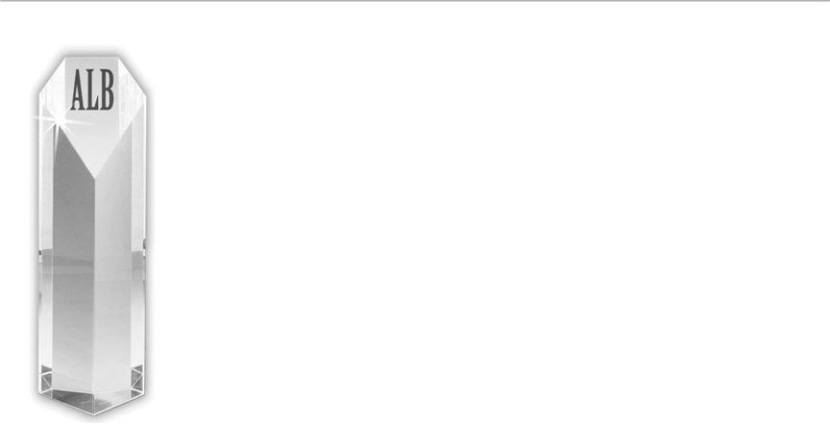

- Charltons’ extensive experience in corporate finance makes us uniquely qualified to provide a first class legal service

- Charltons have representative offices in Shanghai, Beijing and Yangon

- Charltons was named the “Corporate Finance Law Firm of the Year in Hong Kong ” in the Corporate Intl Magazine Global Award 2014

- “Boutique Firm of the Year” / “Boutique Transactional Law Firm of the Year” was awarded to Charltons by Asian Legal Business for the years 2002, 2003, 2006 to 2017 (inclusive) and 2020

- “Hong Kong's Top Independent Law Firm” was awarded to Charltons in the Euromoney Legal Media Group Asia Women in Business Law Awards 2012 and 2013

- “Equity Market Deal of the Year” was awarded to Charltons in 2011 by Asian Legal Business for advising on the AIA IPO

25

Contact Us

Hong Kong

12th Floor, Dominion Centre
43 – 59 Queen’s Road East
Hong Kong

Telephone: (852) 2905 7888

Facsimile: (852) 2854 9596

Email: enquiries@charltonslaw.com
Website: www.charltonslaw.com

China

Beijing Representative Office

3-1703, Vantone Centre
A6# Chaowai Avenue
Chaoyang District
Beijing

People's Republic of China 100020

Telephone: (86) 10 5907 3299
Facsimile: (86) 10 5907 3299
Email: enquiries.beijing@charltonslaw.com

Myanmar

Yangon Office of Charltons Legal Consulting Ltd

161, 50th Street
Yangon
Myanmar
Email: enquiries.myanmar@charltonslaw.com

In association with:-


Shanghai Representative Office

Networked with:-
Room 2006, 20th Floor
Fortune Times

1438 North Shanxi Road
Shanghai
People's Republic of China
200060

Telephone: (86) 21 6277 9899

Facsimile: (86) 21 6277 7899
Email: enquiries.shanghai@charltonslaw.com

26

