- Backdoor Listing in Hong Kong


www.charltonslaw.com

Hong Kong: A Leading International Stock Market
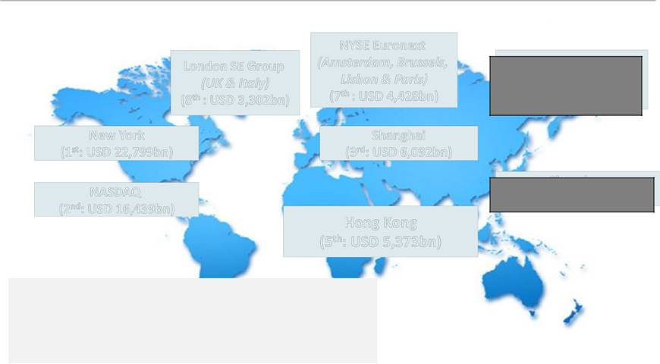

 |  |  |  |  |  |  | NYSE Euronext
 | London SE Group |  |  |  |  | (Amsterdam, Brussels,
 |  |  |  |  |  |  | Lisbon & Paris)
 |  |  | (UK & Italy) |  |  |  | Lisbon & Paris)
 |  |  |  |  |  |  | (7th : USD 4,428bn)
 | th |  | : USD 3,302bn) |  |  |  | (7th : USD 4,428bn)
 | (8
New York |  |  |  |  |  |  | Shanghai
(1st: USD 22,799bn) |  |  |  |  |  |  | (3rd: USD 6,092bn)
NASDAQ
(2nd: USD 16,439bn)
 |  |  |  |  |  |  | Hong Kong
 |  |  |  |  |  |  | (5th: USD 5,373bn)

By market capitalisation, Hong Kong is the world’s 5th largest and Asia’s 3rd largest exchange (after Shanghai and Japan) as at the end of September 2020.

Japan Exchange Group
(Tokyo & Osaka)
(4th: USD 6,075bn)

Shenzhen
(6th: USD 4,535bn)
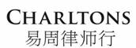

Source: SFC based on data from the World Federation of Exchanges and Bloomberg. Figures for Hong Kong includes the GEM board; figures for the London SE Group include those of London Stock Exchange and Borsa Italiana; figures for the NYSE Euronext include those of Euronext Amsterdam, Euronext Brussels, Euronext Lisbon and Euronext Paris; and figures for the Japan Exchange Group includes those of Tokyo Stock Exchange and Osaka Securities Exchange.

1

HKEx: Top IPO Funds Raising Platform
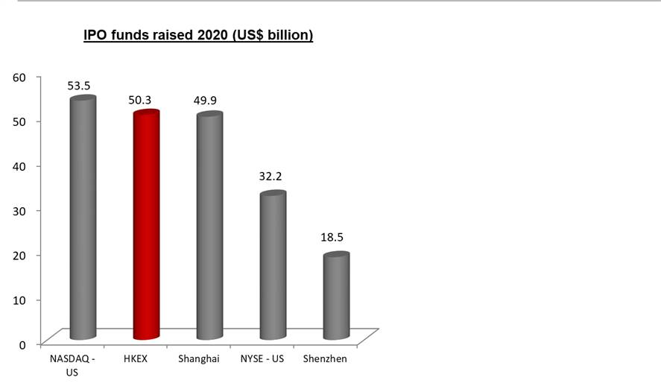

 The Stock Exchange of Hong Kong
(SEHK or the HKEx or the Exchange)
was the second largest IPO market in
2020 in terms of funds raised.

 A total of US$50.3 billion IPO funds
was raised in Hong Kong in 2020.

 There were 154 new listings in 2020:

o Main Board – 146

o GEM–8

Source: Hong Kong Exchanges and Clearing Limited and KPMG

2

 | Ten Largest Hong Kong IPOs in 2020
 |  |  | IPO funds raised
 | Company name | Industry | (HK$bn)
1 | JD.com | TMT | 34.6
2 | JD Health International Inc. | Healthcare / Life Sciences | 31.0
3 | NetEase, Inc. | TMT | 24.3
4 | Yum China Holdings Inc. | Consumer Markets | 17.3
5 | China Bohai Bank Co., Ltd. | Financial Services | 15.9
6 | GDS Holdings Limited | TMT | 14.9
7 | Evergrande Property Services Group Limited | Industrial | 14.3
8 | Hangzhou Tigermed Consulting Co., Ltd. | Healthcare / Life Sciences | 12.3
9 | China Resources Mixc Lifestyle Services Limited | Consumer Markets | 12.3
10 | New Oriental Education & Technology Group Inc. | Education | 11.6


Source: Hong Kong Exchanges and Clearing Limited and KPMG

3

Ten Largest IPOs on the HKEx


 |  |  | IPO funds raised
 | Company name | Industry | (HK$bn)
1 | AIA Group Ltd. | Financials – Insurance | 159.08
2 | Industrial and Commercial Bank of China Ltd. – H Shares | Financials – Banks | 124.95
3 | Alibaba Group Holding Ltd. - SW | Information Technology - Software & | 101.20
 |  | Services
4 | Agricultural Bank of China Ltd. – H Shares | Financials – Banks | 93.52
5 | Bank of China Ltd. – H Shares | Financials – Banks | 86.74
6 | China Construction Bank Corporation – H Shares | Financials – Banks | 71.58
7 | Postal Savings Bank of China Co Ltd – H Shares | Financials – Banks | 59.15
8 | China Tower Corporation Ltd – H Shares | Telecommunications – Satellite & | 58.80
 |  | Wireless Communication
9 | Budweiser Brewing Co. APAC Ltd. | Consumer Staples - Food & Beverages | 45.08
10 | China Unicom (Hong Kong) Ltd. | Telecommunications – | 43.61
 |  | Telecommunication Services

Source: Hong Kong Exchanges and Clearing Limited

4

HKEx Attracts a Diverse Portfolio of Issuers
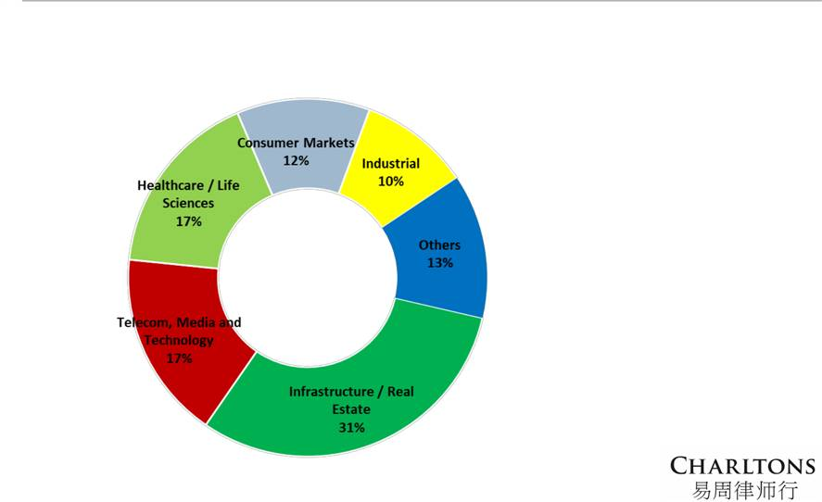

Number of Main Board IPOs by Sector (2020)





Issuers from the

Infrastructure / Real Estate sector dominate the new listing markets in 2020.

Over one-quarter of the new Main Board issuers were from the Infrastructure / Real Estate sector.

Source: KPMG

5

HKEx: A Strong Equity Fund Raising Platform

Total Equity Funds Raised in 2020 (up to 30 Nov) (HK$ bn)
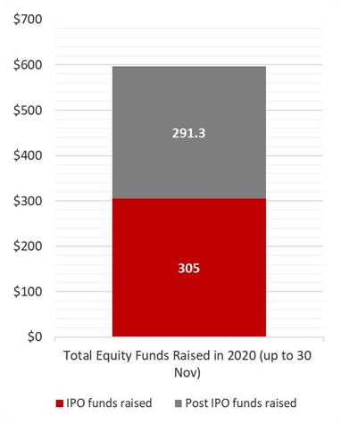

 A strong equity fund raising platform:

o A total of HK$596.3 billion in equity funds was raised in 2020 as at 30 November 2020.

 Remains a top IPO fundraising platform:

o A total amount of HK$305 billion was raised in 2020 as at 30 November 2020.

 A strong secondary capital raising market:

o A total of HK$291.3 billion was raised from post-IPO fundraising activities in 2020 as at 30 November 2020.

Source: Hong Kong Exchanges and Clearing Limited

6

HKEx: A Highly Active Stock Exchange

Average Daily Equity Turnover (HK$ m)

 High-level market liquidity:
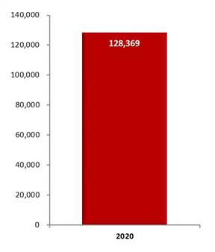

o HKEx is a highly active stock exchange with a total equity turnover of HK$29,011.5 billion in 2020 as at 30 November 2020.

o The average daily equity turnover was HK$128,369 million.

o Deep liquidity is partly driven by a diverse investor base.

Source: Hong Kong Exchanges and Clearing Limited

7

HKEx: Diverse Investor Base

Distribution of Cash Market Trading Value by Origin (2016)
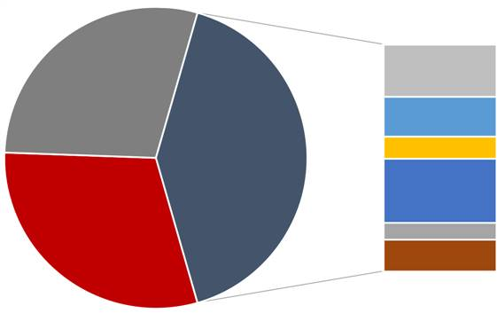

Exchange Participant (EP)

principal trading
28.9%
 | Overseas investors
 | (retail + institutional)
Local investors | 41.1%
(retail + institutional)

30.0%

^ others includes investors from Australia, Japan, Taiwan and the rest of the world

Source: Hong Kong Exchanges and Clearing Limited, HKEx Cash Market Transaction Survey 2016

US – 8.1%

UK – 9.3%

Europe (excluding UK) –

5.4%

Mainland China – 8.7%

Singapore – 3.3%

Others^ – 5.4%

8

HKEx: Primary Financing Platform for Mainland Enterprises


 |  |  |  |  | Mainland | % of
 |  |  | Unit | Total | Enterprise^ | Total
 | As at 30 November 2020
 | No. of listed companies |  | No. | 2,528 | 1,308 | 51.7%
 | Market capitalisation |  | HK$bn | 45,739.8 | 36,589.3 | 80.0%
 | As at 30 November 2020
 | Total equity funds raised |  | HK$bn | 596.3 | 510.1 | 79.0%
 | - IPO funds raised |  | HK$bn | 305.0 | 300.6 | 98.6 %
 | - Post IPO funds raised |  | HK$bn | 291.3 | 209.5 | 71.9%

- Given its diverse investor base, HKEx has been the primary financing platform for Chinese enterprises that seek to go international.

- Chinese companies account for over

50% of Hong Kong’s listed market in terms of number of listed companies and over 80% in terms of market capitalisation.

- refers to H-share companies, red chip companies and Mainland private enterprises Source: Hong Kong Exchanges and Clearing Limited

9

Hong Kong: a Bridge between China and the World

Advantages to List International Companies in Hong Kong

Access to Mainland Chinese investors, currently through:

- Qualified Domestic Institutional Investor (QDII) scheme: allowing Chinese institutional investors to invest in offshore capital markets

- China-Hong Kong Stock Connect: Shanghai-Hong Kong Stock Connect and Shenzhen-Hong Kong Stock Connect were launched in November 2014 and October 2016 respectively, allowing Mainland Chinese investors to invest directly in Hong Kong listed stocks. The stock connect schemes facilitate the broadening of Hong Kong’s investor base and add liquidity to the Hong Kong market adding momentum to the market

Raise company’s reputation and brand awareness in China and other Asian markets





Strong and sound legal and regulatory framework: Hong Kong’s legal system is based on English common law, providing a solid foundation for companies to raise funds and confidence to investors.

World’s freest economy: adopting a free market policy with no capital flow restrictions

- Hong Kong ranked first from 1995 to 2019 in relation to the Index of Economic Freedom.

Source: Heritage Foundation/Wall Street Journal, Hong Kong Exchanges and Clearing Limited

10

Selected International Listings in Hong Kong

Sisram Medical
 |  | Samsonite |  | Kazakhmys |  | Prada
USD 112 m |  | USD 1.25 bn |  | introduction |  | USD 2.1 bn

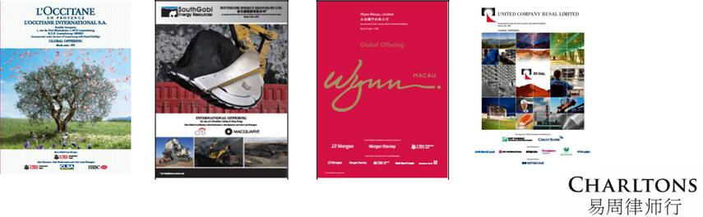
 |  |  |  | Rusal
L’OCCITANE | South Gobi |  | Wynn | Rusal
L’OCCITANE | South Gobi |  | Wynn | USD 2.2 bn
USD 783m | USD 439m |  | USD 1.9 bn | USD 2.2 bn

Source: Hong Kong Exchanges and Clearing Limited
11

HK IPO Market – 2020

Despite the COVID-19 pandemic impacting global IPO markets, Hong Kong’s IPO market performed well in 2020, with the Hong Kong Stock Exchange taking second place in terms of IPO funds raised (US$50.3 billion – an increase of 24.5% compared to 2019). This is largely attributable to a number of secondary listings by overseas-listed Chinese companies, such as JD.com, NetEase and Yum China.

There is an increasing number of US-listed Chinese-based companies returning for secondary listings in Hong Kong. During 2020, nine US-listed Chinese-based companies have completed secondary listings, raising a total of HKD 131.3 billion, representing approximately 34 percent of funds raised.

In terms of sectors, infrastructure and real estate continue to dominate the market, accounting for 31% of all IPOs, followed by TMT and healthcare/life sciences (both accounting for 17% of all IPOs and ranking co-first in terms of funds raised).

Notable IPOs in 2020 included the HK$ 34.6 billion IPO of JD.com, a Chinese supply chain-based technology and service provider, the HK$ 31.0 billion IPO of JD Health International Inc., one of the largest online healthcare platform in China, the HK$24.3 billion IPO of NetEase, Inc., a Chinese mobile game and e-commerce company, and the HK$17.3 billion IPO of Yum China Holdings, Inc, one of the largest restaurant company in China.

Source: KPMG, Deloitte and EY publications

12

HK IPO Market – Outlook

- Market sentiment for 2021 is likely to be driven a number of uncertainties including COVID-19 and Sino-US relations, however Hong Kong is expected to retain its position as one of the top exchanges globally in terms of IPO proceeds.

- This is in view of the increasing numbers of overseas-listed Chinese companies looking to Hong Kong for secondary listings, a trend which is most notable among US-listed Chinese tech companies owing to geopolitical tensions and post-IPO performances.

- The healthcare/life sciences industry is expected to remain one of the major contributors to the Hong Kong IPO market with the pandemic having created the need for robust healthcare services and capital investments.

- Hong Kong also has the potential to be bolstered by a number of factors including:

  - the expected increase in Chinese “take-private” deals and possible subsequent relisting in Hong Kong or Shanghai

  - HKEx’s Consultation Paper on Corporate WVR Beneficiaries, which would allow corporates to benefit from WVR

  - the launch of the wealth management connect scheme in the Greater Bay Area

Source: KPMG, Deloitte and EY publications

13

Hong Kong’s Markets







Main Board – caters for established companies able to meet its profit or other financial requirements.

GEM – a second standalone market for small and mid-sized companies, and has lower admission criteria than Main Board listings.

The post-listing obligations of GEM and Main Board companies are broadly similar. Key difference – quarterly reporting is mandatory for GEM companies but only recommended for Main Board companies

14

Accepted Jurisdictions





The Main Board and GEM Listing Rules allow the listing of companies incorporated in Hong Kong, China, Bermuda and the Cayman Islands

The Exchange has accepted 28 jurisdictions as acceptable jurisdictions of incorporation –

- Austria, Australia, Brazil, the British Virgin Islands, Canada (Alberta, British Columbia and Ontario), Cyprus, England & Wales, France, Germany, Guernsey, India, Ireland, Israel, the Isle of Man, Italy, Japan, Jersey, Republic of Korea, Labuan, Luxembourg, Netherlands, Russia, Singapore, the United States (State of California, State of Delaware and State of Nevada).

15

Backdoor Listing vs. IPO

- A backdoor listing is generally considered as a “reverse takeover” (RTO) which is broadly defined to include an acquisition (or series of acquisitions) of assets by a listed issuer which, in the opinion of the Exchange, attempts to achieve a listing of the acquired assets while circumventing the Listing Rules' requirements for a new listing applicant.





Historically, RTOs have been used as an alternative means of achieving a stock exchange listing.

The fact that no significant regulatory review was required (and there was no prospectus requirement) meant that the timeframe for completion of an RTO was considerably shorter than that for an IPO.

16

Backdoor Listing vs. IPO

- Costs can also be saved due to the lack of an underwriter. It will be much easier for the company acquiring the listed company to raise capital, as investors will have a clearly defined exit strategy through the public market.

- Some of the drawbacks to RTOs are that their speed and eventual value are sometimes overestimated, and they are sometimes completed without enough regard for the uninvolved shareholders.

17

Background to Hong Kong’s Position on RTOs





The listing rules of the Stock Exchange of Hong Kong Ltd. (Exchange) provide for stringent regulation of RTOs.

Major amendments to the Exchange’s listing rules (Listing Rules) took effect on 31 March, 2004 which introduced specific reverse takeover rules (RTO Rules) to the Main Board Rules for the first time (previously RTO Rules were contained in the Listing Rules for the Exchange’s Growth Enterprise Market (GEM)) and aligned the existing GEM RTO Rules with the new Main Board RTO provisions.

- The 2004 RTO Rules were aimed at putting a stop to “back door listings” to which the Exchange had long objected: its argument being that they were being used to circumvent the Listing Rules.

- Essentially, it was possible to inject assets into a listed company in return for a change of control while avoiding the onerous listing criteria of Chapter 8 required to be met by a listing applicant seeking to list on the Exchange’s Main Board.

18

The RTO rules

- The 2004 RTO Rules, in essence, require :

  - an acquisition (or series of acquisitions) of assets which constitute both an attempt to achieve a listing of the relevant assets and a means of circumventing the Listing Rules’ requirements for new listing applicants, to be treated as a new listing;

  - the assets to be acquired or the enlarged group to be able to meet the minimum criteria for listing;

  - the preparation of a listing document containing both the information required in a new applicant’s listing document and the information required for a very substantial acquisition under Main Board Rule 14.69 (GEM Rule 19.69); and

  - compliance with the announcement and shareholders’ approval requirements applicable to a “very substantial acquisition” (VSA).

19

RTO as Work-Out Tool





Backdoor listings provided a well-trodden route for bank creditor driven restructurings of distressed listed companies. The point has been made that the March 2004 Rule changes (whose primary aim was the improvement of listed companies’ corporate governance standards) stemmed from the Exchange’s view at the time, that the corporate governance standards of certain Hong Kong listed companies were below par and that these companies adversely affected the overall quality of the market.

However, that overriding concern failed to acknowledge any distinction between a rescue and non-rescue situation. For creditors of a distressed listed company, the listing status was often the “asset” that was most capable of being realised.

- Previously, it had been possible for bank creditors to achieve a disposal of a “listed shell” through the entry of a White Knight and so achieve some level of recoveries from their bad debt positions. This was often supplemented by a well-timed exit from an equity position held by the banks following the restructuring.

- This route was often preferable to the alternative of a liquidation from which the returns likely to be generated from the company’s underlying assets were less certain.

20

The Listing Rule Definition

- The definition of Reverse Takeovers introduced in Main Board Rule 14.06B and GEM Rule 19.06B (which remains the current definition) is:

  - An acquisition or a series of acquisitions by a listed issuer which, in the opinion of the Exchange, constitutes, or is part of a transaction and/or arrangement or series of transactions and/or arrangements which constitute:

▪

▪

an attempt to achieve a listing of the acquisition targets (as defined in rule 14.04(2A)); and

a means to circumvent the requirements for new applicants set out in Chapter 8 of the Listing Rules. (our emphasis added)

21

The Listing Rule Definition

- According to those paragraphs, a “reverse takeover” normally refers to:

  - an acquisition or a series of acquisitions of assets (aggregated under Rules 14.22 and 14.23) by a listed issuer which constitute a VSA where there is, or which will result in, a change of control (as defined in the Takeovers Code (i.e. 30%)) of the listed issuer (other than at the level of its subsidiaries); or

  - acquisition(s) of assets by a listed issuer which constitute a VSA from a person or group (or their associates) under any agreement or arrangement entered into by the listed issuer within 36 months of that person or group gaining control of the listed issuer (where the original transaction did not constitute an RTO). In determining whether one or more transactions constitute a VSA, the denominator in the percentage ratio calculation is measured at the time of the change of control or the acquisition(s), whichever produces the lower figure.

22

The Listing Rule Definition







The 2019 Listing rule amendments extended the period during which a series of transactions must be aggregated from twenty-four months to thirty-six months.

As a result, acquisitions in the to thirty-six months after a change in control, which individually or together cross the threshold of a VSA, will constitute an RTO and be treated as a new listing.

The difficulty that this rule poses in the context of a restructuring is that the net worth of companies following a restructuring is generally not that large. Hence almost any acquisition of a reasonable size is likely to trigger the RTO rules retrospectively.

- The first hurdle faced by a listed issuer following a restructuring is the requirement in Main Board Rule 13.24/GEM Rule 19.24 for listed companies to carry out sufficient operations and have assets of a sufficient value to justify their continued listing which effectively renders cash companies unsuitable for continued listing. Since no further additions to the business can be made for thirty-six months (unless the assets acquired or the enlarged group are able to satisfy the listing criteria for new listings), it will be necessary to ensure that the business is sustainable for the thirty-six month period.

23

The Listing Rule definition

- The definition of RTO in the Listing Rules gives the Exchange a very wide discretion to determine that a transaction is designed to circumvent the listing requirements and should be treated as an RTO.

- In the Listing Committee Annual Report 2007, the Listing Committee confirmed that while paragraphs (a) and (b) of Rule 14.06(6) (currently Note 2 of Rule 14.06B) refer to two specific forms of reverse takeovers, these are not meant to be exhaustive.

- Transactions which are in substance backdoor listings, but do not fall strictly within paragraphs (a) and (b) of the Rule, may still be considered reverse takeovers subject to the Listing Rules.

24

Listing Rules Requirements for an RTO

- Treatment as new listing

  - Where a listed issuer proposing a reverse takeover is treated as a new listing applicant, the enlarged group or the assets to be acquired must be able to meet the financial tests in Main Board Rule 8.05 or GEM Rule 11.12A and the enlarged group must be able to meet all other listing criteria of Main Board Chapter 8 or GEM Chapter 11 of the Listing Rules (Main Board Rule 14.54/GEM Rule 19.54).

  - The listed issuer must comply with the procedures and requirements for new listing applicants set out in Chapter 9 of the Main Board Rules (Chapter 12 of the GEM Rules) and must issue a listing document and pay the initial listing fee. A reverse takeover listing document is required to include virtually all the information required by Part A of Appendix 1 to the Listing Rules in addition to the information required for a very substantial acquisition under Main Board Rules 14.63 and 14.69 (GEM 19.63 to 19.69).

25

Listing Rules Requirements for an RTO

- Announcement requirement

  - The applicant must, following a short suspension in dealings of its securities, make an announcement to all shareholders regarding the RTO in accordance with Main Board Rule 2.07C/ GEM Rule 16.17.

  - The announcement must contain all pertinent information about the transaction, including the matters listed in Main Board Rules 14.58 and 14.60 (GEM Rules 19.58 and 19.60).

  - However, these are just the basic requirements, and any other pertinent information must be included as well.

  - The Exchange decides on a case-by-case basis what constitutes sufficient information.

26

Listing Rules Requirements for an RTO

- Requirement for shareholders’ approval

  - An RTO must be made conditional on being approved by shareholders in general meeting and the listing document must be sent to shareholders at the same time as, or before, the listed issuer gives notice of the general meeting to approve the transaction.

  - The announcement of the reverse takeover must state the expected date of despatch of the listing document and, if this is more than 15 business days after the publication of the announcement, reasons for this must be given.

  - The listing document must include an Accountants’ Report for the 3 preceding financial years on the business, company or companies to be acquired (Main Board Rule 14.69(4) and GEM Rule 19.69(4)).

27

Listing Rules Requirements for an RTO

- Requirement for shareholders’ approval

  - At a general meeting to approve an RTO, any shareholder and his associates are barred from voting if the shareholder has a “material interest” in the transaction.

  - In relation to an RTO, the Listing Rules further require that where there is a change in control of the listed issuer and the existing controlling shareholder(s) will dispose of shares to any person, the existing controlling shareholder(s) cannot vote in favour of the acquisition of assets from the incoming controlling shareholder or his associates at the time of the change in control.

  - This prohibition does not however apply where the decrease in the outgoing shareholder’s shareholding results solely from a dilution through the new issue of shares to the incoming controlling shareholder rather than a disposal of shares by the outgoing shareholder.

28

Other Regulatory Issues

- It is also important to bear in mind Rule 25 of the Takeovers Code on Special Deals with Favourable Conditions which prohibits an offeror and its associates from entering into a deal to buy a company’s shares which involves favourable conditions being offered to one or more shareholders which are not available to all the other shareholders.

- In addition, if there is a whitewash application for a waiver from the obligation to make a general offer to all shareholders by the incoming shareholder, all connected shareholders are likely to be barred from voting on it, as one of the conditions for the grant of a waiver of the mandatory offer obligation is that the transaction is approved at a shareholders’ meeting by an “independent vote” – i.e. by shareholders “who are not involved in or interested in, the transaction”. (Note 1 to Rule 26)

29

Meeting the Criteria for a New Listing Applicant

- The enlarged group or the assets to be acquired will need to meet the requirements for listing which in the case of a Main Board listing will require the applicant to satisfy the requirements of Main Board Rule 8.05 as to operating history and management and satisfy one of the three financial tests (profit test, market capitalization/revenue test or market capitalization/revenue/cash flow test).





An applicant for listing on GEM will need to meet the positive cash flow requirement and requirements as to operating history and management of GEM Rule 11.12A.

The enlarged group must also meet all other basic listing conditions in Chapter 8 (Chapter 11 of GEM).

30

Asset Injections Satisfying the Listing Requirements

- One of the remaining paths for rescuing a distressed listed company remains the injection of assets which meet the Listing Rules’ requirements for listing. This is acceptable to the Exchange as the issuer is subject to the full requirements of the Listing Rules.

- Transactions in the 36 months after the restructuring may be subject to HKEx’s notifiable transactions requirements, but will not need to be aggregated with the original reverse takeover transaction which has already triggered the new listing requirements.

- The downside for bank creditors leading a restructuring is that the pool of investors with assets meeting the listing requirements, and who are willing to invest in this type of restructuring, is likely to be small. As the investor is bringing his own assets, the likelihood is that he’ll be in a strong position to negotiate down the price for the listed company.

- Creditor banks who take an equity position in the restructuring should benefit in the long term given the injection of new assets. In the short-term, however, commentators have remarked that the immediate cash payout is likely to be substantially less than on a cash subscription type restructuring.

31

Charltons


- Charltons’ extensive experience in corporate finance makes us uniquely qualified to provide a first class legal service

- Charltons have representative offices in Shanghai, Beijing and Yangon

- Charltons was named the “Corporate Finance Law Firm of the Year in Hong Kong ” in the Corporate Intl Magazine Global Award 2014

- “Boutique Firm of the Year” / “Boutique Transactional Law Firm of the Year” was awarded to Charltons by Asian Legal Business for the years 2002, 2003, 2006 to 2017 (inclusive) and 2020

- “Hong Kong's Top Independent Law Firm” was awarded to Charltons in the Euromoney Legal Media Group Asia Women in Business Law Awards 2012 and 2013

- “Equity Market Deal of the Year” was awarded to Charltons in 2011 by Asian Legal Business for advising on the AIA IPO

32

Charltons – Directory Listings / Recommendations
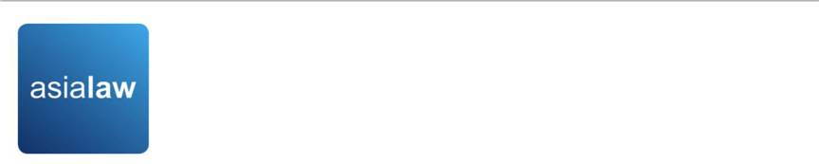

- Asialaw Profiles 2021
  - Capital markets - Highly recommended

  - Corporate and M&A - Highly recommended
  - Investment funds - Highly recommended

  - Private equity - Highly recommended

  - Banking and financial services - Recommended

  - Technology and telecommunications - Recommended

  - Regulatory - Recommended

- Chambers and Partners
  - Corporate/M&A: Independent Hong Kong Firms - Band 3

- Chambers Ranked Individuals

  - Julia Charlton - Capital Markets: Equity (International firms) China - Recognised Practitioner
  - Julia Charlton - Corporate/M&A: Independent Hong Kong Firms - Band 3

  - Clinton Morrow - Corporate/M&A: Independent Hong Kong Firms - Recognised Practitioner

- IFLR1000
  - Capital markets : Equity - Other notable

  - M&A - Other notable

- IFLR1000 Ranked Individuals
  - Julia Charlton - Highly regarded



33

Charltons


- Excellent links and networks with law firms worldwide.

- Julia Charlton was:

  - named a “Leading Lawyer” by Asia Law & Practice for the years 2002, 2003, 2006-2020 (inclusive)

  - awarded ‘Hong Kong Capital Markets Lawyer of the Year’ by Finance Monthly Global Awards 2014.

  - named a ‘Leading Advisor’ by Acquisition International for 2013.

  - awarded the American Chamber of Commerce of Hong Kong / South China Morning Post Women of Influence: Professional of the Year 2008.

  - finalist of Veuve Clicquot Business Woman Award 2018 Hong Kong
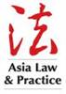



34



















Practice Areas


Capital markets

Corporate and commercial

Securities

Mergers and acquisitions

Investment funds: China and offshore

Derivatives

Restructuring

Venture capital

Investment

35

- Capital Markets

  - Global offerings and GDRs

  - IPOs and Placings

  - Listing on the Hong Kong, Shanghai, Shenzhen, London and Luxembourg stock exchanges

- Corporate and Commercial

  - Mergers and Acquisitions

  - Joint ventures

  - Stock exchange advisory

  - Corporate governance

  - Stock options

  - Employment law

- Securities

  - Compliance and disclosure

  - Dealing and advisory authorisations in Hong Kong and Mainland China

  - Options

- Investment Funds: China and Offshore

  - Authorised and unauthorised funds

  - Stock exchange listing (including Hong Kong, Dublin, London, Cayman, Bermuda stock exchanges)

  - Closed-end and open-ended structures

  - Hedge funds

Practice Areas

- Mergers and Acquisitions

  - Hong Kong Code on Takeovers and Mergers

  - Public offerings

  - Reverse takeovers

  - Private acquisitions

  - Due diligence in China and elsewhere in Asia

- Derivatives

  - Structuring listed and unlisted derivatives

  - Placings on Hong Kong and Luxembourg listed warrants and other structured products

  - Compliance and regulatory

- Restructuring

  - Schemes of arrangement

  - Workouts

  - Corporate recovery

  - Asset injections

- Investment

  - China investment regulations

  - Structuring a major foreign direct investment projects

  - Evaluation and due diligence

- Private Equity and Venture Capital

  - Optimum PRC and offshore structures

  - Preferred stock financing

  - PRC regulations

  - Exit Strategies

36

Our services

Our services include:


- As the company’s lawyer, principal responsibilities include, inter alia:

  - advising the company on the relevant listing and regulatory requirements in Hong Kong

ο

ο

ο

ο

ο

ο

ο

advising on any reorganisation plans and share option schemes

assisting the company to prepare all relevant documents for the listing, including the prospectus (upon request), deeds, directors’ undertakings, service contracts, appointment letters, committee terms of reference, waiver applications, connected transaction analysis and submissions and other applicable documents

issuance of legal opinions

assisting the company to prepare for due diligence to be conducted by the sponsor

conducting directors’ training

coordinating with legal adviser of relevant jurisdictions

liaising with the Stock Exchange on behalf of the company

37

Our services


- As the sponsor’s lawyer, principal responsibilities include, inter alia:

ο

ο

ο

ο

advising the sponsor and underwriters on the relevant Hong Kong legal and regulatory requirements in connection with the proposed listing

assisting the sponsor to conduct due diligence on the company

reviewing due diligence documents and conducting verification of the prospectus and coordinating with the auditor in relation to verification of financial information

preparing the listing application, submissions, checklists and other documents required to be submitted

ο

ο

ο

ο

Preparing documentation and advising on the marketing, underwriting, syndication, stabilization etc. of the share offering

preparing sections of the prospectus

preparing response to regulators over vetting process

reviewing all documents and disclosures prepared by the company’s lawyer

38

The Charltons Team

The team is composed of individuals with the following knowledge, skills and experience:

- A detailed knowledge of Hong Kong law and practice in relation to IPOs and equity fund raising transactions of public companies.

- Extensive experience in providing legal services for Hong Kong and PRC-related IPO transactions.

- In depth knowledge of the Listing Rules of both GEM and the Main Board of the Hong Kong Stock Exchange.

- Depth and range of experience in advising companies in connection with IPO and listing transactions.

39

Team Profile: Julia Charlton

Julia Charlton – Partner


- Julia, LL.B (1st class Honours), A.K.C (Kings College, London) was admitted as a solicitor in England & Wales in 1985 and has practised as a solicitor in Hong Kong since 1987.

- Julia is a member of the Takeovers Panel and the Takeovers Appeal Panel of the SFC, and served the maximum permitted term as a member of the Listing Committee of the Stock Exchange of Hong Kong Limited for six years from 2012 to 2018.

- Julia was named a “Leading Lawyer” by Asia Law & Practice for the years 2002, 2003, and 2006 to 2017.

- Julia was named a “Leading Advisor” by Acquisition International for 2013.

- Julia was also named the “Capital Markets Lawyer of the Year – Hong Kong” in the Finance Monthly Global Awards 2014.

- Julia has extensive experience in China work and is a Mandarin speaker.

40

Team Profile: Calvin Ho

Calvin Ho – Partner


- Calvin, Bachelor of Laws (LL.B) & Bachelor of Commerce (B.Com) (University of Melbourne), was admitted as solicitor in Hong Kong since 2009

- Calvin is a capital markets lawyer who regularly advises on IPOs, spin-offs, pre-IPO consultations, review and appeals as well as other related matter. Selected experience include:

  - advised AIA Group Limited (1299) in connection with regulatory aspects of listing on the Main Board (Equity Market Deal of the Year, 2011 ALB Awards Hong Kong)





advised United Company RUSAL Plc (486), one of the world’s largest aluminium company, on legal and regulatory aspects of its listing on Main Board as well as post-listing transactions (including very substantial transactions, redomiciliation etc.) and other ongoing legal and compliance issues

advised on successful listing of True Partner Capital Holdings

Limited (8657), Fu Shek Financial Holdings Ltd (2263) Excalibur Global Financial Holdings (8350), Zhi Sheng Group Holdings Ltd (8370), Medicskin Holdings Limited (8307), China Singyes New Materials Holdings Ltd (8073) etc. and transfer of listing of from GEM to Main Board of KVB Kunlun Holdings Limited (6877)

41

Professional Experience

- Charltons has considerable experience in advising companies or sponsors in relation to listings on the Main Board or the GEM of the Hong Kong Stock Exchange, and has extensive experience in bringing both private and state-owned Chinese enterprises to market

- The following slides sets out selected IPO experience of Charltons. In addition to these IPOs, Charltons is often considered specialists in the field and is often engaged to advise on complex IPO-related matters, some of which involves extensive consultations, negotiations and dialogue with the Hong Kong regulators. By way of example, recently, we have been involved in:

  - advised the proposed spin-off on the Main Board of the steel processing, distribution and recycling businesses from the listed parent company engaged in real estate and property development, involving complex issues leading to appeals on various levels of the Listing Committee of the Stock Exchange

  - advised on the proposed spin-off on the Main Board of reproductive healthcare services business of a financial conglomerate which involved technical regulatory and valuation issues requiring extensive consultation with the Stock Exchange

42

Professional Experience

- advised as HK counsel and regulatory specialist in connection with the proposed listing on Main Board (and subsequently proposed U.S. listing) of Bitmain, the largest cryptocurrency mining hardware company and operator of mining pools involving highly complex regulatory advice and due diligence

- advised on the proposed spin-off on the Main Board of application software services business from the parent company engaged in solutions and integration services which involved extensive negotiation with Stock Exchange on valuation and delineation issues

- currently advising on the possible relaunch of an IPO by a financial services provider which has attempted and failed to list on the Main Board (previously on GEM) of the Stock Exchange due to complex regulatory issues

- currently advising the sponsor on due diligence enquiries from the regulators concerning an lapsed listing application on the Main Board by a cement producer involving technical issues

As capital market lawyers, we are also heavily involved in post-listing compliance and regulatory issues as well as restructurings and privatisations involving listed entities. For example, we advised the managing director in relation to the privatisation of Hopewell, and is currently advising on a number of other privatisations, redomiciliation and restructurings involving prominent listed groups.

43

Examples of IPO Experience
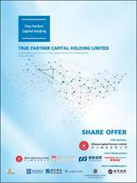

- True Partner Capital Holding Limited (listed on the the GEM of the SEHK in October 2020), Charltons acted as the Hong Kong legal adviser to the sponsor and underwriters)

- Fu Shek Financial Holdings Limited (listed on the Main Board of the SEHK) in February 2020, Charltons acted as Hong Kong legal adviser to sponsor and underwriters)

- Tianli Education International Holdings Limited (listed on the Main Board of the SEHK in July 2018, Charltons acted as the Hong Kong legal adviser to the sponsor and underwriters)


44

Examples of IPO Experience
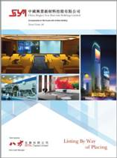

- Excalibur Global Financial Holdings Limited (listed on the GEM of the SEHK in January 2018, Charltons acted as the Hong Kong legal adviser to the sponsor and underwriters)

- China Singyes New Materials Holdings Limited (listed on the GEM of the SEHK in June 2017, Charltons acted as the Hong Kong legal adviser to the sponsor and underwriters in connection with spins-off and listing)

- Tree Holdings Limited (listed on the GEM of the SEHK, Charltons acted as the Hong Kong legal adviser to the sponsor and underwriters)


45

Examples of IPO Experience
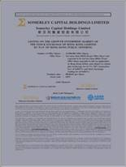

- Somerley Capital Holdings Limited (listed on the GEM of the SEHK in March 2017, Charltons acted as the Hong Kong legal adviser to the company)

- Zhi Sheng Group Holdings Limited (listed on the GEM of the SEHK in January 2017, Charltons acted as the Hong Kong legal adviser to the sponsor and underwriters)

- Medicskin Holdings Limited (listed on the GEM of the SEHK in December 2014, Charltons acted as the Hong Kong legal adviser to the company)
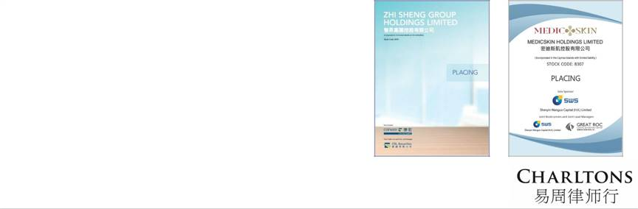

46

Examples of IPO Experience
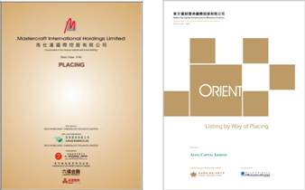

- Orient Securities International Holdings Limited (listed on the GEM of the SEHK in January 2014, Charltons acted as the Hong Kong legal adviser to the sponsor and underwriters)

- Mastercraft International Holdings Limited (listed on the GEM of the SEHK, Charltons acted as the Hong Kong legal adviser to the sponsor and underwriters)

- Branding China Group Limited (listed on the GEM of the SEHK, Charltons acted as the Hong Kong legal adviser to the sponsor and underwriters)

- AIA Group Ltd. (listed on the Main Board of the SEHK , Charltons acted as the Hong Kong legal adviser to AIG, the controlling shareholder)


47

Examples of IPO Experience

- United Company RUSAL Plc (listed on the Main Board of the SEHK, Charltons acted as the Hong Kong legal adviser to the controlling shareholder)

- China Titans Energy Technology Group Co., Limited (listed on the Main Board of the SEHK , Charltons acted as the Hong Kong legal adviser to the sponsor and underwriters)

- Mingfa Group (International) Company Limited (listed on the Main Board of the SEHK , Charltons acted as the Hong Kong legal adviser to the company)

- Greens Holdings Limited (listed on the Main Board of the SEHK, Charltons acted as the Hong Kong legal adviser to the company)
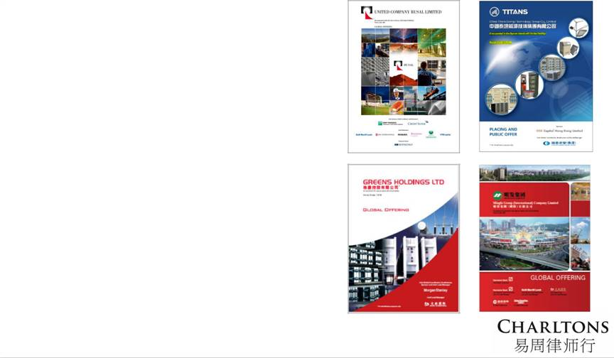

48

Examples of IPO Experience
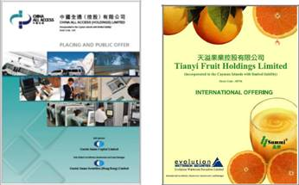

    - China All Access (Holdings) Limited (listed on the Main Board of the SEHK, Charltons acted as the Hong Kong legal adviser to the sponsor and underwriters)

- China Tianyi Fruit Holdings Limited (listed on the Main Board of the SEHK, Charltons acted as the Hong Kong legal adviser to the sponsor and underwriters)

  - China High Speed Transmission Equipment Group Co., Ltd. (listed on the Main Board of the SEHK, Charltons acted on behalf of the company)

  - Zhejiang Shibao Co., Ltd. (listed on the GEM of the SEHK, Charltons acted as the Hong Kong legal adviser to the company)


49

Other IPO Experience

- Fu Ji Food and Catering Services Holding Ltd. (listed on the Main Board of the SEHK, Charltons represented the strategic investor)

- China Fire Safety Enterprise Group Holdings Ltd. - previously named Fujian Wanyou Fire Safety Technology Holdings Ltd. - (listed on the GEM of the SEHK, Charltons represented the strategic investor)

- Shanghai Fudan-Zhangjiang Bio-Pharmaceutical Co. Ltd. (listed on GEM of the SEHK, Charltons acted as the Hong Kong legal adviser to the sponsor)





Tianjin TEDA Biomedical Engineering Co. Ltd. (listed on GEM of the SEHK, Charltons acted as the Hong Kong legal adviser to the sponsor)

Zheda Lande Scitech Ltd. (listed on GEM of the SEHK, Charltons acted as the Hong Kong legal adviser to the company)

- Merdeka Resources Holdings Ltd. - previously named TradeEasy Holdings Ltd. - (listed on GEM of the SEHK, Charltons acted as the Hong Kong legal adviser to the company)

- E. Bon Holdings Ltd. (listed on the Main Board of the SEHK, Charltons acted as the Hong Kong legal adviser to the sponsor)

- Great Wall Technology Co. Ltd. (listed on the Main Board of the SEHK, Charltons acted as the Hong Kong legal adviser to the company)

50

Contact Us

Hong Kong

12th Floor, Dominion Centre
43 – 59 Queen’s Road East
Hong Kong

Telephone: (852) 2905 7888

Facsimile: (852) 2854 9596

Email: enquiries@charltonslaw.com
Website: www.charltonslaw.com

China

Beijing Representative Office

3-1703, Vantone Centre
A6# Chaowai Avenue
Chaoyang District
Beijing

People's Republic of China 100020

Telephone: (86) 10 5907 3299
Facsimile: (86) 10 5907 3299
Email: enquiries.beijing@charltonslaw.com

Myanmar

Yangon Office of Charltons Legal Consulting Ltd

161, 50th Street
Yangon
Myanmar
Email: enquiries.myanmar@charltonslaw.com

In association with:-
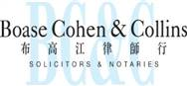

Shanghai Representative Office

Networked with:-
Room 2006, 20th Floor
Fortune Times

1438 North Shanxi Road
Shanghai
People's Republic of China
200060

Telephone: (86) 21 6277 9899

Facsimile: (86) 21 6277 7899
Email: enquiries.shanghai@charltonslaw.com

51

