- CHARLTONS – A Hong Kong Corporate Finance Law Firm


www.charltonslaw.com

Charltons


- Charltons’ extensive experience in corporate finance makes us uniquely qualified to provide a first class legal service





Charltons have representative offices in Shanghai, Beijing and Yangon

Charltons was named the “Corporate Finance Law Firm of the Year in Hong Kong ” in the Corporate Intl Magazine Global Award 2014

- “Boutique Firm of the Year” / “Boutique Transactional Law Firm of the Year” was awarded to Charltons by Asian Legal Business for the years 2002, 2003 and 2006 to 2017 (inclusive)

- “Hong Kong's Top Independent Law Firm” was awarded to Charltons in the Euromoney Legal Media Group Asia Women in Business Law Awards 2012 and 2013

- “Equity Market Deal of the Year” was awarded to Charltons in 2011 by Asian Legal Business for advising on the AIA IPO

1

Charltons – Directory Listings / Recommendations


- Asialaw Profiles 2021
  - Capital markets - Highly recommended

  - Corporate and M&A - Highly recommended

  - Investment funds - Highly recommended

  - Private equity - Highly recommended

  - Banking and financial services - Recommended

  - Technology and telecommunications - Recommended

  - Regulatory - Recommended

- Chambers and Partners
  - Corporate/M&A: Independent Hong Kong Firms - Band 3

- Chambers Ranked Individuals
  - Julia Charlton - Capital Markets: Equity (International firms) China - Recognised Practitioner

  - Julia Charlton - Corporate/M&A: Independent Hong Kong Firms - Band 3

  - Clinton Morrow - Corporate/M&A: Independent Hong Kong Firms - Recognised Practitioner

- IFLR1000
  - Capital markets : Equity - Other notable

  - M&A - Other notable

- IFLR1000 Ranked Individuals
  - Julia Charlton - Highly regarded



2

Charltons


- Excellent links and networks with law firms worldwide.

- Julia Charlton was:

  - named a “Leading Lawyer” by Asia Law & Practice for the years 2002, 2003, 2006-2020 (inclusive)

  - awarded ‘Hong Kong Capital Markets Lawyer of the Year’ by Finance Monthly Global Awards 2014.

  - named a ‘Leading Advisor’ by Acquisition International for 2013.

  - awarded the American Chamber of Commerce of Hong Kong / South China Morning Post Women of Influence: Professional of the Year 2008.

  - finalist of Veuve Clicquot Business Woman Award 2018 Hong Kong
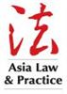



3

Practice Areas


- Hong Kong capital markets

- Corporate and commercial

- Securities

- Mergers and acquisitions

- Investment funds: China and offshore

- Derivatives







Restructuring

Venture capital

Investment

4

- Capital Markets

  - Global offerings and GDRs

  - IPOs and Placings

  - Listing on the Hong Kong, Shanghai, Shenzhen, London and Luxembourg stock exchanges

- Corporate and Commercial

  - Mergers and Acquisitions

  - Joint ventures

  - Stock exchange advisory

  - Corporate governance

  - Stock options

  - Employment law

- Securities

  - Compliance and disclosure

  - Dealing and advisory authorisations in Hong Kong and Mainland China

  - Options

- Investment Funds: China and Offshore

  - Authorised and unauthorised funds

  - Stock exchange listing (including Hong Kong, Dublin, London, Cayman, Bermuda stock exchanges)

  - Closed-end and open-ended structures

  - Hedge funds

Practice Areas

- Mergers and Acquisitions

  - Hong Kong Code on Takeovers and Mergers

  - Public offerings

  - Reverse takeovers

  - Private acquisitions

  - Due diligence in China and elsewhere in Asia

- Derivatives

  - Structuring listed and unlisted derivatives

  - Placings on Hong Kong and Luxembourg listed warrants and other structured products

  - Compliance and regulatory

- Restructuring

  - Schemes of arrangement

  - Workouts

  - Corporate recovery

  - Asset injections

- Investment

  - China investment regulations

  - Structuring a major foreign direct investment projects

  - Evaluation and due diligence

- Private Equity and Venture Capital

  - Optimum PRC and offshore structures

  - Preferred stock financing

  - PRC regulations

  - Exit Strategies

5

Team Profile: Julia Charlton

Julia Charlton – Partner


- Julia, LL.B (1st class Honours), A.K.C (Kings College, London) was admitted as a solicitor in England & Wales in 1985 and has practised as a solicitor in Hong Kong since 1987.

- Julia is a member of the Takeovers Panel and the Takeovers Appeal Panel of the SFC, and served the maximum permitted term as a member of the Listing Committee of the Stock Exchange of Hong Kong Limited for six years from 2012 to 2018.

- Julia was named a “Leading Lawyer” by Asia Law & Practice for the years 2002, 2003, and 2006 to 2017.

- Julia was named a “Leading Advisor” by Acquisition International for 2013.

- Julia was also named the “Capital Markets Lawyer of the Year – Hong Kong” in the Finance Monthly Global Awards 2014.

- Julia has extensive experience in China work and is a Mandarin speaker.

6

 Legal service overview – IPO
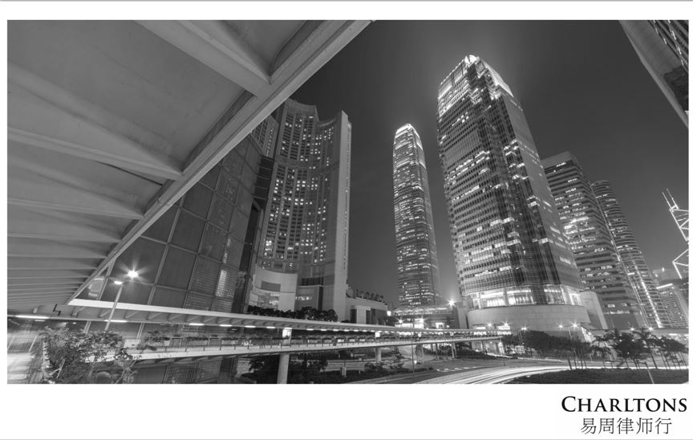

7

Professional Experience – IPO

Our team is experienced in advising companies or sponsors in relation to listings on the

Main Board or the GEM Board of the Hong Kong Stock Exchange, and our services include :

As the company’s lawyer :

- advising the company on the relevant listing requirements in Hong Kong

- assisting the company to prepare all relevant documents for the listing, including reviewing the prospectus

- assisting the company to prepare for due diligence to be conducted by the sponsor and the sponsor’s legal adviser

- conducting directors’ training for the company

- coordinating with legal adviser of relevant jurisdictions

- liaising with the Stock Exchange on behalf of the company

8

Professional Experience – IPO

- As the sponsor’s lawyer :

  - advising the sponsor on the relevant requirements under the listing rules in relation to the sponsor

  - assisting the sponsor to conduct due diligence on the company

  - reviewing due diligence documents and conduct verification of the prospectus and coordinating with the auditor in relation to verification of financial information

  - preparing all relevant documents (including all confirmations and statement of interests and responsibility letters) for the sponsor

  - reviewing all documents prepared by the company’s lawyer

9

Professional Experience

- The following slides sets out selected IPO experience of Charltons. In addition to these IPOs, Charltons is often considered specialists in the field and is often engaged to advise on complex IPO-related matters, some of which involves extensive consultations, negotiations and dialogue with the Hong Kong regulators. By way of example, recently, we have been involved in:

  - advised the proposed spin-off on the Main Board of the steel processing, distribution and recycling businesses from the listed parent company engaged in real estate and property development, involving complex issues leading to appeals on various levels of the Listing Committee of the Stock Exchange

  - advised as HK counsel and regulatory specialist in connection with the proposed listing on Main Board (and subsequently proposed U.S. listing) of Bitmain, the largest cryptocurrency mining hardware company and operator of mining pools involving highly complex regulatory advice and due diligence

As capital market lawyers, we are also heavily involved in post-listing compliance and regulatory issues as well as restructurings and privatisations involving listed entities. For example, we advised the managing director in relation to the privatisation of Hopewell, and is currently advising on a number of other privatisations, redomiciliation and restructurings involving prominent listed groups.

10

Examples of IPO Experience
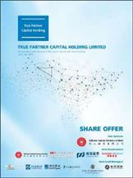

- True Partner Capital Holding Limited (listed on the the GEM of the SEHK in October 2020), Charltons acted as the Hong Kong legal adviser to the sponsor and underwriters)

- Fu Shek Financial Holdings Limited (listed on the Main Board of the SEHK) in February 2020, Charltons acted as Hong Kong legal adviser to sponsor and underwriters)

- Tianli Education International Holdings Limited (listed on the Main Board of the SEHK in July 2018, Charltons acted as the Hong Kong legal adviser to the sponsor and underwriters)


11

Examples of IPO Experience
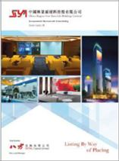

- Excalibur Global Financial Holdings Limited (listed on the GEM of the SEHK in January 2018, Charltons acted as the Hong Kong legal adviser to the sponsor and underwriters)

- China Singyes New Materials Holdings Limited (listed on the GEM of the SEHK in June 2017, Charltons acted as the Hong Kong legal adviser to the sponsor and underwriters in connection with spins-off and listing)

- Tree Holdings Limited (listed on the GEM of the SEHK, Charltons acted as the Hong Kong legal adviser to the sponsor and underwriters)


12

Examples of IPO Experience
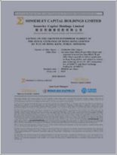

- Somerley Capital Holdings Limited (listed on the GEM of the SEHK in March 2017, Charltons acted as the Hong Kong legal adviser to the company)

- Zhi Sheng Group Holdings Limited (listed on the GEM of the SEHK in January 2017, Charltons acted as the Hong Kong legal adviser to the sponsor and underwriters)

- Medicskin Holdings Limited (listed on the GEM of the SEHK in December 2014, Charltons acted as the Hong Kong legal adviser to the company)


13

Examples of IPO Experience
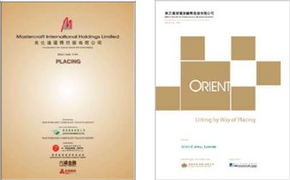

- Orient Securities International Holdings Limited (listed on the GEM of the SEHK in January 2014, Charltons acted as the Hong Kong legal adviser to the sponsor and underwriters)

- Mastercraft International Holdings Limited (listed on the GEM of the SEHK, Charltons acted as the Hong Kong legal adviser to the sponsor and underwriters)

- Branding China Group Limited (listed on the GEM of the SEHK, Charltons acted as the Hong Kong legal adviser to the sponsor and underwriters)

- AIA Group Ltd. (listed on the Main Board of the SEHK , Charltons acted as the Hong Kong legal adviser to AIG, the controlling shareholder)
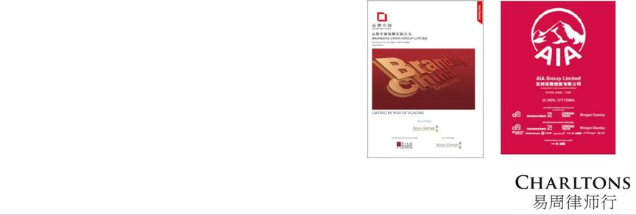

14

Examples of IPO Experience

- United Company RUSAL Plc (listed on the Main Board of the SEHK, Charltons acted as the Hong Kong legal adviser to the controlling shareholder)

- China Titans Energy Technology Group Co., Limited (listed on the Main Board of the SEHK , Charltons acted as the Hong Kong legal adviser to the sponsor and underwriters)

- Mingfa Group (International) Company Limited (listed on the Main Board of the SEHK , Charltons acted as the Hong Kong legal adviser to the company)

- Greens Holdings Limited (listed on the Main Board of the SEHK, Charltons acted as the Hong Kong legal adviser to the company)


15

Examples of IPO Experience
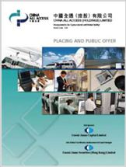

  - China All Access (Holdings) Limited (listed on the Main Board of the SEHK, Charltons acted as the Hong Kong legal adviser to the sponsor and underwriters)

- China Tianyi Fruit Holdings Limited (listed on the Main Board of the SEHK, Charltons acted as the Hong Kong legal adviser to the sponsor and underwriters)

- China High Speed Transmission Equipment Group Co., Ltd. (listed on the Main Board of the SEHK, Charltons acted on behalf of the company)

- Zhejiang Shibao Co., Ltd. (listed on the GEM of the SEHK, Charltons acted as the Hong Kong legal adviser to the company)



16

Other IPO Experience

- Fu Ji Food and Catering Services Holding Ltd. (listed on the Main Board of the SEHK, Charltons represented the strategic investor)

- China Fire Safety Enterprise Group Holdings Ltd. - previously named Fujian Wanyou Fire Safety Technology Holdings Ltd. - (listed on the GEM of the SEHK, Charltons represented the strategic investor)

- Shanghai Fudan-Zhangjiang Bio-Pharmaceutical Co. Ltd. (listed on GEM of the SEHK, Charltons acted as the Hong Kong legal adviser to the sponsor)

- Tianjin TEDA Biomedical Engineering Co. Ltd. (listed on GEM of the SEHK, Charltons acted as the Hong Kong legal adviser to the sponsor)

- Zheda Lande Scitech Ltd. (listed on GEM of the SEHK, Charltons acted as the Hong Kong legal adviser to the company)

- Merdeka Resources Holdings Ltd. - previously named TradeEasy Holdings Ltd. - (listed on GEM of the SEHK, Charltons acted as the Hong Kong legal adviser to the company)

- E. Bon Holdings Ltd. (listed on the Main Board of the SEHK, Charltons acted as the Hong Kong legal adviser to the sponsor)

- Great Wall Technology Co. Ltd. (listed on the Main Board of the SEHK, Charltons acted as the Hong Kong legal adviser to the company)

17

The Regulatory Regime for IPO Sponsors

- The sponsors regulatory regime includes:

○

○

○

Prospectus liabilities

- The amended Companies Ordinance clearly states that sponsors have both civil and criminal liabilities for misstatements in prospectus.

New Paragraph 17 of the Code of Conduct for Persons Licensed by or Registered with the Securities and Futures Commission (the “Code of Conduct”)

- And higher standards applicable to IPO sponsors, emphasising the standard of due diligence and requirements in relation to the recording of the work undertaken.

Listing Rules by the HKEx covering listing timetable, guidance materials and templates.

18

The Regulatory Regime for IPO Sponsors (cont’d)

- Paragraph 17 of the Code of Conduct sets out the outcomes expected by the SFC, but does not address how such outcomes are to be achieved.

- In order to help sponsors and other IPO participants better understand the revised standards contained in the Code of Conduct, Charltons acted as the co-ordinating law firm in relation to the publication of the Hong Kong Sponsors Due Diligence Guidelines (“Due Diligence Guidelines”) produced jointly by leading Hong Kong law firms, two of the Big Four accounting firms and more than 40 banks or financial advisory businesses.

- In addition to drafting the Due Diligence Guidelines, Charltons is responsible for managing and leading the publication of the Due Diligence Guidelines.

- The Due Diligence Guidelines can be downloaded for free at www.duediligenceguidelines.com, a web site created and managed by Charltons.
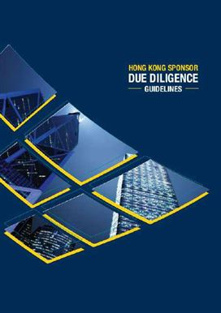

19

The Regulatory Regime for IPO Sponsors (cont’d)


- The Due Diligence Guidelines are 762 pages long and were completed over a year of extensive consultation.

- A number of international and PRC investment banks in Hong Kong, medium-sized local sponsors and professional institutions (e.g. CCB International (Holdings) Limited, Linklaters and KPMG) were involved in the consultation process.

20

The Regulatory Regime for IPO Sponsors (cont’d)

- The Due Diligence Guidelines include chapters on :

  - Knowing the Listing Applicant and its Management
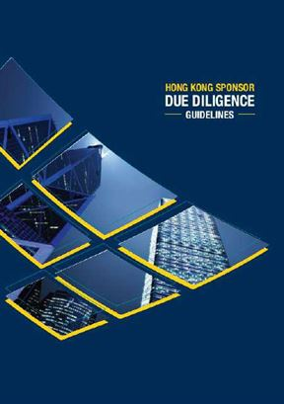

○

○

○

○

○

○

○

○

○

Verification Practice

Business Model

Interviews of Major Business Stakeholders

Controlling Shareholders’ Relationship with the Listing Applicant

Connected Persons and Connected Transactions

Financials

Internal Controls

Material Contracts

Biological Assets

21

 Legal Services Overview – M&A
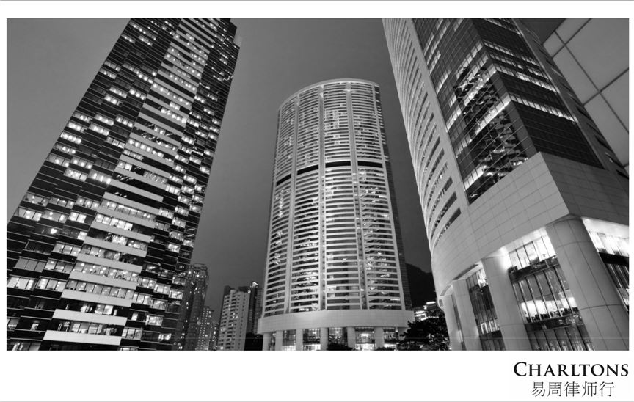

22

Professional Experience – M&A

Charltons’ team is experienced in :

- As general counsel, taking the lead in cross-border M&A transactions

- Reviewing transaction structures and advising on the relevant legal issues from a Hong Kong legal perspective

- Advising on relevant announcement and disclosure requirements in Hong Kong

- Coordinating with professional legal advisers and other advisers (including financial advisers) in relation to issues in other relevant jurisdictions

- Conducting due diligence and identifying relevant legal issues on companies incorporated in Hong Kong and liaising with Chinese lawyers relating to due diligence on companies incorporated in China

23

Professional Experience – M&A

- Taking the lead to draft relevant transaction documents and coordinating with professional advisers of the relevant jurisdictions in relation to documents governed by non-Hong Kong law

- Negotiating terms and conditions of the transaction and advising in relation to relevant rights and obligations therein

- Preparing completion documents and coordinating with professional advisers of relevant jurisdictions in relation to completion documents governed by non-Hong Kong law

- If applicable, reviewing and commenting on legal opinions prepared by legal advisers of the relevant jurisdictions

- Attending and coordinating completion in Hong Kong

- Attending filings (if applicable) and stamping (if applicable) in Hong Kong

24

Recent M&A Experience

Our recent M&A experience includes :

- Advising on the partial disposal of a licensed asset management group based in Hong Kong to an international French bank

- Advised on a complex two-step acquisition of the Kainantu Gold and Copper Project in Papua New Guinea from Barrick Gold Corporation

- Advised on the sale of the Dermot Group, a VPN market leader in the PRC, to the NASDAQ listed 21Vianet Group, Inc.

- Advised a Hong Kong listed company on its major disposal of an associate US automobile dealership group to a NYSE listed company

- Advised a Hong Kong and Shenzhen dual listed pharmaceutical company on successfully gaining control of another PRC pharmaceutical company

- Advised Hong Kong listed Paladin Limited on successfully resisting a hostile takeover

- Advised a Hong Kong listed company on the proposed disposal of a major copper project in Peru to Glencore International AG

25

Recent M&A Experience

- Advised a UK company on the equity swap involving the disposal of coal and anthracite projects in Tajikistan for equity interests in Kaisun Energy Group Limited, a Hong Kong listed company

- Advised a major PRC State owned mining company listed on the Shanghai and Hong Kong Stock Exchange on the acquisition of the entire interest of Long Province Resources Limited, the owner of gold mining assets in China’s Gansu province

- Advised a Hong Kong GEM board listed company in successfully defending a hostile takeover attempt by a shareholder of the company

- Advised the major shareholders of a Hong Kong listed company in connection with a restructuring mandatory unconditional cash offer and reverse takeover

- Advised a major US retailer in connection with acquisition of interests in a PRC and Asian based online retailer who are engaged in online sales of branded goods

- Advised a major Vietnamese group on the acquisition of a Hong Kong holding company owning five prestigious hotels in Vietnam

- Advised a Chinese Mining Consortium on the takeover of Monterrico Metals plc, a
company listed on AIM with mining assets in Peru

26

Recent M&A Experience

- Advised a major insurance loss adjuster on the asset and business acquisition of GAB Robins, a group specialising in insurance appraisals in Hong Kong and Taiwan

- Advised a major PRC State-owned mining company listed on the Shanghai and Hong Kong Stock Exchange on its takeover bid for Indophil Resources ML, an Australian publicly listed company and an explorer and developer of gold and copper-gold opportunities in the Asia-Pacific region, in particular, the Philippines

- Advised a major PRC State-owned mining company listed on the Shanghai and Hong Kong Stock Exchange on its acquisition of Commonwealth British Minerals Limited, a joint venture between Avocet Mining Plc and the Tajikistan government to explore, exploit and develop gold deposits and other minerals in Tajikistan

- Advised a major PRC State-owned mining company listed on the Shanghai and Hong Kong Stock Exchange on a possible tender offer to purchase a major gold-copper project in Chile

- Advised a major PRC State-owned mining company listed on the Shanghai and Hong Kong Stock Exchange on its acquisition of 60% participation interest in Altynken Limited Liability Company which engages in gold explorations projects in the Kyrgyz Republic

27

 Legal Services Overview – Funds & SFC Licensing


28







Funds Practice


We have broad market experience in providing legal services in connection with the structuring, marketing, regulation and operation of private investment funds in a range of regions worldwide, including offshore funds and China funds.

Charltons is committed to provide integrated, comprehensive, flexible and innovative fund solutions to meet your objectives within the shortest possible time.

We have worked with funds listing in Hong Kong, London, Luxembourg, Dublin, Bermuda and the Cayman Islands

29

Funds Practice

- Our scope of work usually includes:

- Drafting the offering memorandum of the fund

- Drafting transaction documents such as subscription agreement, investment management agreement, investment advisory agreement, custodian agreement and investor agreements

- Drafting the amended and restated memorandum and articles of association for the fund

- Coordination throughout

30

Recent Funds Experience

Our recent funds experience include :

- Establishment Cayman based fund investing in consumer and technology markets in greater China and the US

- Established Myanmar based fund focused on investment opportunities and building sustainable businesses in Myanmar

- Established BVI regulated processional hedge fund.

- Advised FSA-regulated “fund of funds” investment management company in respect of SFC-licensing application.

- Established Cayman based fund investing in international futures contracts and foreign currency exchanges.

- Advised SFC-licensed investment manager in respect of the establishment of a Cayman based CIMA-regulated fund investing in China-related securities.

31

Recent Funds Experience

Our recent funds experience include (cont’d) :

- Established BVI “professional” regulated mutual fund listed on the Irish Stock Exchange and investing in Asian convertible bonds, debt, and various arbitrage and absolute return strategies.

- Advised SFC-licensed fund manager on ongoing compliance issues under the SFO and SFC Codes.

- Established Cayman CIMA-regulated SPC focused on real estate investments in Dubai, Abu Dhabi, Bahrain, Qatar and Oman, as well as investments in property-related securities listed on the Dubai Financial Market, the Abu Dhabi Securities Market, and other stock exchanges in the Gulf region.

- Advised Hong Kong based investment management company on marketing and distribution in Hong Kong of fund generating returns through a UK litigation funding scheme secured by insurance contracts.

32

Recent Funds Experience

Our recent funds experience include (cont’d) :

Advised a European fund manager on a private equity investment in a PRC based fire protection group subsequently listed on the Hong Kong Stock Exchange.

Advised a European fund manager on the subscription and investment in convertible bonds of a PRC based food group subsequently listed on the Hong Kong Stock with two rounds of financing.

Advised a European fund manager on private equity investment in an offshore holding company of a PRC battery-manufacturing group by way of a pre-initial public offer placement of the Convertible Bonds of the Company, which was subsequently listed on the Hong Kong Stock Exchange.

33

Recent Funds Experience

Our recent funds experience include (cont’d) :

Advised a European fund manager on private equity investment in an offshore holding company of a PRC fish products and manufacturer.

Advised a Shanghai based IT company on 1st and 2nd round convertible share financing.

Advised a Hong Kong and PRC vpn group on several rounds of preference share financing from a US based venture capital firm.

34

The Hong Kong Licensing Regime

- The licensing and registration of persons operating in Hong Kong’s securities and futures markets is dealt with in Part V of the Securities and Futures Ordinance (SFO) which came into effect on 1 April 2003. The SFO is administered by the SFC.

- Part V of the SFO establishes a ‘single licence’ regime whereby a person requires only one licence or registration to conduct different types of regulated activities.

- The SFO prohibits any person from carrying on a business (or holding himself out as carrying on a business) in a regulated activity unless an appropriate authorisation has been granted or an exemption or exclusion applies.

35

Types of Regulated Activities

- Currently, there are 10 types of ‘regulated activities’ in Hong Kong :

- Type 1: dealing in securities

- Type 2: dealing in futures contracts

- Type 3: leveraged foreign exchange trading o Type 4: advising on securities

o Type 5: advising on futures contracts

o Type 6: advising on corporate finance

o Type 7: providing automated trading services

o Type 8: securities margin financing

o Type 9: asset management

o Type 10: providing credit rating services

36

The Licensed Corporation

- For a corporation to be licensed to carry out regulated activities in Hong Kong, section 116

(2) of the SFO requires that it has to be either a company incorporated in Hong Kong or an overseas company registered under Part XI of the Companies Ordinance having a principal place of business in Hong Kong (i.e. branch company) .

- In general, Hong Kong branch offices are subject to the same legal and tax consequences as companies incorporated in Hong Kong.

- In particular, the tax rate applied to profits is the same for local and foreign companies.

- The main reason for preferring a Hong Kong subsidiary over a branch is that the subsidiary will be completely separate from its parent so that the parent will not be liable for the debts of the subsidiary.

37

Recent Licensing Experience

- We regularly assist and make submissions to the SFC on behalf of clients for obtaining of licenses to carry out regulated activities in Hong Kong

- Selected licensing work:

o

o

o

o

o

recently advised a US headquartered financial-services firm in connection with its establishment of a Hong Kong subsidiary or branch for the set up of a futures contracts dealing practice in Hong Kong and the establishment of its leveraged foreign exchange business in Hong Kong

recently advised on the approval for change of substantial shareholder and approval of new nominated responsible officer of a fund management and securities advisory firm following its acquisition by a Thai private banking group

recently advised on the approval for change of substantial shareholders following the global merger of our client, an independently-owned private capital investment management firm, with a locally-based private investment group

recently advised on the approval to carry out asset management and securities advisory services in connection with a US-based group focusing on global energy and investments funds, which we were also advising in connection with its Chapter 21 listing on the Hong Kong Stock Exchange

recently advised on the merger of Hong Kong offices of a Taiwanese financial services and securities firm (which we assisted in setting up) with the Hong Kong subsidiary of another listed Taiwanese financial group

38

- Legal Services Overview – General Commercial Advice and Company Secretarial Services


39

General Commercial Advice

Charltons advises on general commercial matters, including but not limited to:

- Advising on general commercial transactions and other general commercial matters under Hong Kong law

- Advising on contracts, including suppliers and customers contracts governed by Hong Kong law

- Advising on facility and loan transactions and issuance of legal opinions

- Advising on debt issues and offerings

- Advising on employment related matters under Hong Kong law

- Advising on proposed restructuring proposals from a Hong Kong legal perspective

- Drafting / preparing documents in relation to general commercial transactions from a Hong Kong legal perspective

- Giving input on PRC matters and liaising with PRC lawyers on PRC-related matters

40

Company Secretarial Services

Charltons also provide legal administrative services to Hong Kong private company, including but not limited to:

Preparing and amending articles of association under Hong Kong law and corresponding filings with the Companies Registry;

acting as name company secretary of the Hong Kong company in the name of our service company;

preparing annual returns and corresponding filings with the Companies Registry; preparing documents in relation to the annual general meeting; keeping and updating statutory books and records;

preparing documents in relation to share transfers and filings with the Stamp Office for stamping;

preparing documents and corresponding filings with the Companies Registry in relation to the following; and

provision of registered office address.

41

 Legal Services Overview – Myanmar


42

Legal Services in Myanmar

- In 2012 Charltons expanded our practice by opening up a branch office in Yangon so we can assist clients doing business in Myanmar. We are one of the very first overseas law firms to open up a branch office in Myanmar and to be in a position to support both new and existing clients doing business in Myanmar, from a local base.

- Charltons’ lawyers have enjoyed long held personal and professional relationships with Burmese business leaders and international investors pursuing opportunities in Myanmar.

- When necessary, Charltons works in cooperation with highly regarded local lawyers to offer clients an extensive suite of legal services. Our goal is to combine international best practice with local knowledge to help our clients formulate and put in place the local strategies that best match their business needs and goals.

- The Charltons team in Myanmar advise on a wide range of general corporate matters including but not limited to the establishment of operations (together with all relevant applications to government departments and agencies), on-going fillings, company secretarial services, the establishment of joint ventures, local due diligence, offshore investment structures, share subscriptions in local companies (together with the establishment of trust arrangements where applicable), investment in the natural resources sector, Myanmar company legal advice and other Myanmar company law matters.

43

Recent Professional Experience in Myanmar

Examples of recent professional experience in Myanmar include the following:

Providing ongoing advice in relation to the international listing of a Myanmar infrastructure company

Providing ongoing advise to a Hong Kong resident Myanmar national in relation to the development of a condominium in Yangon

Advised on the establishment of a foreign invested early learning centre in Myanmar

Advised an LSE/TSX listed oil and gas company tender for onshore blocks, including assisting in negotiations with local partners, data review and liaising with Government

Advised an international energy company on proposed midstream and downstream gas operations in Myanmar

Advised a foreign-invested Myanmar hotel resort company on their contract rate agreement

Advised an international law firm on a trademark registration in Myanmar

Advised a Myanmar orientated fund with a focus on ethical investment in Myanmar

44

Recent Professional Experience in Myanmar

Examples of recent professional experience in Myanmar include the following (cont’d):

- Provided preliminary advice in relation to the incorporation of a Myanmar-foreign joint venture established to bid for a licence to operate the Myanmar national lottery

- Advised Myanmar gold mining company seeking foreign investment / joint venture partners

- Advised foreign investor on a share subscription in Mandalay business park development company

- Provided preliminary advice to a Myanmar company on applications for peripheral telecom licences in Myanmar

- Provided preliminary advise in relation to the establishment of micro-finance institution in Myanmar

- Advised foreign owned mining company in Myanmar in a dispute with a local director

- Provided preliminary advice in relation to the establishment of a charitable health care centre in Myanmar

- Provided advice to numerous foreign companies in relation to the establishment of operations in Myanmar under both the Myanmar Foreign Investment Law and the Myanmar Companies Act

45

- Local and International Legal Networks


46

Association with Boase Cohen & Collins in Hong Kong

- Charltons is an independent Hong Kong law firm focusing on corporate finance. To extend our reach of client service capabilities, we work in association with Boase Cohen & Collins, a boutique law firm that offers a full and comprehensive range of legal services to a broad cross section of clients.

- Boase Cohen & Collins’ core practice areas include civil and criminal litigation, dispute resolution (including arbitration and mediation), matrimonial, intellectual property, probate, immigration, personal injury, employment and labour.

- We, together with Boase Cohen & Collins, operate as a full service law firm to meet the diverse needs of our clients worldwide.

47

Association with Grandall Law Firm in Hong Kong

- Grandall is one of the largest and most reputable law firms in China. Their professional expertise in various areas of law and their international networks make them one of our most valuable associate firms.

- Grandall’s practice areas include, amongst others, real estate, environmental protection and green energy, intellectual property, IT & E-commerce, maritime law and international trade remedies & WTO.

- In July 2017, we assisted Grandall in organising the Belt and Road Legal Services Forum in Chengdu, China, in which more than 350 legal professionals attended.

- Along with Grandall, Charltons signed the Cooperation Charter of the “Belt and Road” Legal Services Cooperative along with 30 other law firms from 20 countries and regions around the world.

48

International Legal Networks

- Charltons is an independent law firm in Hong Kong. Yet, we have an excellent legal networks worldwide. We are currently a member of two global legal associations, Legalink and Avrio Advocati.

- Legalink and Avrio Advocati comprised of reputable member firms practicing in major financial centres around the globe, including Asia, Europe, Africa, North America, South America and Australasia.

- We have established close relationships with member firms and share a commitment to jointly provide cross-border personalised legal services to international clients. Our connection with these global networks enables our clients to be able to choose the right law firm with the appropriate expertise in the particular jurisdiction, and enables us to provide our clients with access to leading law firms around the world.

- As a member of Legalink and Avrio Advocati, we from time to time attend members meetings and conference to enhance our relationships with the members firms and our understanding of their practice. Through these meetings, we are able to educate ourselves about the issues that matter most to our clients in the different jurisdictions represented. By meeting lawyers from all over the world, we feel ourselves enriched with the latest development of the global legal environment.

49

Contact Us


Hong Kong Office

12th Floor

Dominion Centre

43 – 59 Queen’s Road East

Hong Kong

Telephone: (852) 2905 7888

Fax: (852) 2854 9596

Email: enquiries@charltonslaw.com

Website: www.charltonslaw.com

50

Other Locations

China

Beijing Representative Office

3-1703, Vantone Centre A6# Chaowai Avenue Chaoyang District Beijing
People's Republic of China 100020

Telephone: (86) 10 5907 3299
Facsimile: (86) 10 5907 3299 enquiries.beijing@charltonslaw.com

Shanghai Representative Office

Room 2006, 20th Floor
Fortune Times
1438 North Shanxi Road
Shanghai
People's Republic of China 200060

Telephone: (86) 21 6277 9899
Facsimile: (86) 21 6277 7899 enquiries.shanghai@charltonslaw.com

In association with:-
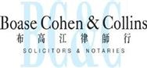

Networked with:-


Myanmar

Yangon Office of Charltons Legal Consulting Ltd


161, 50th Street
Yangon
Myanmar

enquiries.myanmar@charltonslaw.com

51

