Introduction

- The regulation of the oil and gas sector in Myanmar has undergone rapid change since the introduction of political reforms
- The Constitution of the Republic of the Union of Myanmar 2008, stipulates that the state is the ultimate owner of all natural resources,
- Myanmar Oil & Gas Enterprise (“MOGE”) is the national oil and gas company of Myanmar which also serves as the energy sector's regulatory agency.
- All foreign participation in oil and gas activity takes place through joint venture arrangements with MOGE
- The MOGE falls under the auspices of the Ministry of Energy

Petroliferous Basin of Myanmar

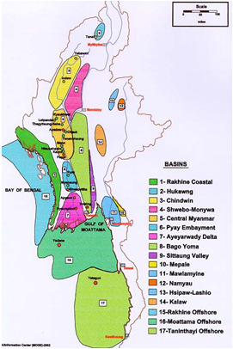
SEDIMENTARY BASINS
- Rakhine Coastal
- Hukaung
- Chindwin
- Shwebo-Monywa
- Central Myanmar
- Pyay Embayment
- Ayeyarwady Delta
- Bago Yoma Basin
- Sittaung Valley
- Mepale
- Mawlamyine
- Namyau
- Hsipaw-Lashio
- Kalaw
- Rakhine offshore
- Moattama offshore
- Tanintharyi offshore

STATUS OF EXPLORATION (Offshore)

Thoroughly Explored Basins
- Rakhine Offshore
- Moattama Offshore
- Tanintharyi Offshore

STATUS OF EXPLORATION (Onshore)

  - Thoroughly Explored Basins
    - Central Myanmar
    - Pyay Embayment
    - Ayeyarwady Delta
(Only Part of the Basin)

  - Explored to Some Extent
- Chindwin
- Rakhine Coastal

  - Very Little Explored
- Hukaung
- Shwebo-Monywa
- Bago Yoma

  - Not Explored Yet
- Hsipaw-Lashio
- Namyau
- Kalaw
- Sittaung Valley
- Mawlamyine
- Mepale (Oil Shale)

Product Sharing Contract (“PSC”)

- The Energy Planning Department (“EPD”) is responsible for negotiating PSC’s with foreign oil companies
- Three types of PSC’s are awarded: onshore blocks, shallow water offshore blocks, and deep water offshore blocks
- The government takes a royalty from the total gross production revenue as well as an economic rent from the remaining revenue available for sharing.
- The remainder is the contractor’s revenue entitlement.
- For the contractor, the entitlement consists of cost recovery plus the contractor’s share of remaining revenue available for sharing.
- Cost recovery may include capital, operating or other expenses

Typical PSC Calculation

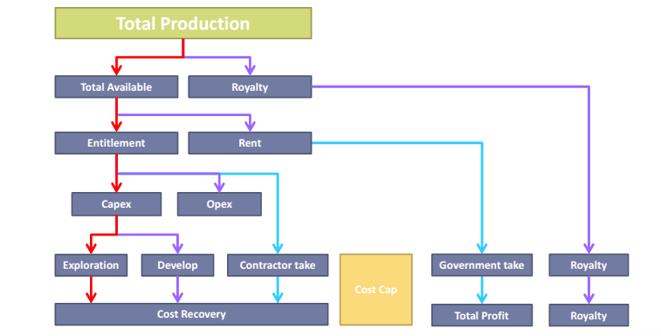

Myanmar PSC Calculation

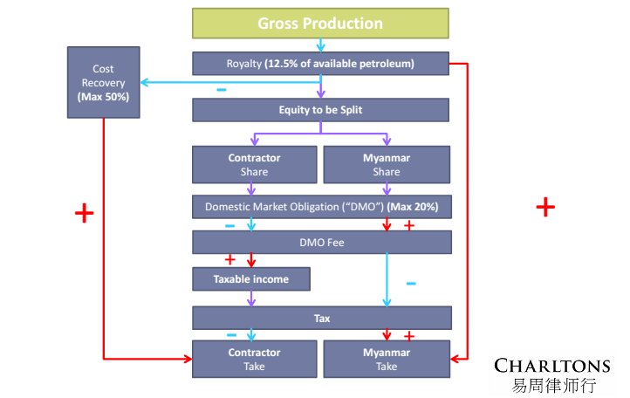

Myanmar PSC’s – Key Terms (Onshore Blocks)

- Initial term of the Exploration Period (3 years)
Year 1 – G&G study and seismic acquisition, processing and interpretation
Year 2 – to drill minimum one (1) well
Year 3 – post- well evaluation & to drill one (1) well
(or) to drill two (2) wells during Year 2 & 3

Contractor will have the option to back-off

- 1st Extension (2 years)
Year 4 – prospect evaluation
Year 5 – to drill one (1) well
(or) to drill two (2) wells during Year 2 & 3

Contractor will have the option to back-off

- 2nd Extension (1 year)
Year 6 – to drill one (1) well

Contractor will have the option to back-off

- Production Period | 20 years from the date of completion of developmentin accordance with development plan (or) according to petroleum sales agreement, which ever is longer
- Signature Bonus | Payment within 30days after signing of the contract.
- Royalty | 12.5% of all available petroleum
- Domestic Requirement | 20% of crude oil and 25% of natural gas of the contractor’s share of profit petroleum
- Training Fund | Exploration Period = 25,000 US$ p/a  Production Period = 50,000 US$ p/a
- Research & Development Fund | 0.5% of contractor’s share of profit petroleum
- State Participation | 15% undivided interest and MOGE has the option to extend up to 25% at its own discretion.
- Income Tax | 25% on the contractor’s net profit.  (5 years tax holiday starting from the date of production.)
- Governing Law | Laws of the Republic of Union of Myanmar

Bidding Process (On-shore)

- Letter of Expression of Interest to be sent to the Director General of the Ministry of Energy and to include*: -
- Copy of Memorandum and Articles of Association
- Copy Certificate of Incorporation
- Copy Latest Annual Report
- Copy Detailed Track Record

* Documentation to be endorsed for authenticity by the respective Embassy of the Republic of the Union of Myanmar in the applicant’s county of incorporation (or nearest Embassy),

- Bidders who pass “pre-qualification” i.e. those who demonstrate they have the technical competency, financial capability, experience, expertise and technical know-how to conduct petroleum exploration and development work, will be presented with a General Overview of each block
- Proposal Standard Terms and Conditions explained to potential bidders
- Bidders submit up to three proposals together with proposed Terms and Conditions
- Bidders proposed Terms and Conditions are assessed
- Bidders must cooperate with a local company (list of companies will be provided by the Energy Planning Department)

Oil Production Split (Onshore Blocks)
Crude oil | MOGE | Contractor
Between 0 – 10 ,000 barrels per day | 60% | 40%
Between 10,001 – 20,000 barrels per day | 65% | 35%
Between 20,001 – 50,000 barrels per day | 70% | 30%
Between 50,001 and 100,000 barrels per day | 80% | 20%
Between 100,001 and 150,000 barrels per day | 85% | 15%
In excess of 150,000 barrels per day | 90% | 10%

Gas Production Split (Onshore Blocks)

Natural gas | MOGE | Contractor
Up to 60 MMCFD | 60% | 40%
Between 61 and 120 MMCFD | 65% | 35%
Between 121 and 300 MMCFD | 70% | 30%
Between 301 and 600 MMCFD | 80% | 20%
Between 601 and 900 MMCFD | 85% | 15%
In excess of 900 MMCFD | 90% | 10%

Myanmar PSC’s – Key Terms (Shallow Offshore)

- Exploration Period | 3 years with Seismic and drilling program.  Extension (1 year x 2 times)
- Production Period | 20 years for each commercial discovery (or) according to the Petroleum Sales Agreement, whichever is longer.
- Data Fee | Payment within 30 days after signing
- Signature Bonus | Payment within 30 days after entering into the exploration period
- Royalty | 12.5% of all Available Petroleum
- Cost Recovery | Maximum 50% of all Available Petroleum for water depth 600 feet less Maximum 60% of all available petroleum for water depth more than 600 feet
- Domestic Requirement | 20% of Crude Oil and 25% of Natural Gas of contractor’s share of fair market values
- Training Fund | Exploration Period = 25,000 US$ p/a  Production Period = 50,000 US$ p/a
- Research & Development Fund | 0.5% of contractor’s share of profit petroleum
- State Participation | Undivided up to 20% after commercial discovery and up to 25% if the reserves are greater than 5 TCF
- Income Tax | 25% on the contractor’s net profit  (3 years tax holiday starting from the date of production.)
- Governing Law | Laws of the Republic of the Union of Myanmar
- Arbitration | Myanmar Arbitration Act 1944

Oil Production Split (Shallow Offshore)

Crude oil | 600 feet or less |  | more than 600 feet
BOPD | MOGE% | CONT.% | MOGE% | CONT.%
0 – 25,000 | 60 | 40 | 60 | 40
25,001 – 50,000 | 65 | 35 | 65 | 35
50,001 – 100,000 | 80 | 20 | 75 | 25
100,001 – 150,000 | 85 | 15 | 80 | 20
> 150,000 | 90 | 10 | 85 | 15

Natural Gas Production Split (Shallow Offshore)

Natural gas | 600 feet or less |  | more than 600 feet
MMCFD | MOGE% | CONT.% | MOGE% | CONT.%
0 – 300 | 65 | 35 | 60 | 40
301 – 600 | 75 | 25 | 70 | 30
601 – 900 | 85 | 15 | 80 | 20
> 900 | 90 | 10 | 90 | 10

Myanmar PSC’s – Key Terms (Deep Offshore)

- Study Period | TEA Period - 2 Years  seismic acquisition, processing and interpretation / geological studies
- Exploration Period | 3 years with seismic and drilling program.  Extension (1 year x 2 times)
- Production Period | 20 years for each commercial discovery (or) according to the petroleum sales agreement, whichever is longer.
- Data Fee | Payment within 30 days after signing the contract
- Signature Bonus | Payment within 30 days after entering into the exploration period
- Royalty | 12.5% of all available petroleum
- Cost Recovery | Depth ≤ 600 ft. – 50% of all available petroleum  Depth between 600 – 2000 ft. – 60% of all available petroleum  Depth over 2,000 feet – 70% of all available petroleum
- Domestic Requirement | 20% of Crude Oil and 25% of Natural Gas of CONTRACTOR's share at 90% of fair market values
- Training Fund | Exploration Period = 50,000 US$ p/a  Production Period = 100,000 US$ p/a
- Research & Development Fund | 0.5% of contractor’s share of profit petroleum
- State Participation | Undivided up to 20% after commercial discovery and up to 25% if the reserves are greater than 5 TCF
- Income Tax | 25% on the contractor's net profit.  (5 years tax holiday starting from the date of production.)
- Governing Law | Laws of the Republic of the Union of Myanmar
- Arbitration | UNCITRAL Arbitration Rules

Oil Production Split (Deep Offshore)

Crude oil | Less than 2,000 feet |  | Over 2,000 feet
BOPD | MOGE% | CONT.% | MOGE% | CONT.%
0 – 25,000 | 60 | 40 | 60 | 40
25,001 – 50,000 | 65 | 35 | 65 | 35
50,001 – 100,000 | 80 | 20 | 75 | 25
100,001 - 150,000 | 85 | 15 | 80 | 20
> 150,000 | 90 | 10 | 85 | 15

Natural Gas Production Split (Deep Offshore)

Natural gas | Less than 2,000 feet |  | Over 2,000 feet
MMCFD | MOGE% | CONT.% | MOGE% | CONT.%
0 - 300 | 65 | 35 | 55 | 45
301 - 600 | 75 | 25 | 65 | 35
601 - 900 | 85 | 15 | 75 | 25
> 900 | 90 | 10 | 80 | 20

Myanmar PSC’s – Capital Gains

Applicable to both onshore and offshore (deep and shallow)

If the company formed under the provisions of the contract sell or transfer its Shares of the Company and if a profit is being made the contractor is liable to pay to the Government of the Union of Myanmar the following tranches out of the Net Profit made on the sale or transfer of the shares of the company, registered under the contract: -

If the amount of Net Profit is up to US$100 million | 40%
If the amount of Net Profit is between US$100 million and US$150 million | 45%
If the amount of Net Profit is over US$150 million | 50%

Production Bonuses - Oil

Onshore | Offshore -shallow | Offshore – deep
Upon approval of Development Plan = 0.50 MMUS$ | Upon approval of Development Plan = 1.00 MMUS$ | Upon approval of Development Plan = 1.00 MMUS$
10,000 BOPD (for 90 consecutive days production) = 1.50 MMUS$ | 25,000 BOPD (for 90 consecutive days production) = 2.00 MMUS$ | 25,000 BOPD (for 90 consecutive days production) = 2.00 MMUS$
30,000 BOPD (for 90 consecutive days production) = 2.00 MMUS$ | 50,000 BOPD (for 90 consecutive days production) = 3.00 MMUS$ | 50,000 BOPD (for 90 consecutive days production) = 3.00 MMUS$
50,000 BOPD (for 90 consecutive days production) = 3.00 MMUS$ | 100,000 BOPD (for 90 consecutive days production) = 4.00 MMUS$ | 100,000 BOPD (for 90 consecutive days production) = 4.00 MMUS$
100,000 BOPD (for 90 consecutive days production) = 4.00 MMUS$ | 150,000 BOPD (for 90 consecutive days production) = 5.00 MMUS$ | 150,000 BOPD (for 90 consecutive days production) = 5.00 MMUS$
200,000 BOPD (for 90 consecutive days production) = 6.00 MMUS$ | 200,000 BOPD (for 90 consecutive days production) = 10.00 MMUS$ | 200,000 BOPD (for 90 consecutive days production) = 10.00 MMUS$

Production Bonuses – Natural Gas

Onshore | Offshore -shallow | Offshore – deep
Upon approval of Development Plan = 0.50 MMUS$ | Upon approval of Development Plan = 1.00 MMUS$ | Upon approval of Development Plan = 1.00 MMUS$
60 MMCFD (for 90 consecutive days production) = 1.50 MMUS$ | 150 MMCFD (for 90 consecutive days production) = 2.00 MMUS$ | 150 MMCFD (for 90 consecutive days production) = 2.00 MMUS$
180 MMCFD (for 90 consecutive days production) = 2.00 MMUS$ | 300 MMCFD (for 90 consecutive days production) = 3.00 MMUS$ | 300 MMCFD (for 90 consecutive days production) = 3.00 MMUS$
300 MMCFD (for 90 consecutive days production) = 3.00 MMUS$ | 600 MMCFD (for 90 consecutive days production) = 4.00 MMUS$ | 600 MMCFD (for 90 consecutive days production) = 4.00 MMUS
600 MMCFD (for 90 consecutive days production) = 4.00 MMUS$ | 750 MMCFD (for 90 consecutive days production) = 5.00 MMUS$ | 750 MMCFD (for 90 consecutive days production) = 5.00 MMUS$
900 MMCFD (for 90 consecutive days production) = 6.00 MMUS$ | 900 MMCFD (for 90 consecutive days production) = 10.00 MMUS | 900 MMCFD (for 90 consecutive days production) = 10.00 MMUS$

Advising The Natural Resources Industry

Charltons assists natural resource companies together with individuals, institutional investors and financial institutions and other professional parties involved in the natural resources industry with:-

- Capital Raising - equity, debt and loan financing
- Mergers & Acquisitions
- Public Market Offers
- Mining/Oil and gas Agreements
- IPO’s and pre IPO enquiries
- IP protection
- Establishment of operations in Hong Kong and the PRC

Capital raising – Advising Natural Resources Companies

Charltons is committed to assisting natural resource companies to put in place the most suitable investment structure to accommodate their development plans. Charltons advises on the following: -

- Placings to existing shareholders (where option is available)
- Share sale / subscription agreements and shareholder agreements
- Injection of PE capital via both incorporated and unincorporated joint ventures
- Where applicable the drafting and/or review of “off-take” agreements
- Due Diligence
- The preparation of information memoranda or other investor “teasers”

Capital Raising – Advising Investors

Charltons is experienced in acting for private equity and institutional investors. We understand their objectives and the risk minimization strategies they employ in relation to: -

- The cyclical nature of commodity demand,
- Unpredictability surrounding exploration and production costs,
- Access to transport infrastructure, management, to labour,
- Changing national regulations,
- Geo-political concerns,
- Local inflation,
- Environmental compliance
- Currency volatility

Charltons is experienced in acting for private equity and institutional investors. We understand their objectives and the risk minimization strategies they employ in relation to (cont’d): -

- Risks associated with sustainability and mine-rehabilitation,
- Geographic remoteness
- Community relations
- Longer investment horizon

At Charltons we understand the factors that influence natural resource investors and are experienced in advising on the legal safeguards that should be put in place to protect them. We assist investors balance the goals of risk minimization and profit maximization

Capital Raising – Advising Investors (Cont’d)

Selected Legal Services
- Due diligence
- Placings to existing shareholders (where option is available)
- Drafting share sale / subscription agreements and shareholder agreements
- IP protection where investor / farm-in party contributes IP
- Injection of PE capital via both incorporated and unincorporated joint ventures
- Where applicable the drafting and/or review of “off-take” agreements
- Exit strategies (including Hong Kong IPOs)
- Representing PE investor as shareholder
- Advising the PE investor’s board representative (where applicable)
- Putting in place corporate governance policies and practices to protect investor / investment
- Conflicts of interests with the invested company
- Freedom to transfer interests
- Investor rights
- Anti-dilution provisions
- Tag / drag along rights
- Borrowing and charges
- IP transfers

Capital Raising – Advising Lenders

We are experienced in advising lenders on the legal aspects of mining project financing, including senior, mezzanine, subordinated and convertible debt together with more traditional corporate debt financing arrangements. We can also advise on bridge financing and other credit facility arrangements and assist listed and private companies and financial institutions on debt purchases. Our services include advising on: -

- proposed project structure (including where applicable SPVs established to facilitate debt arrangement)
- primary financing documents
- due diligence
- provision of security and/or reviewing or drafting security documents as required

We are experienced in advising lenders on the legal aspects of mining project financing, including senior, mezzanine, subordinated and convertible debt together with more traditional corporate debt financing arrangements. We can also advise on bridge financing and other credit facility arrangements and assist listed and private companies and financial institutions on debt purchases. Our services include advising on (cont’d): -

- insurance arrangements and review of insurance documentation
- the legal aspects of life of mine plans and development plans
- hedging arrangements
- off-take agreements, infrastructure agreements, construction agreements, equipment agreements, operating agreements, maintenance agreements, and product purchase agreements

Capital Raising – Advising Borrowers

We are experienced in advising sponsors and borrowers on the legal aspects of natural resource project financing. We have advised some of the leading PRC and international natural resource companies on their debt offerings. We are also always happy to help junior resource companies who may be unfamiliar with the debt financing option, better understand the process so they can make the right choice as to what financing model best suits them. Among other things, Charlton’s assists borrowers with the following: -

- Drafting and/or reviewing primary financing documents
- The provision of security and/or reviewing or drafting security documents as required
- Coordinating the due diligence process on behalf of the miner borrower
- Reviewing and/or drafting off-take agreements, infrastructure agreements, construction agreements, equipment agreements, operating agreements, maintenance agreements, and product purchase agreements

We are experienced in advising sponsors and borrowers on the legal aspects of natural resource project financing. We have advised some of the leading PRC and international natural resource companies on their debt offerings. We are also always happy to help junior resource companies who may be unfamiliar with the debt financing option, better understand the process so they can make the right choice as to what financing model best suits them. Among other things, Charlton’s assists borrowers with the following (cont’d): -

- Equity contributions (where the financing model combines both debt and equity)
- The legal aspects of life of mine/project plans and development plans
- Hedging arrangements
- The Listing Agreement (where applicable)
- Options, warrants, and similar rights
- Convertible debt securities

Mergers And Acquisitions
We are frequently retained by major domestic and international natural resource companies, financial institutions and leading international law firms to provide strategic counsel in M&A transactions. We advise on: -

- Takeovers, mergers and acquisitions in both private and public markets
- Due diligence investigations
- Management/leveraged buyouts
- Privatisations
- Group restructurings and reorganisations
- Corporate finance and structuring

Mergers And Acquisitions – Acquisitions In The PRC

Charltons is experience in advising, in cooperation with PRC counsel, on acquisitions in the PRC and on disposals of natural resource assets by Chinese mining state-owned Enterprises (“SOEs”) including: -

- Direct Equity Acquisitions
- Offshore / Indirect Acquisition
- Asset Acquisitions
- Governmental Approval Processes for PRC Acquisitions
- Documentation
- Approval Process and Timing
- Non-Governmental Consents and Approvals
- Foreign Exchange Issues
- Additional Information for Listed Companies

Mining Due Diligence – Some Key Considerations

Charltons is experienced in coordinating the legal due diligence process for natural resource companies contemplating an acquisition. We work closely with local lawyers, geologists and independent technical experts to help miners manage the due diligence process.

- Site Retirement / Site Rehabilitation
- Inventory
- Exploration Equipment
- Customers & suppliers
- Risk Factors
- Foreign Investment

Contact us

Hong Kong Office
12th Floor
Dominion Centre
43 – 59 Queen’s Road East
Hong Kong

Telephone (852) 2905 7888
Fax : (852) 2854 9596
Email : enquiries@charltonslaw.com
Website : http://www.charltonslaw.com

Other locations

China





Beijing Representative Office
In association with:
Networked with:
3-1703, Vantone Centre
A6# Chaowai Avenue
Chaoyang District
Beijing
People's Republic of China
100020

Telephone: (86) 10 5907 3299
Facsimile: (86) 10 5907 3299
enquiries.beijing@charltonslaw.com

Shanghai Representative Office
Room 2006, 20th Floor
Fortune Times
1438 North Shanxi Road
Shanghai
People's Republic of China
200060

Telephone: (86) 21 6277 9899
Facsimile: (86) 21 6277 7899
enquiries.shanghai@charltonslaw.com

Myanmar

Yangon Office of Charltons Legal Consulting Ltd
161, 50th Street
Yangon
Myanmar
enquiries.myanmar@charltonslaw.com

